**Course Description**

pandas is the world's most popular Python library, used for everything from data manipulation to data analysis. In this course, you'll learn how to manipulate DataFrames, as you extract, filter, and transform real-world datasets for analysis.

Using pandas, you’ll explore all the core data science concepts. Using real-world data, including Walmart sales figures and global temperature time series, you’ll learn how to import, clean, calculate statistics, and create visualizations—using pandas to add to the power of Python!

**1. Transforming Data**

Let’s master the pandas basics. Learn how to inspect DataFrames and perform fundamental manipulations, including sorting rows, subsetting, and adding new columns.



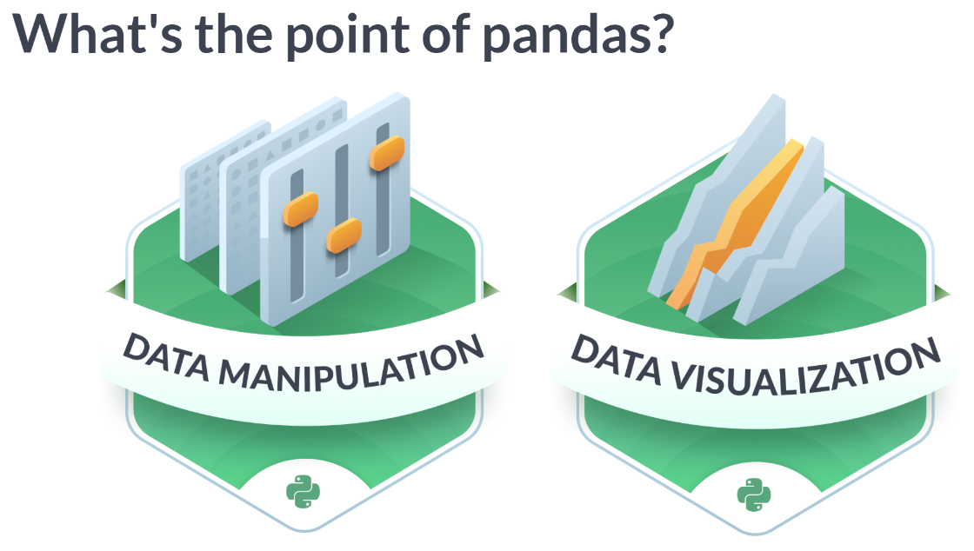  
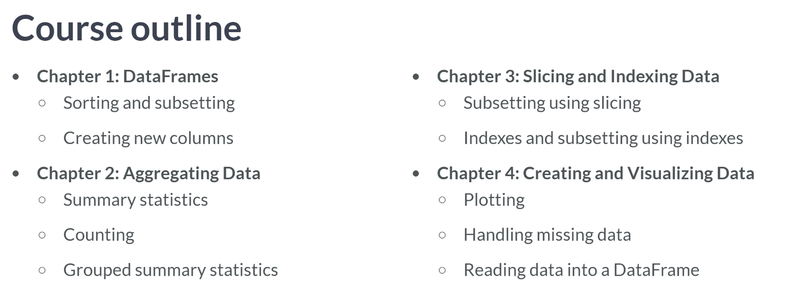

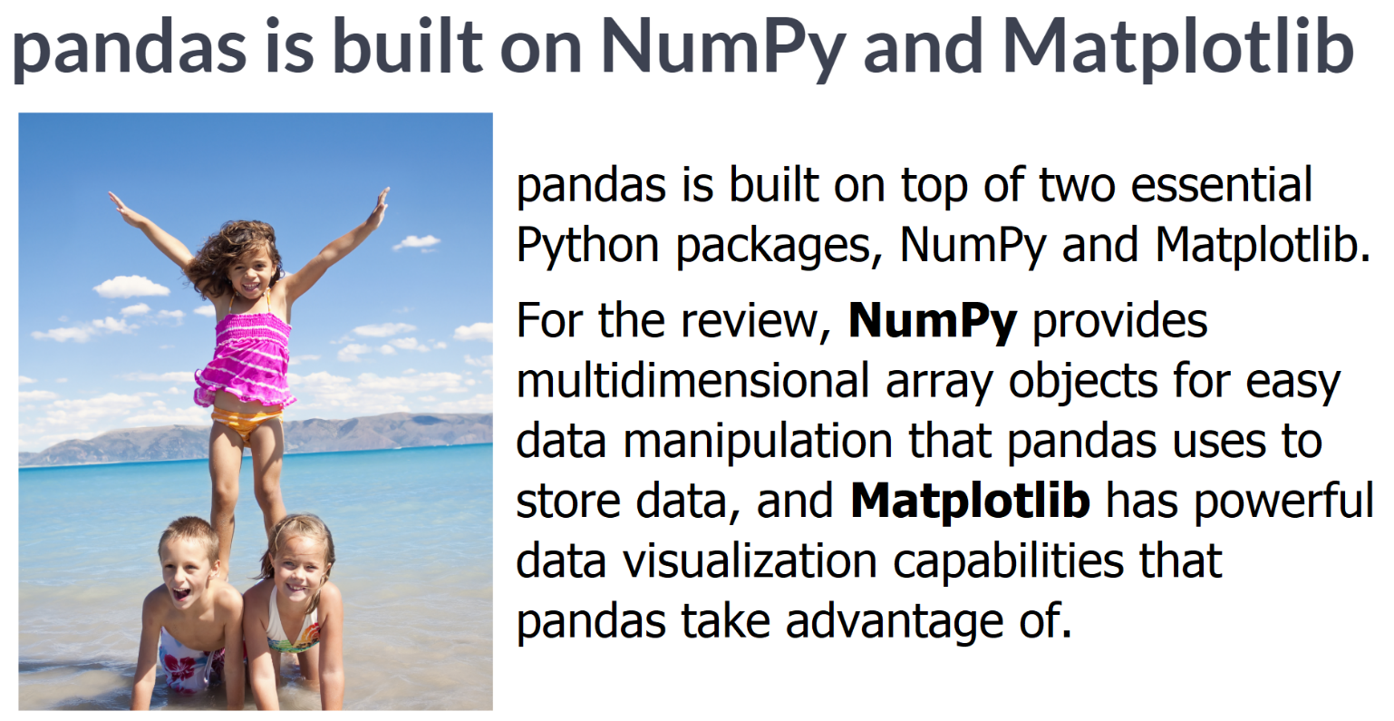

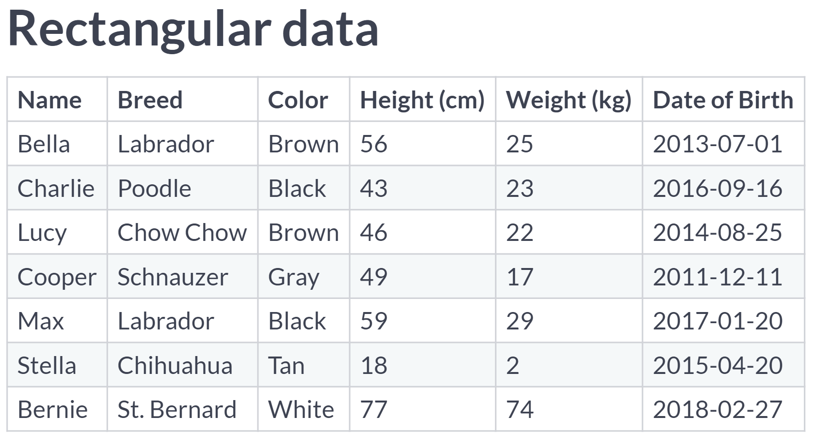  
There are several ways to store data for analysis, but rectangular data, sometimes called "tabular data", is the most common form. Each observation is a row, and each variable is a column.

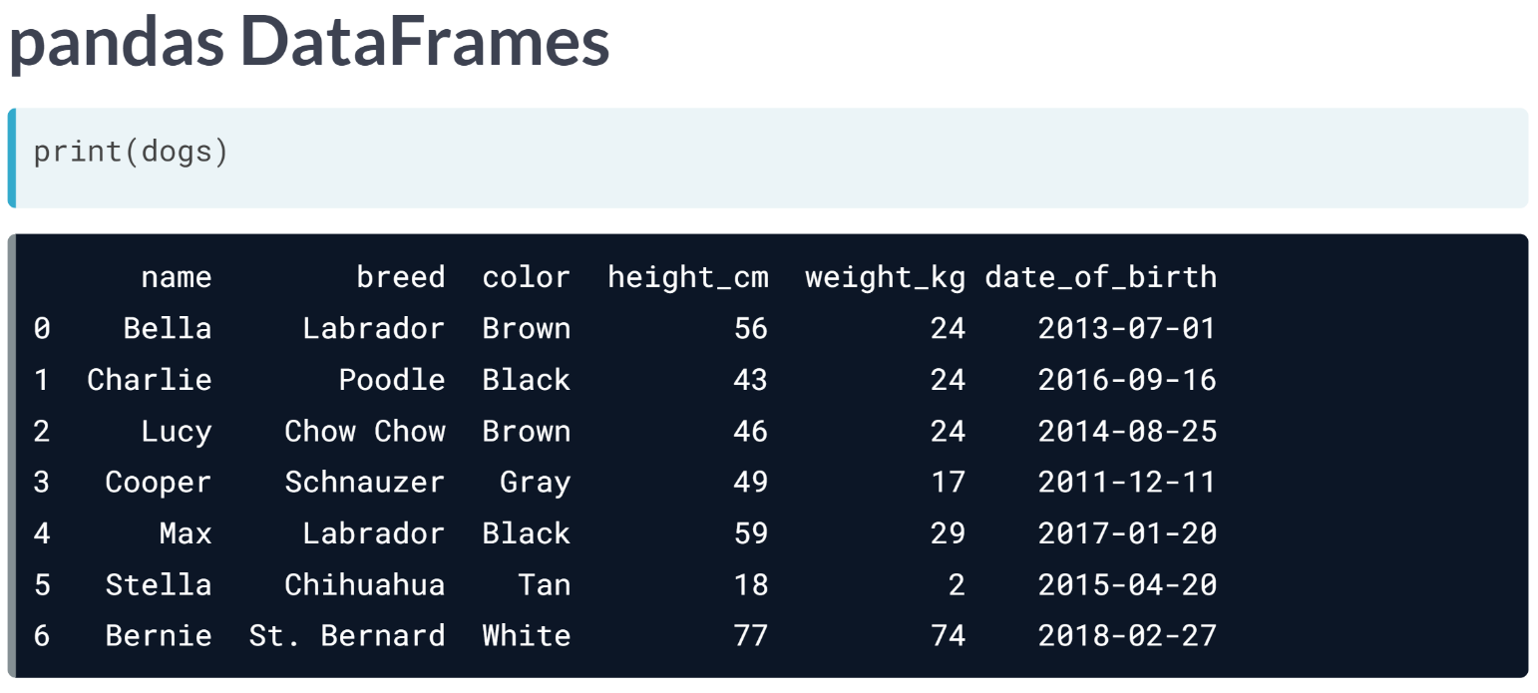  
In pandas, rectangular data is represented as a DataFrame object. Every programming language used for data analysis has something similar to this. R also has DataFrames, while SQL has database tables. Every value within a column has the same data type, either text or numeric, but different columns can contain different data types.

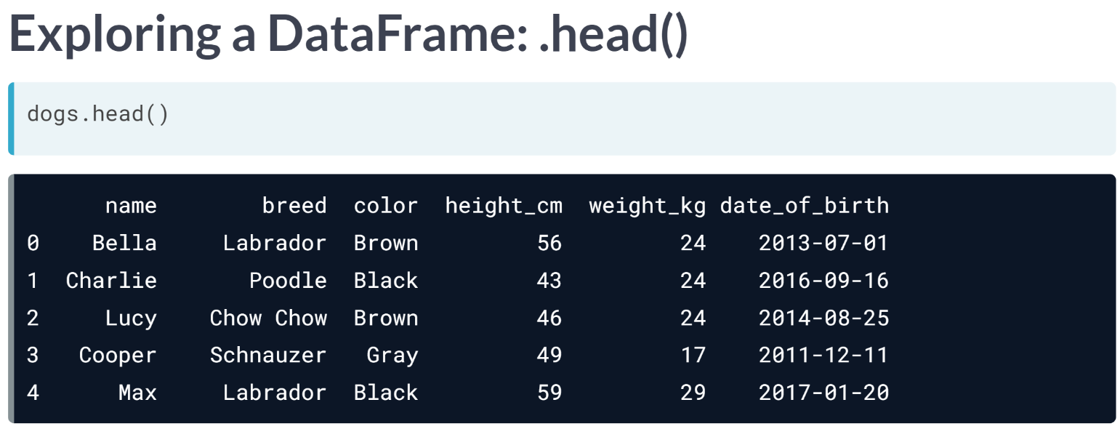  
***head()*** method is handy when you are looking at a large dataset.

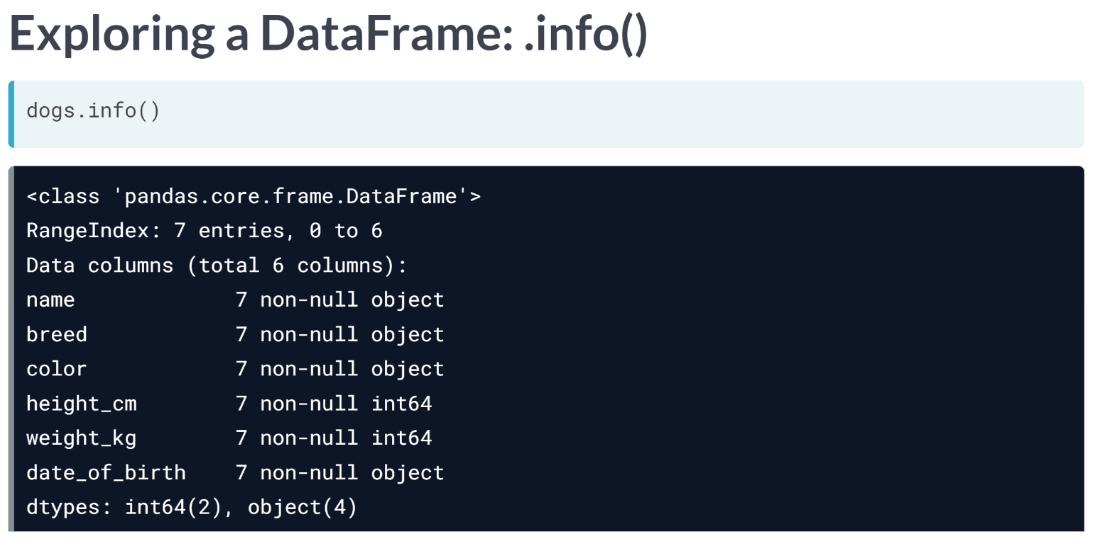  
The info method displays the names of columns, the data types they contain, and whether they have any missing values.

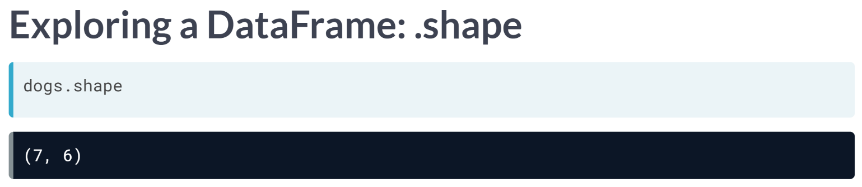  
DataFrame's shape attribute contains a tuple that holds the number of rows followed by the number of columns. Since this is an attribute instead of a method, you write it without parentheses.

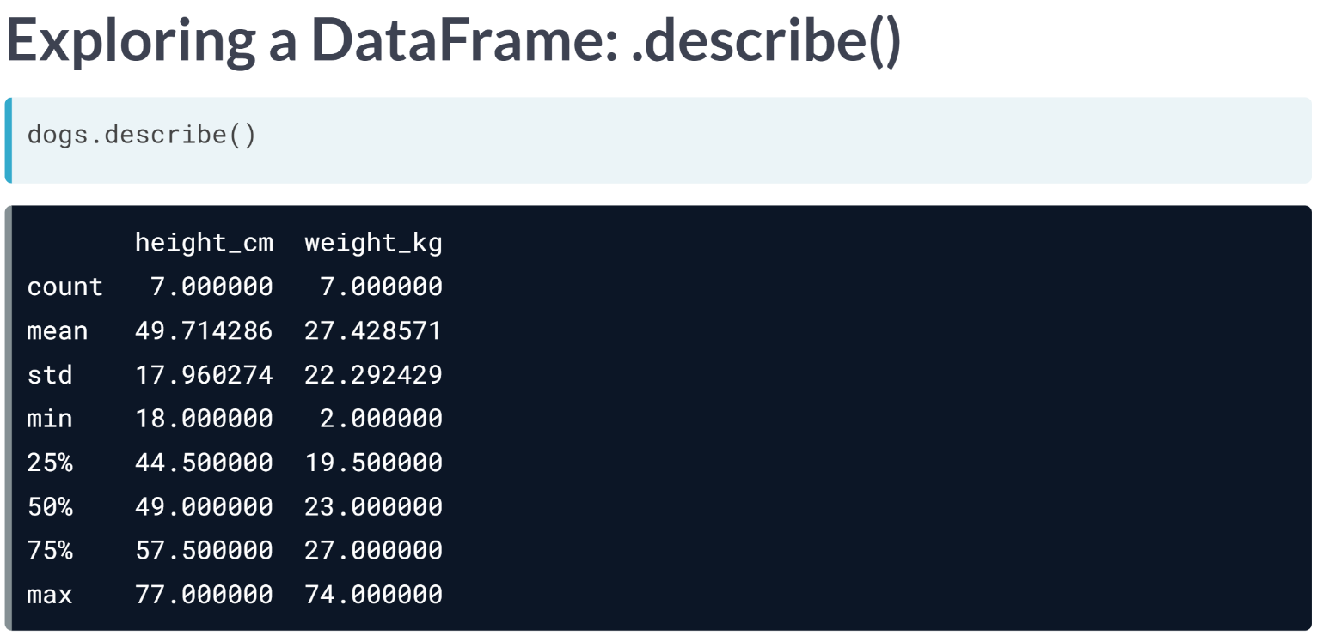  
The describe() method computes some summary statistics for numerical columns, such as mean and median. "count" is the number of non-missing values in each column. describe() is good for a quick overview of numeric variables, but if you want more control, you will see how to perform more specific calculations later in the course.

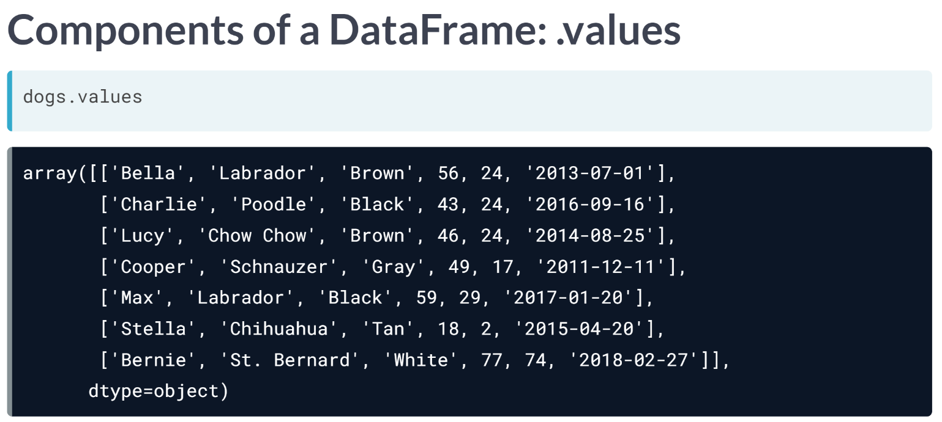  
DataFrames consist of three different components, accessible using attributes. The values attribute contains the data values in a 2D NumPy array.

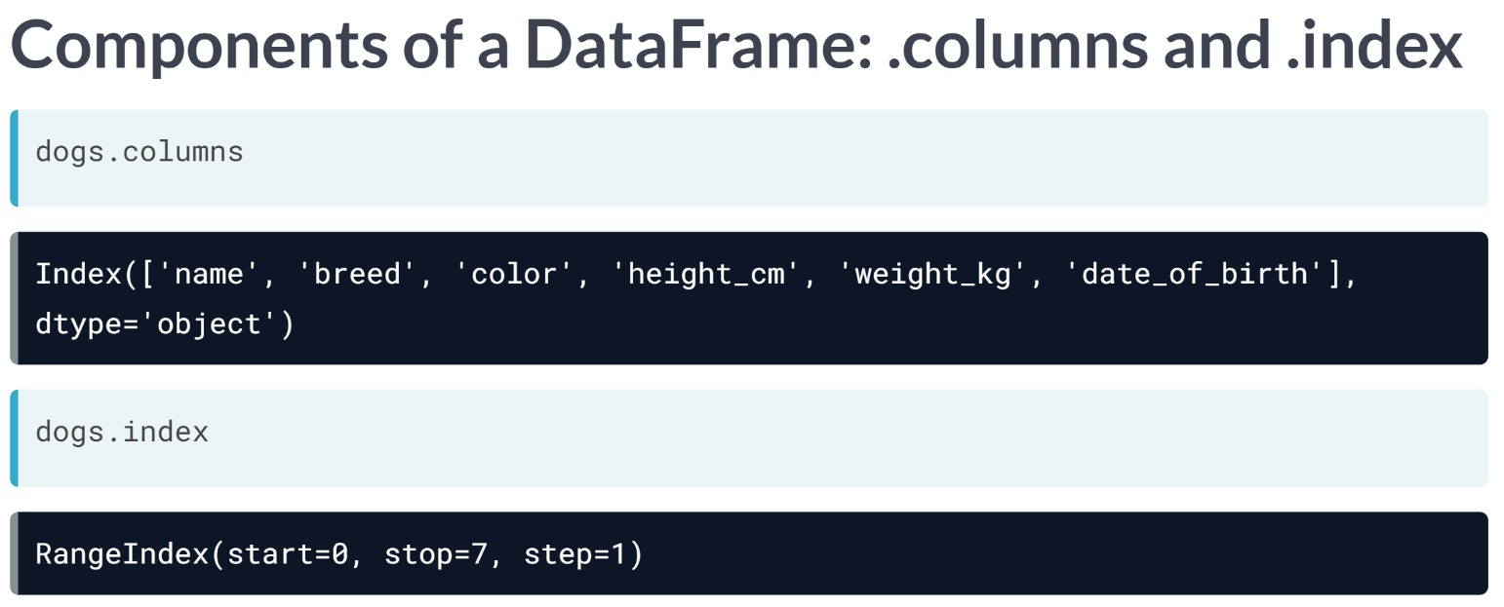  
The other two components of a DataFrame are labels for columns and rows. The columns attribute contains column names, and the index attribute contains row numbers or row names. Note that row labels are stored in .index, not in .rows. This allows for flexibility in labels.

# Inspecting a DataFrame

When you get a new DataFrame to work with, the first thing you need to do is explore it and see what it contains. There are several useful methods and attributes for this.

* .head() returns the first few rows (the “head” of the DataFrame).
* .info() shows information on each of the columns, such as the data type and number of missing values.
* .shape returns the number of rows and columns of the DataFrame.
* .describe() calculates a few summary statistics for each column.

homelessness is a DataFrame containing estimates of homelessness in each U.S. state in 2018. The individual column is the number of homeless individuals not part of a family with children. The family_members column is the number of homeless individuals part of a family with children. The state_pop column is the state's total population.

pandas is imported for you.

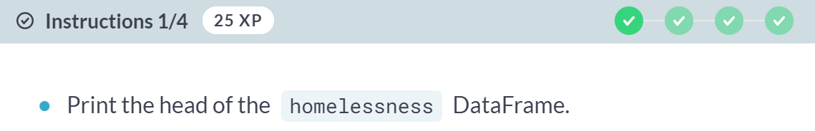

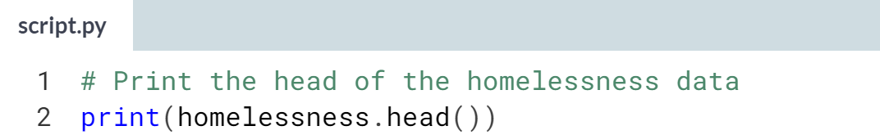

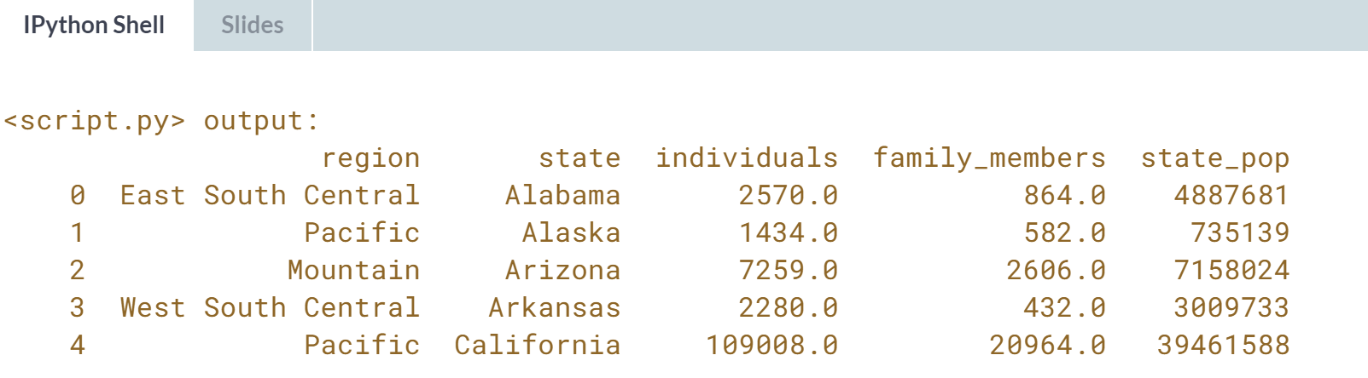

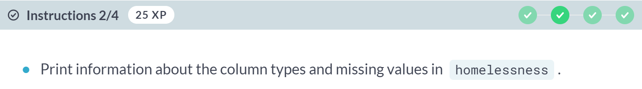

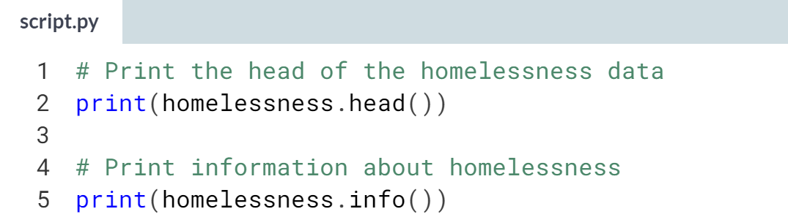

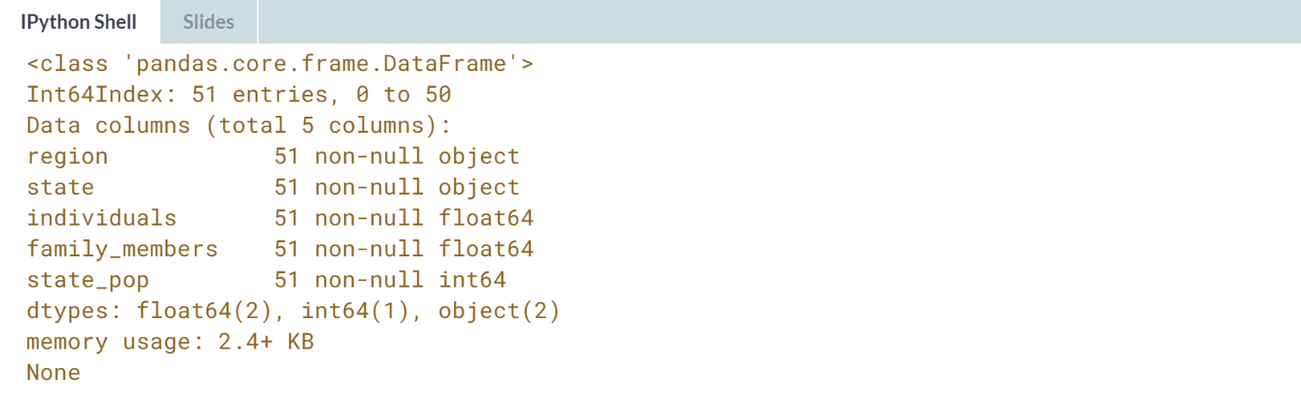

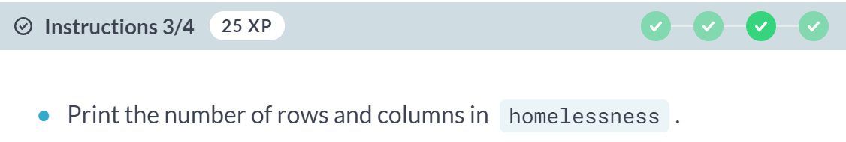

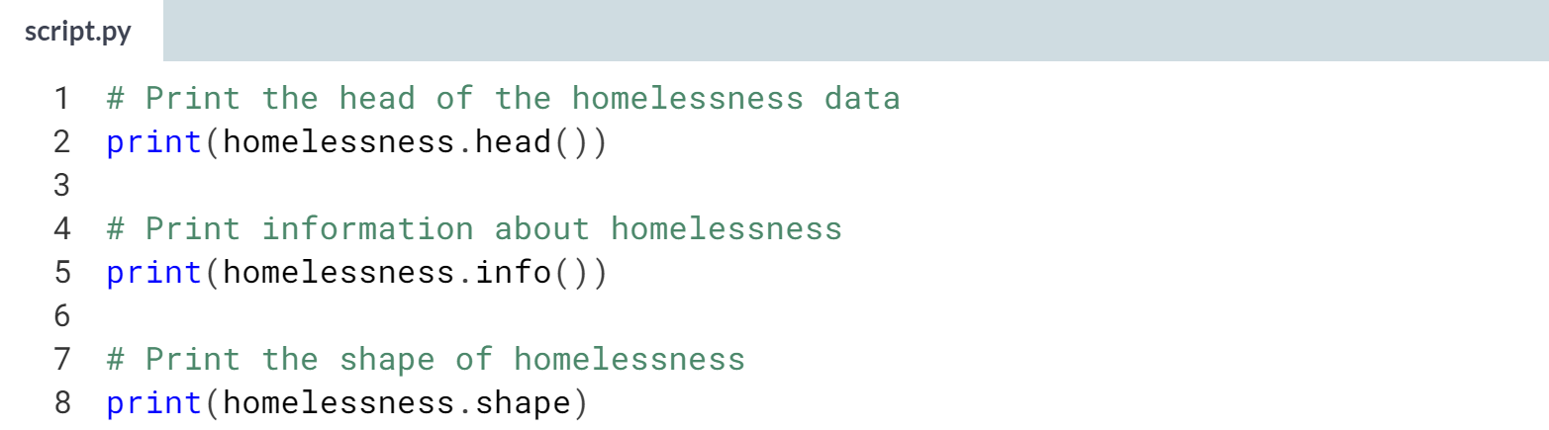



**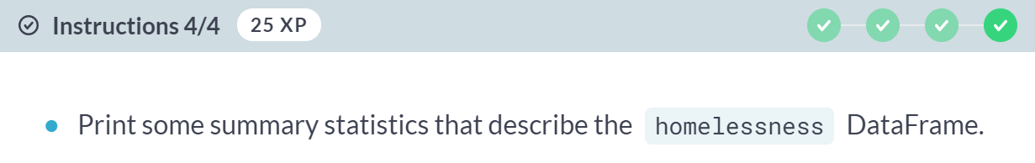  
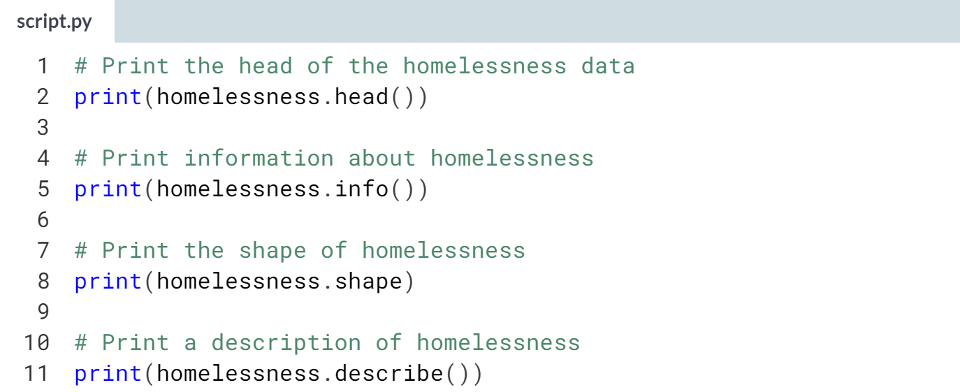**

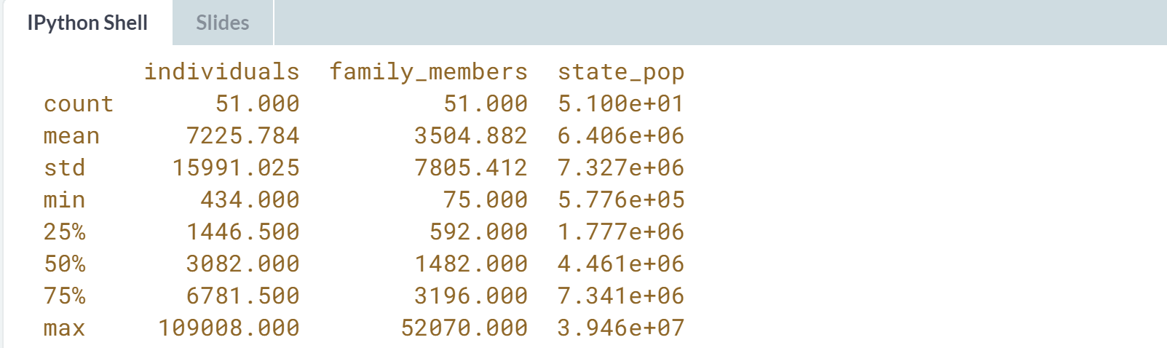  
Insightful inspecting! You can see that the average number of homeless individuals in each state is about 7226. Let's explore the DataFrame further.

# Parts of a DataFrame

To better understand DataFrame objects, it's useful to know that they consist of three components, stored as attributes:

* .values: A two-dimensional NumPy array of values.
* .columns: An index of columns: the column names.
* .index: An index for the rows: either row numbers or row names.

You can usually think of indexes as being like a list of strings or numbers, though the pandas Index data type allows for more sophisticated options. (These will be covered later in the course.)

homelessness is available.

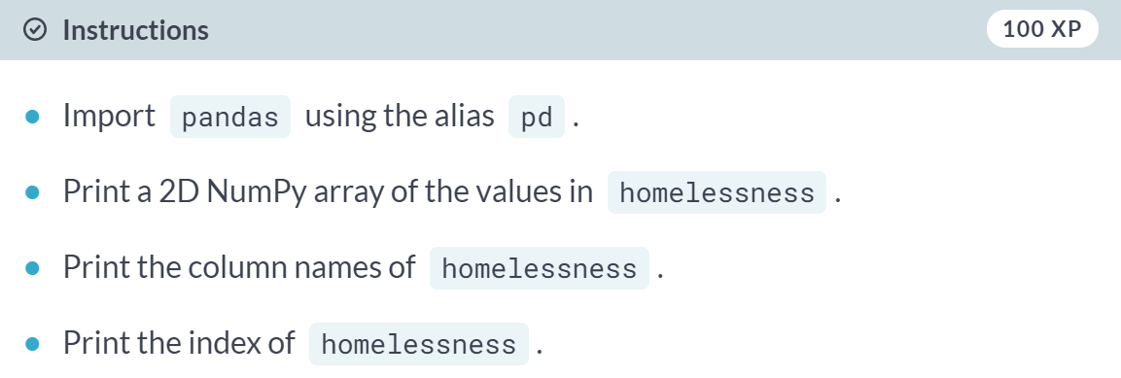

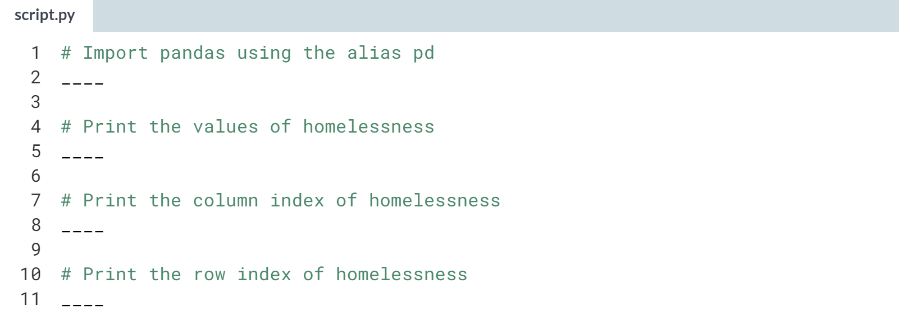

(Answer and Result on the next page)

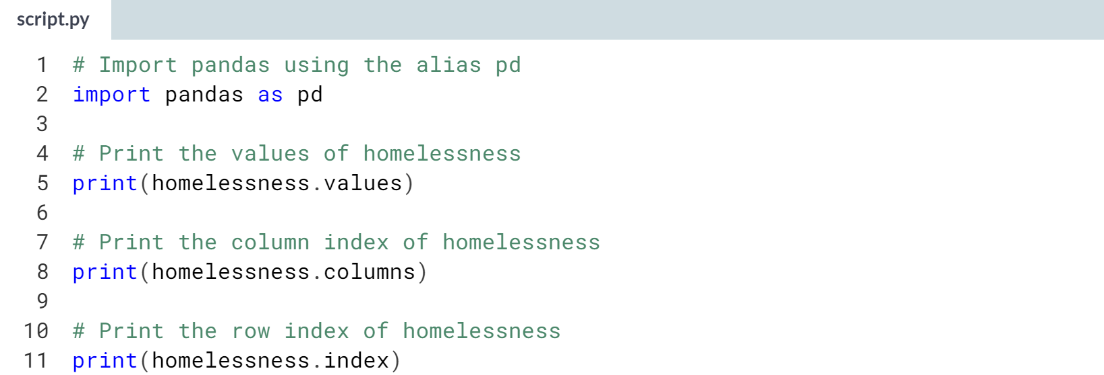

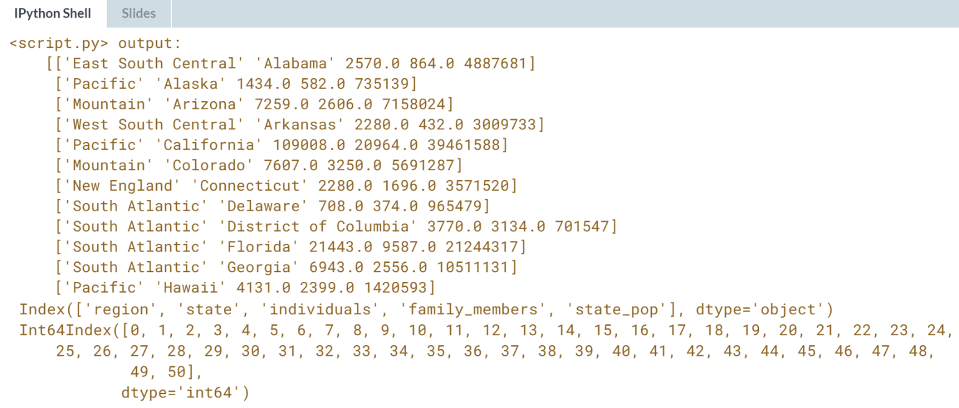



We will cover the two simplest, and possibly most important ways, to find interesting parts of your DataFrame.

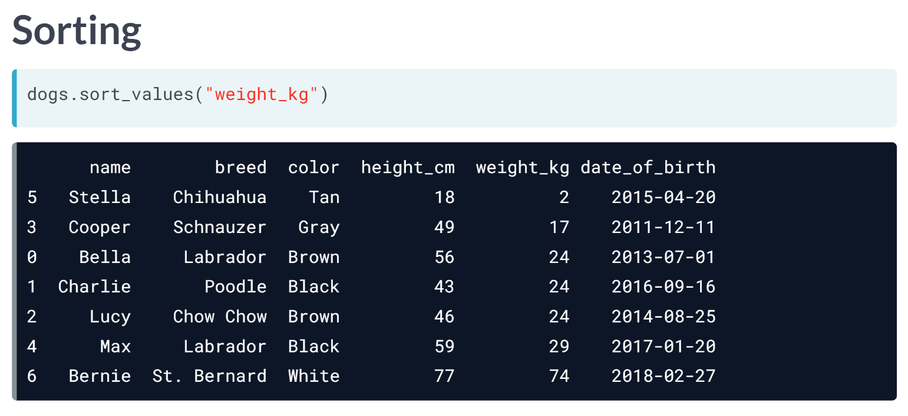  
The first thing you can do is change the order of the rows by sorting them so that the most interesting data is at the top of the DataFrame. You can sort rows using the ***sort_values()*** method, passing in a column name that you want to sort by. For example, when we apply ***sort_values()*** on the weight_kg column of the dogs DataFrame, we get the lightest dog at the top, and the St. Bernard at the bottom.

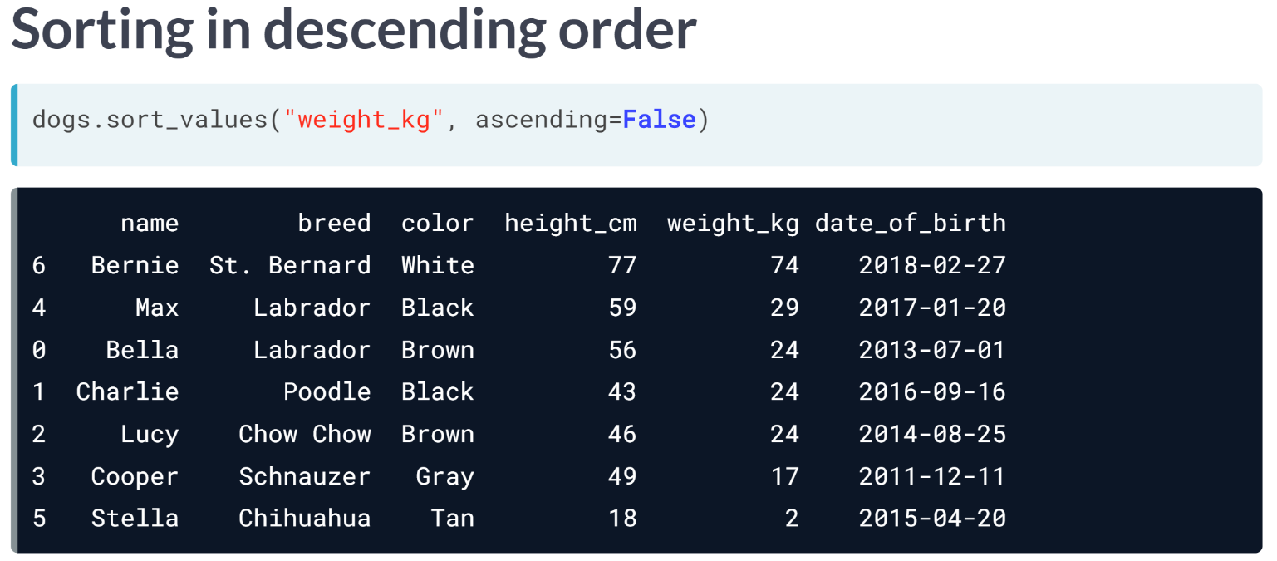  
Setting the ascending argument to False will sort the data other way around, from heaviest dog to lightest dog.

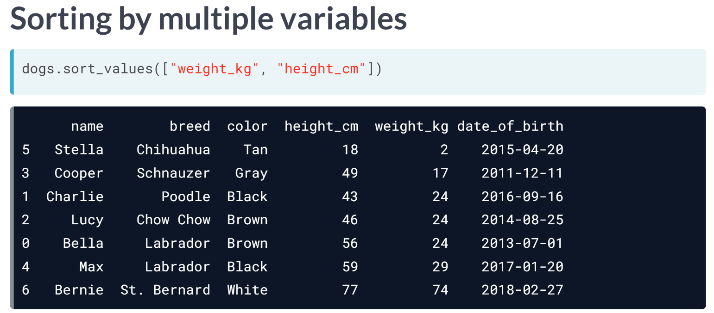  
We can sort by multiple variables by passing a list of column names to sort_values. Here, we sort first by weight, then by weight. Notice how Charlie, Lucy, and Bella are ordered from shortest to tallest, even though they all weigh the same.

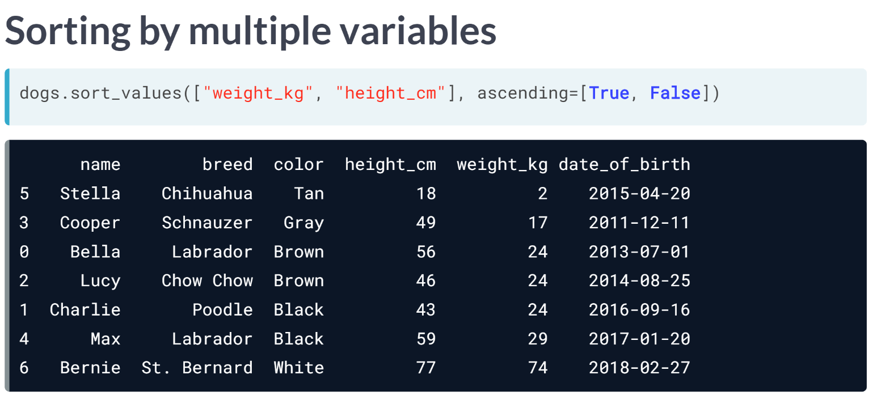To change the direction values are sorted in, pass a list to the ascending argument to specify which direction sorting should be done for each variable. Now, Charlie, Lucy, and Bella are ordered from tallest to shortest.

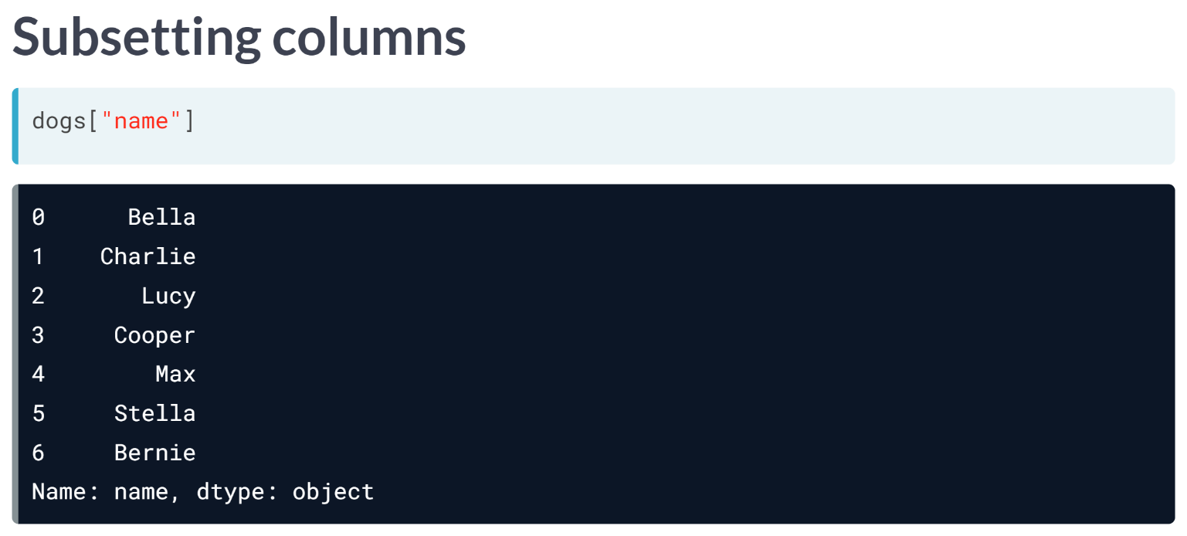  
We may want to zoom in on just one column. We can do this using the name of the DataFrame followed by square brackets with a column name inside. Here, we can look at just the name column.

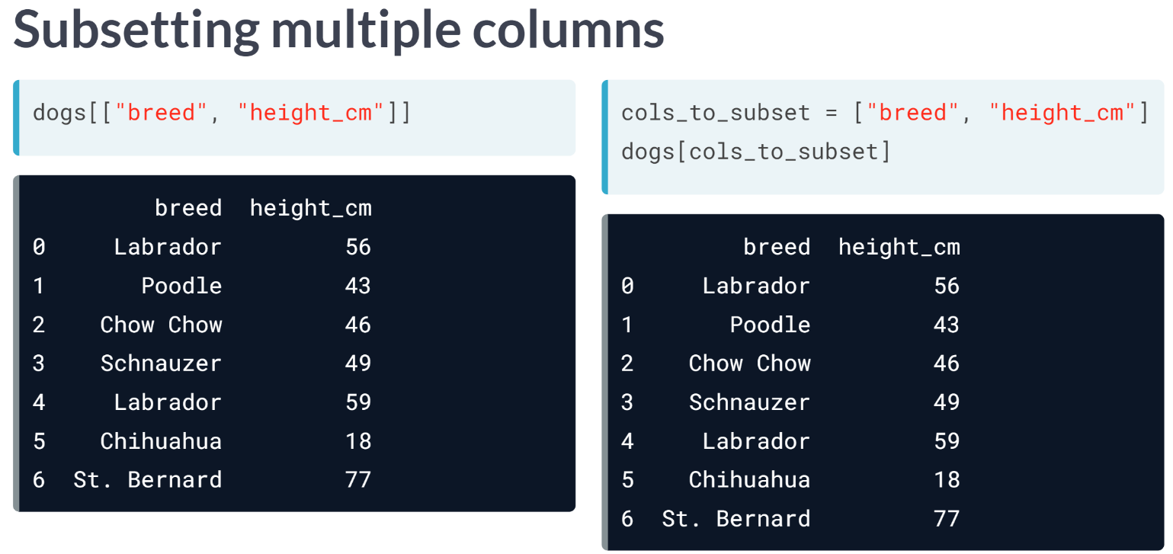  
To select multiple columns, you need two pairs of square brackets. In this code, the inner and outer brackets are performing different tasks.

The outer square brackets are responsible for subsetting the DataFrame, while the inner square brackets are creating a list of column names to subset.

This means that you could provide a separate list of column names as a variable and then use that list to perform the same subsetting.

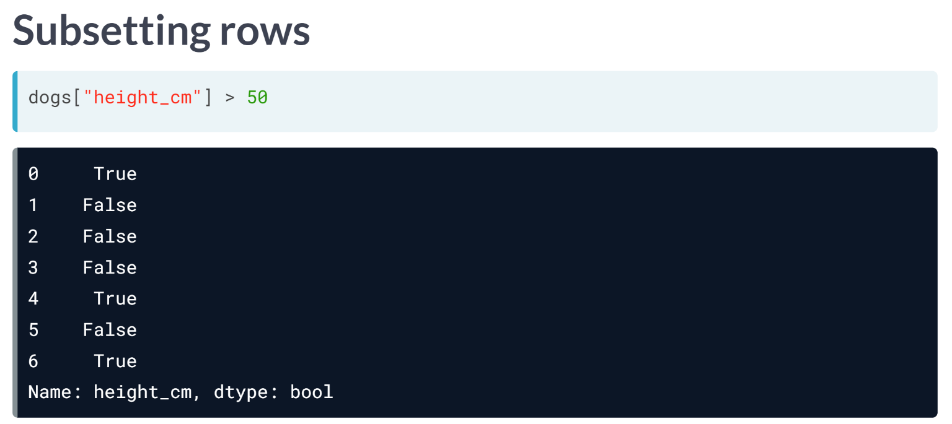  
There are lot of different ways to subset rows. The most common way to do this is by creating a logical condition to filter against. For example, let's find all the dogs whose height is greater than 50 centimeters. Now we have a True or False value for every row.

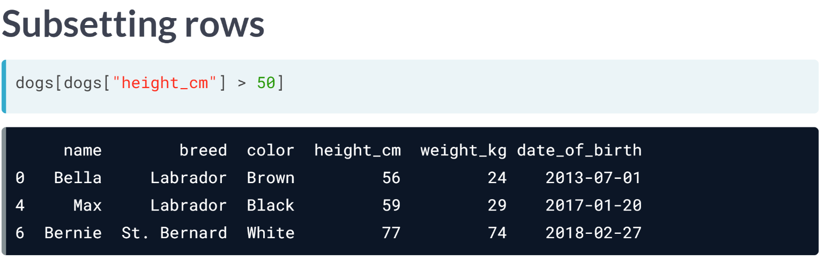  
We can use the logical condition inside of brackets to subset the rows we are interested in to get the actual list of dogs taller than 50 centimeters

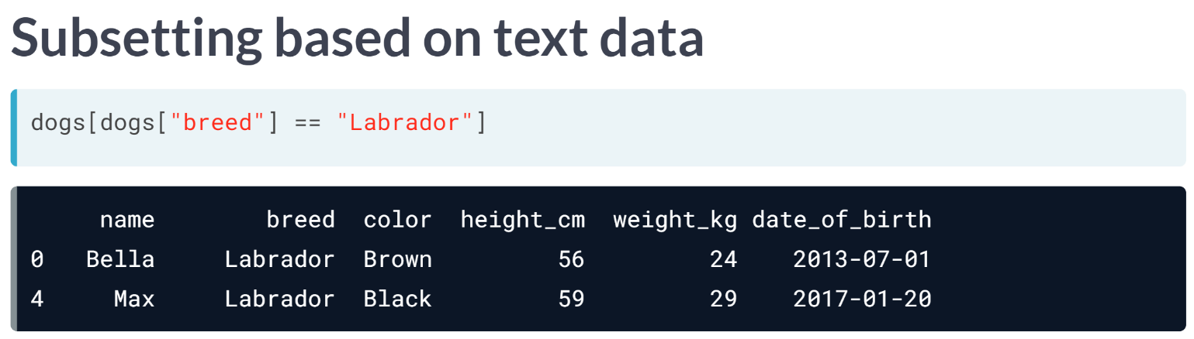  
We can also subset rows based on text data. Here, we use the double equal sign in the logical condition to filter the dogs that are Labradors.

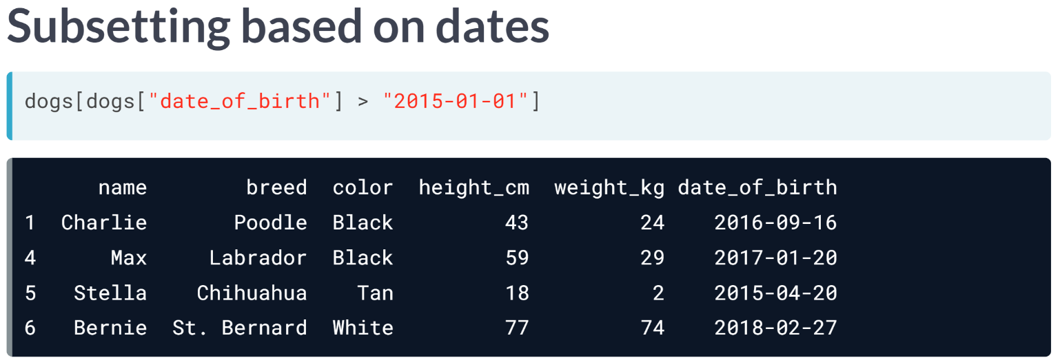  
We can also subset based on dates. Here, we filter all the dogs born after 2015. Notice that the dates are in quotes and are written as year-month-day format.

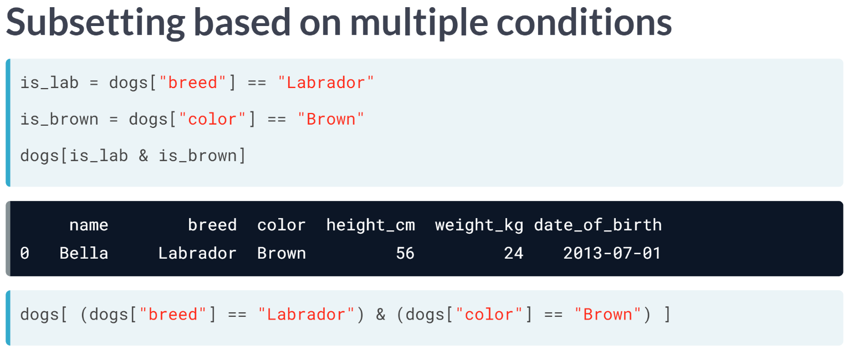  
To subset the rows that meet multiple conditions, you can combine conditions using logical operators, such as the "and" operator seen here, meaning that only rows that meet both of these conditions will be subsetted. You could also do this in one line of code, but you will need also to add parentheses around each condition.

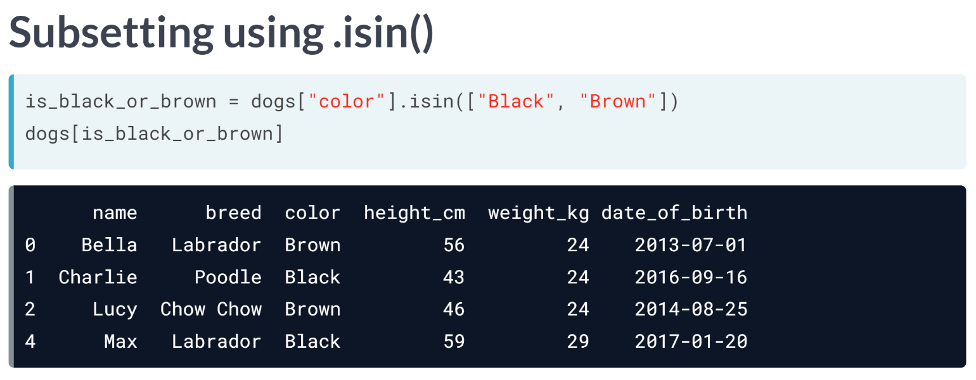  
If you want to filter on multiple values of a categorical variable, the easiest way is to use the ***isin()*** method. This takes in a list of values to filter for.

Here, we check if the color of the dog is black or brown and use this condition to subset the data.

# Sorting rows

Finding interesting bits of data in a DataFrame is often easier if you change the order of the rows. You can sort the rows by passing a column name to .sort_values().

In cases where rows have the same value (this is common if you sort on a categorical variable), you may wish to break the ties by sorting on another column. You can sort on multiple columns in this way by passing a list of column names.

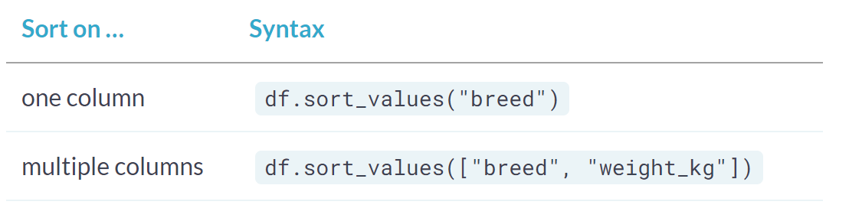

By combining .sort_values() with .head(), you can answer questions in the form, "What are the top cases where…?". homelessness is available and pandas is loaded as pd.

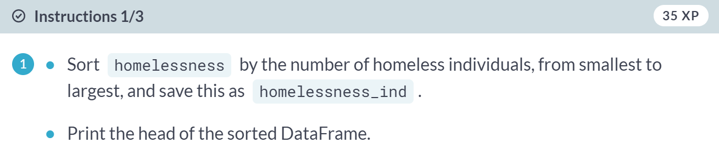

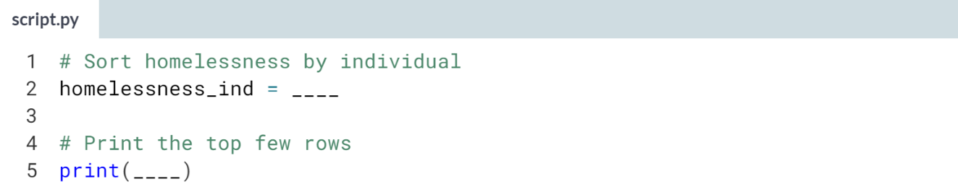  
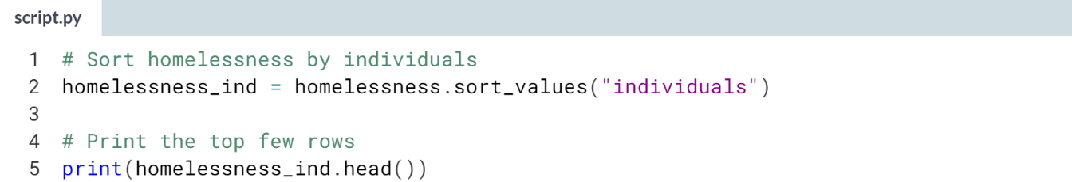  
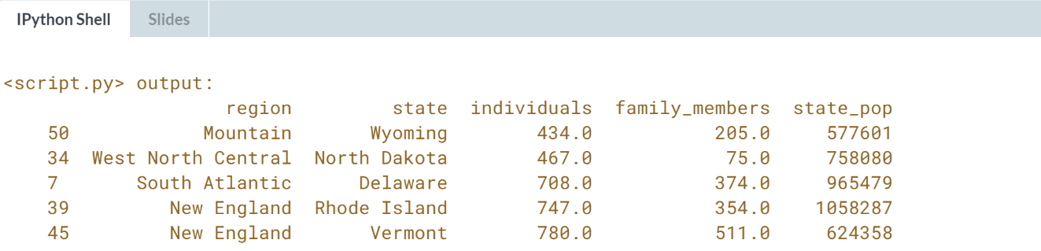

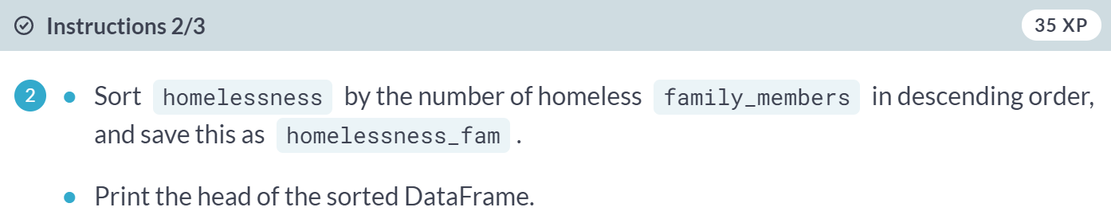

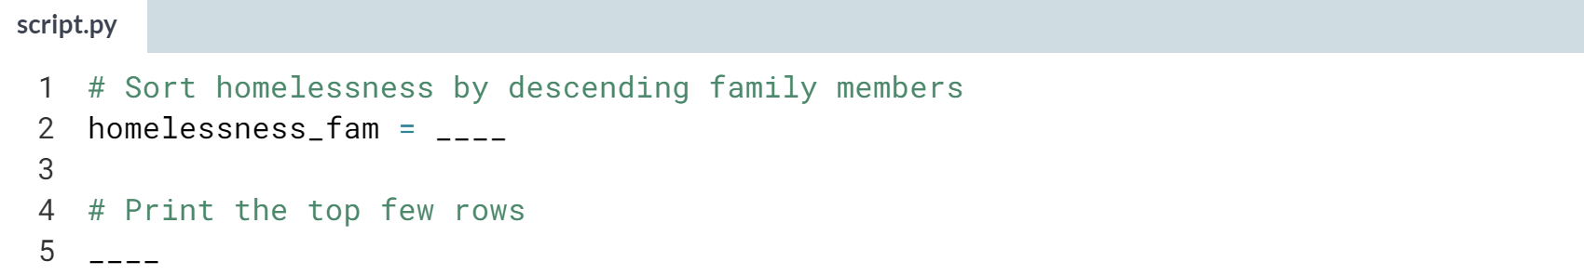  
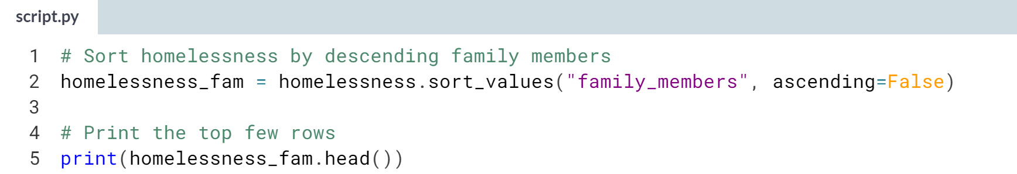  
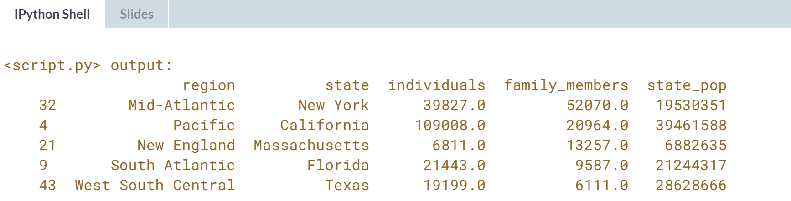

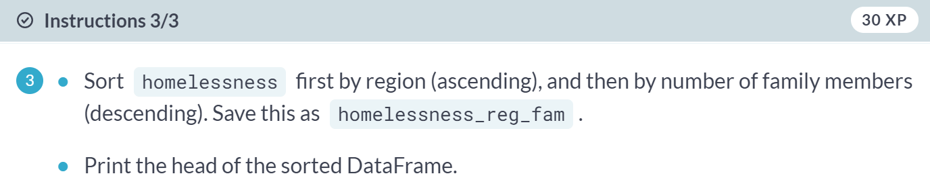

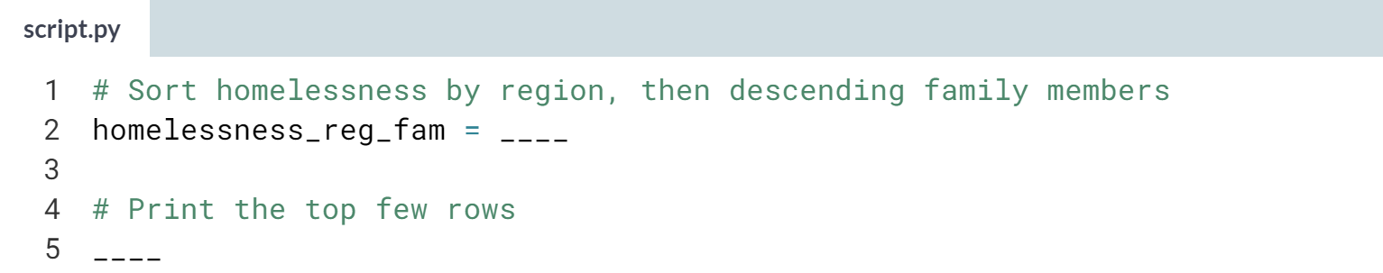

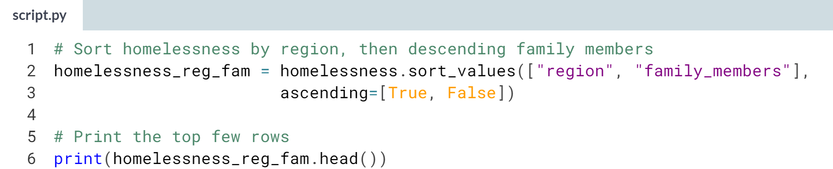  
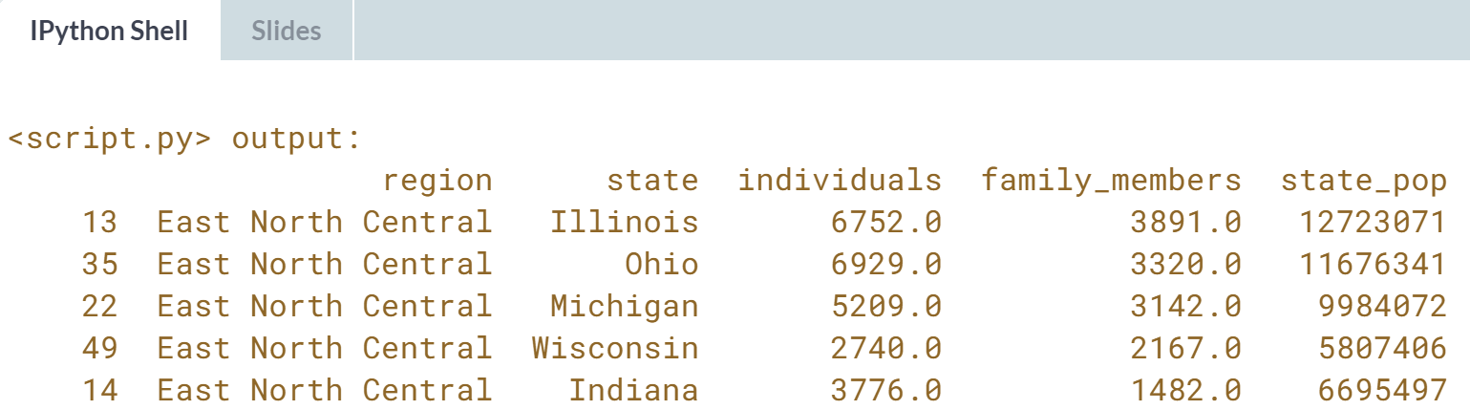  
Your head is sorted! Using ***.sort_values()*** and ***.head()*** form a powerful pair.

# Subsetting columns

When working with data, you may not need all of the variables in your dataset. Square-brackets ([]) can be used to select only the columns that matter to you in an order that makes sense to you. To select only "col_a" of the DataFrame df, use



To select "col_a" and "col_b" of df, use



homelessness is available and pandas is loaded as pd.

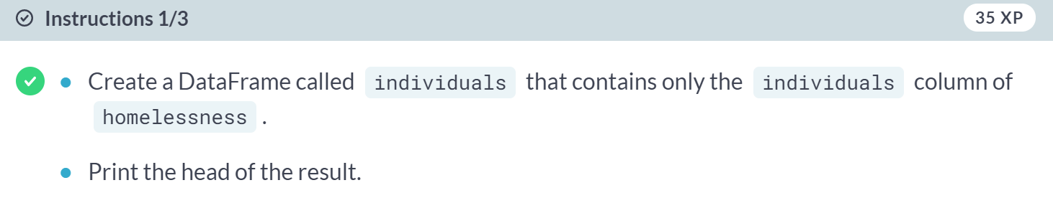

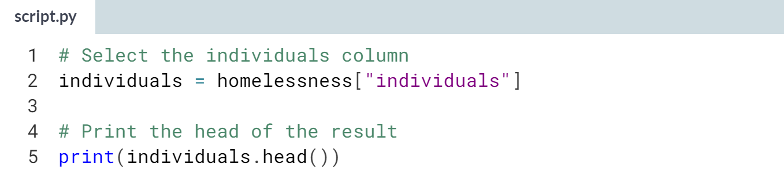

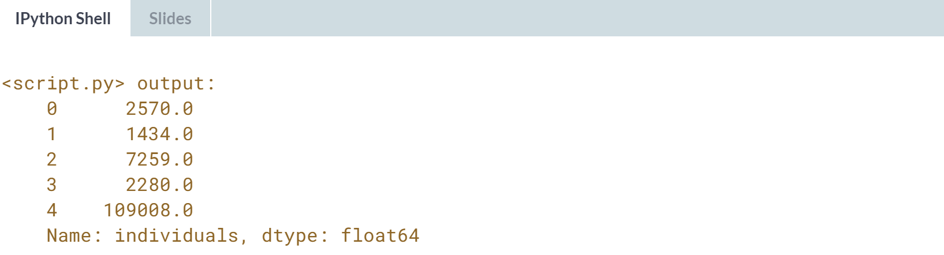

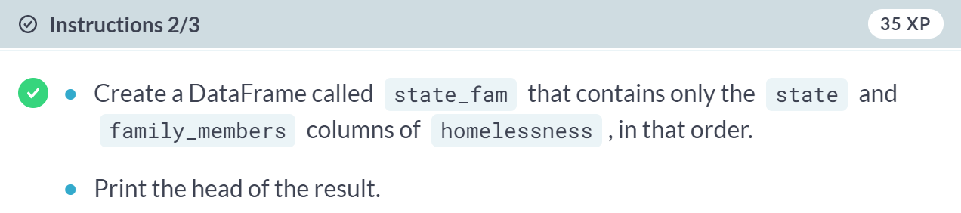

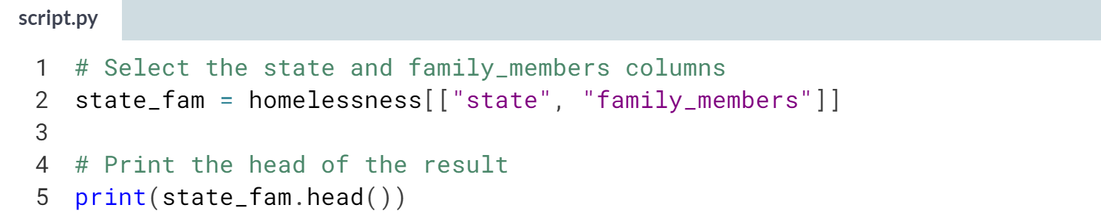

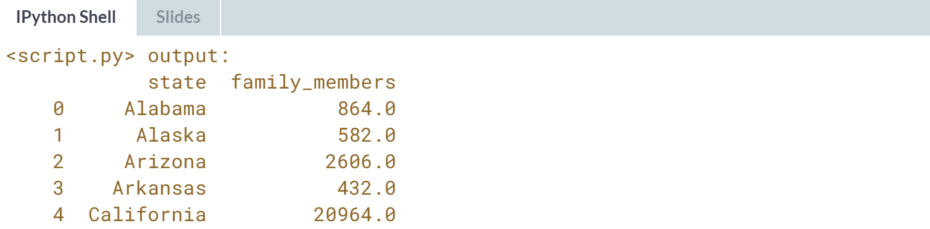

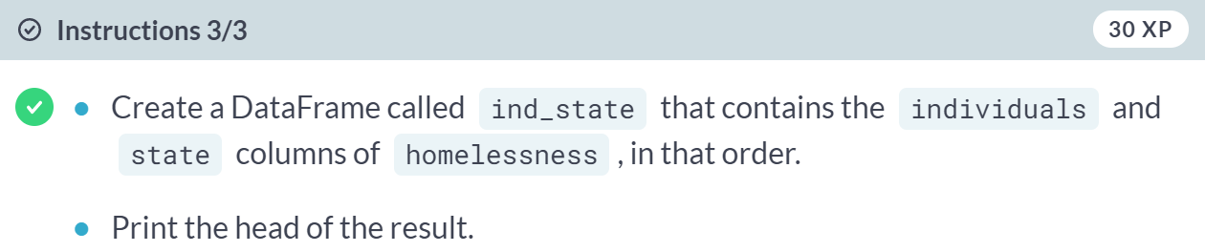

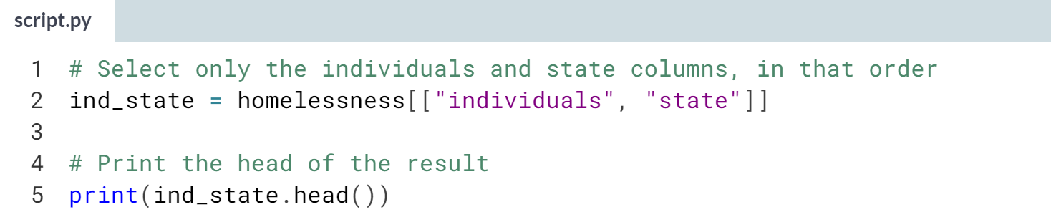

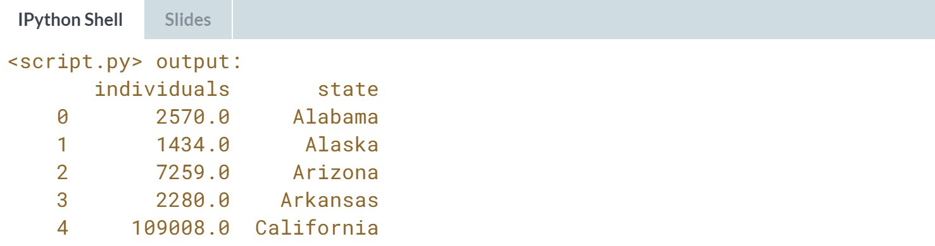  
Radical reordering! Selecting and reordering columns can make data easier to work with.

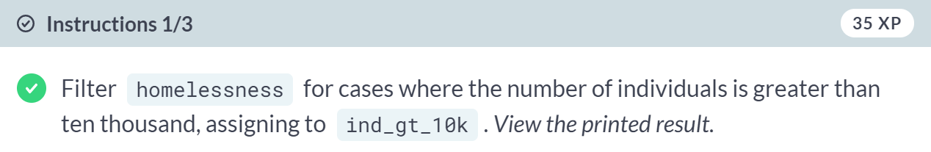

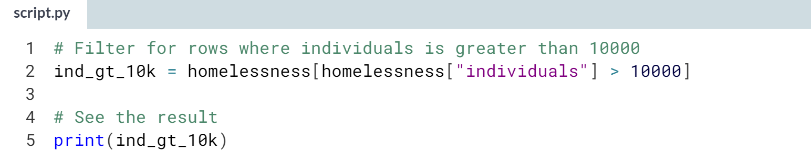

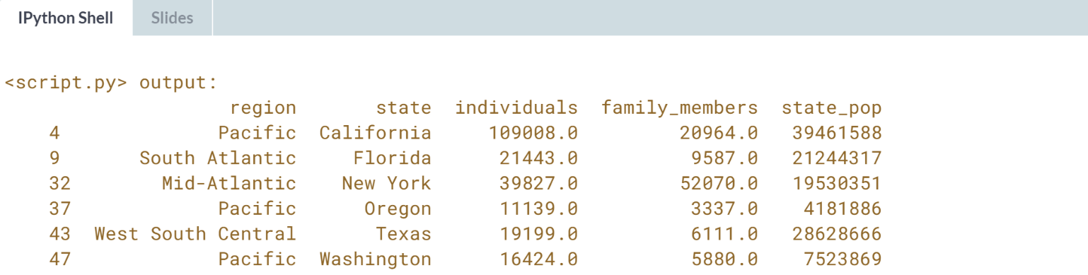

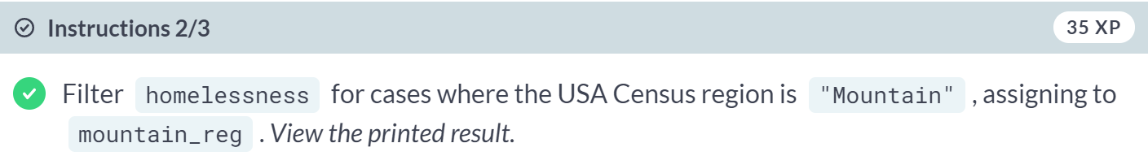

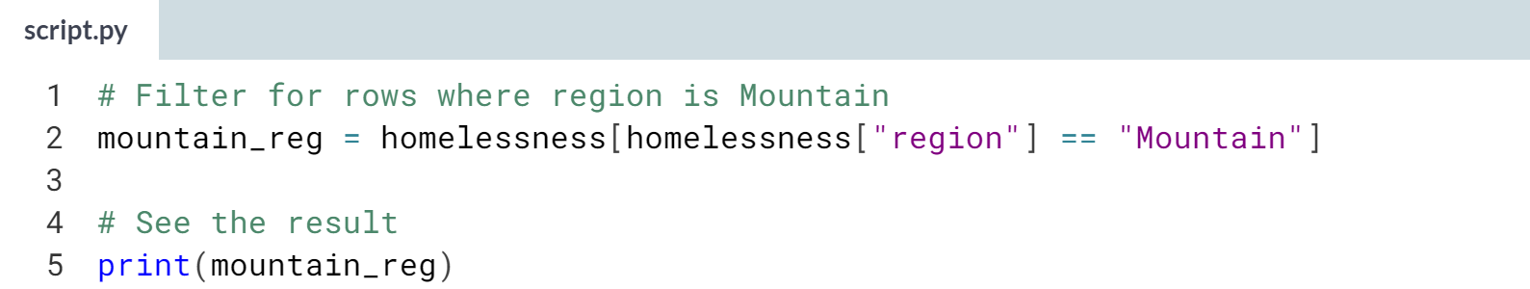

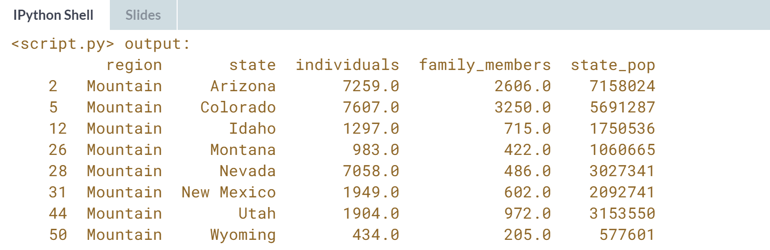

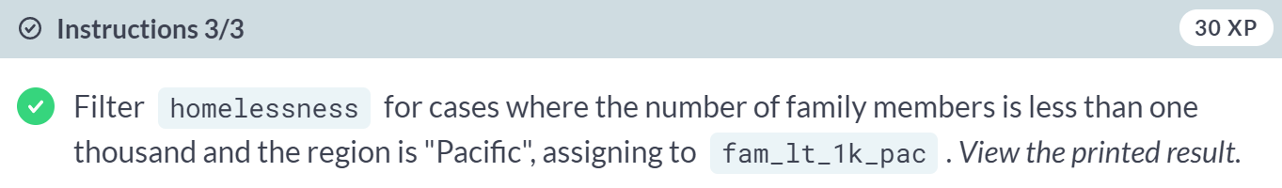

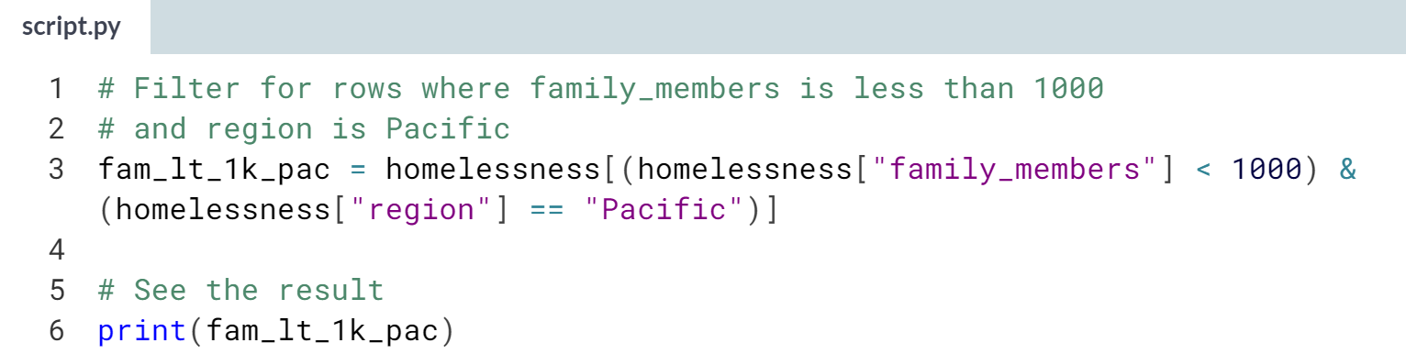

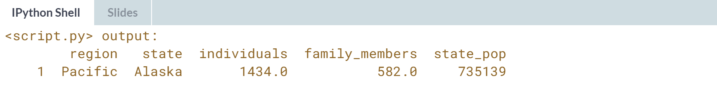

Superb subsetting! Using square brackets plus logical conditions is often the most powerful way of identifying interesting rows of data.

# Subsetting rows by categorical variables

Subsetting data based on a categorical variable often involves using the "or" operator (|) to select rows from multiple categories. This can get tedious when you want all states in one of three different regions, for example.

Instead, use the .isin() method, which will allow you to tackle this problem by writing one condition instead of three separate ones.



homelessness is available and pandas is loaded as pd.

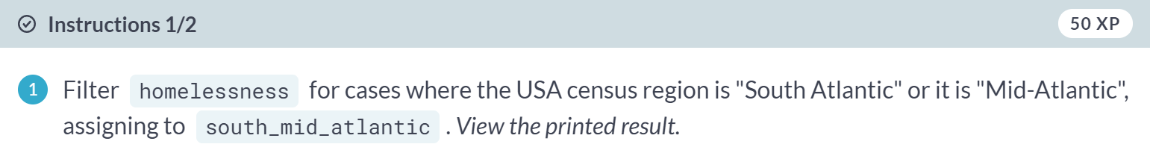

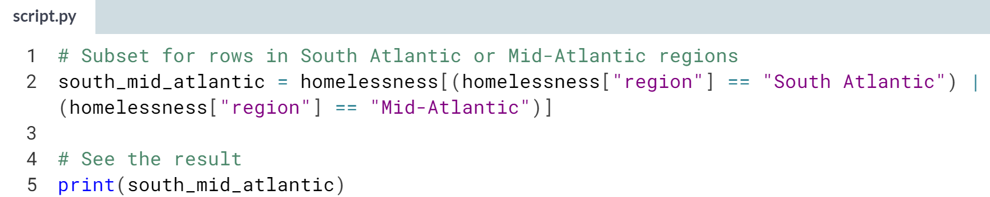  
  
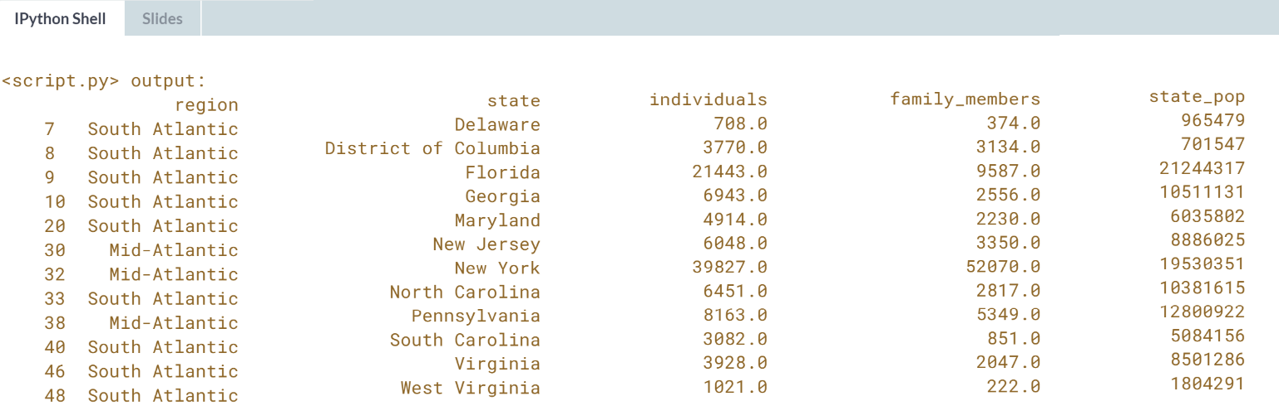

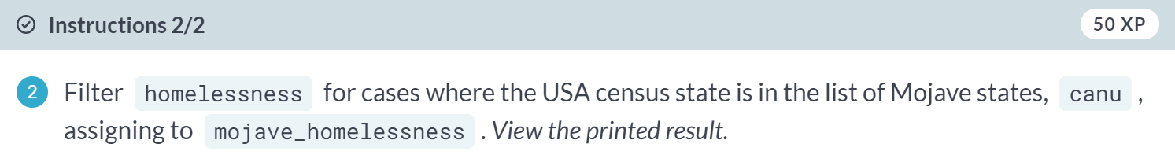

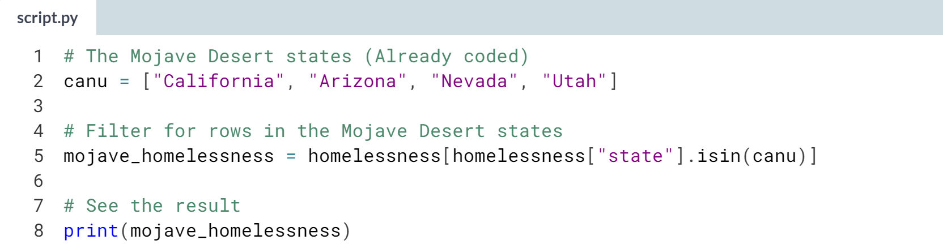

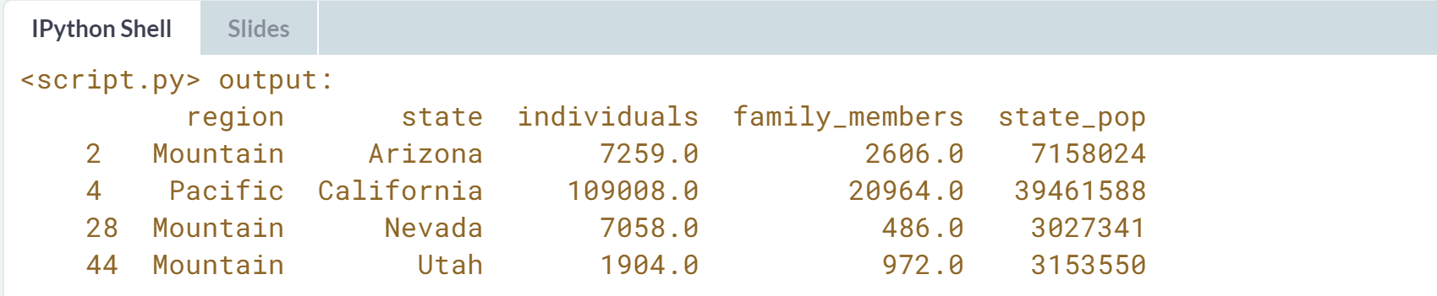

Success is in the air! Using ***.isin()*** makes subsetting categorical variables a breeze.



Often when you first receive a DataFrame, the contents aren't exactly what you want. You may have to add new columns derived from existing columns.

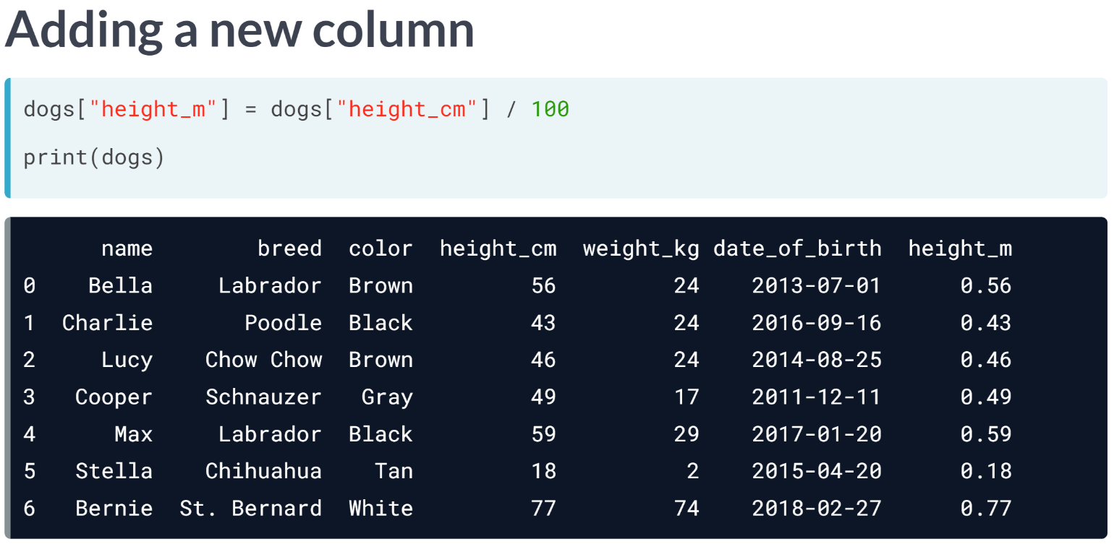  
Creating and adding new columns can go by many names, including mutating a DataFrame, transforming a DataFrame, and feature engineering.

Let's say we want to add a new column to our DataFrame that has each dog's height in meters instead of centimeters.

On the left-hand side of the equals sign, we use the square brackets with the name of the new column we want to create.

On the right-hand side, we have the calculation. Notice that both the existing column and the new column we just created are in the DataFrame.

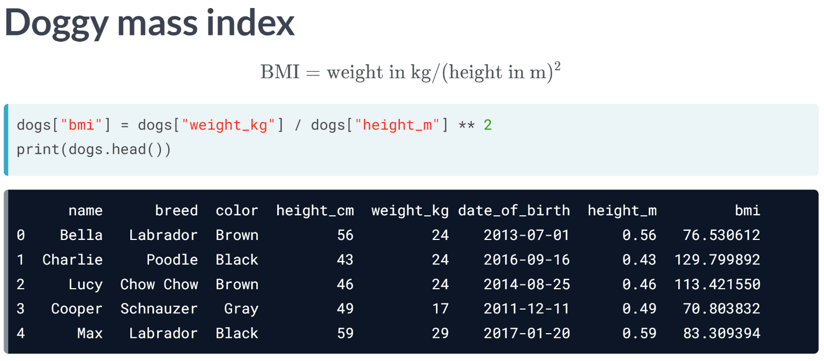  
Let's see what the results are if we calculate the BMI of these dogs. BMI is usually calculated by taking a person's weight in kilograms and dividing it by their height in meters, squared.

Again, the new column is on the left-hand side of the equals, but our calculation involves two columns.

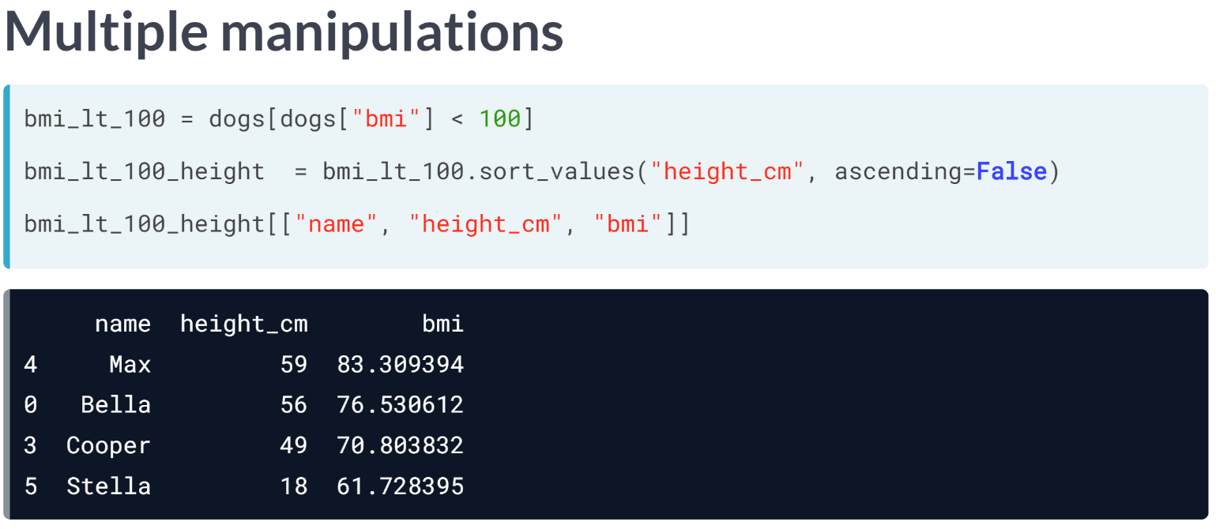  
The real power of pandas comes in when you combine all the skills you've learned so far. Let's say that we want to figure out the names of skinny, tall dogs.

1. First, we take the subset of dogs who have a BMI of under 100, to define the skinny dogs.
2. Next, we sort the result in descending order of height to get the tallest skinny dogs at the top.
3. Finally, we keep only the columns we are interested in.

When analyzing data, we can see that Max is the tallest dog with a BMI of under 100.

# Adding new columns

You aren't stuck with just the data you are given. Instead, you can add new columns to a DataFrame. This has many names, such as transforming, mutating, and feature engineering.

You can create new columns from scratch, but it is also common to derive them from other columns, for example, by adding columns together, or by changing their units.

homelessness is available and pandas is loaded as pd.

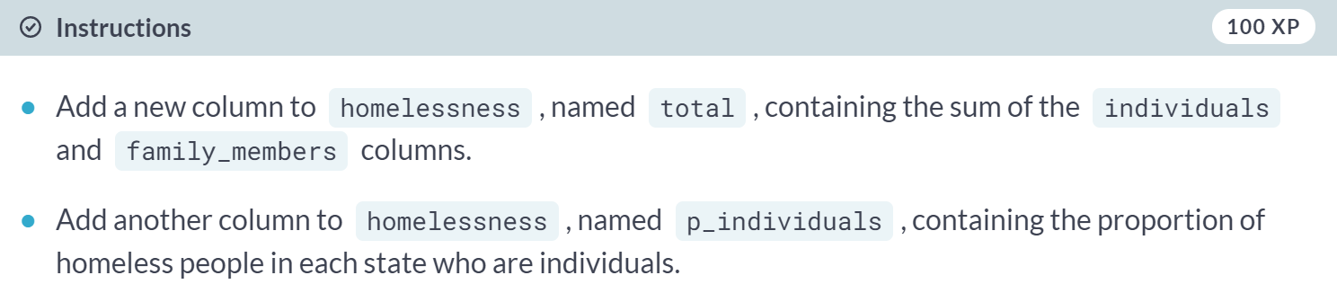

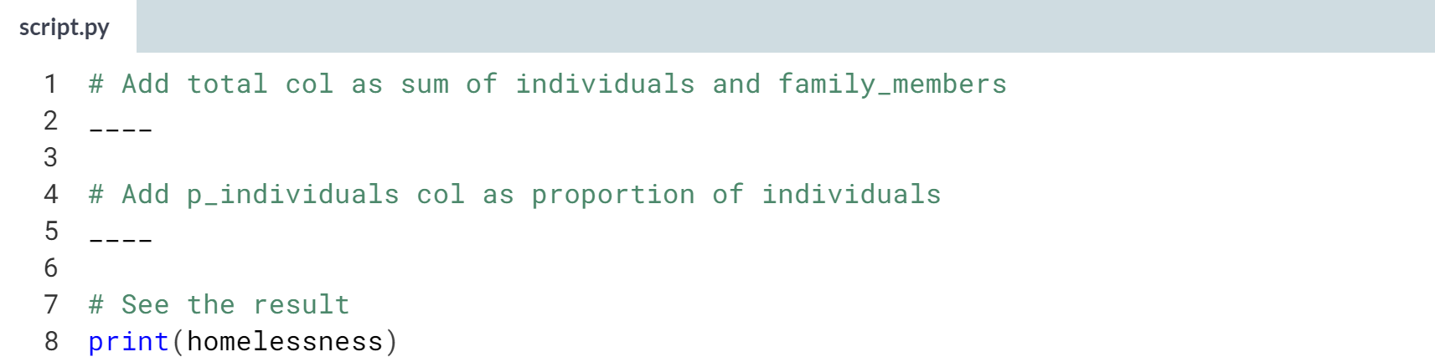  
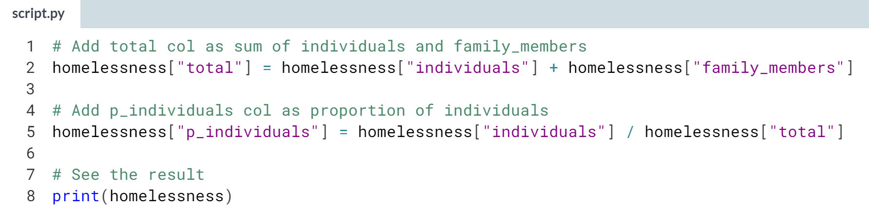  
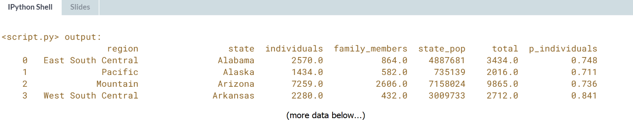  
Astounding column assignment! If your dataset doesn't have the exact columns you need, you can often make your own from what you have.

# Combo-attack!

You've seen the four most common types of data manipulation: sorting rows, subsetting columns, subsetting rows, and adding new columns. In a real-life data analysis, you can mix and match these four manipulations to answer a multitude of questions.

In this exercise, you'll answer the question, "Which state has the highest number of homeless individuals per 10,000 people in the state?" Combine your new pandas skills to find out.

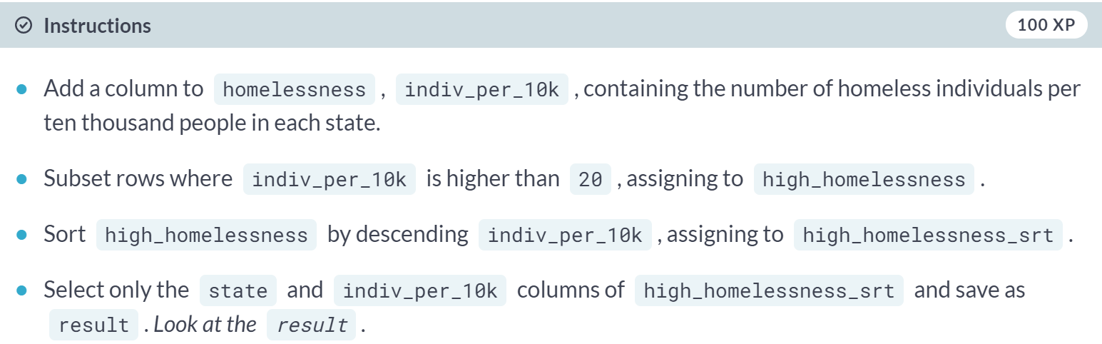

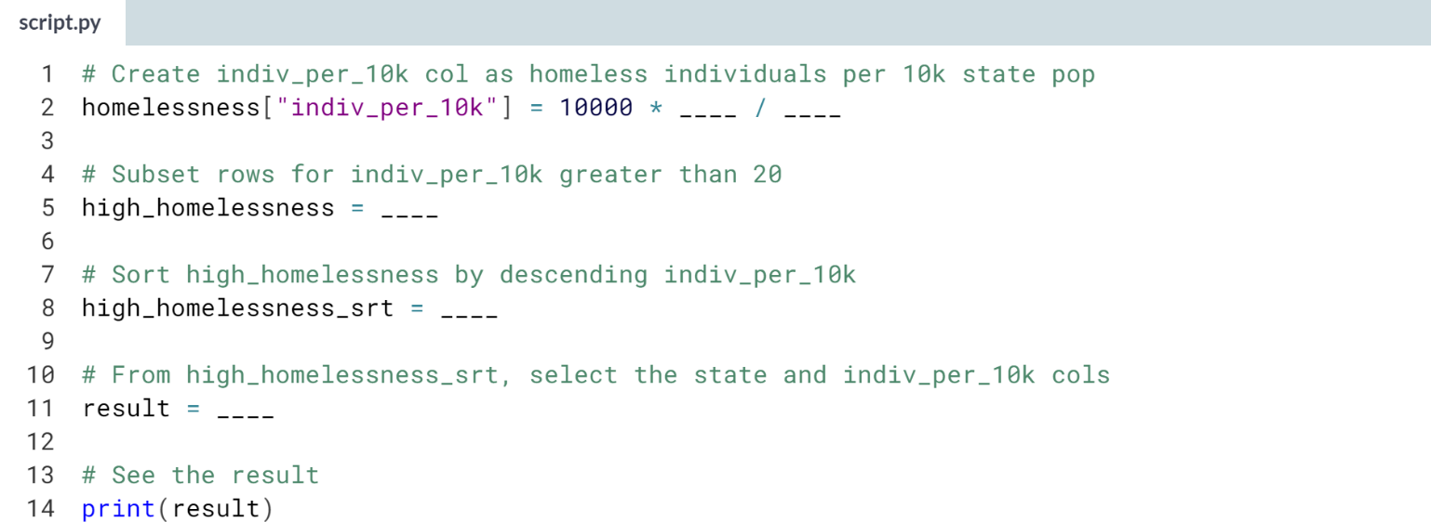

(Solution on the next page)

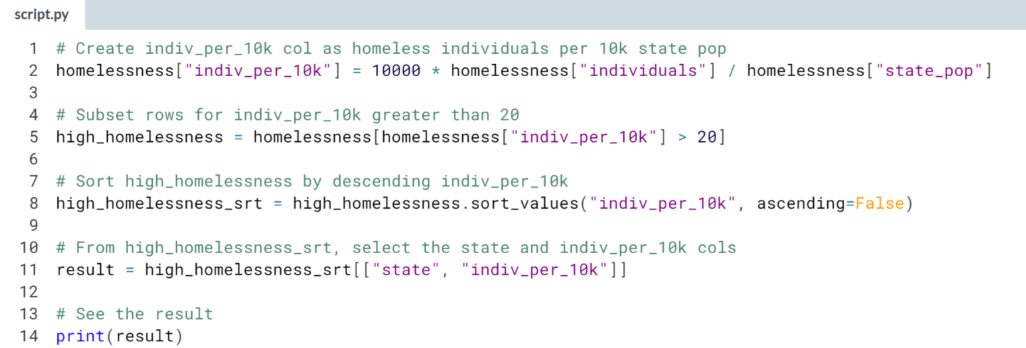

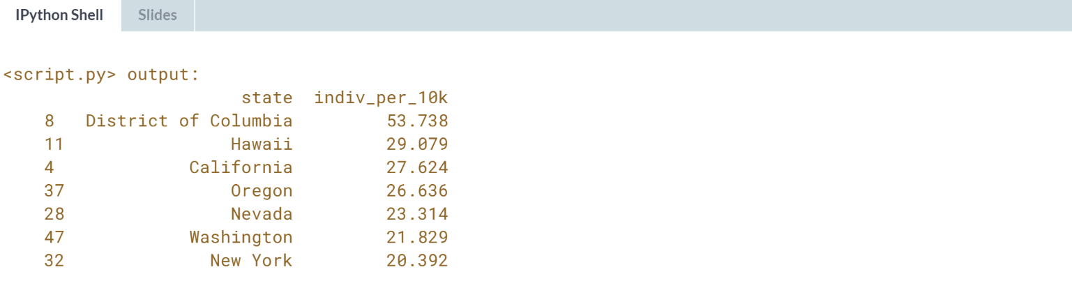

Cool combination! Washington D.C. has the highest number of homeless individuals - almost 54 per ten thousand people. This is almost double the number of the next-highest state, Hawaii.

If you combine new column addition, row subsetting, sorting, and column selection, you can answer lots of questions like this.

**2. Aggregating Data**

In this chapter, you’ll calculate summary statistics on DataFrame columns, and master grouped summary statistics and pivot tables.



In this chapter, we will talk about aggregating data, starting with summary statistics. Summary statistics, as follows from their name, are numbers that summarize and tell you about your dataset.

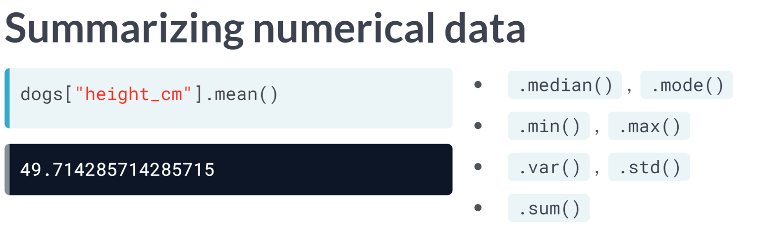  
One of the most common summary statistics for numeric data is the mean, which is one way of telling you where the "center" of your data is. You can calculate the mean of a column by selecting the column with square brackets and calling .mean(). There are other summary statistics method you can perform.

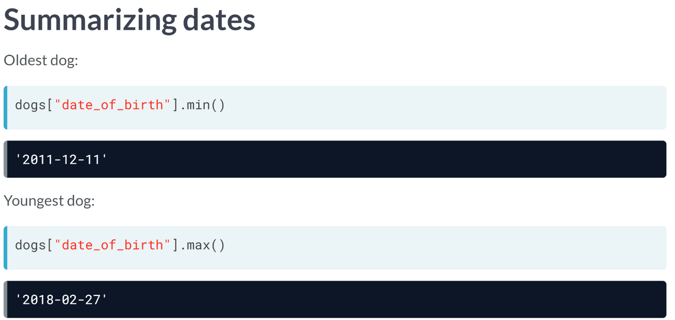  
You can also get summary statistics for date columns. For example, we can find the oldest dog's date of birth by taking the minimum of the date of birth column. Similarly, we can take the maximum to see that the youngest dog was born in 2018.

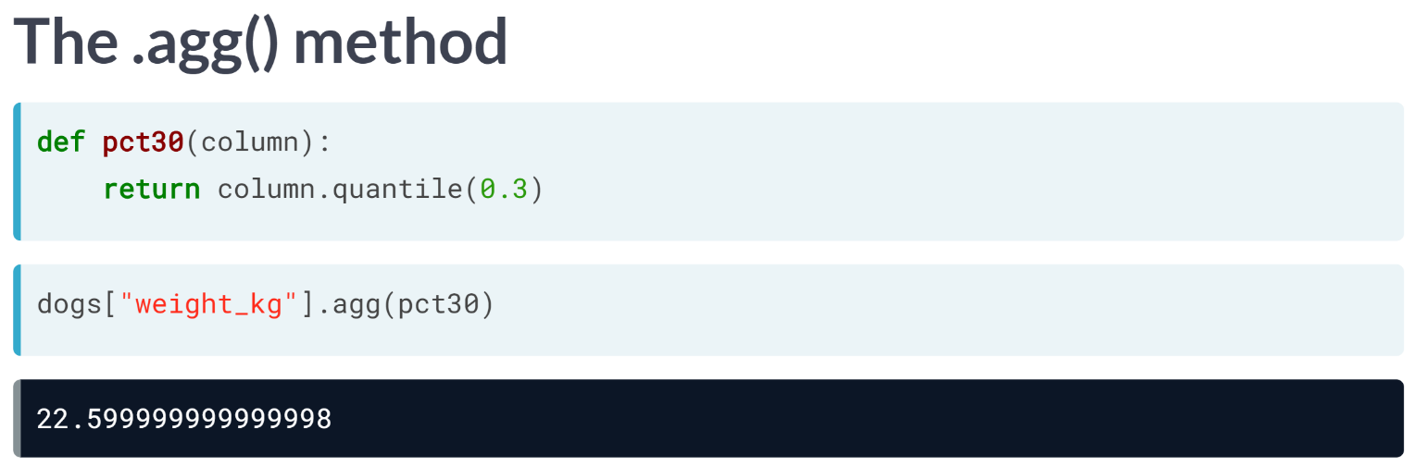  
The aggregate, or ***agg()***, method allows you to compute custom summary statistics. Here, we create a function called pct30 that computes the 30th percentile of a DataFrame column.

Now we can subset the weight column and call ***.agg()***, passing in the name of our function, pct30. It gives us the 30th percentile of the dogs' weights.

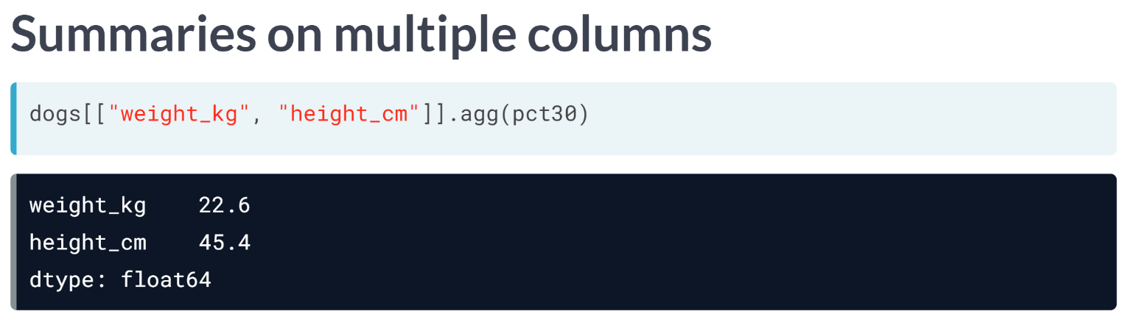  
***agg()*** can also be used on more than one column. By selecting the weight and height columns before calling ***agg()***, we get the 30th percentile for both columns.

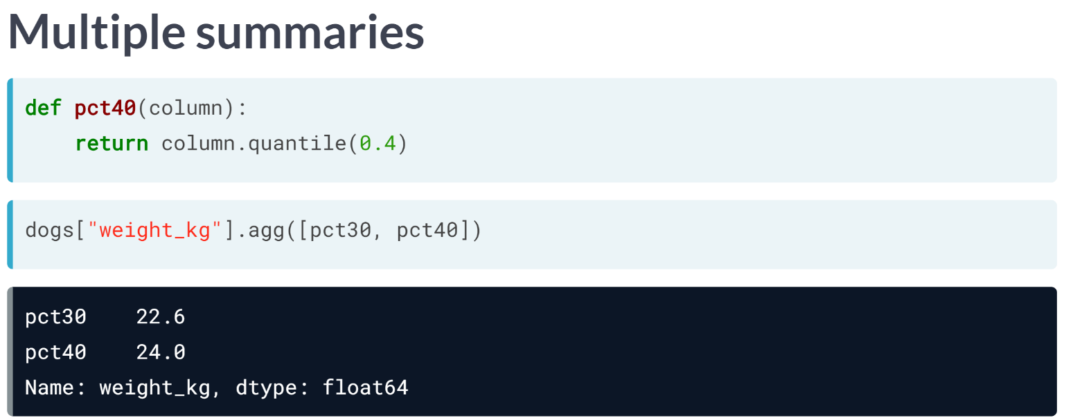  
We can also use ***agg()*** to get multiple summary statistics at once. Here's another function that computes the 40th percentile called pct40. We can pass a list of functions into ***agg()***, in this case pct30 and pct40, which will return the both 30th and 40th percentiles of the dog's weights.

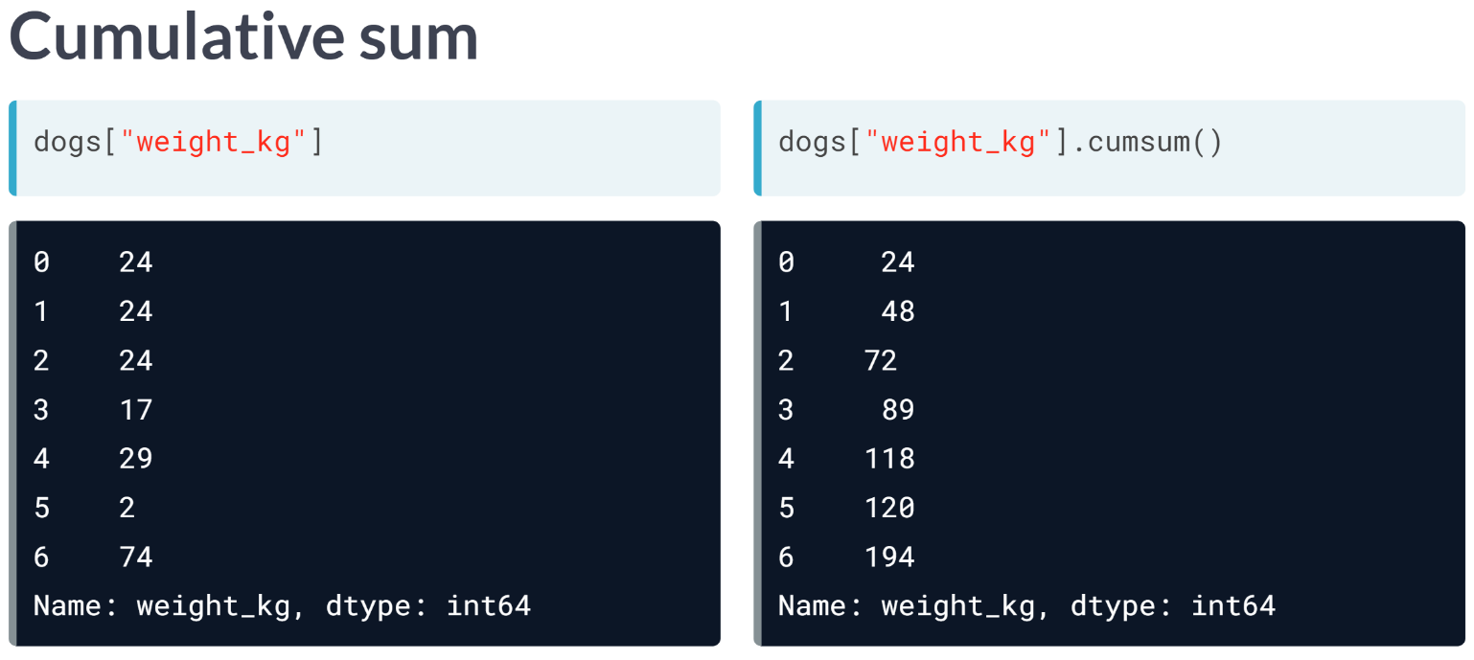  
pandas also has methods for computing cumulative statistics, for example, the cumulative sum. Calling ***cumsum()*** on a column returns not just one number, but a number for each row of the DataFrame.

The first number returned (or the number in the 0th index) is the first dog's weight. The next number is the sum of the first and second dog's weights.

The third number is the sum of the first, second, and third dogs' weight, and so on. The last number is the sum of all the dogs' weights.

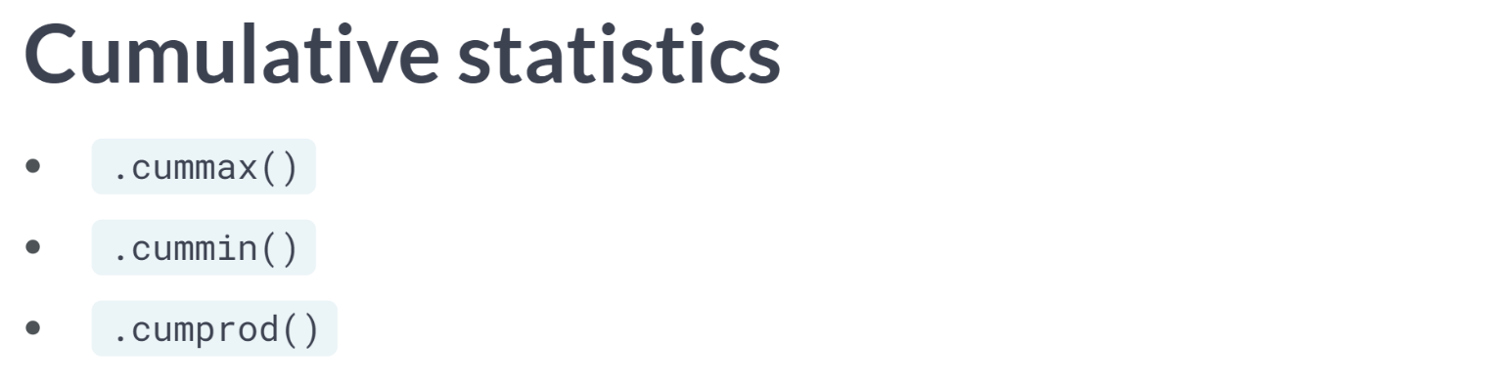  
pandas also has methods for other cumulative statistics, such as these ones above. These all return an entire column of a DataFrame, rather than a single number.

# Mean and median

Summary statistics are exactly what they sound like - they summarize many numbers in one statistic. For example, mean, median, minimum, maximum, and standard deviation are summary statistics. Calculating summary statistics allows you to get a better sense of your data, even if there's a lot of it.

sales is available and pandas is loaded as pd.

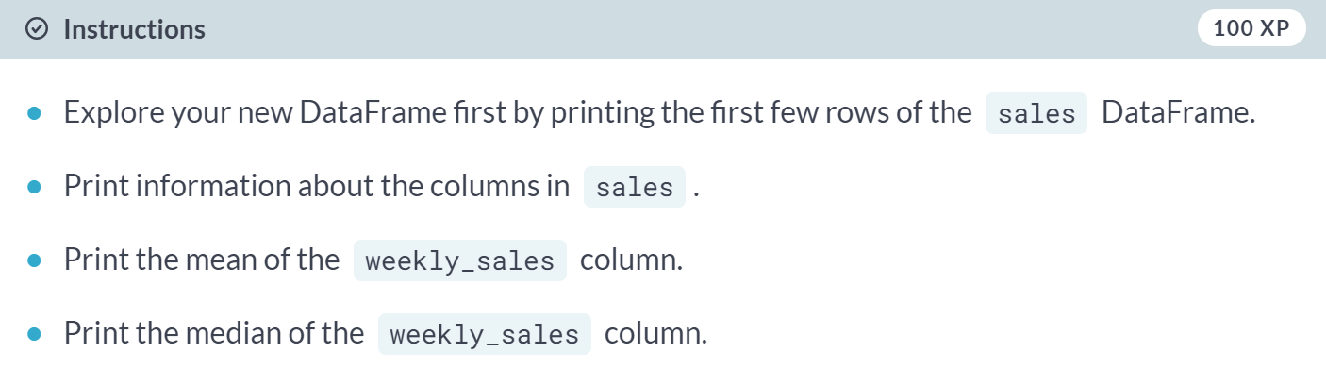

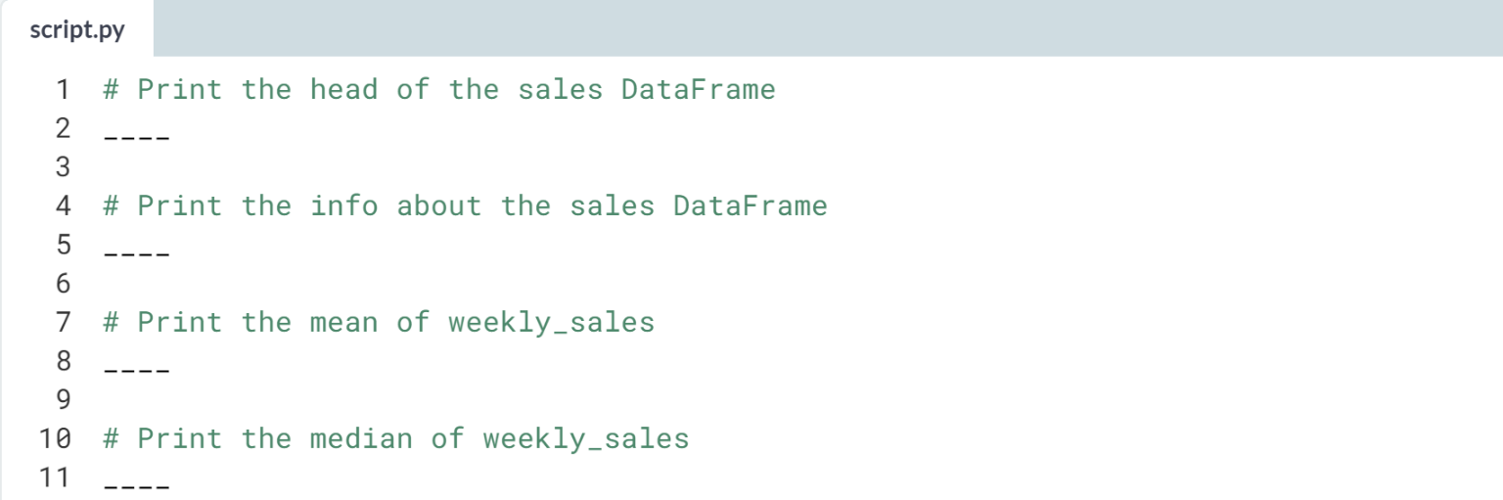

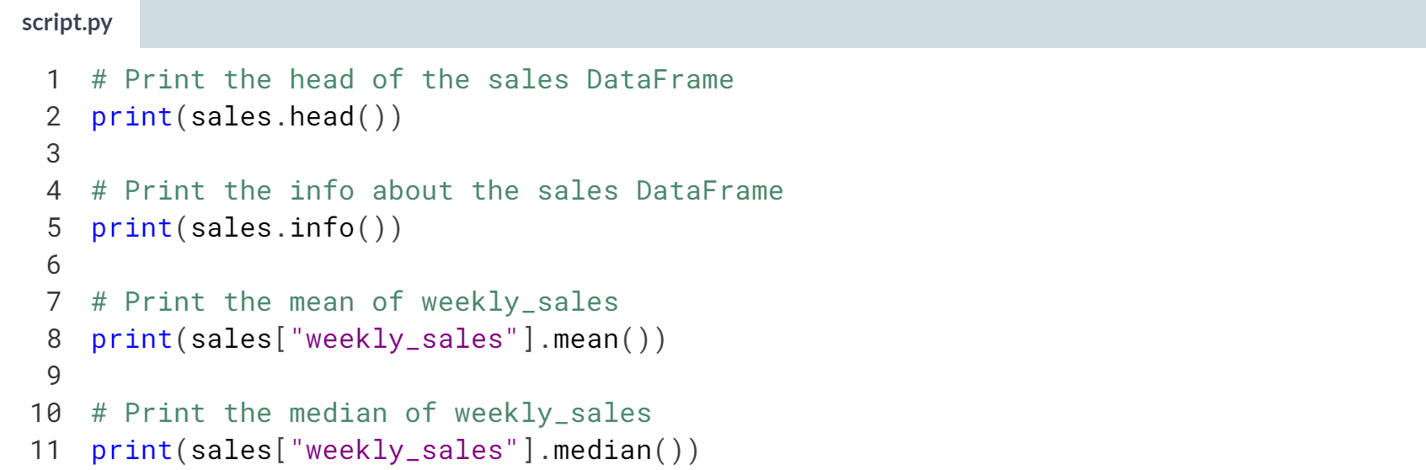

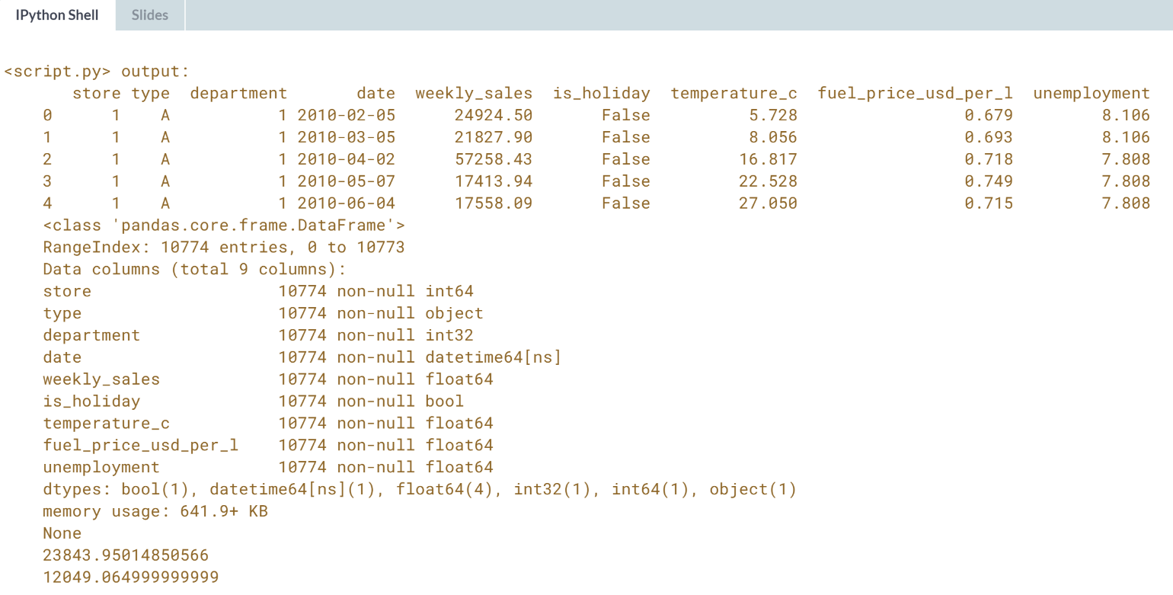

The mean weekly sales is almost double the median weekly sales! This can tell you that there are a few very high sales weeks that are making the mean so much higher than the median.

# Summarizing dates

Summary statistics can also be calculated on date columns which have values with the data type datetime64. Some summary statistics — like mean — don't make a ton of sense on dates, but others are super helpful, for example minimum and maximum, which allow you to see what time range your data covers.

sales is available and pandas is loaded as pd.

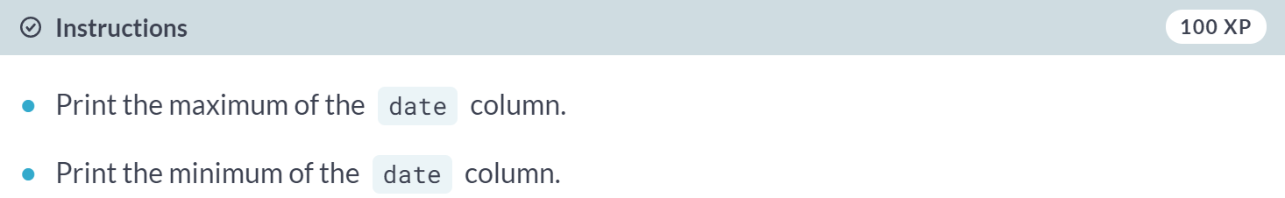

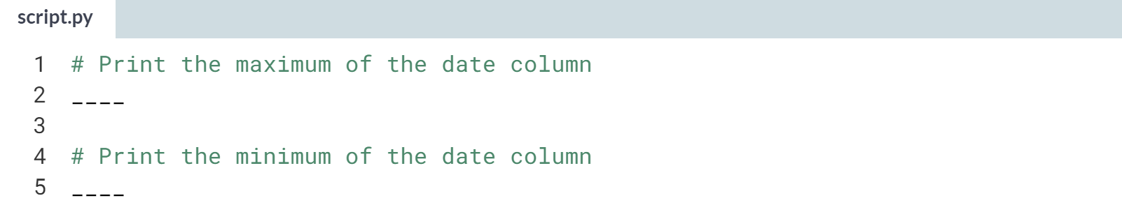

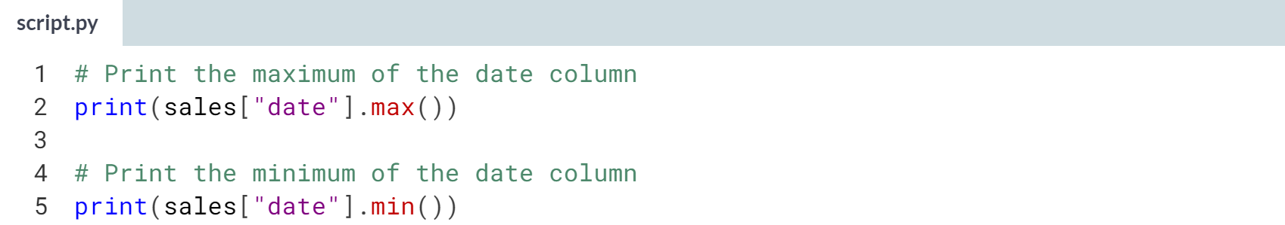

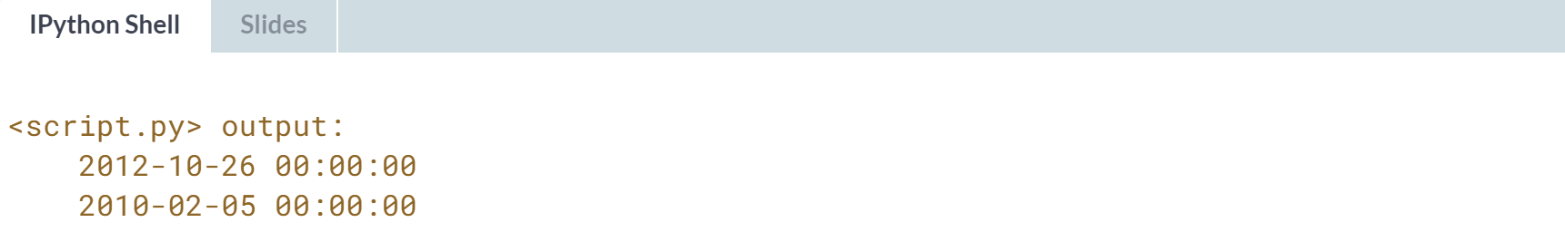

Super summarizing! Taking the minimum and maximum of a column of dates is handy for figuring out what time period your data covers.

In this case, there's data from February of 2010 to October of 2012.

# Efficient summaries

While pandas and NumPy have tons of functions, sometimes you may need a different function to summarize your data.

The .agg() method allows you to apply your own custom functions to a DataFrame, as well as apply functions to more than one column of a DataFrame at once, making your aggregations super-efficient.

In the custom function for this exercise, "IQR" is short for inter-quartile range, which is the 75th percentile minus the 25th percentile. It's an alternative to standard deviation that is helpful if your data contains outliers.

sales is available and pandas is loaded as pd.

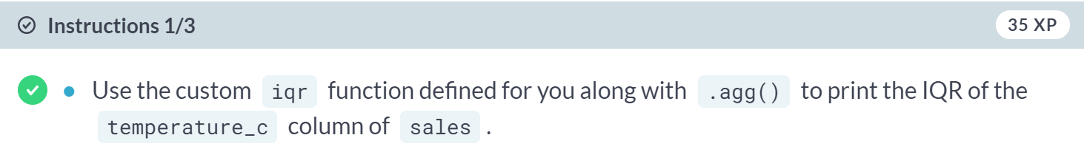

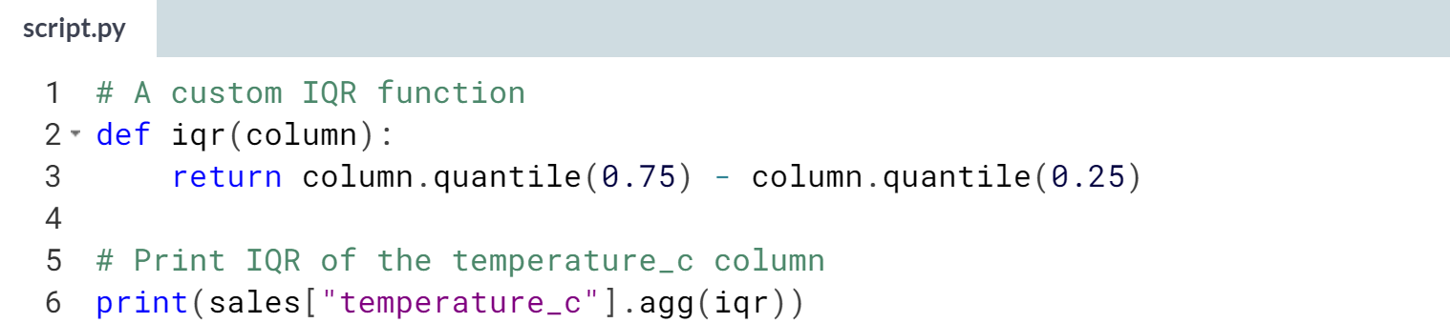

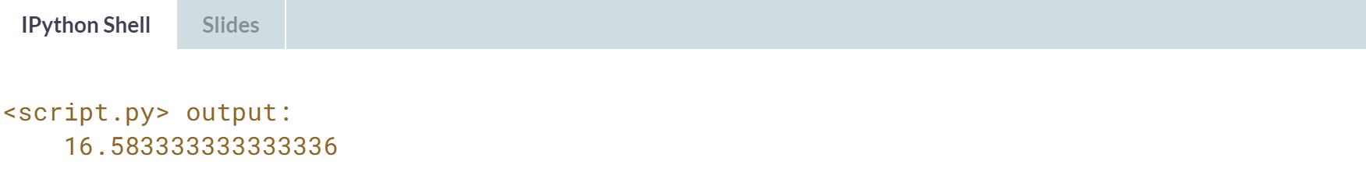

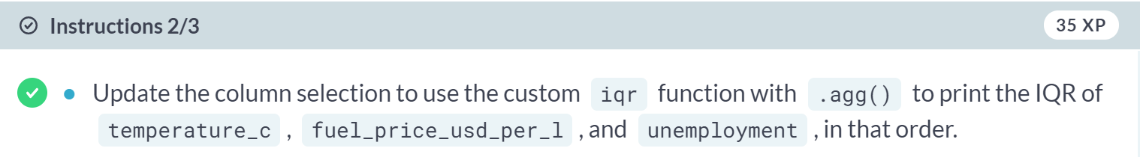

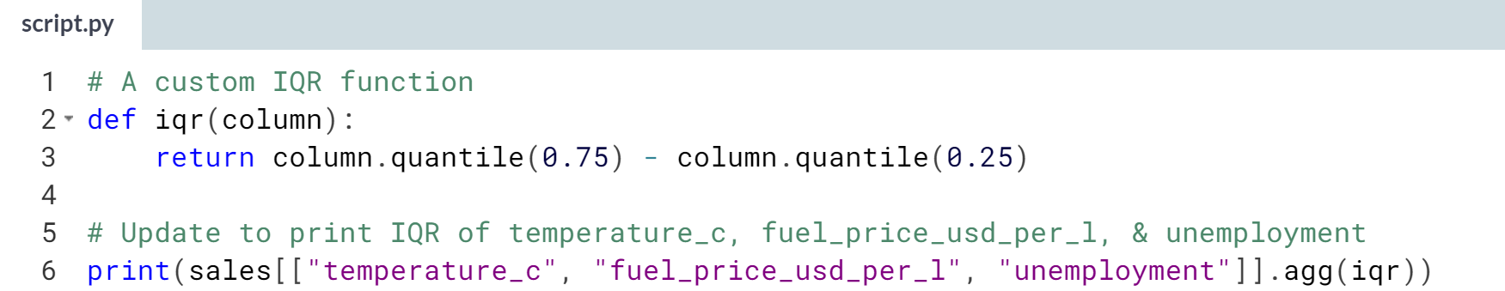

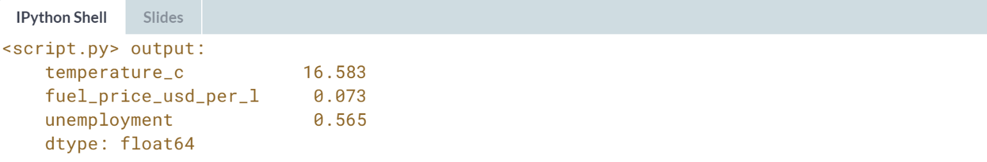

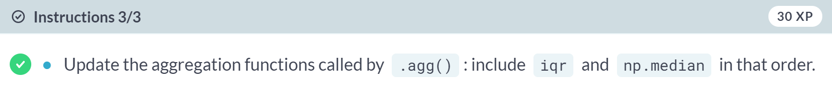

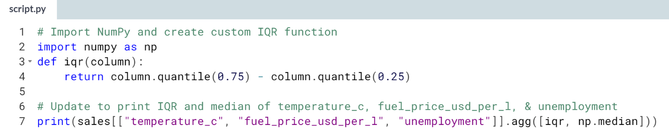

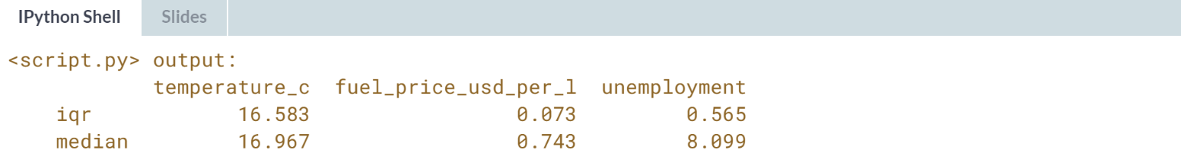  
Excellent efficiency! The ***.agg()*** method makes it easy to compute multiple statistics on multiple columns, all in just one line of code.

# Cumulative statistics

Cumulative statistics can also be helpful in tracking summary statistics over time. In this exercise, you'll calculate the cumulative sum and cumulative max of a department's weekly sales, which will allow you to identify what the total sales were so far as well as what the highest weekly sales were so far.

A DataFrame called sales_1_1 has been created for you, which contains the sales data for department 1 of store 1. pandas is loaded as pd.

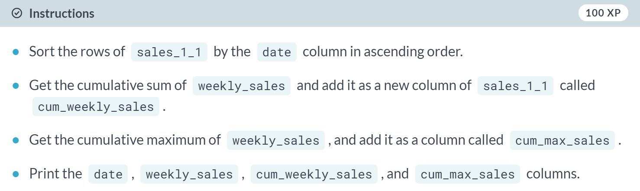

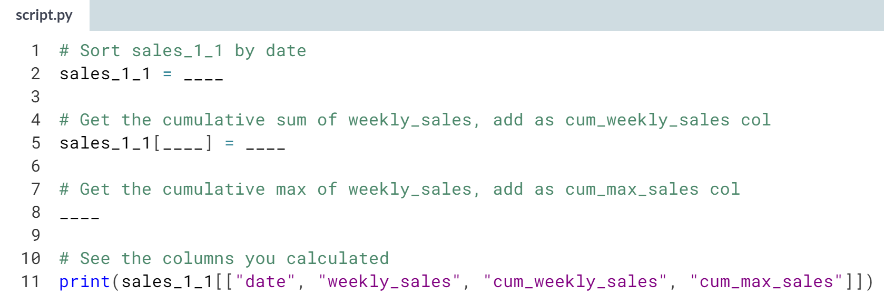

Hint:

1. You can sort rows of a DataFrame using ***.sort_values()***.
2. Use the ***.cumsum()*** method on a column to get a cumulative sum.
3. Use the ***.cummax()*** method on a column to get the cumulative maximum.
4. Remember that you need to use double-brackets to subset multiple columns.

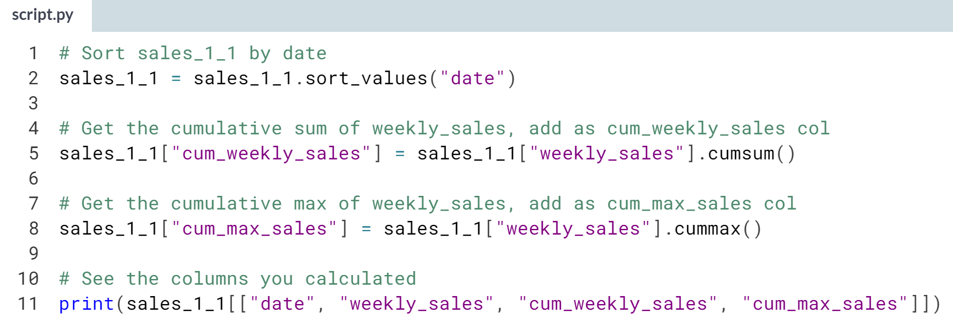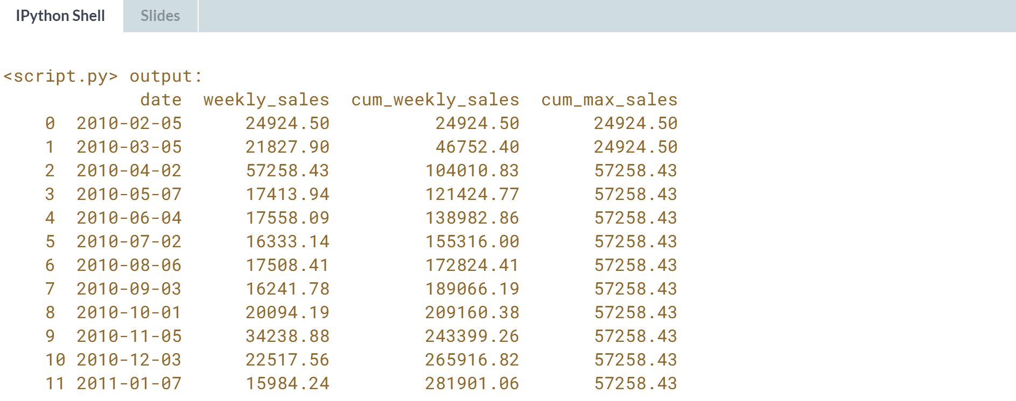

You've accumulated success! Not all functions that calculate on columns return a single number. Some, like the cumulative statistic functions, return a whole column.



In this video, we will learn how to summarize categorical data using counting.

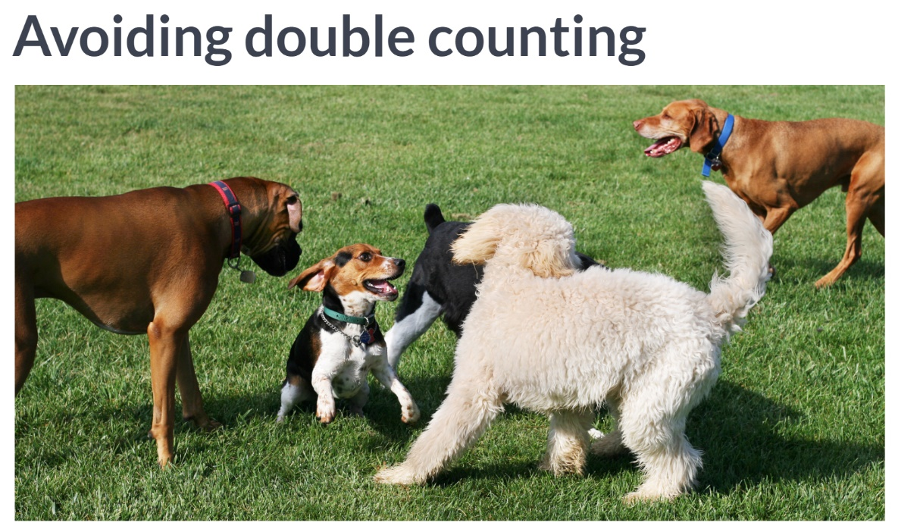  
Counting dogs is no easy task when they are running around the park. It's hard to keep track of who you have and haven't counted.

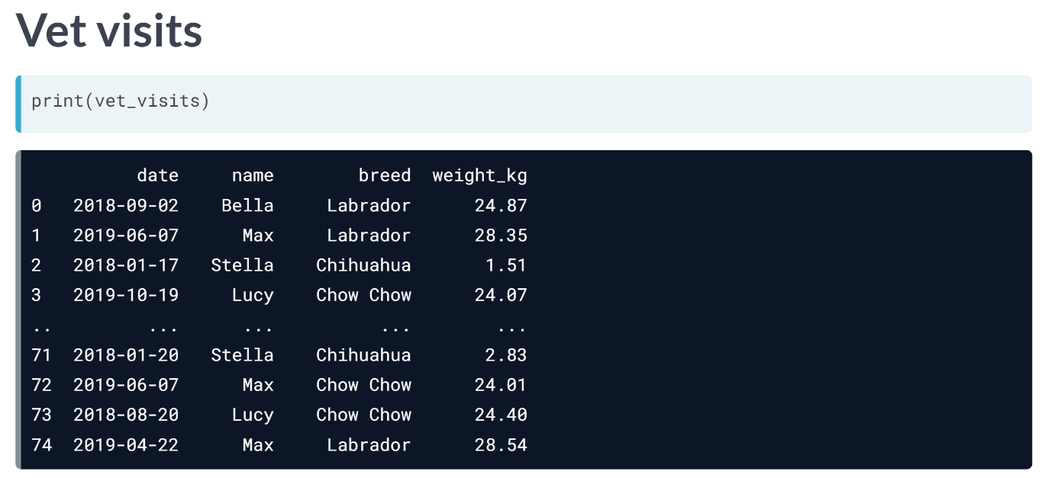  
Here's a DataFrame that contains vet visits. The vet's office wants to know how many dogs of each breed have visited their office.

However, as you can see from the dataset, dogs like Max, Lucy, Stella, have been to the vet more than once. So, we can't just count the number of each breed in the breed column.

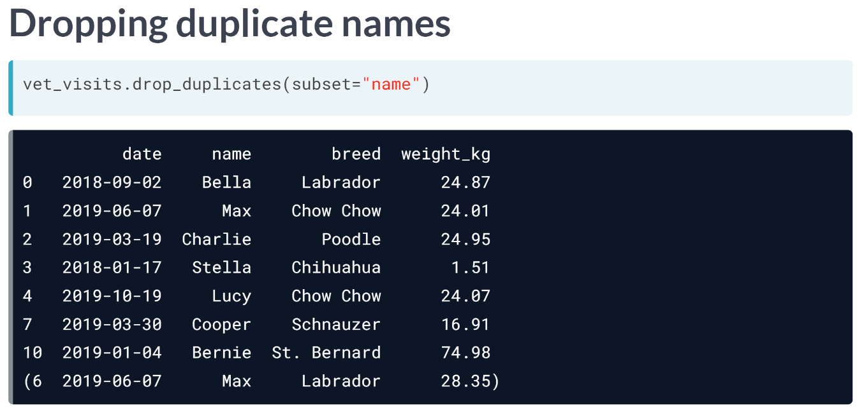  
Let's try to fix this by removing rows that contain a dog name already listed earlier in the dataset, or in other words, we will extract a dog with each name from the dataset once.

We can do this by using the ***drop_duplicates()***method. It takes an argument, subset, which is the column we want to find our duplicates based on - in this case, we want all the unique names.

Now, we have a list of dogs where each one appears once. We have Max the Chow Chow, but where did Max the Labrador go?

Because we have two different dogs with the same name, we will need to consider more than just name when dropping duplicates.

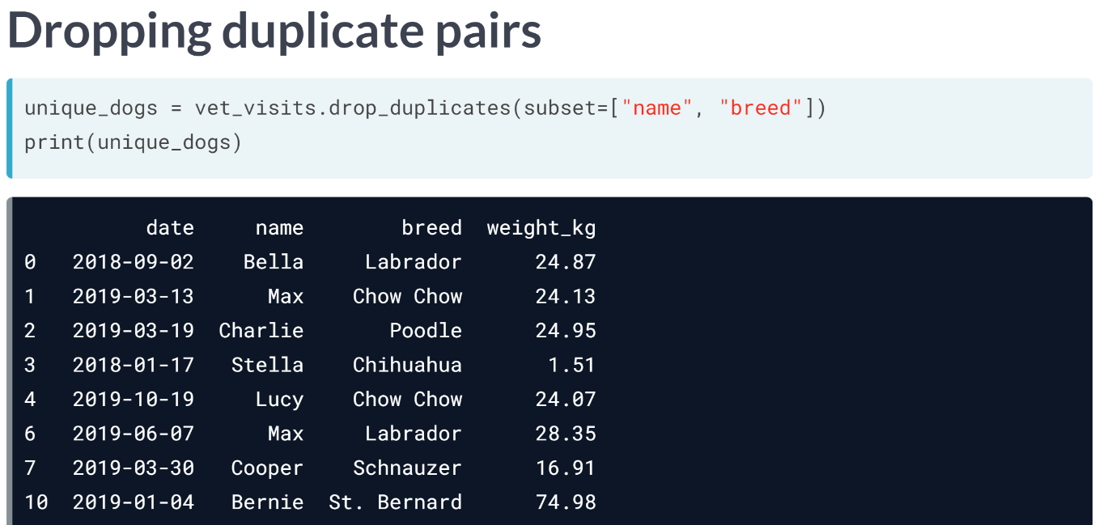  
Since Max from 03-13 and Max from 06-07 are different breeds, we can drop the rows with pairs of name and breed listed earlier in the dataset.

To base our duplicate dropping on multiple columns, we can pass a list of column names to the subset argument, in this case, name and breed. Now, both Maxes have been included, and we can start counting.

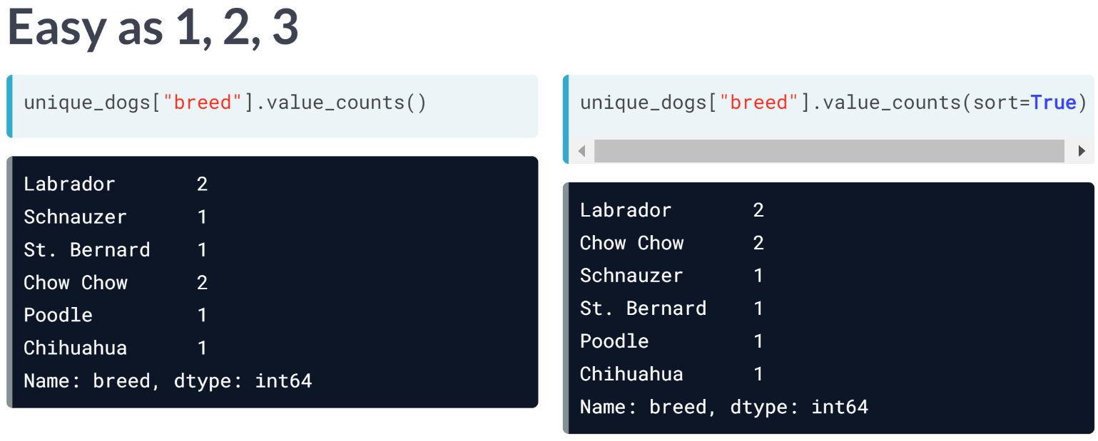  
To count the dogs of each breed, we will subset the breed column and use the ***value_counts()*** method. We can also use the sort argument to get the breeds with biggest counts on top.

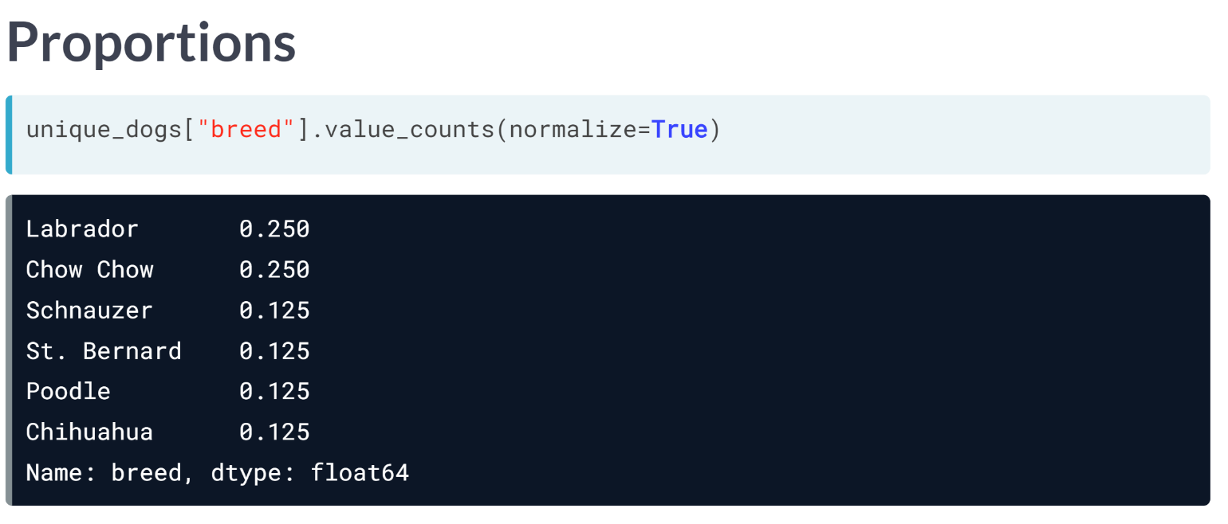  
The normalize argument can be used to turn the counts into proportions of the total. 25 percent of the dogs that go to this vet are Labradors and Chow Chow.

# Dropping duplicates

Removing duplicates is an essential skill to get accurate counts, because often you don't want to count the same thing multiple times. In this exercise, you'll create some new DataFrames using unique values from sales.

sales is available and pandas is imported as pd.

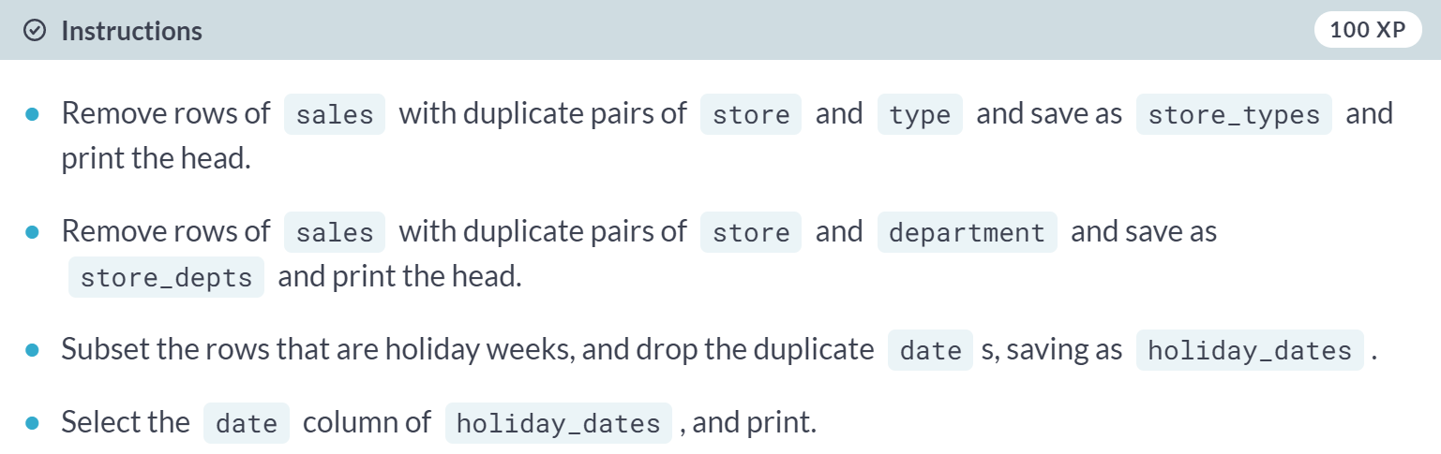

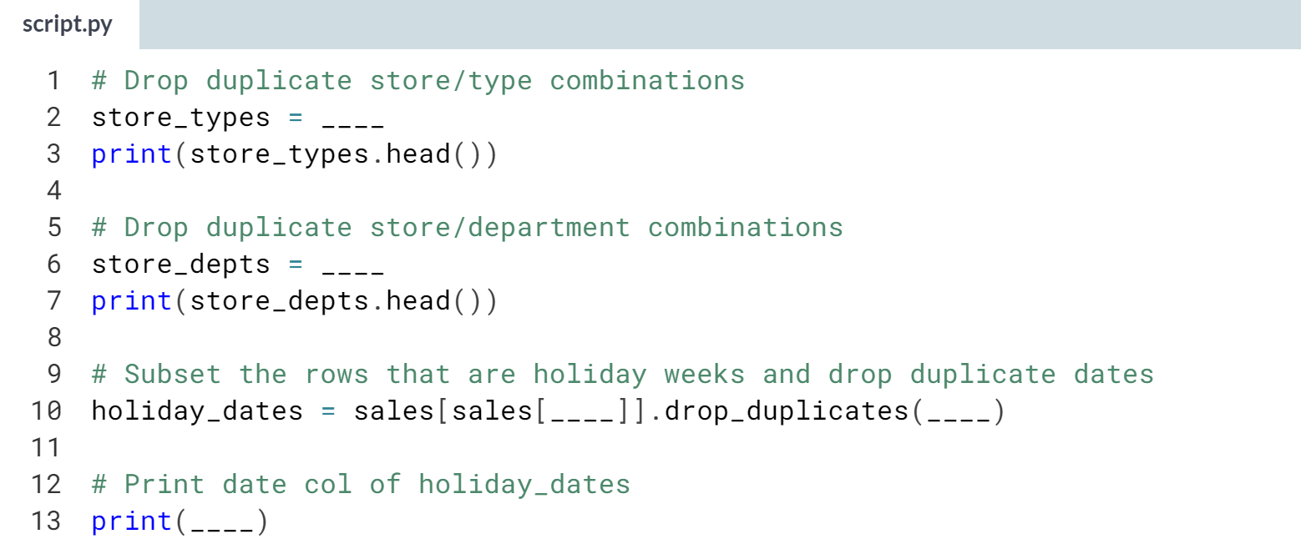

Hint: You can use the ***.drop_duplicates()*** method. The subset argument takes a column name or a list of column names.

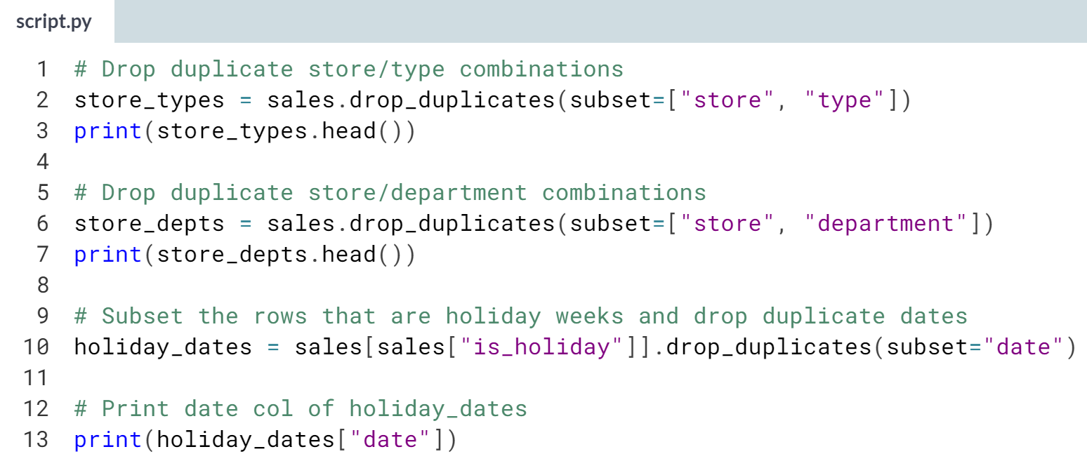

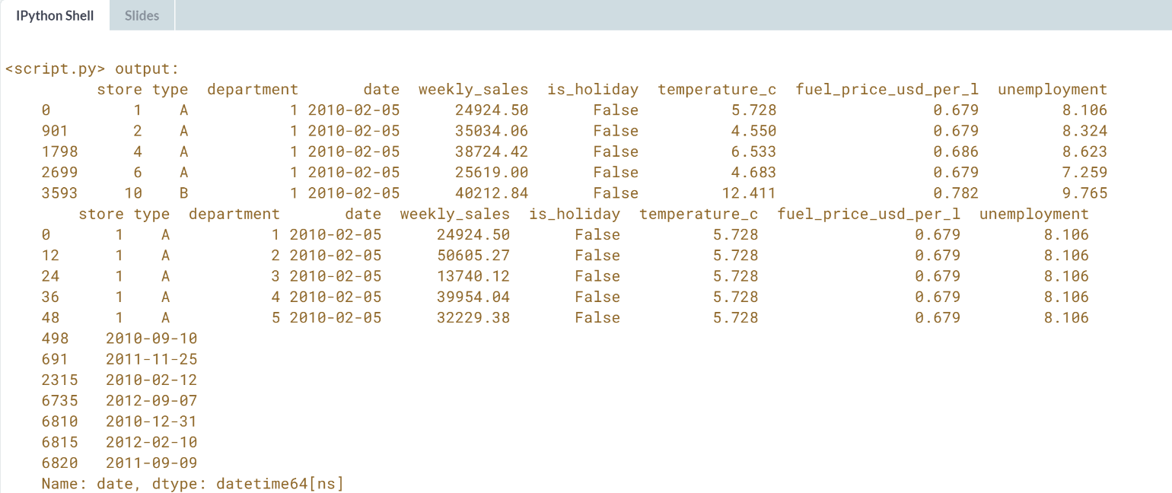Dazzling duplicate dropping! The holiday weeks correspond to the Superbowl in February, Labor Day in September, Thanksgiving in November, and Christmas in December. Now that the duplicates are removed, it's time to do some counting.

# Counting categorical variables

Counting is a great way to get an overview of your data and to spot curiosities that you might not notice otherwise. In this exercise, you'll count the number of each type of store and the number of each department number using the DataFrames you created in the previous exercise:

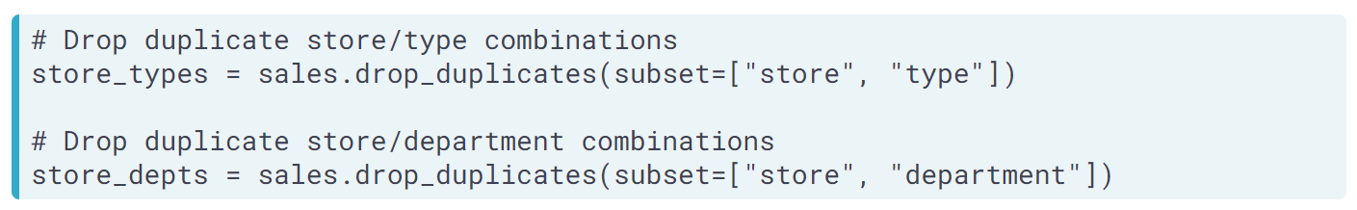

The store_types and store_depts DataFrames you created in the last exercise are available and pandas is imported as pd.

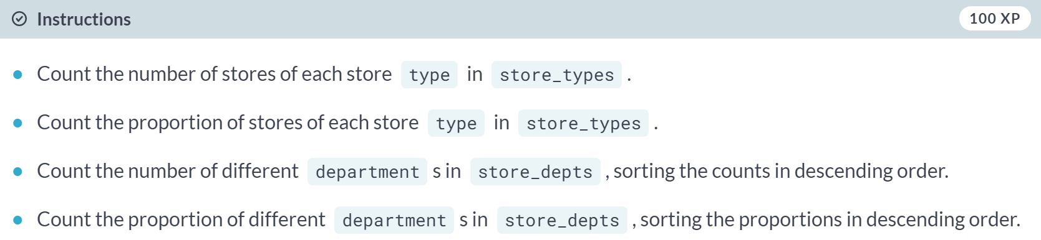

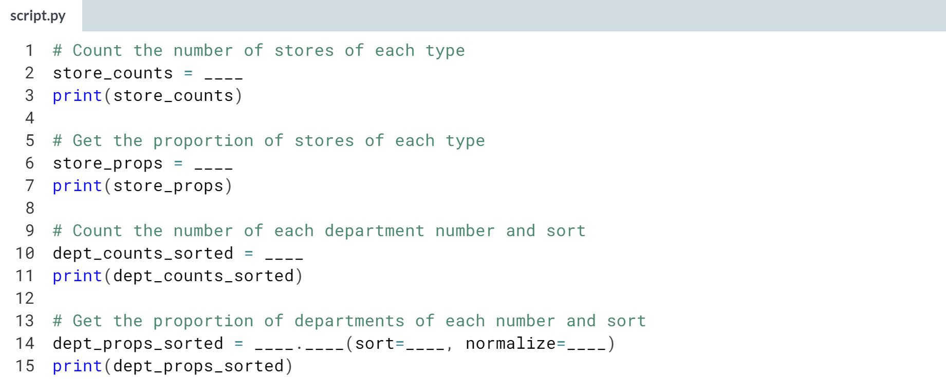

1. Select the type column of *store_types*, then call ***.value_counts()***.
2. Select the department column of *store_depts* and call ***.value_counts()***.
3. To calculate proportions, set normalize to *True* in ***.value_counts()***.
4. To sort the counts, set sort to *True*.

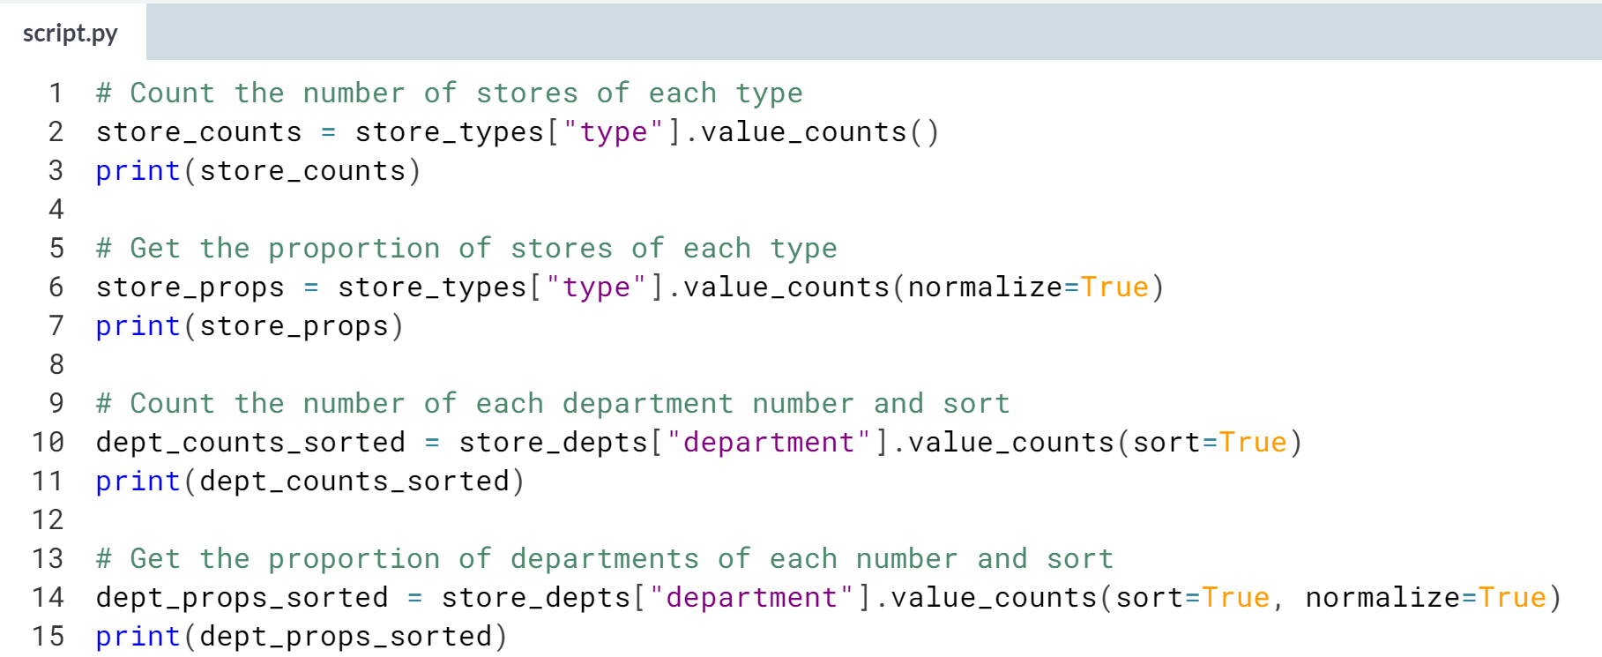

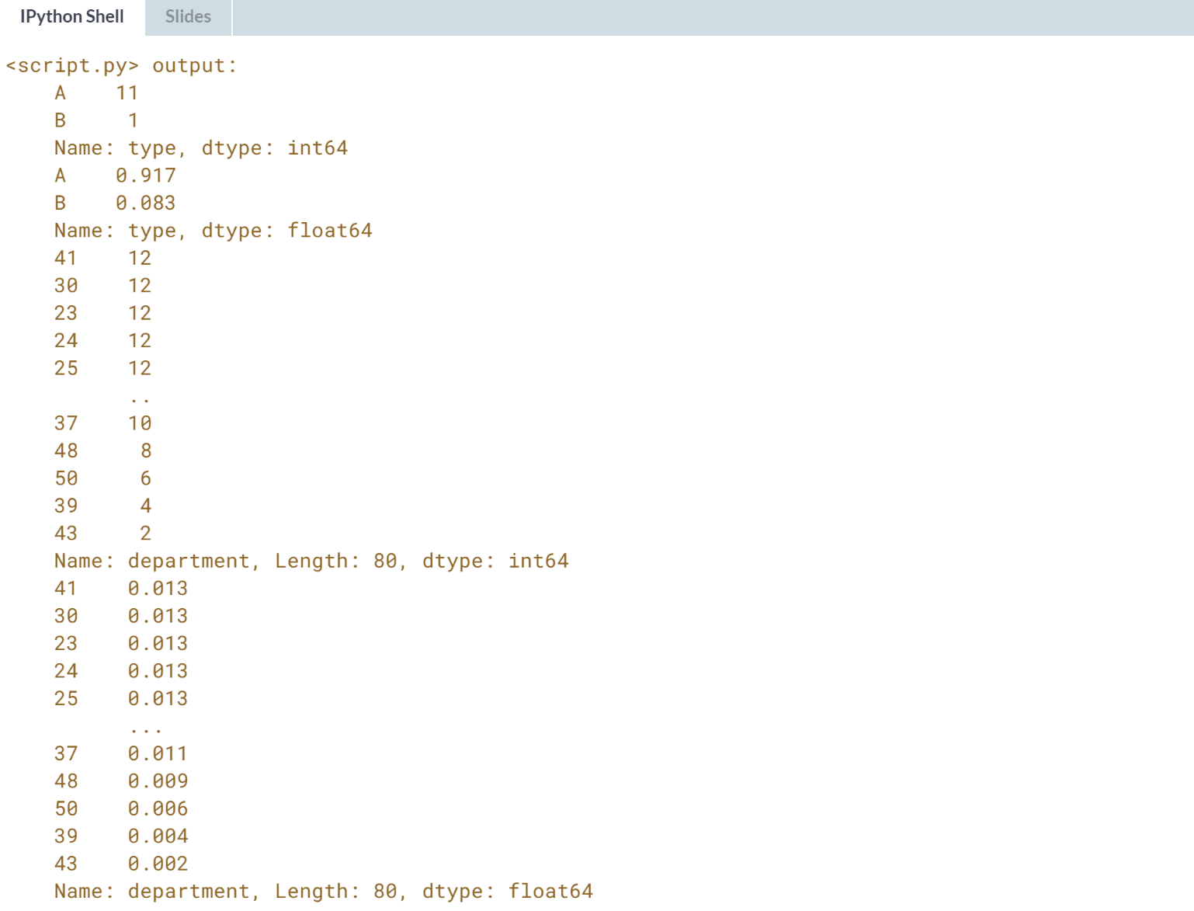  
Great counting! It looks like department 43 only exists in two stores.



So far, we have been calculating summary statistics for all rows of a dataset, but summary statistics can be useful to compare different groups.

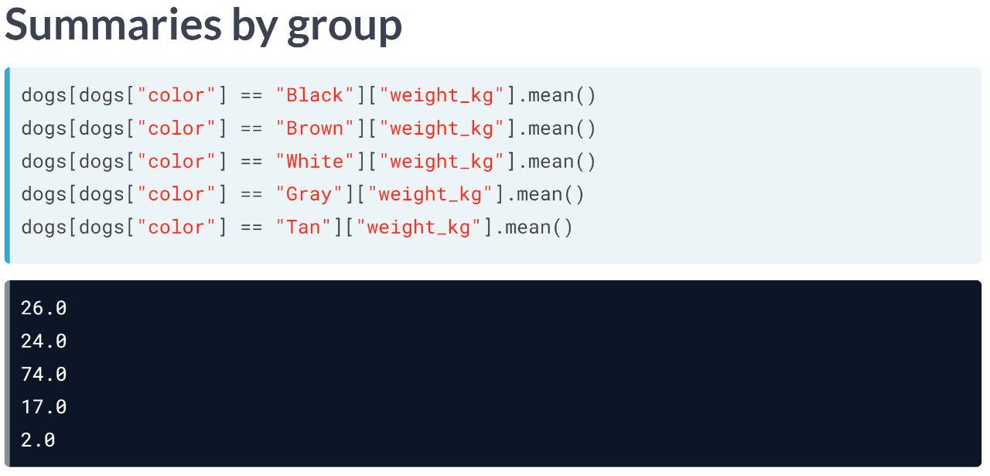  
While computing summary statistics of entire columns may be useful, you can gain many insights from summaries of individual groups.

For example, does one color of dog weigh more than another on average? Are female dogs taller than males? We can already answer these questions with what you have learned so far by subsetting the dogs into groups based on their color and take the mean of each.

But that's a lot of work and the duplicated code means you can easily introduce copy and paste bugs. And that's where the ***groupby()*** method comes in.

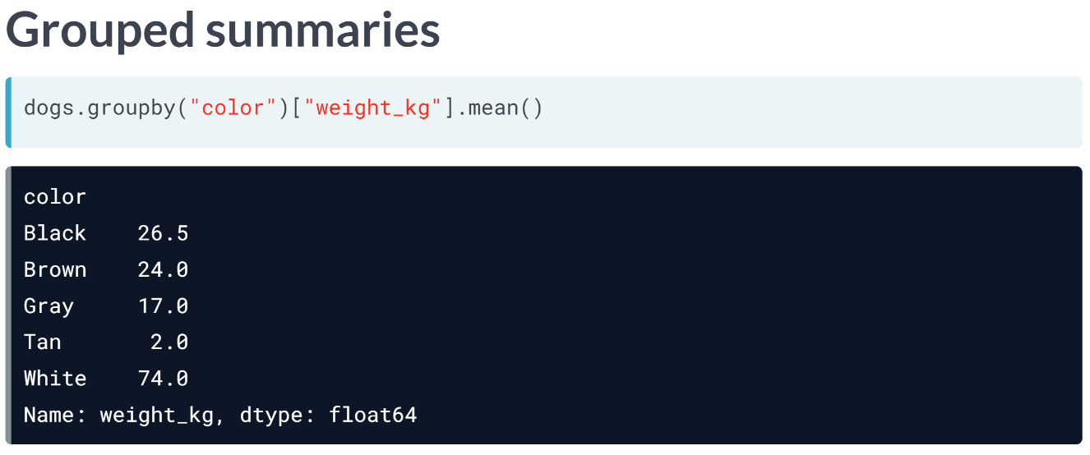  
We can simply group by the color variable, select the weight column, and take the mean. This will give us the mean weight for each dog color.

Notice how this is only one line of code compared to the five we had to write before to get the same result.

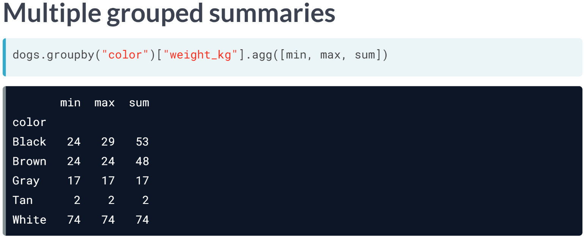  
We can also use groupby with ***agg()*** method to get multiple statistics. Here, we pass a list of functions into ***agg()*** after group by color. This gives us the minimum, maximum, and sum of the different colored dogs' weights.

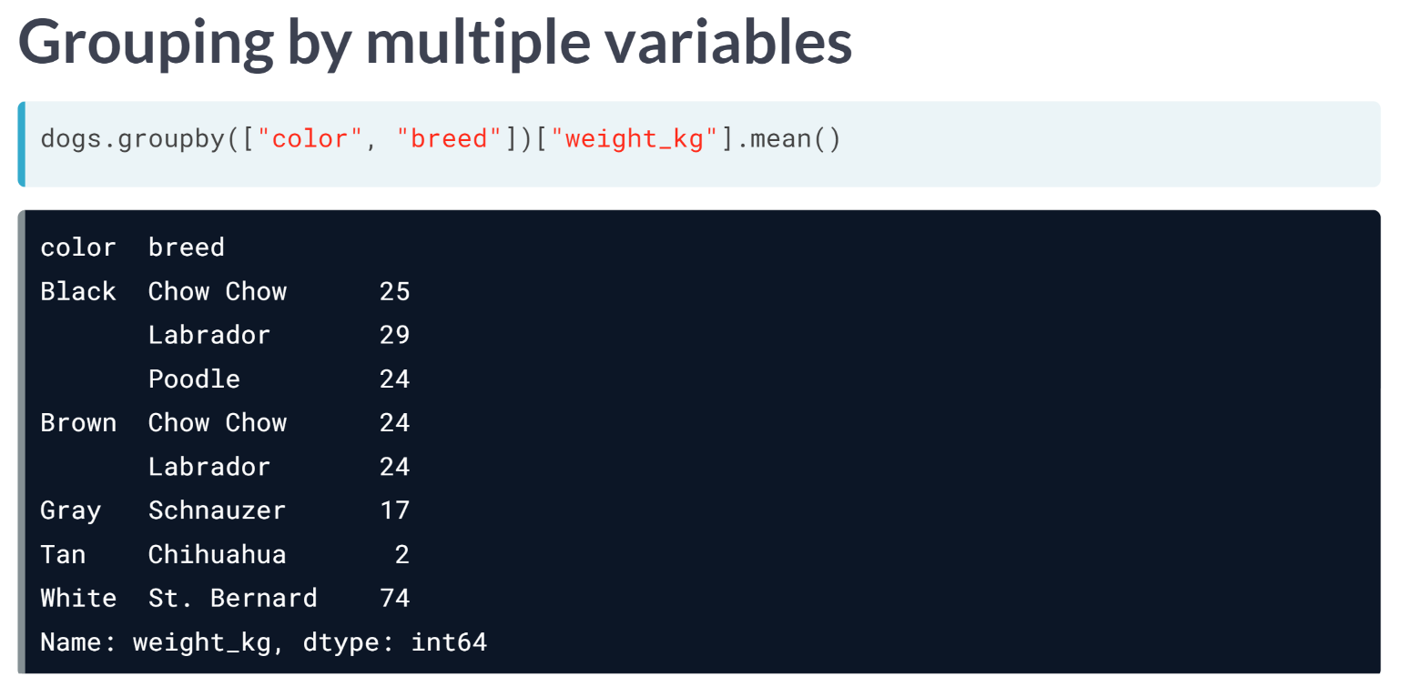  
You can also group by multiple columns and calculate summary statistics. Here, we group by color and breed, select the weight column, and take the mean. This gives us the mean weight of each breed of each color.

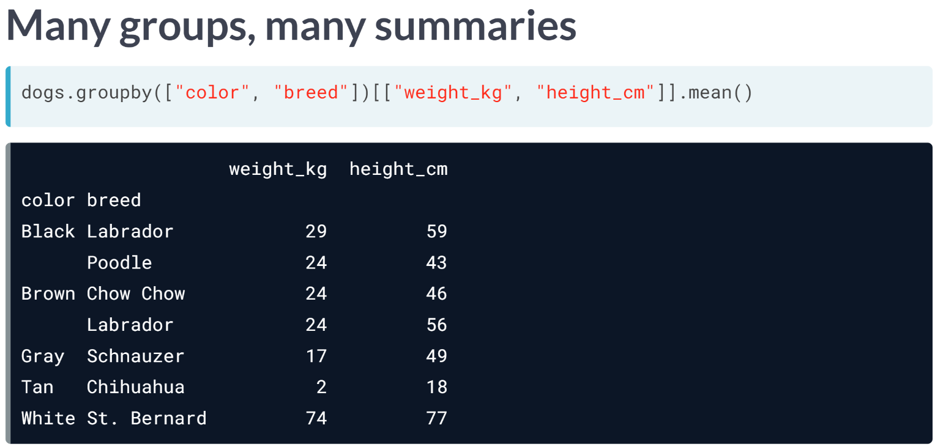  
Lastly, you can also group by multiple columns and aggregate by multiple columns.

# What percent of sales occurred at each store type?

While .groupby() is useful, you can calculate grouped summary statistics without it.

Walmart distinguishes three types of stores: "supercenters", "discount stores", and "neighborhood markets", encoded in this dataset as type "A", "B", and "C".

In this exercise, you'll calculate the total sales made at each store type, without using .groupby(). You can then use these numbers to see what proportion of Walmart's total sales were made at each.

sales is available and pandas is imported as pd.

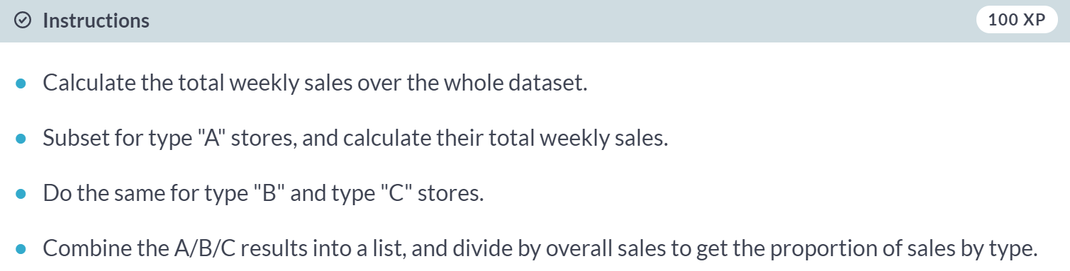

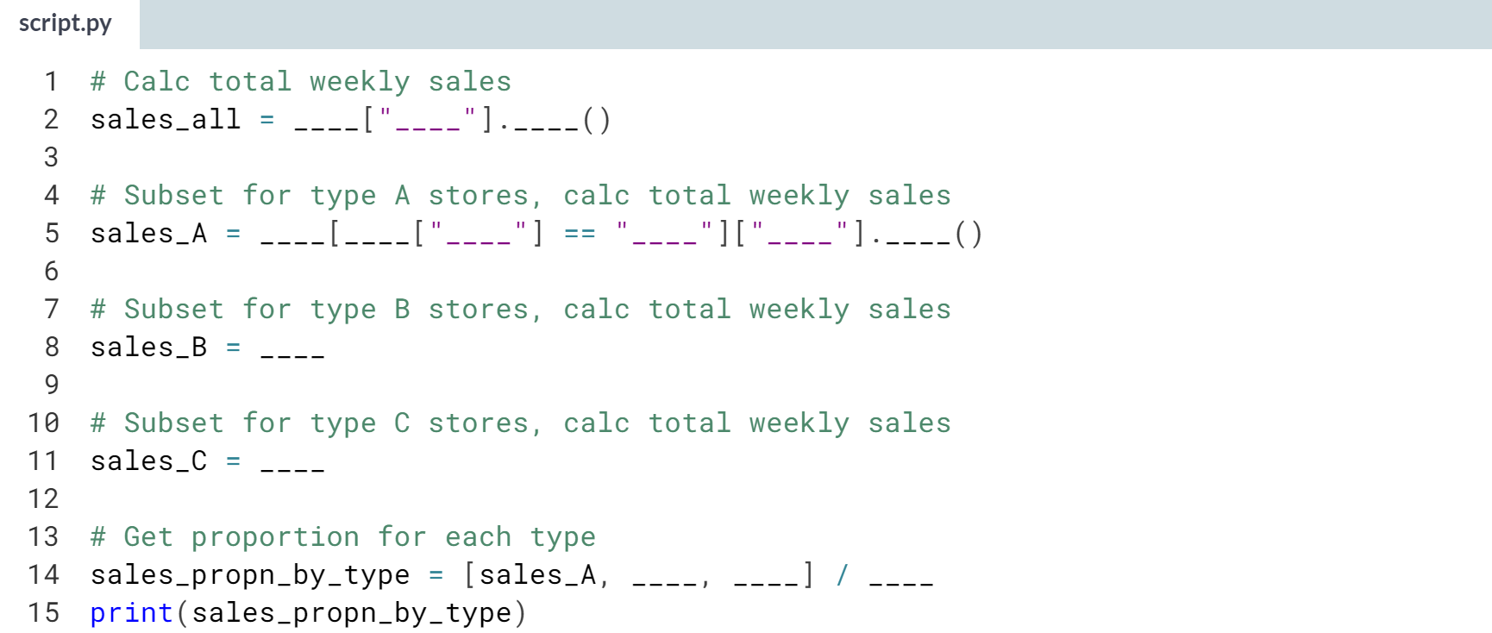  
Hint:

1. For overall sales, select the *"weekly_sales"* column, then calculate the sum.
2. For store type specific sales, use a Boolean condition like *sales["type"] == "some_value"* to subset, before selecting the sales column and calculating the sum.
3. You can divide the whole list by *sales_all*.

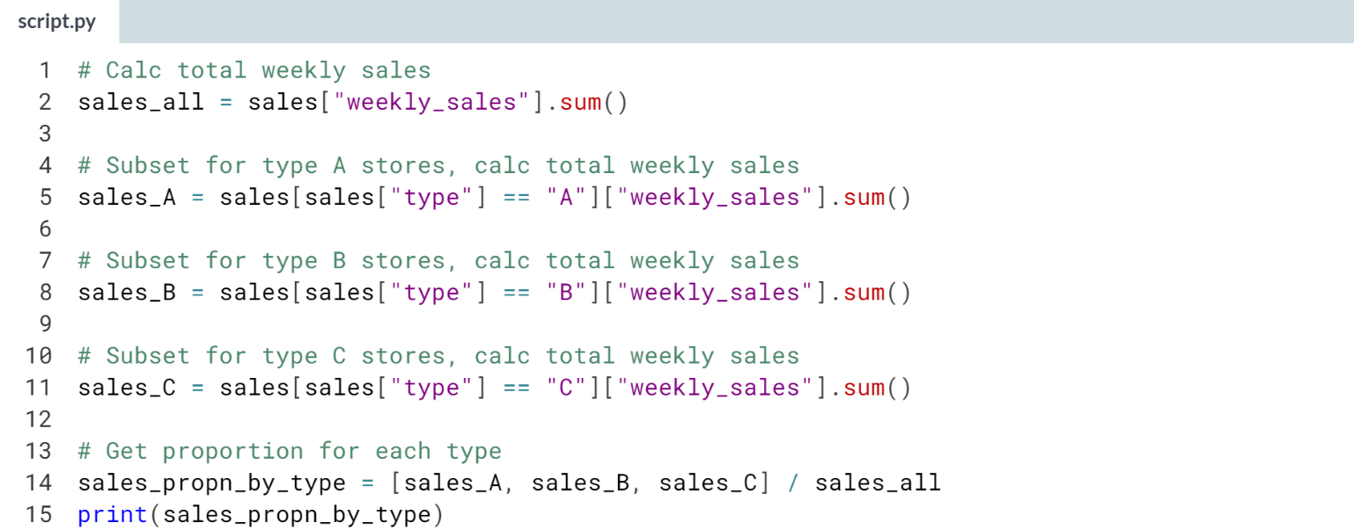

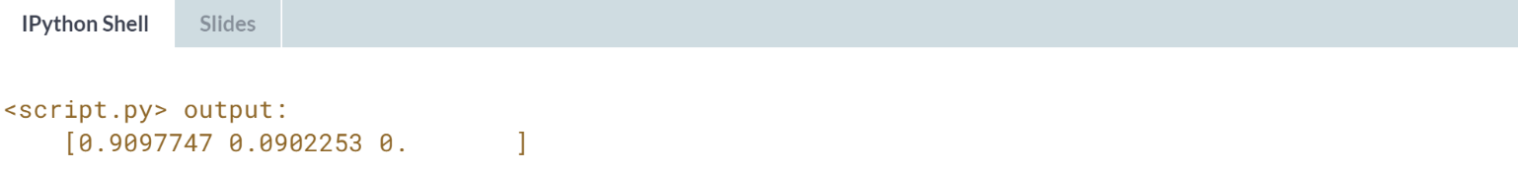

Marvelous mathematics! About 91% of sales occurred in stores of type A', 9% in stores of type B, and there are no sales records for stores of type C.

Now see if you can do this calculation using ***.groupby()***.

# Calculations with .groupby()

The .groupby() method makes life much easier. In this exercise, you'll perform the same calculations as last time, except you'll use the .groupby() method.

You'll also perform calculations on data grouped by two variables to see if sales differs by store type depending on if it's a holiday week or not.

sales is available and pandas is loaded as pd.

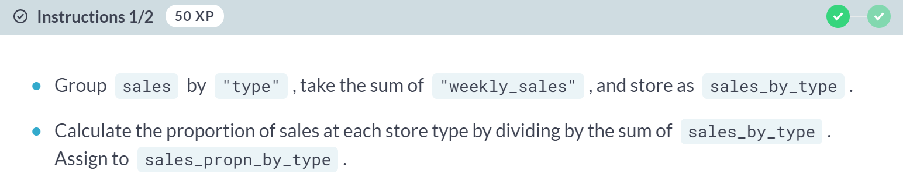

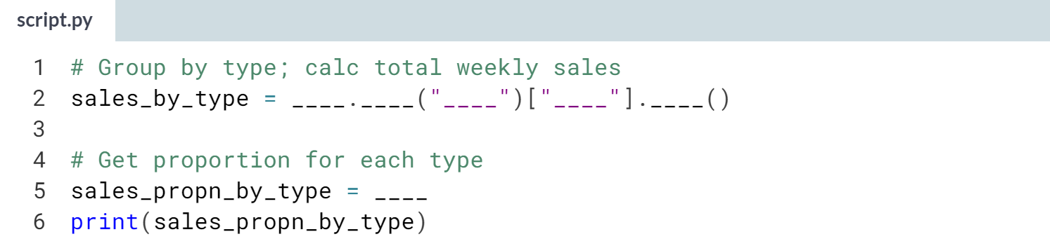  
Hint:

1. Call ***.groupby()***, passing *"type"*, then select the *weekly_sales* column and call ***.sum()***
2. You can use the ***sum()*** function on *sales_by_type* to get the total sales.

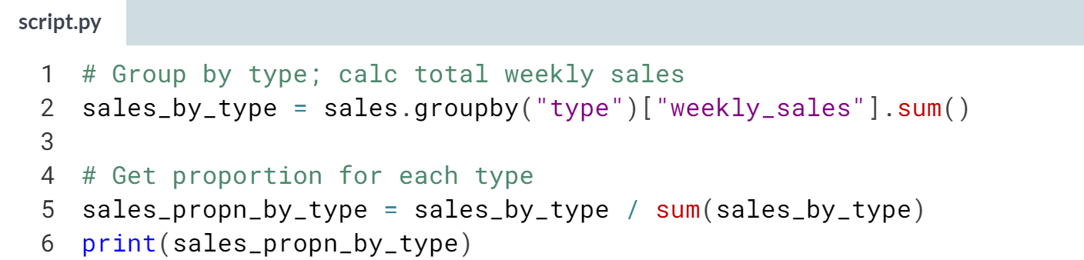  
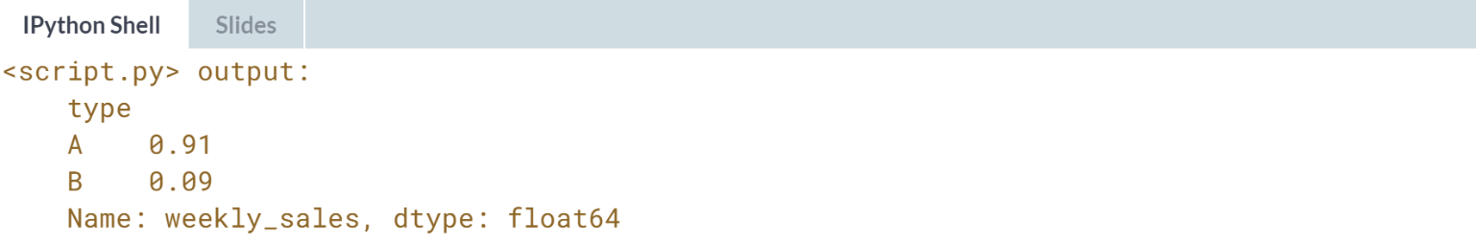

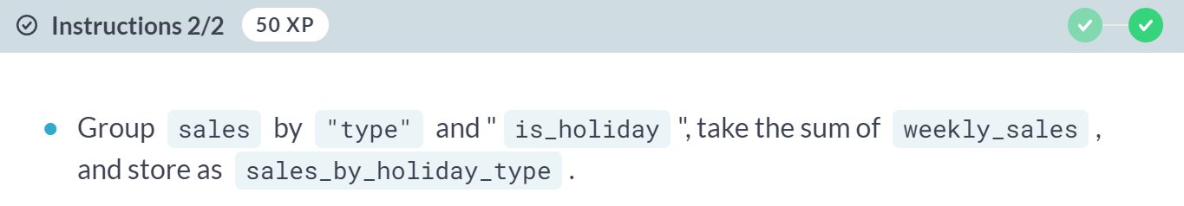

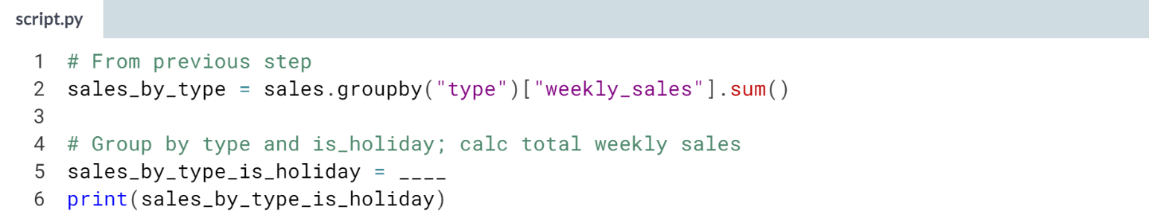

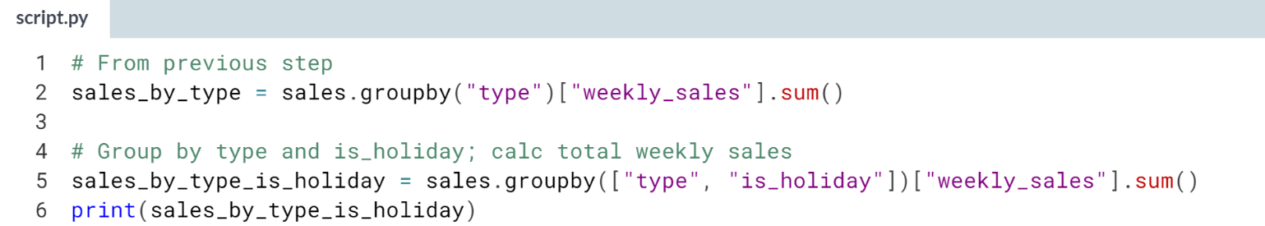

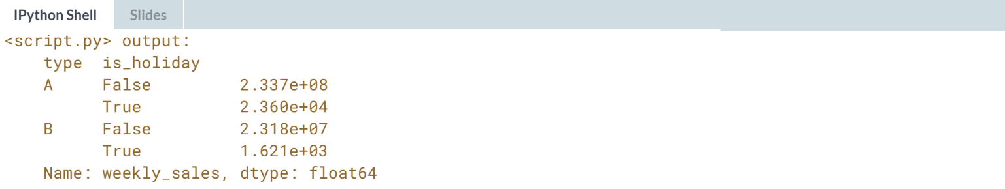

Great grouping! You were able to do the same calculation as in the previous exercise while writing much less code.

# Multiple grouped summaries

Earlier in this chapter you saw that the .agg() method is useful to compute multiple statistics on multiple variables. It also works with grouped data. NumPy, which is imported as np, has many different summary statistics functions, including: np.min, np.max, np.mean, and np.median.

Note that the column name *fuel_price_usd_per_l* has a lowercase "L" at the end, not the number 1.

sales is available and pandas is imported as pd.

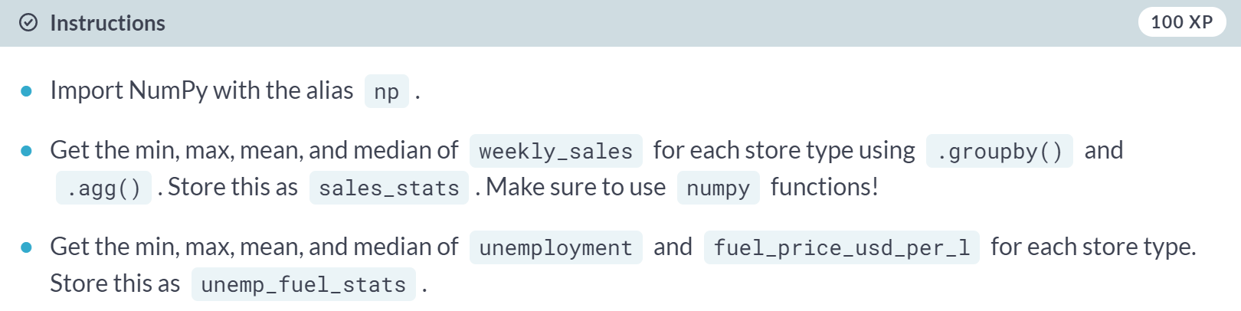

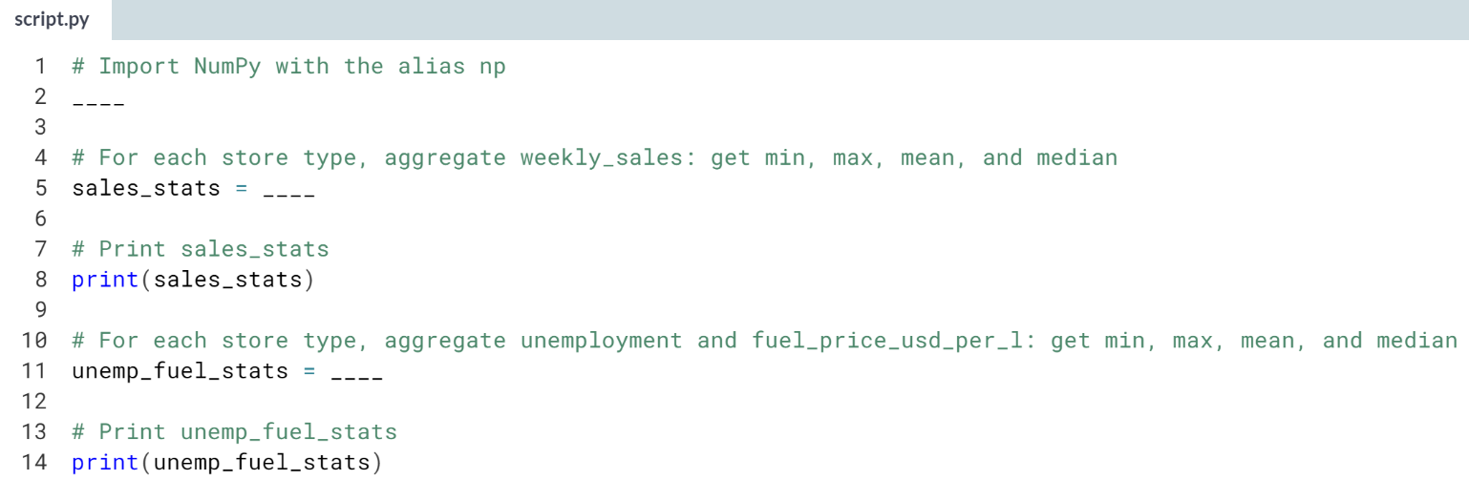

Hint:

1. ***.agg()*** can take in a list of functions. The functions shouldn't be called, so don't use parentheses with them.
2. Remember to ***.groupby()*** before selecting columns.
3. Multiple column selection can be done with double-brackets, *df[["col_a", "col_b"]]*.
4. Note that the column name is *fuel_price_usd_per_l* with a lowercase "L" at the end, not the number 1.

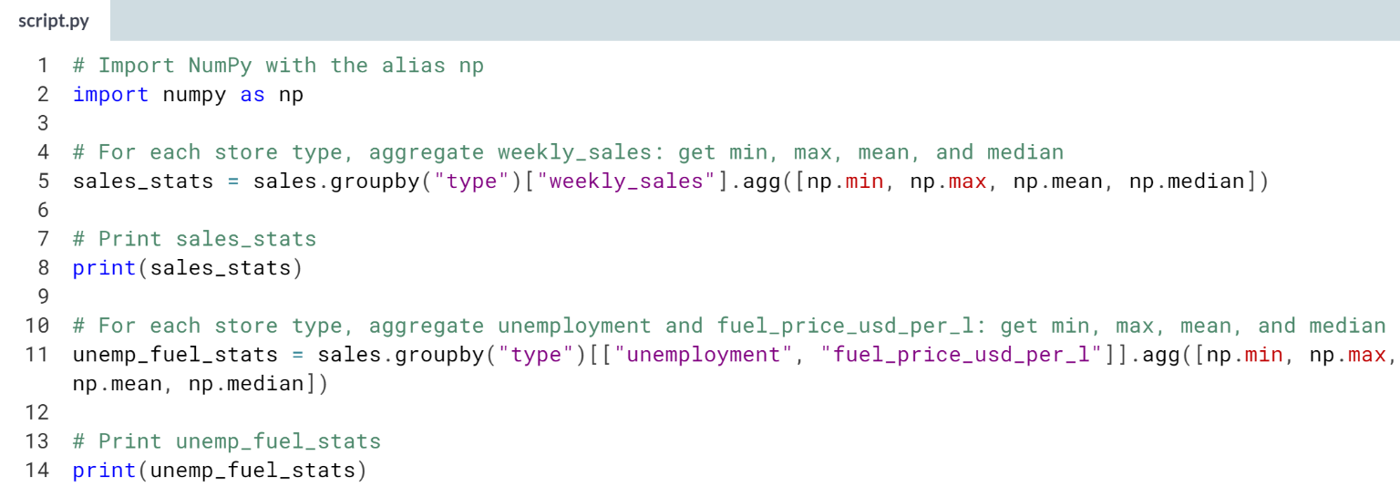

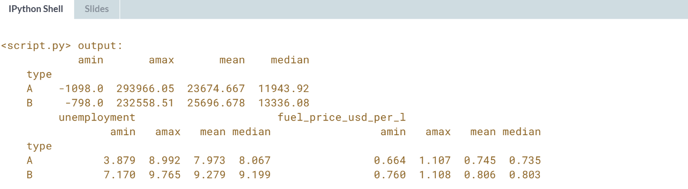

Awesome aggregating! Notice that the minimum *weekly_sales* is negative because some stores had more returns than sales.



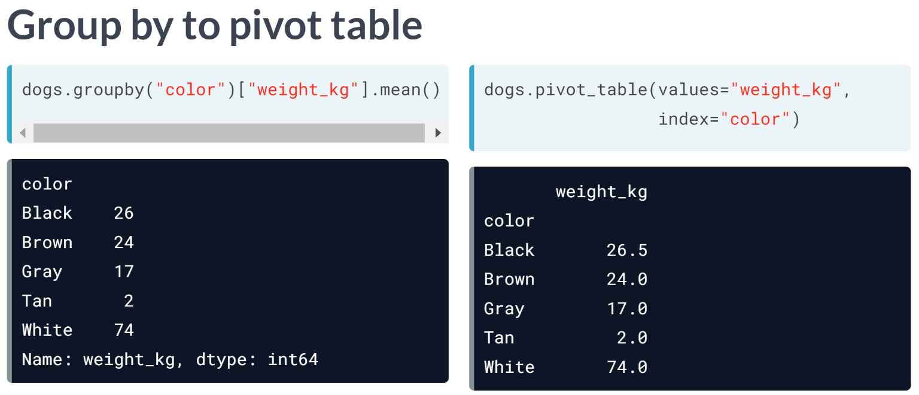  
Pivot tables are another way of calculating grouped summary statistics. In the last lesson, we grouped the dogs by color and calculated their mean weights.

We can do the same thing using ***pivot_table()*** method. The *values* argument is the column that we want to summarize, and the *index* column is the column that you want to group by. By default, ***pivot_table()*** takes the mean value for each group.

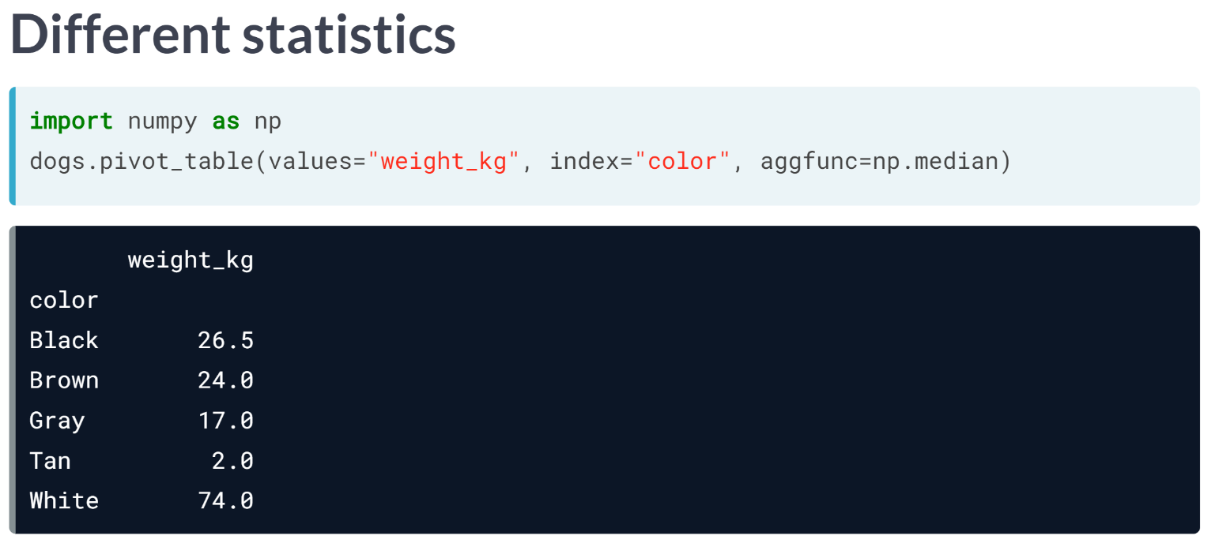  
If we want a different summary statistic, we can use the *aggfunc* argument and pass it a function. Here, we take the median for each dog color using NumPy's median function.

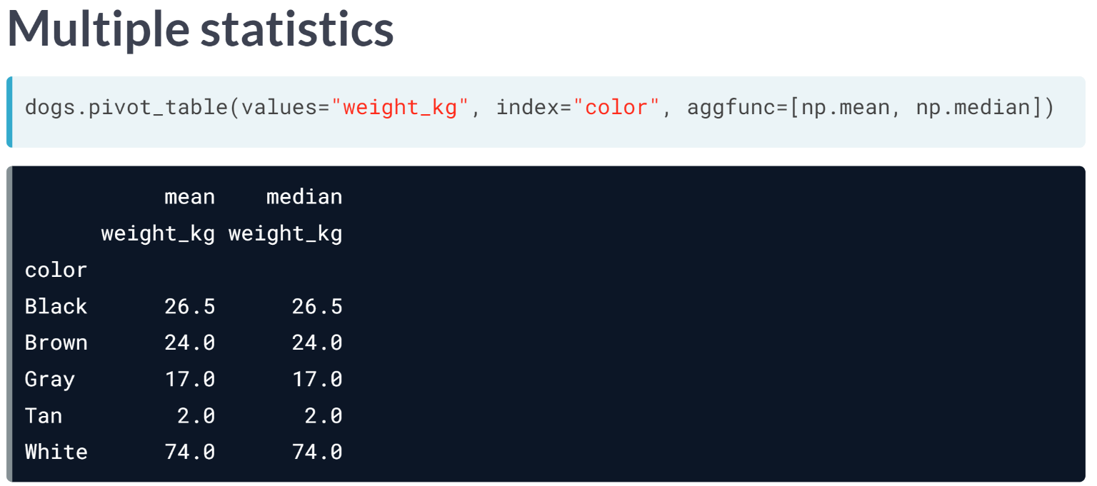  
We can also pass a list of functions to the aggfunc argument to get multiple summary statistics at a time. Here, we get the mean and median for each dog color.

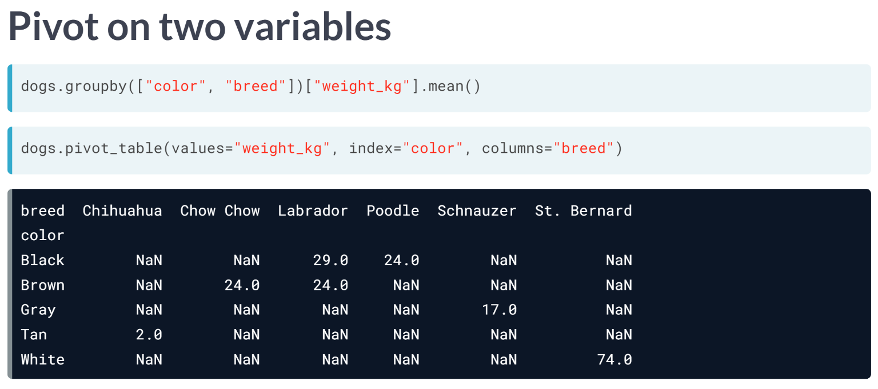  
You also previously computed the mean weight grouped by two variables: color and breed. We can also do this using the pivot_table method.

While the result looks a little different than what we had before, it contains the same numbers. There are NaNs, or missing values, because there are no black Chihuahuas or gray Labradors in our dataset, for example.

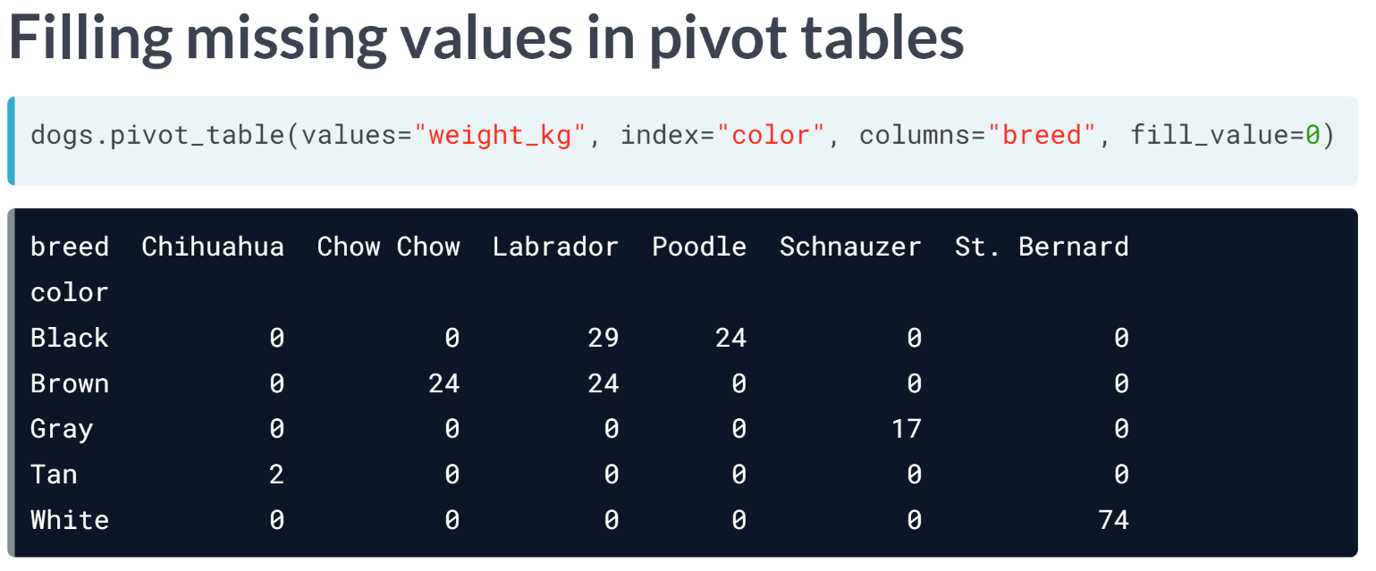  
Instead of having lots of missing values in our pivot table, we can have them filled in using the *fill_value* argument. Here, all of the *NaNs* get filled in with zeros.

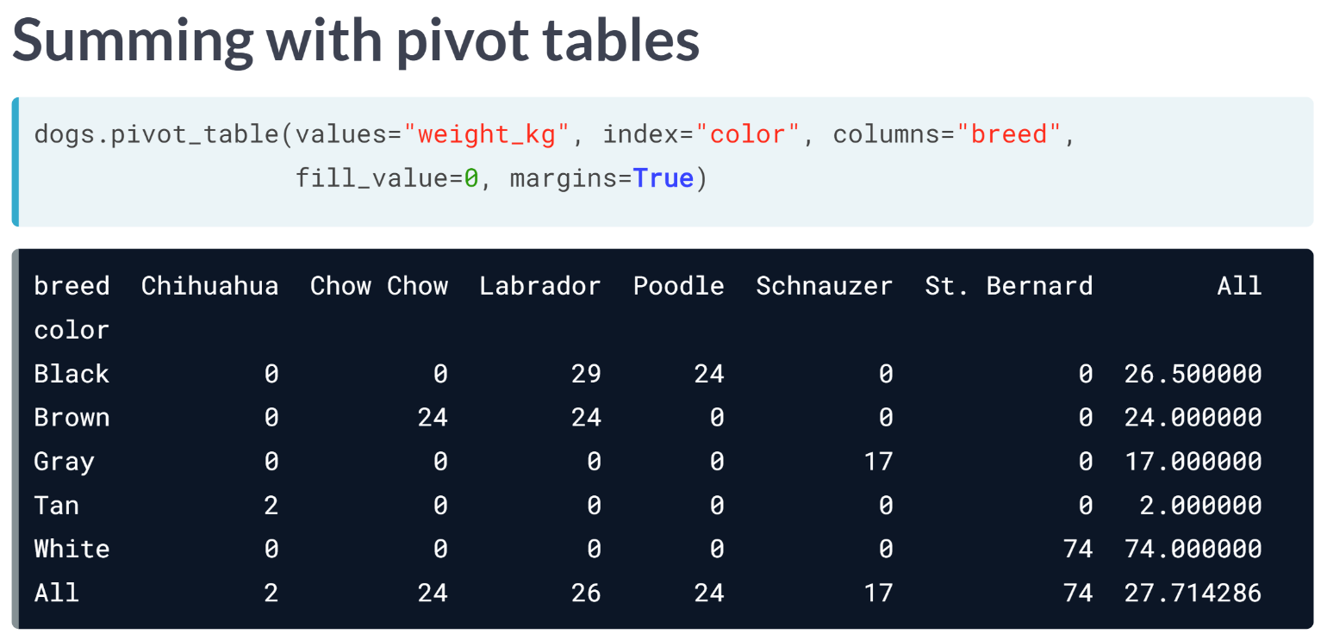  
If we set the margins argument to True, the last row and last column of the pivot table contain the mean of all the values in the column row, not including the missing values that were filled in with 0s.

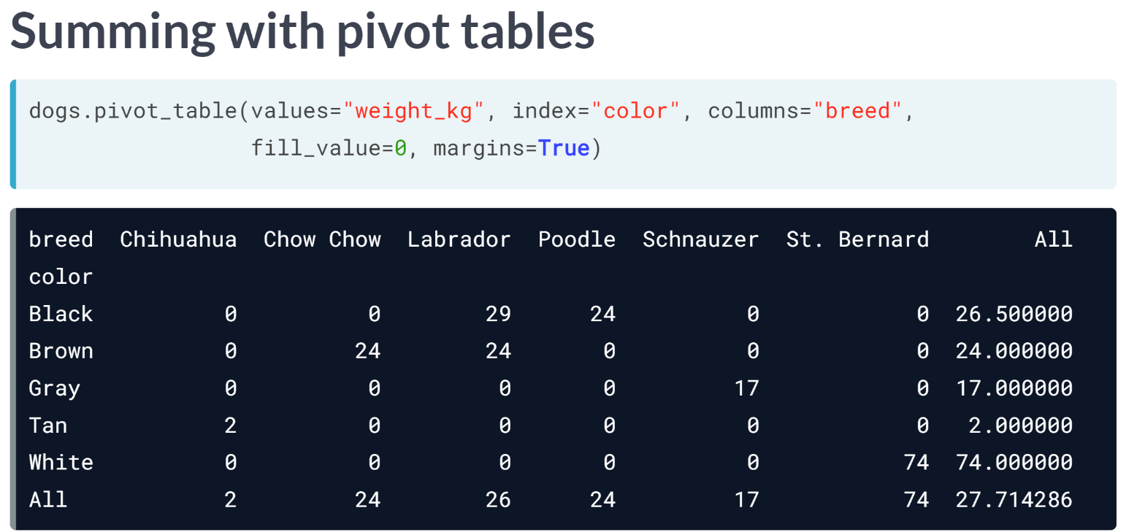  
The value in the bottom right, in the last row and the last column, is the mean weight of all the dogs in the dataset. Using margins = True allows us to see a summary statistic for multiple levels of the dataset: the entire dataset, grouped by one variable, by another variable, and by two variables.

# Pivoting on one variable

Pivot tables are the standard way of aggregating data in spreadsheets. In pandas, pivot tables are essentially just another way of performing grouped calculations.

That is, the .pivot_table() method is just an alternative to .groupby().

In this exercise, you'll perform calculations using .pivot_table() to replicate the calculations you performed in the last lesson using .groupby().

sales is available and pandas is imported as pd.

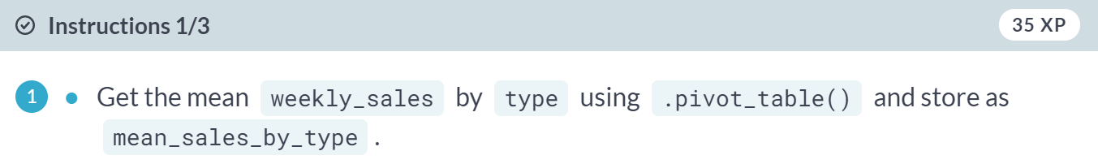

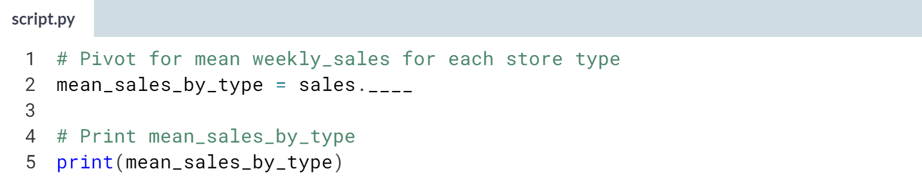

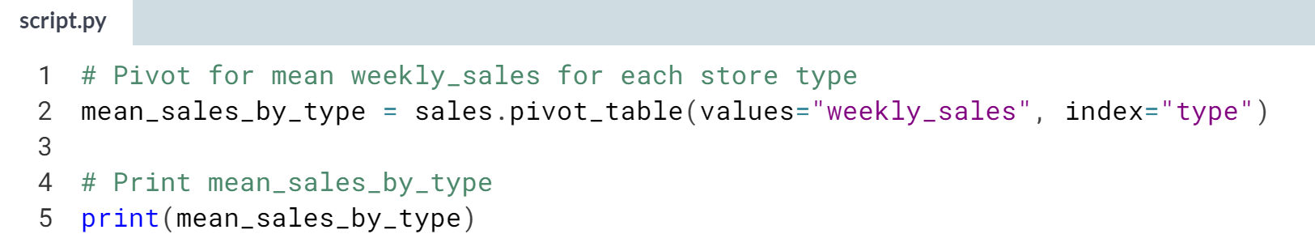

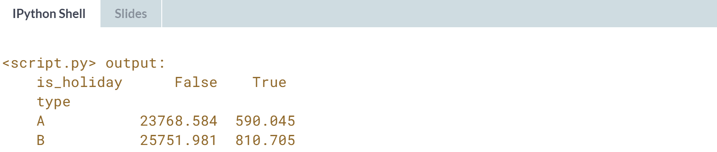

(Exercise continues on the next page)

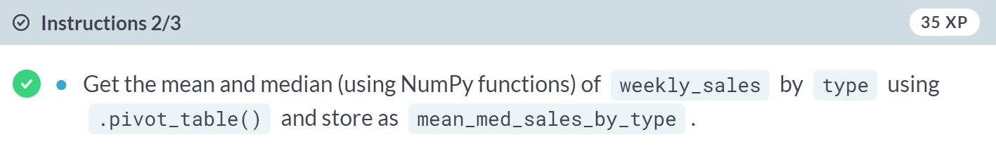

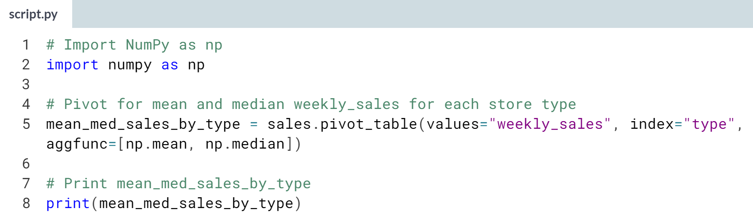

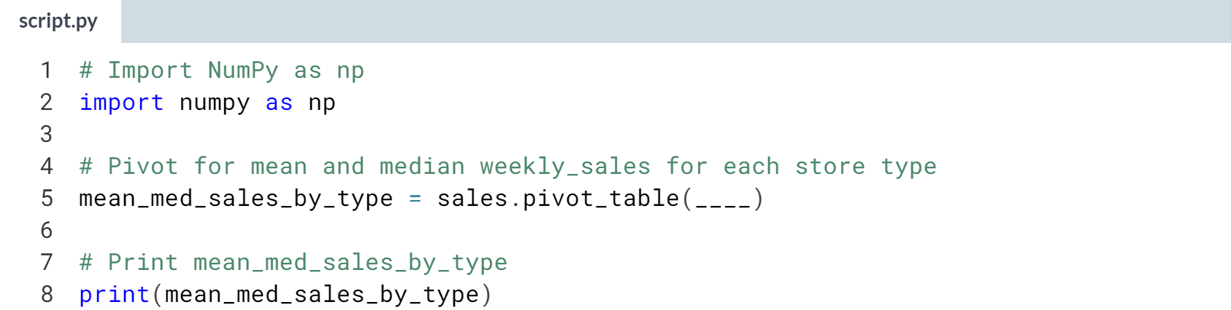

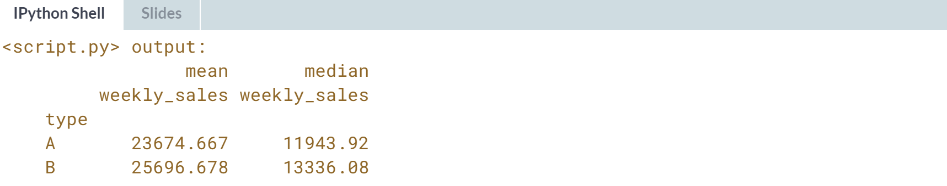

(Exercise continues on the next page)

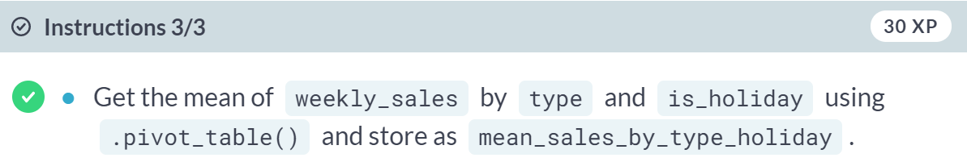

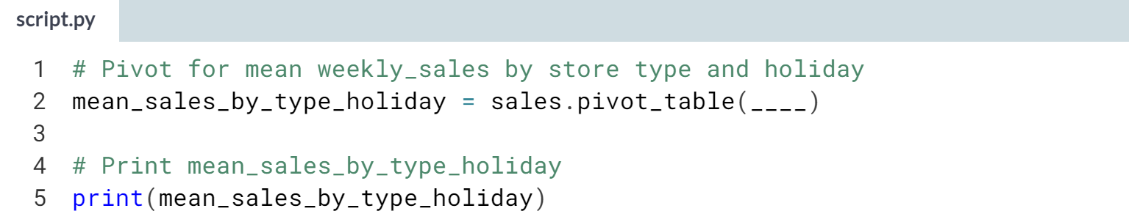

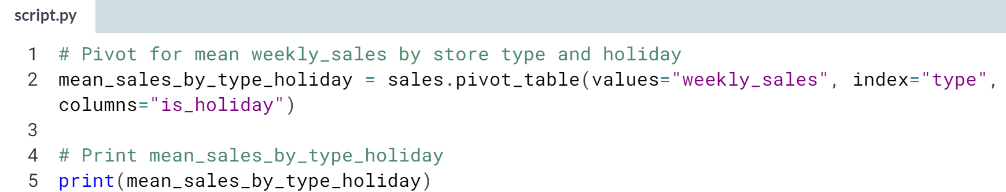

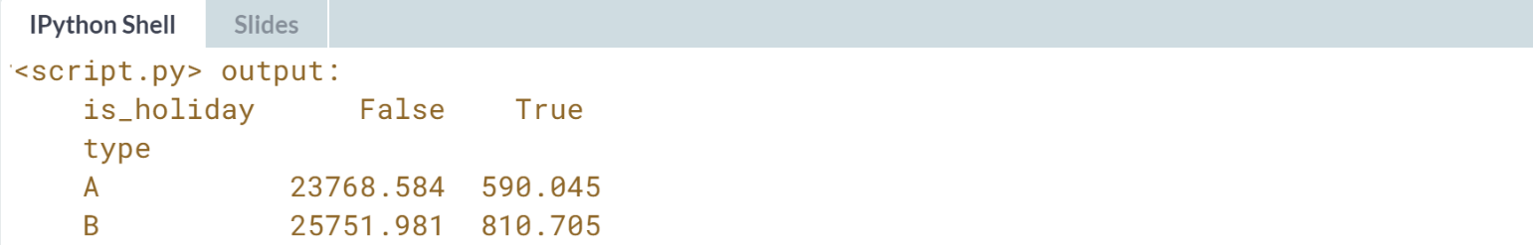

Perfect pivoting! Pivot tables are another way to do the same thing as a group-by-then-summarize.

# Fill in missing values and sum values with pivot tables

The .pivot_table() method has several useful arguments, including fill_value and margins.

* fill_value replaces missing values with a real value (known as imputation). What to replace missing values with is a topic big enough to have its own course ([**Dealing with Missing Data in Python**](https://www.datacamp.com/courses/dealing-with-missing-data-in-python)), but the simplest thing to do is to substitute a dummy value.
* margins is a shortcut for when you pivoted by two variables, but also wanted to pivot by each of those variables separately: it gives the row and column totals of the pivot table contents.

In this exercise, you'll practice using these arguments to up your pivot table skills, which will help you crunch numbers more efficiently!

sales is available and pandas is imported as pd.

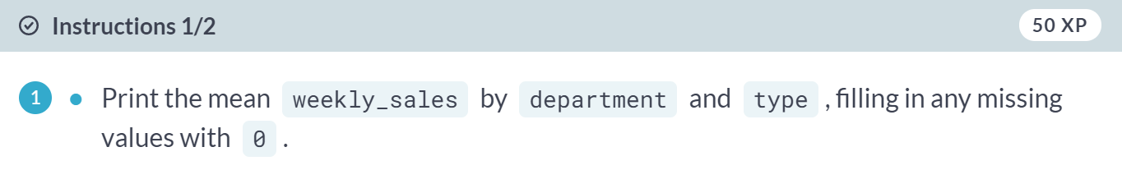



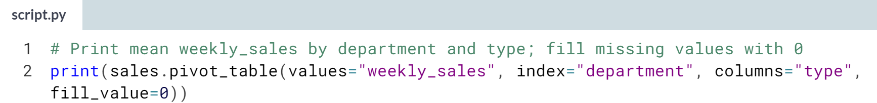

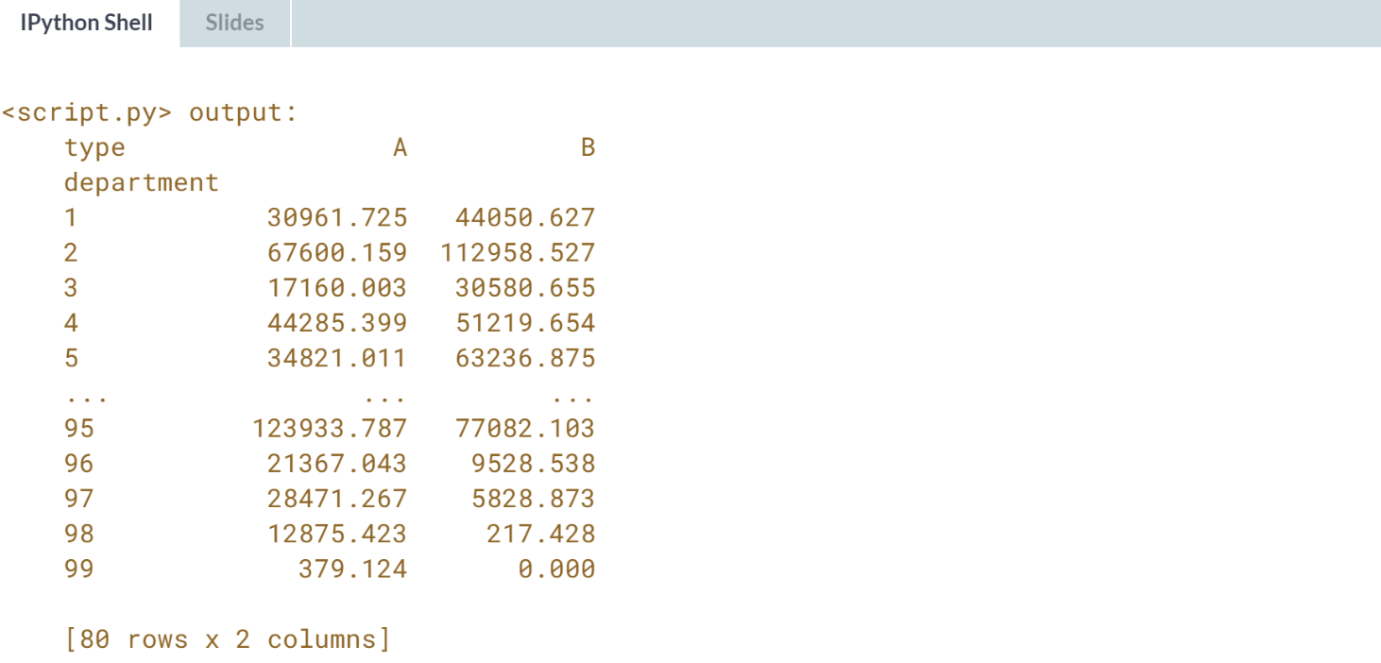

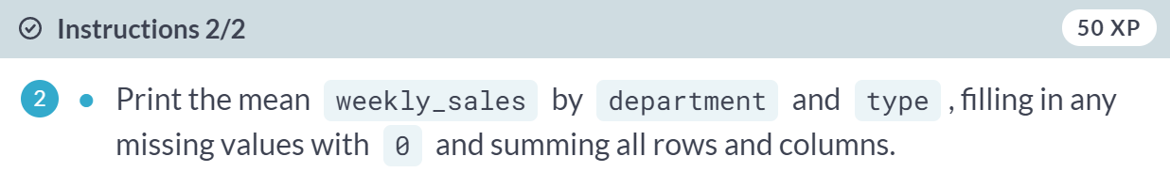

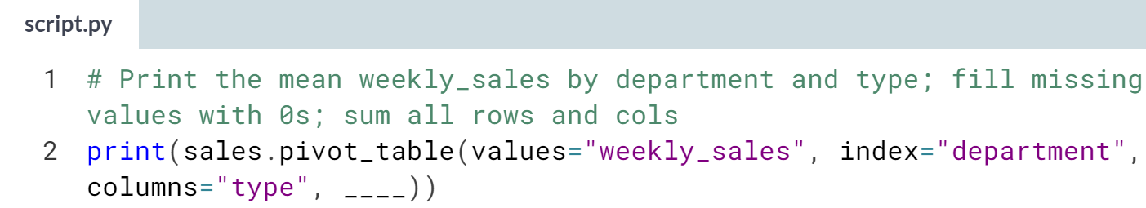

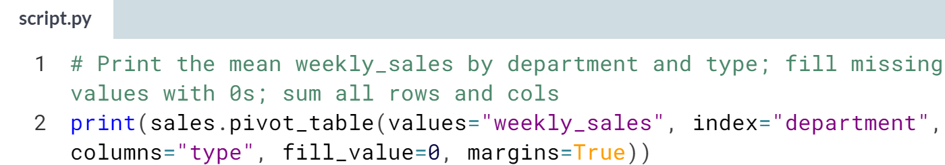

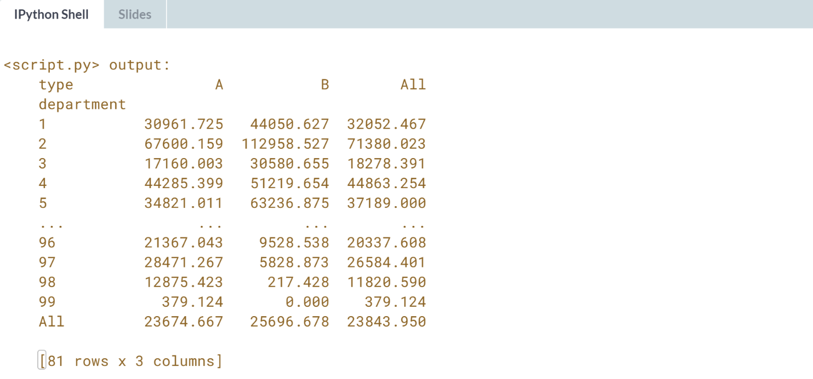  
Magnificent margin making! You are now armed with pivot table skills that can help you compute summaries at multiple grouped levels in one line of code.

**3. Slicing and indexing**

Indexes are supercharged row and column names. Learn how they can be combined with slicing for powerful DataFrame subsetting.



In chapter one, you saw that DataFrames are composed of three parts: **a NumPy array** for the data, and **two indexes** to store the row and column details.

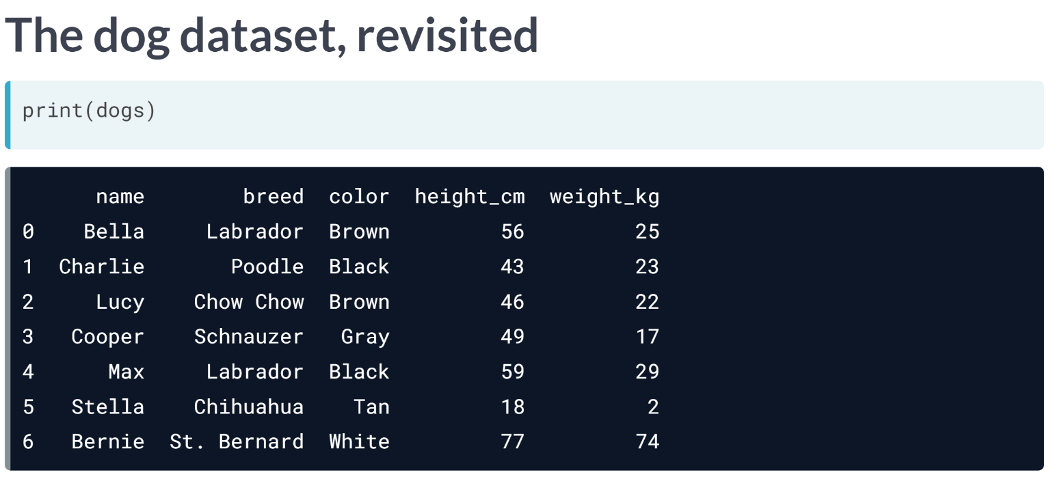  
Here's the dog dataset again.

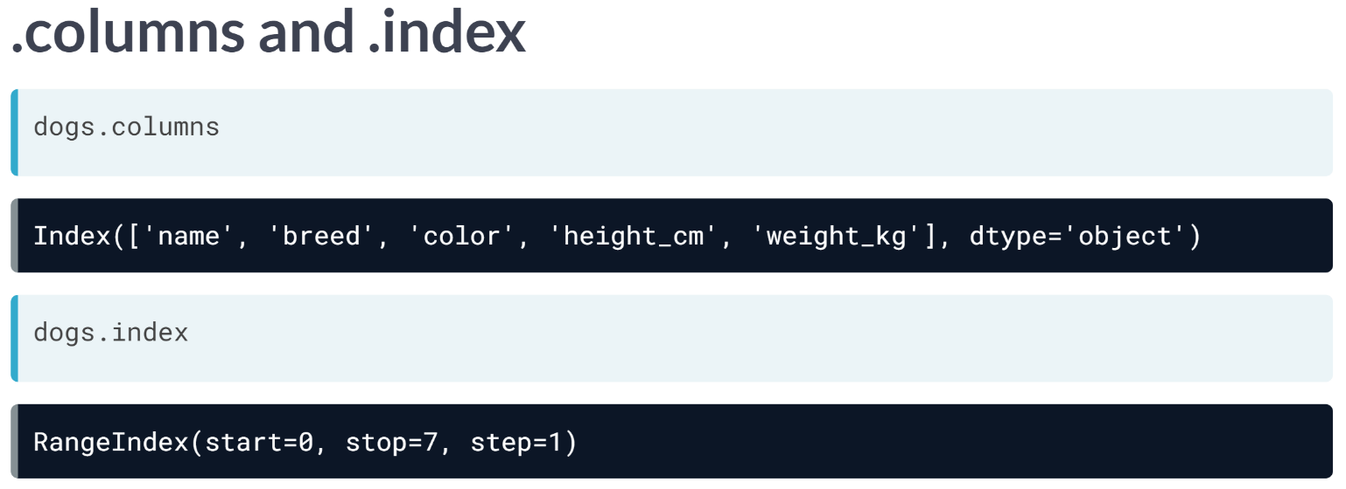  
Recall that **.columns** contains index object of column names, and **.index** contains an index object of row numbers.

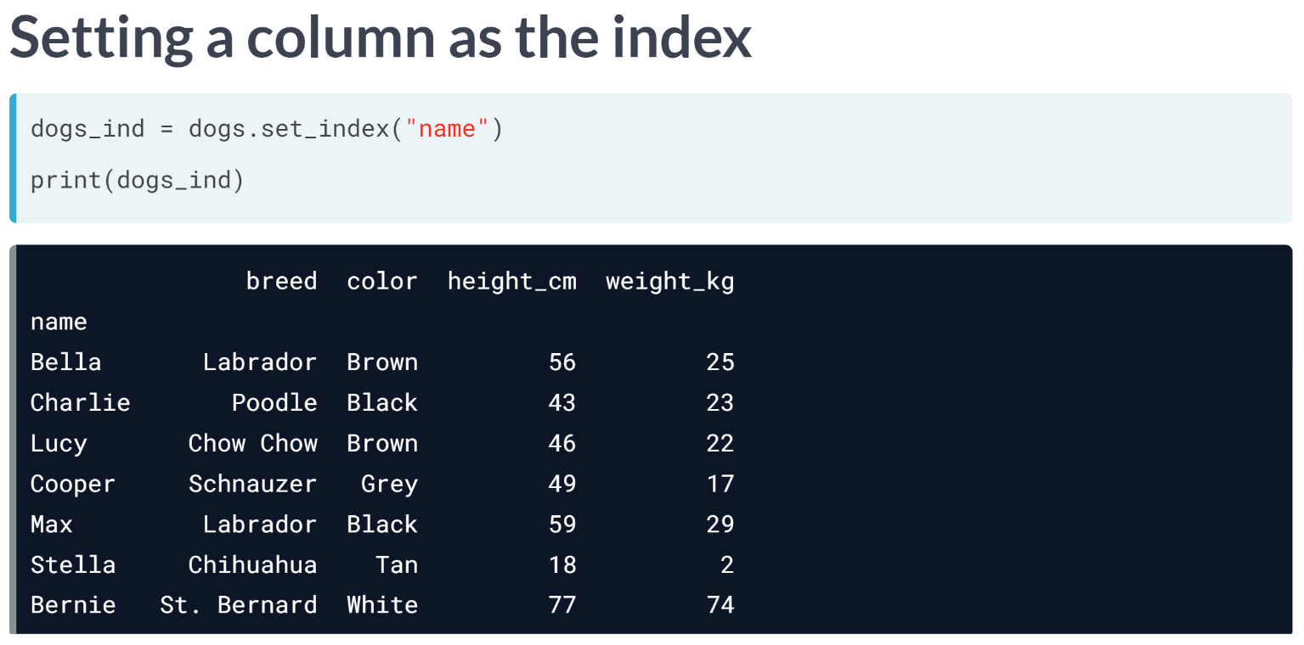  
You can move a column from the body of the DataFrame to the index. This is called "setting an index", and it uses the ***set_index()*** method. Notice that the output has changed slightly; in particular, a quick visual clue that name is now in the index is that the index values are left-aligned rather than right-aligned.

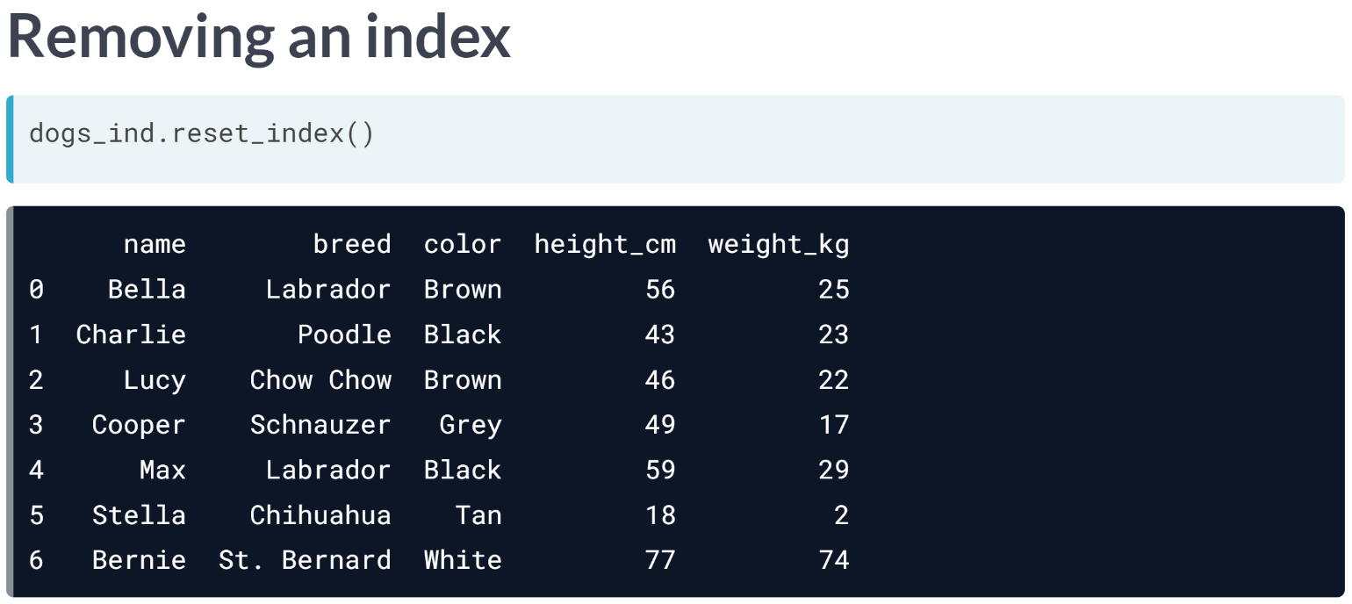  
To undo what you just did, you can reset the index, basically removing it. This is done via ***reset_index()***.

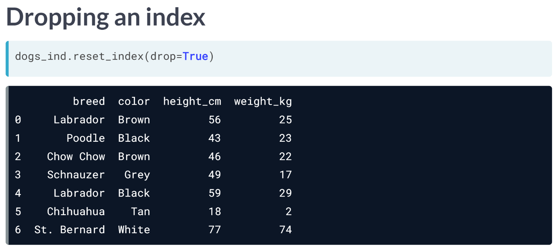  
***reset_index()*** has a drop argument that allows you to discard an index. Here, setting *drop* to *True* entirely removes the dog names.

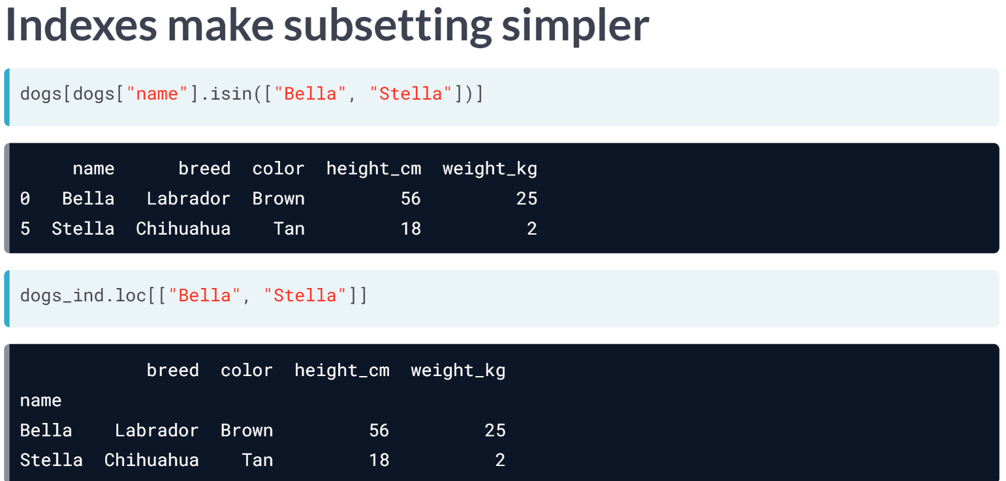  
You may be wondering why you should bother with indexes. The answer is that it makes subsetting code cleaner.

Consider this example of subsetting for the rows where the dog is called Bella or Stella. It's a fairly tricky line of code for such a simple task.

Now look at the equivalent when the names are in the index. DataFrames have a subsetting method called *"loc"*, which filters on index values. Here you simply pass the dog names to loc as a list.

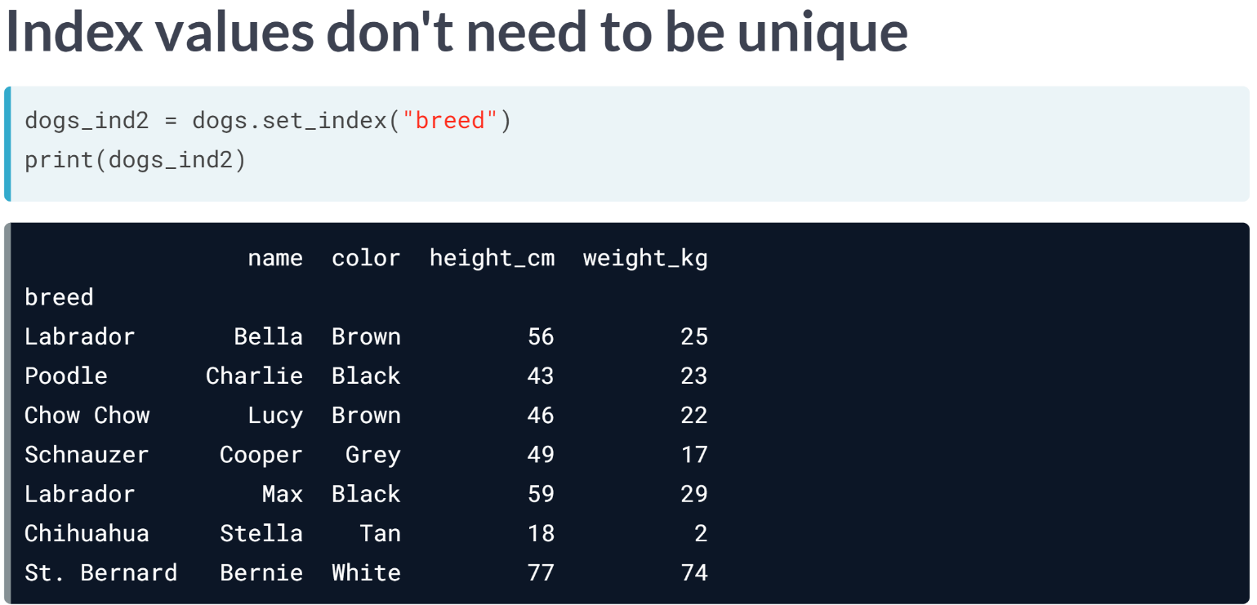  
The values in the index don't need to be unique. Here, there are two Labradors in the index.

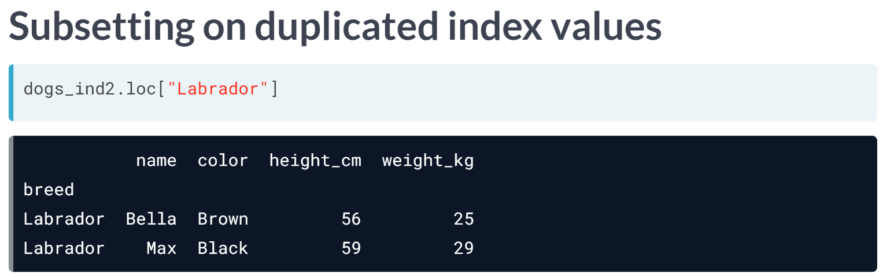  
Now, if you subset on "Labrador" using loc, all the Labrador data is returned.

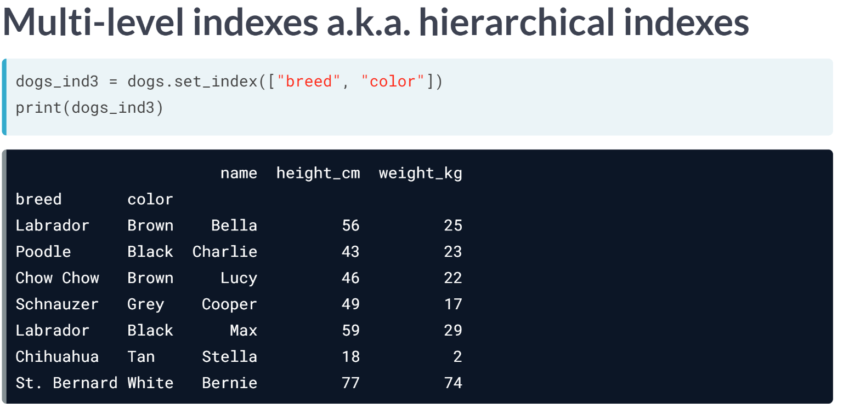  
You can include multiple columns in the index by passing a list of column names to *set_index*. Here, breed and color are included. These are called multi-level indexes, or hierarchical indexes: the terms are synonymous.

There is an implication here that the inner level of index, in this case color, is nested inside the outer level, breed.

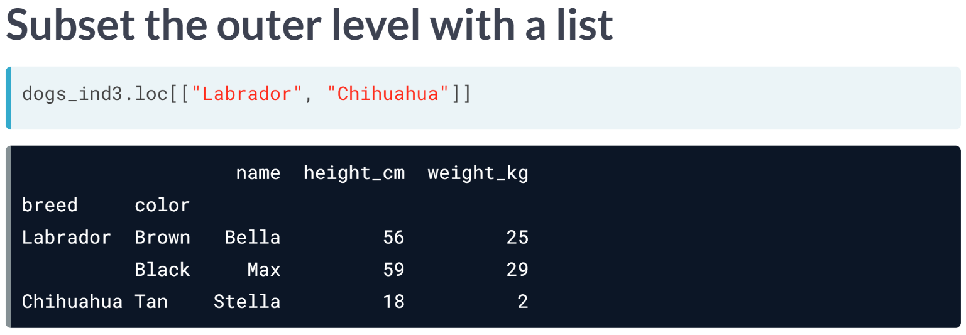  
To take a subset of rows at the outer level index, you pass a list of index values to loc. Here, the list contains Labrador and Chihuahua, and the resulting subset contains all dogs from both breeds.

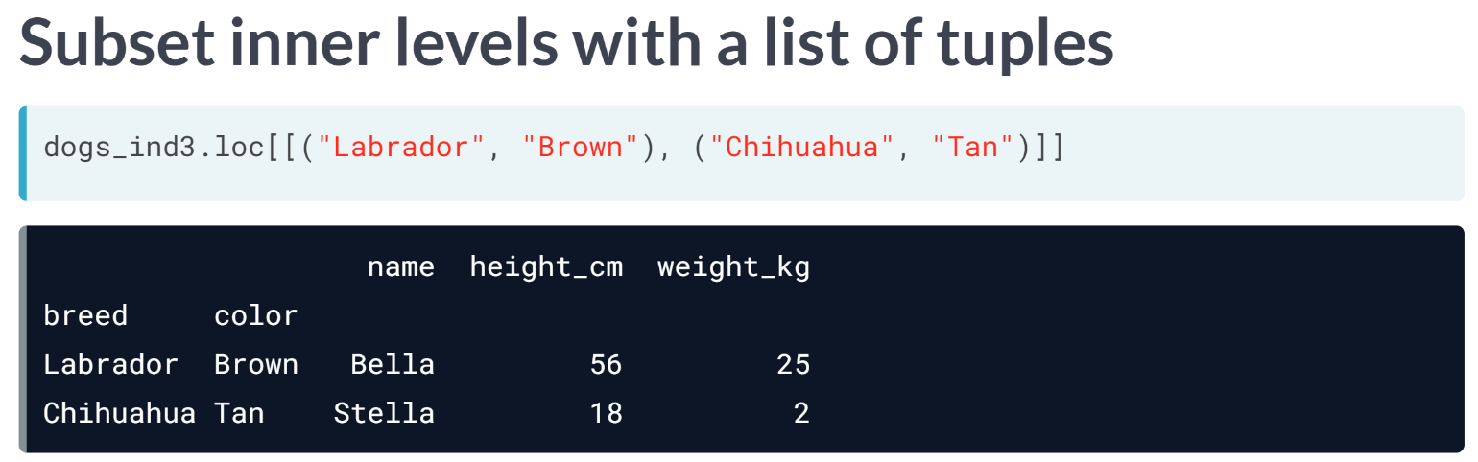To subset on inner levels, you need to pass a list of tuples. Here, the first tuple specifies Labrador at the outer level and Brown at the inner level.

The resulting rows have to match all conditions from a tuple. For example, the black Labrador wasn't returned because the brown condition wasn't matched.

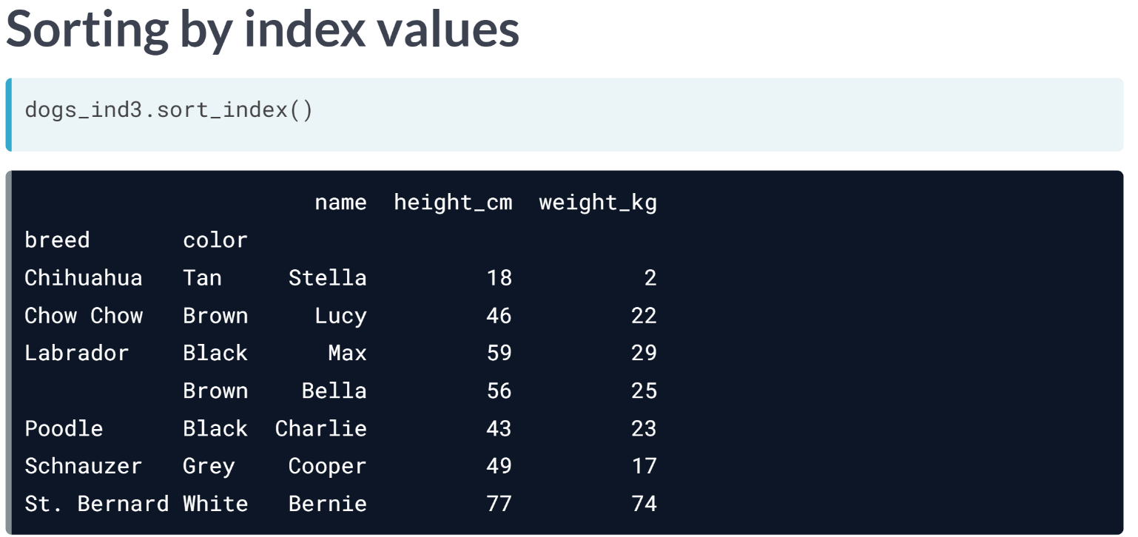

In chapter one, you saw how to sort the rows of a DataFrame using ***sort_values()***. You can also sort by index values using ***sort_index()***.

By default, it sorts all index levels from outer to inner, in ascending order.

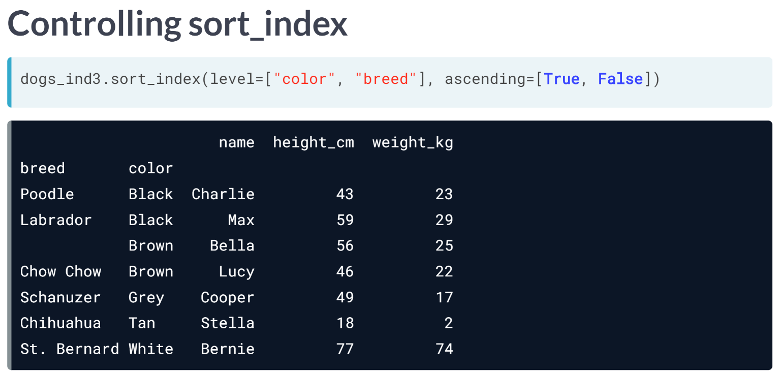  
You can control the sorting by passing lists to the level and ascending arguments.

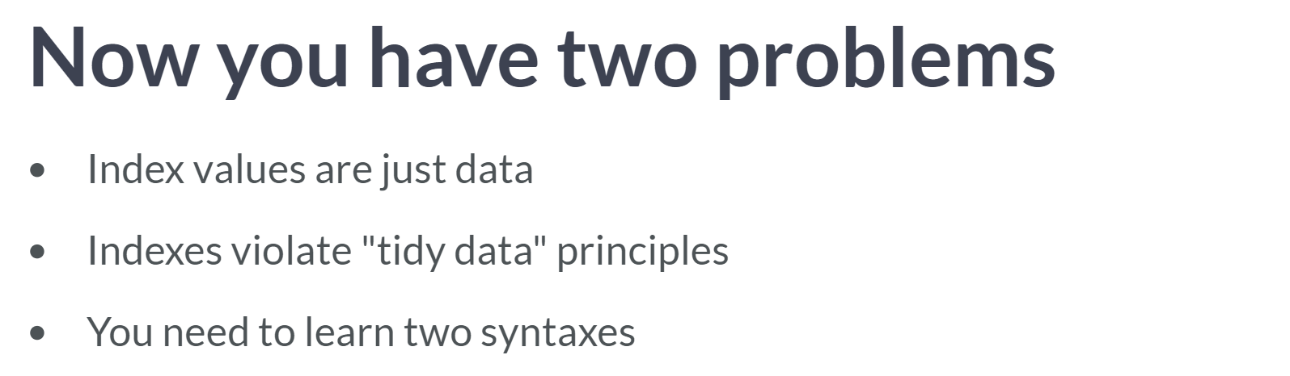  
Index values are just data, and thus storing data in multiple forms makes it harder to think about.

There is a concept called "tidy data", where data is stored in tabular form - like a DataFrame, where each row contains a single observation, and each variable is stored in its own column.

Indexes violate the last rule, since index values don't get their own column.

In pandas, the syntax for working with indexes is different from the syntax for working with columns. By using two syntaxes, your code becomes more complicated, which in turn can result in more bugs.

For these reasons, it is perfectly reasonable to not use indexes. However, it is useful to know how they work for cases when you need to reach other people's code.

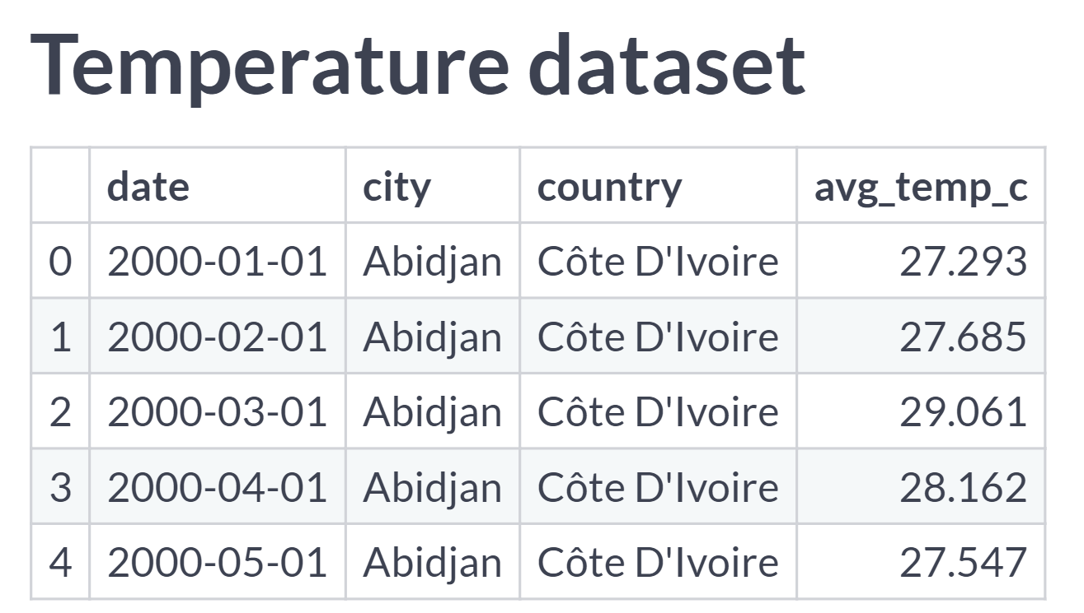  
In this chapter, you will work with monthly time series of air temperatures in cities around the world.

# Setting & removing indexes

pandas allows you to designate columns as an index. This enables cleaner code when taking subsets (as well as providing more efficient lookup under some circumstances).

In this chapter, you'll be exploring temperatures, a DataFrame of average temperatures in cities around the world. pandas is loaded as pd.

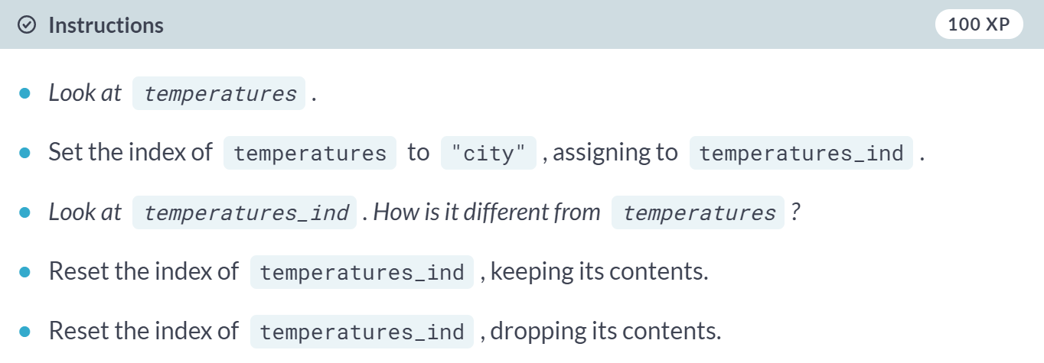

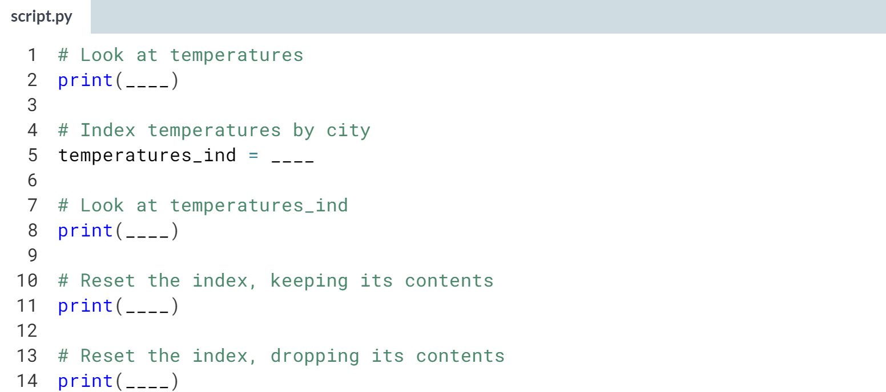

Hint

1. Call ***.set_index()***, passing in the name of the column.
2. Call ***.reset_index()*** without arguments, then setting drop to *True*.

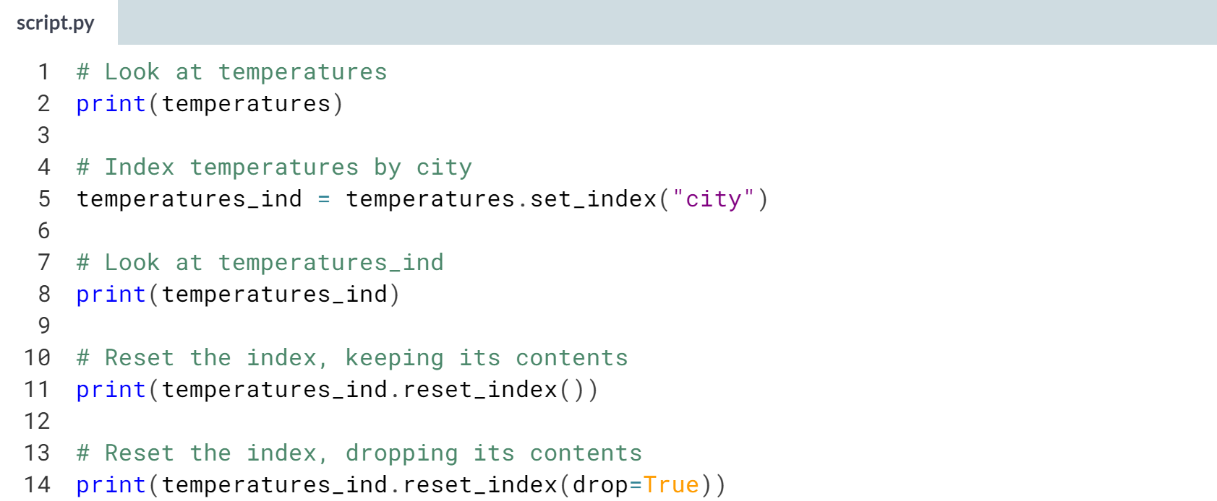

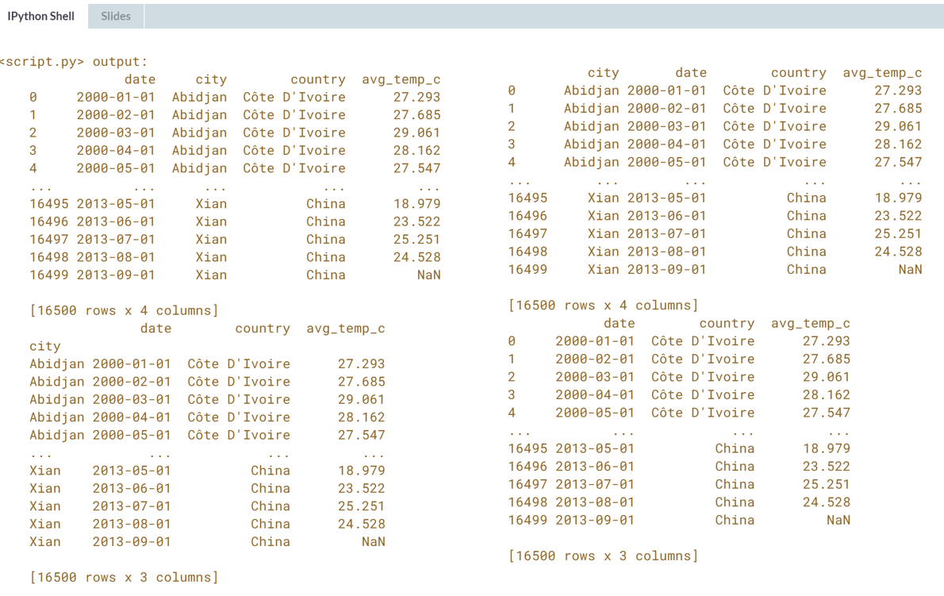  
Incredible indexing! Setting an index allows more concise code for subsetting for rows of a categorical variable via **.loc[]**.

# Subsetting with .loc[]

The killer feature for indexes is .loc[]: a subsetting method that accepts index values. When you pass it a single argument, it will take a subset of rows.

The code for subsetting using .loc[] can be easier to read than standard square bracket subsetting, which can make your code less burdensome to maintain.

pandas is loaded as pd. temperatures and temperatures_ind are available; the latter is indexed by city.

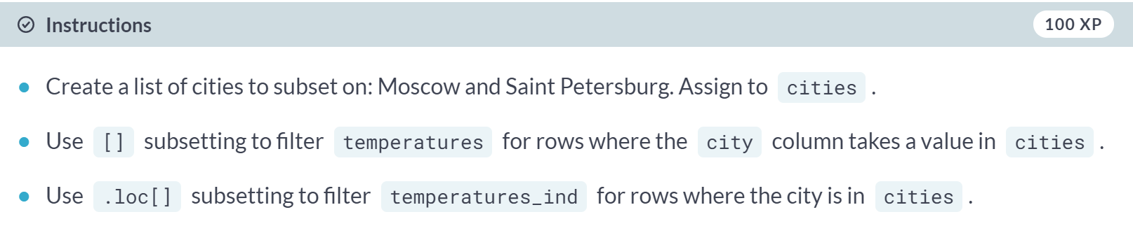

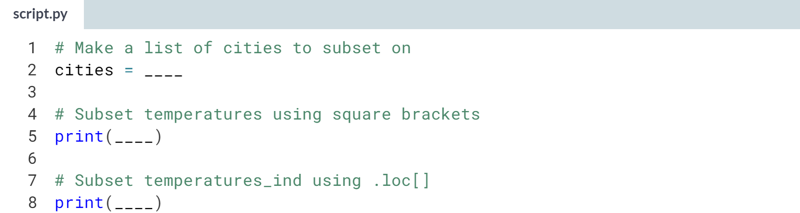

Hint

1. Without an index, subsetting takes the form **df[df["column"].isin(values)]**.
2. With an index, subsetting takes the form **df_ind.loc[values]**.

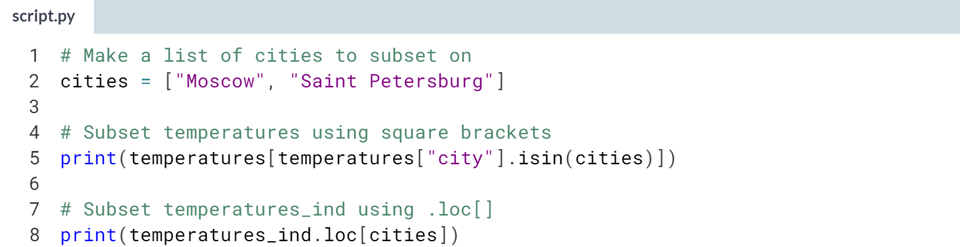

(Solution on the next page)

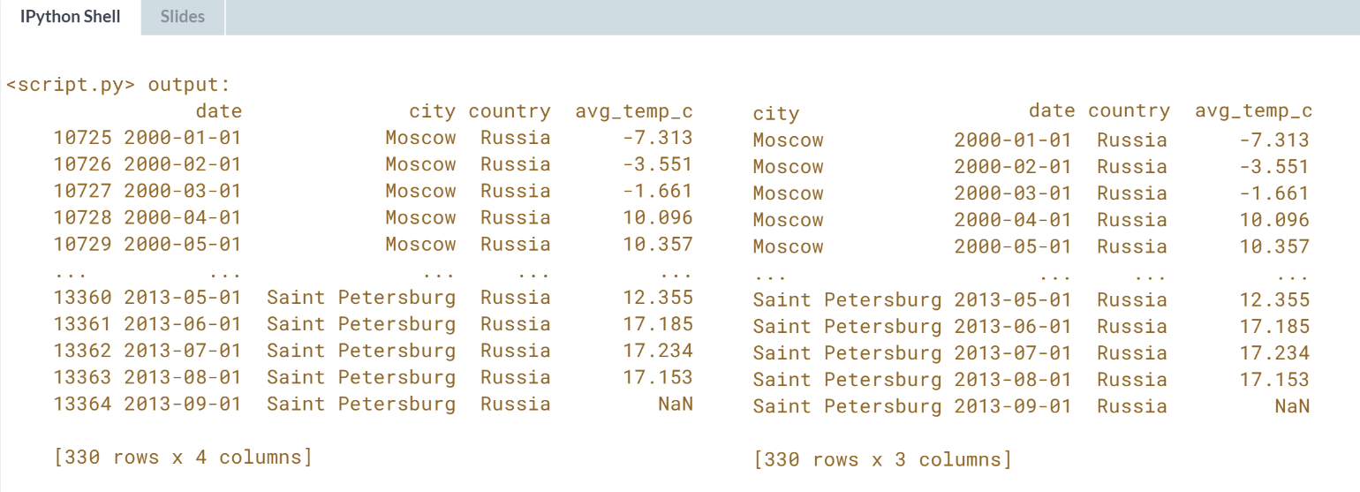

**.loc[]** is used by all the best folk! Setting an index allows more concise code for subsetting rows via **.loc[]**.

# Setting multi-level indexes

Indexes can also be made out of multiple columns, forming a multi-level index (sometimes called a hierarchical index). There is a trade-off to using these.

The benefit is that multi-level indexes make it more natural to reason about nested categorical variables.

For example, in a clinical trial you might have control and treatment groups. Then each test subject belongs to one or another group, and we can say that a test subject is nested inside treatment group.

Similarly, in the temperature dataset, the city is located in the country, so we can say a city is nested inside country.

The main downside is that the code for manipulating indexes is different from the code for manipulating columns, so you have to learn two syntaxes, and keep track of how your data is represented.

pandas is loaded as pd. temperatures is available.

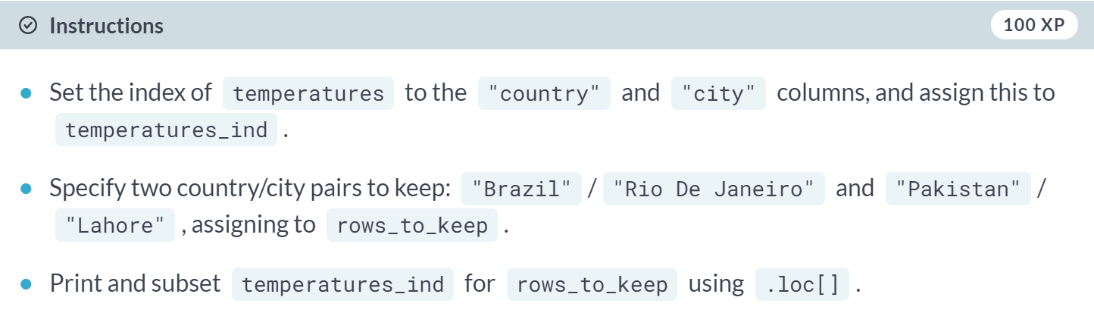

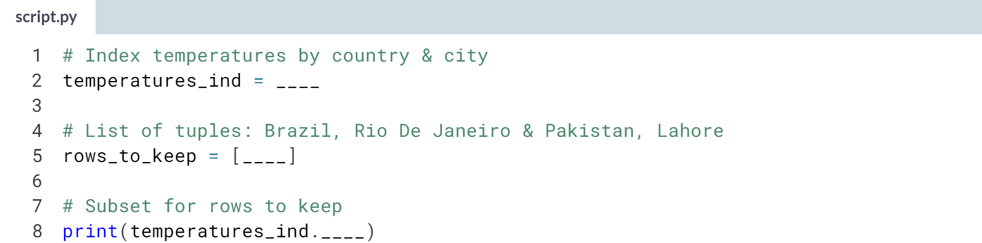  
Hint

1. Call ***.set_index()***, passing the two column names as a list.
2. Specify the rows to keep as a list of tuples: [("a", "b"), ("c", "d")].
3. Call **.loc[]**, passing in *rows_to_keep*.

(Solution on the next page)

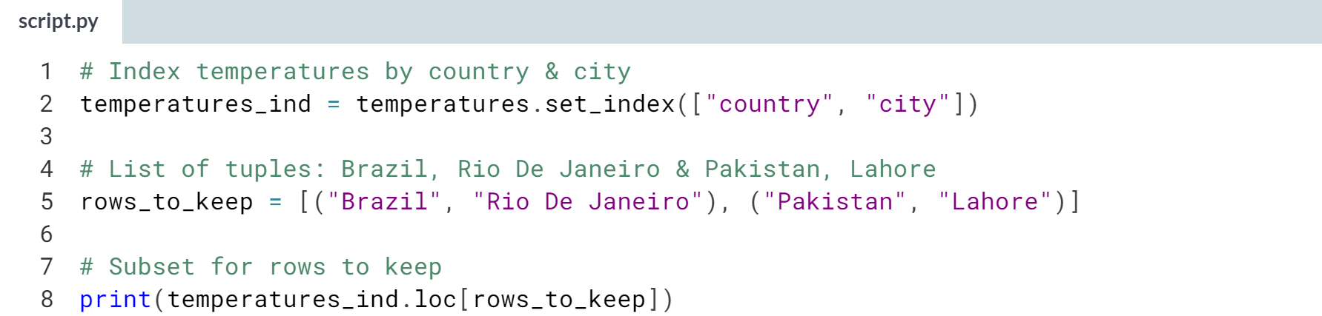

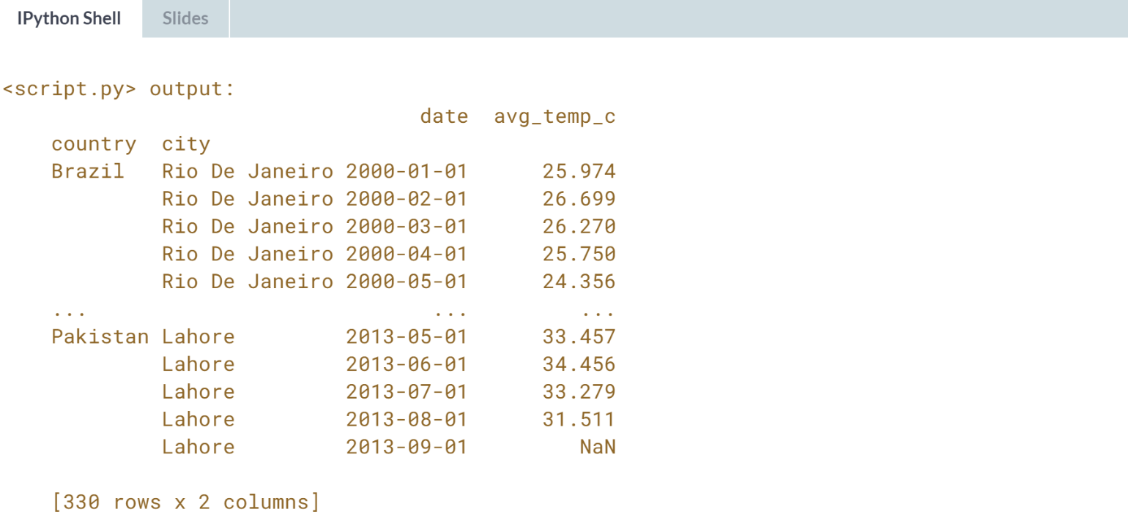

Magnificent multi-level indexing! Multi-level indexes can make it easy to comprehend your dataset when one category is nested inside another category.

# Sorting by index values

Previously, you changed the order of the rows in a DataFrame by calling .sort_values(). It's also useful to be able to sort by elements in the index. For this, you need to use .sort_index().

pandas is loaded as pd. temperatures_ind has a multi-level index of country and city, and is available.

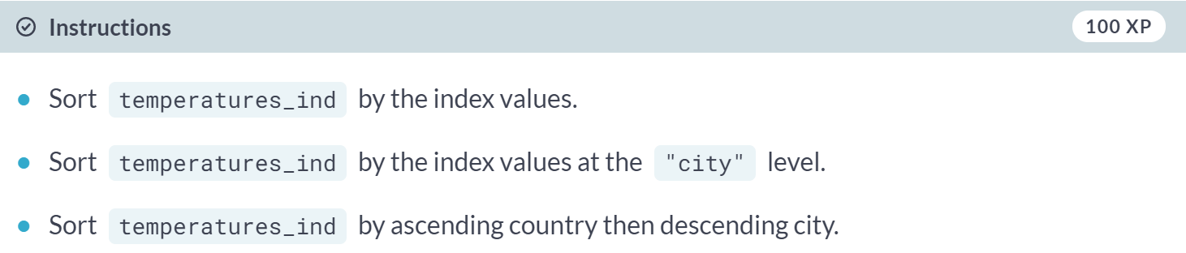

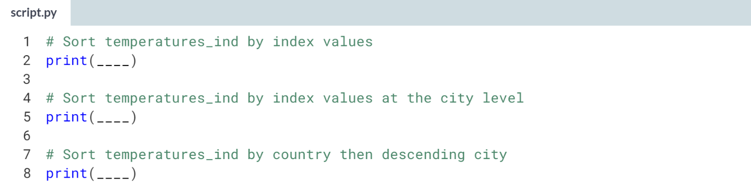

Hint

1. Call ***.sort_index()*** three times.
2. In the most advanced case, you need to set ***level*** to a list of index level names and ***ascending*** to a list of Booleans.

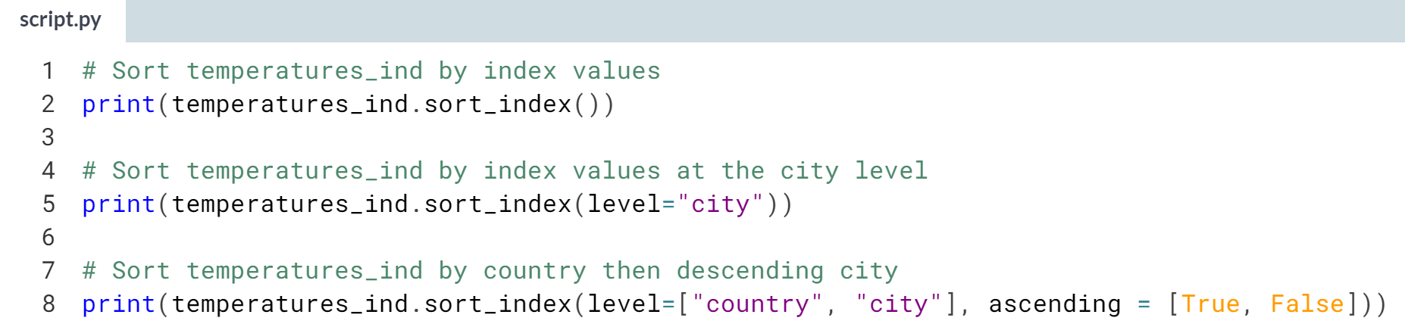

(Result on the next page)

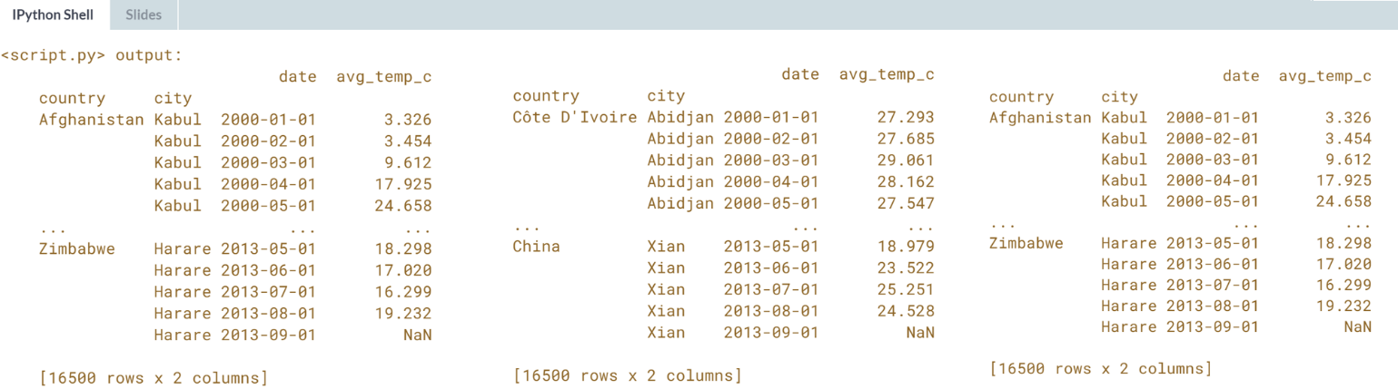  
Sorted! Sorting index values is similar to sorting values in columns, except that you call .sort_index() instead of ***.sort_values()***.



Slicing is a technique for selecting consecutive elements from objects.

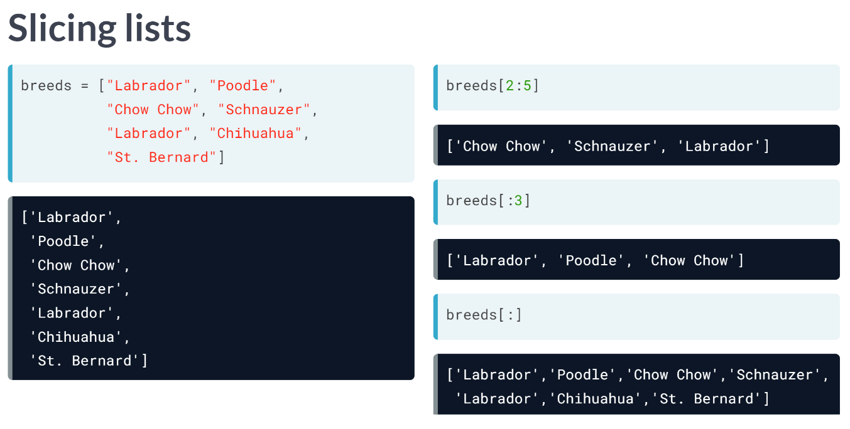  
Here we have dog breeds list. To slice the list, we pass first, and last positions separated by a colon into square brackets. Remember that Python positions start from zero, so 2 actually refers to the third element: Chow Chow.

Also remember that last position, 5, is not included in the slice, so we finish at Labrador, not Chihuahua. If you want the slice to start from the beginning of the list, you can omit the zero. Here, using :3 returns the first three elements. Slicing with colon on its own returns the whole list.

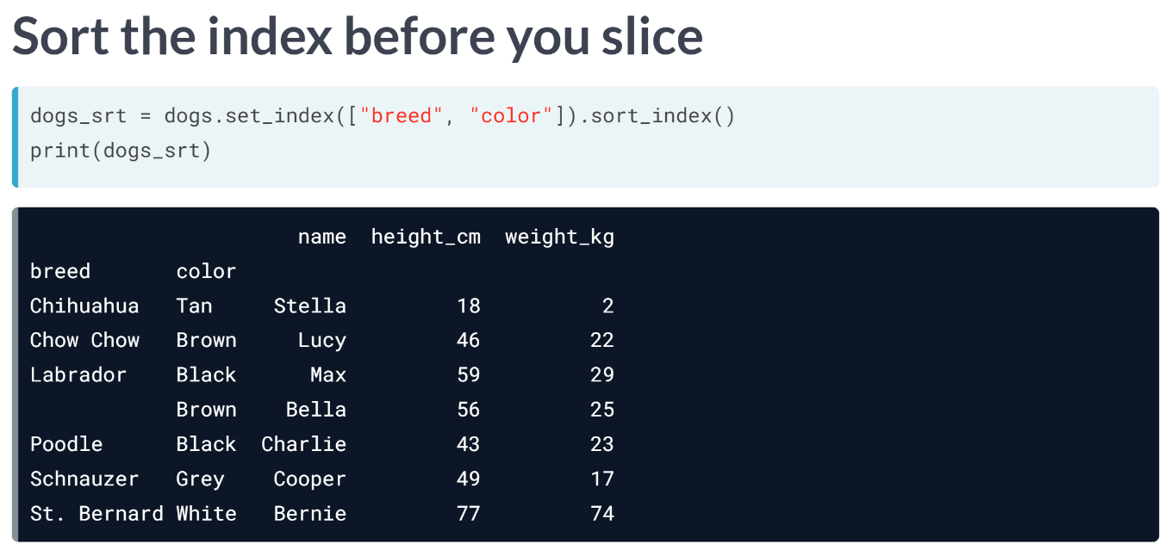  
You can also slice DataFrames, but first you need to sort the index. Here, the dogs dataset has been given a multi-level index of breed and color, then the index is sorted with ***sort_index()***.

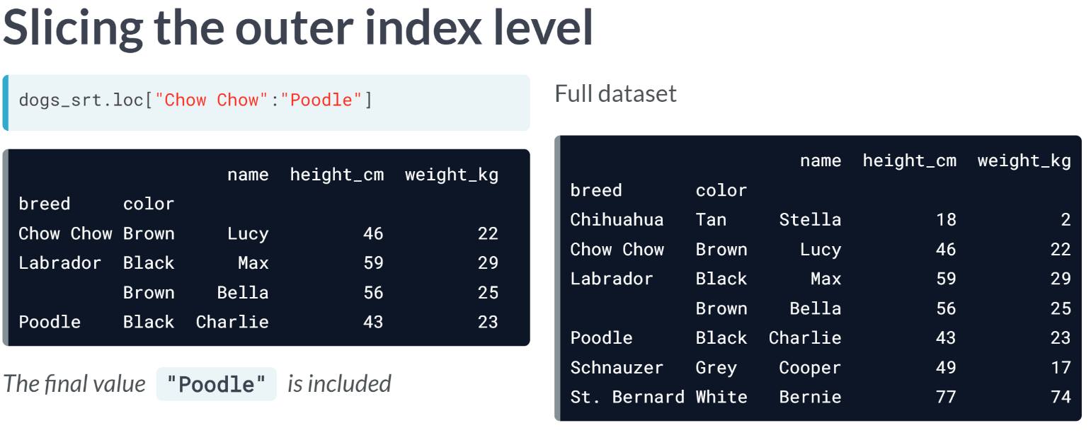  
To slice rows at the outer level of an index, you call loc, passing the first and last values separated by a colon. The full dataset is shown on the right for comparison.

There are two differences compared to slicing lists. Rather than specifying row numbers, you specify index values. Secondly, notice that the final value is included. Here, Poodle is included in the results.

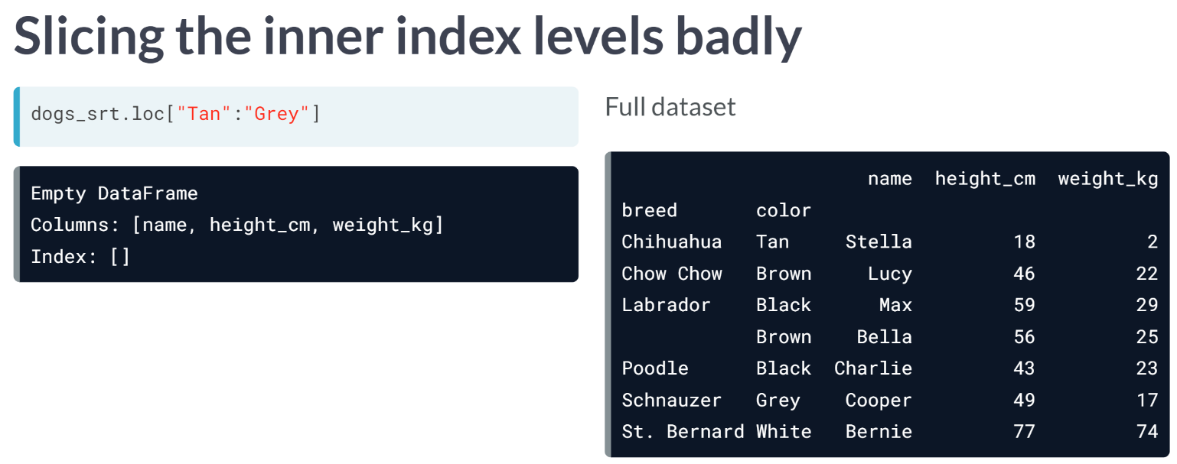  
The same technique doesn't work on inner index levels. Here, trying to slice from Tan to Grey returns an empty DataFrame instead of the six dogs we wanted.

It's important to understand the danger here. pandas doesn't throw an error to let you know that there is a problem, so be careful when coding.

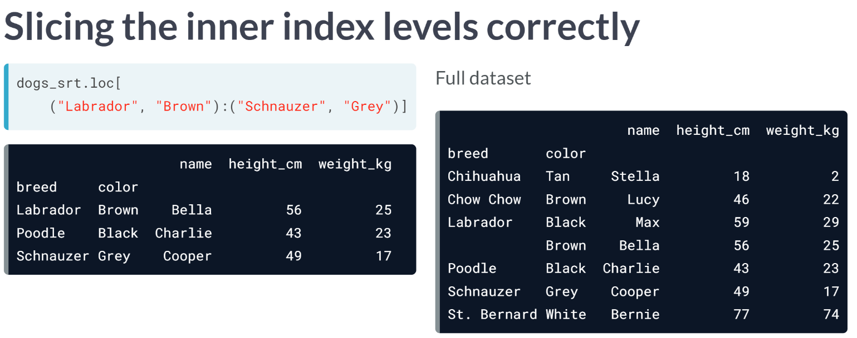  
The correct approach to slicing at inner index levels is to pass the first and last positions as tuples. Here, the first element to include is a tuple of Labrador and Brown.

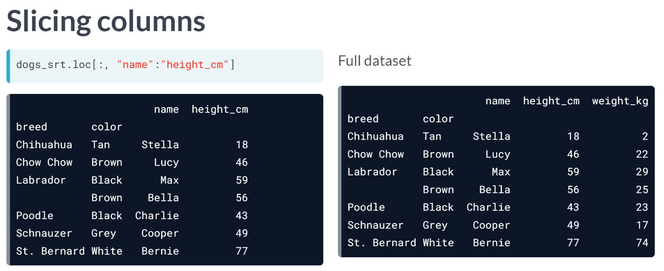

Since DataFrames are two dimensional objects, you can also slice columns. You do this by passing two argument to loc.

The simplest case involves subsetting columns but keeping all rows. To do this, pass a colon as the first argument to loc.

As with slicing lists, a **colon(:)** by itself means "keep everything". The second argument takes **column names** as the first and last position to slice on.

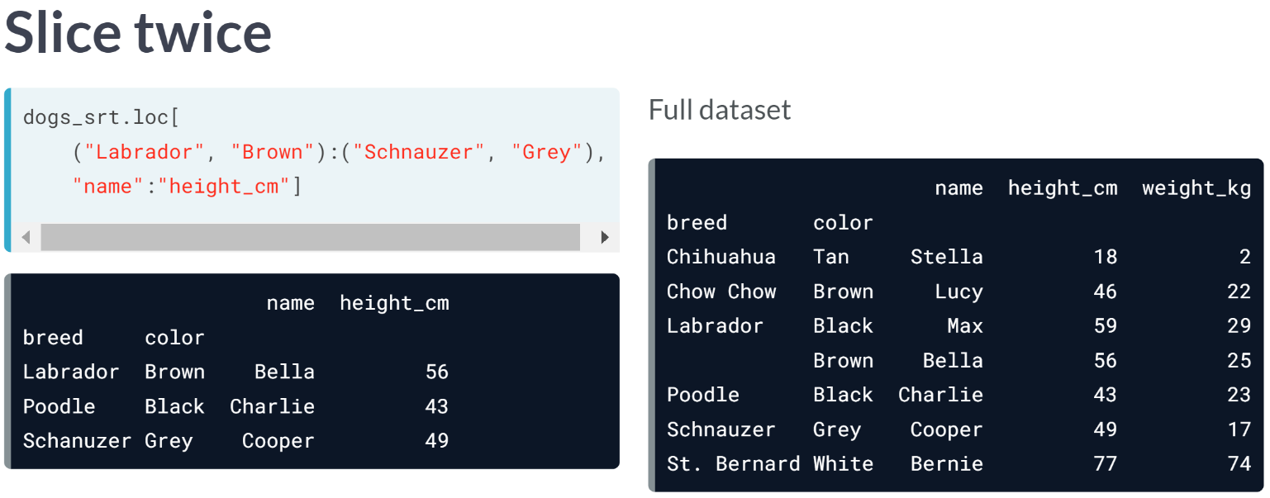  
You can slice on rows and columns at the same time: simply pass the appropriate slice to each argument. Here, you see the previous two slices being performed in the same line of code.

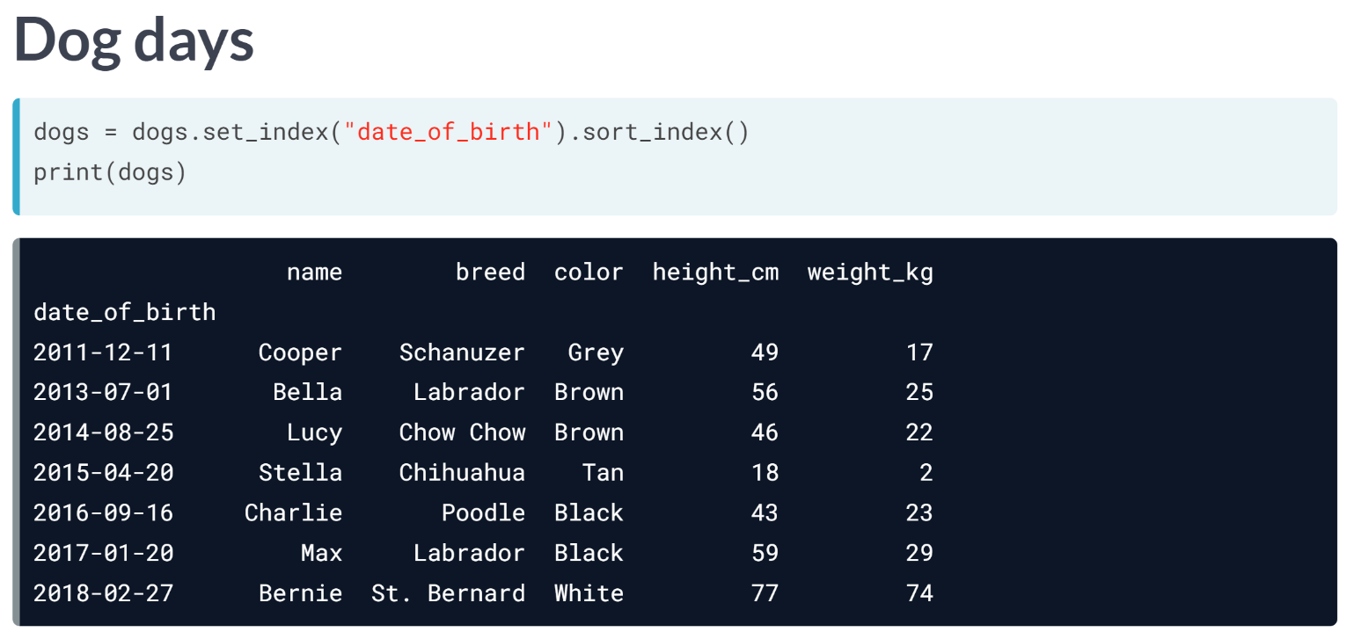  
An important use case of slicing is to subset DataFrames by a range of dates. To demonstrate this, let's set the *date_of_birth* column as the index, and sort by this index.

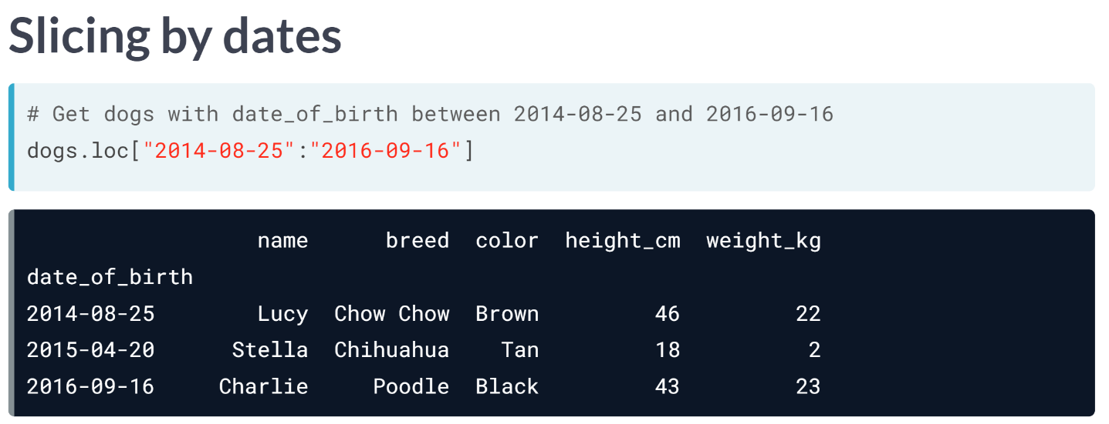  
You slice dates with the same syntax as other types. The first and last dates are passed as strings.

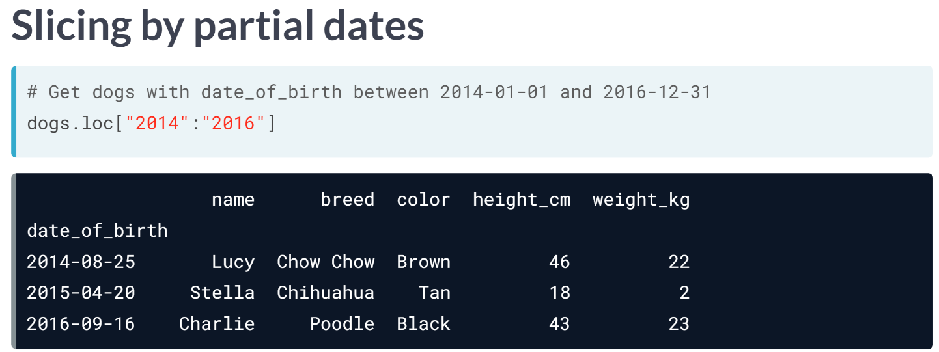

One helpful feature is that you can slice by partial dates. Here, the first and last positions are only specified as 2014 and 2016, with no month or day parts. pandas interpret this as slicing from the start of 2014 to the end of 2016; that is, all dates in 2014, 2015, and 2016.

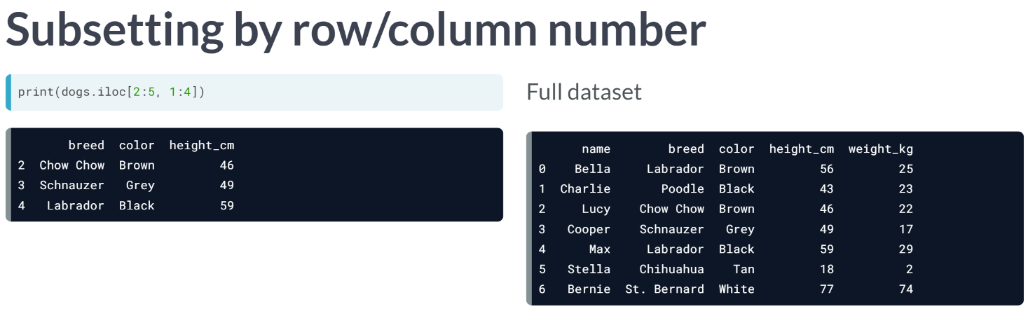  
You can also slice DataFrames by row or column number using the iloc method. This uses a similar syntax to slicing lists, except that there are two arguments: one for rows and one for columns. Notice that like list slicing but unlike loc, final values aren't included in the slice.

# Slicing index values

Slicing lets you select consecutive elements of an object using first:last syntax. DataFrames can be sliced by index values, or by row/column number; we'll start with the first case. This involves slicing inside the .loc[] method.

Compared to slicing lists, there are a few things to remember.

* You can only slice an index if the index is sorted (using .sort_index()).
* To slice at the outer level, first and last can be strings.
* To slice at inner levels, first and last should be tuples.
* If you pass a single slice to .loc[], it will slice the rows.

pandas is loaded as pd. temperatures_ind has country and city in the index, and is available.

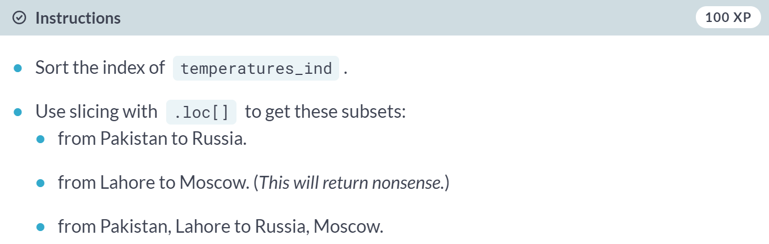

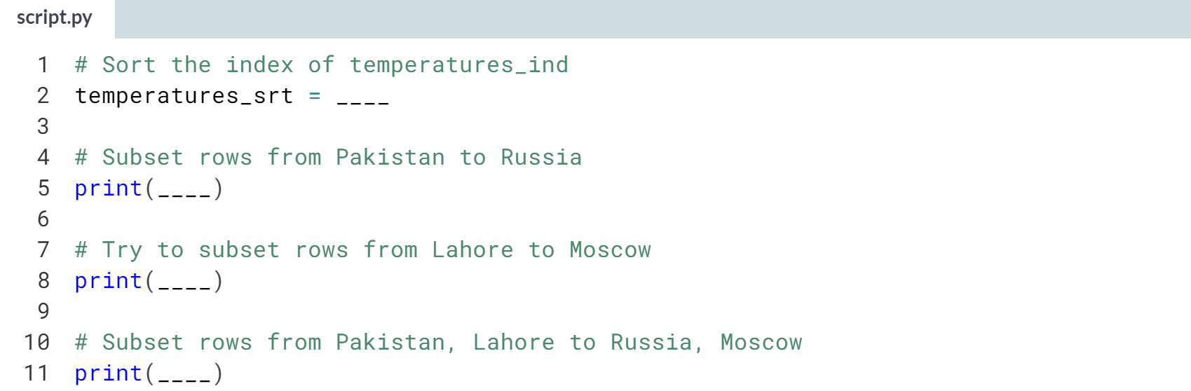

Hint

1. Call ***.sort_index()*** without arguments.
2. Slice with code in the form **df.loc["a":"b"]** twice.
3. Then slice with code like **df.loc[("a", "b"):("c", "d")]**.

(Solution on the next page)

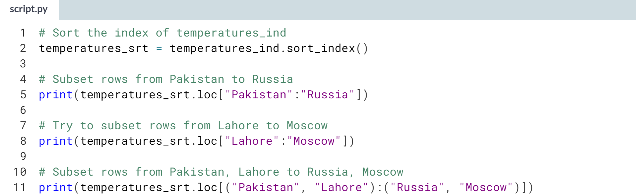

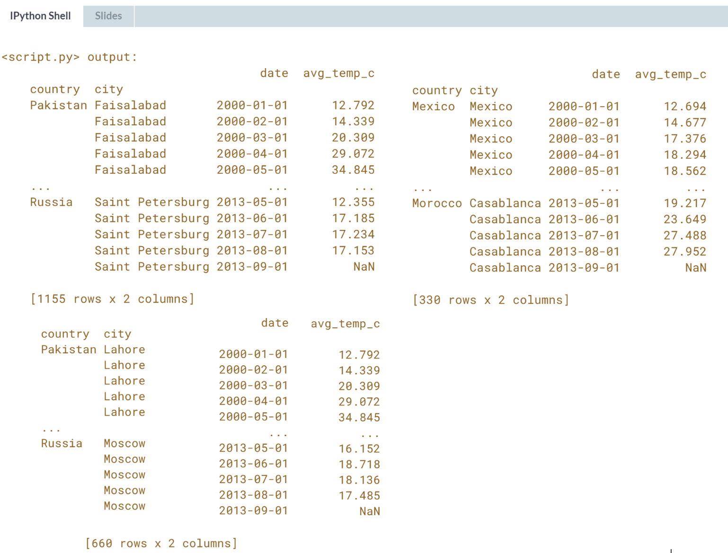

That's a nice slice! Combining slicing with **.loc[]** provides a concise syntax for subsetting.

# Slicing in both directions

You've seen slicing DataFrames by rows and by columns, but since DataFrames are two dimensional objects it is often natural to slice both dimensions at once. That is, by passing two arguments to .loc[], you can subset by rows and columns in one go.

pandas is loaded as pd. temperatures_srt is indexed by country and city, has a sorted index, and is available.

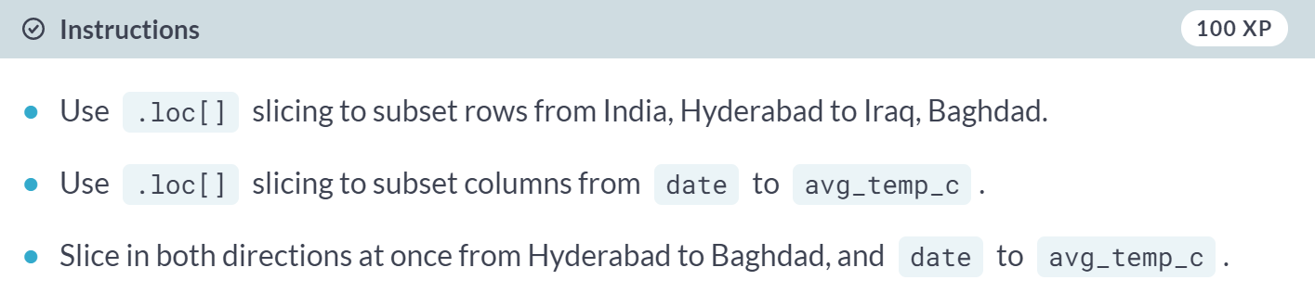

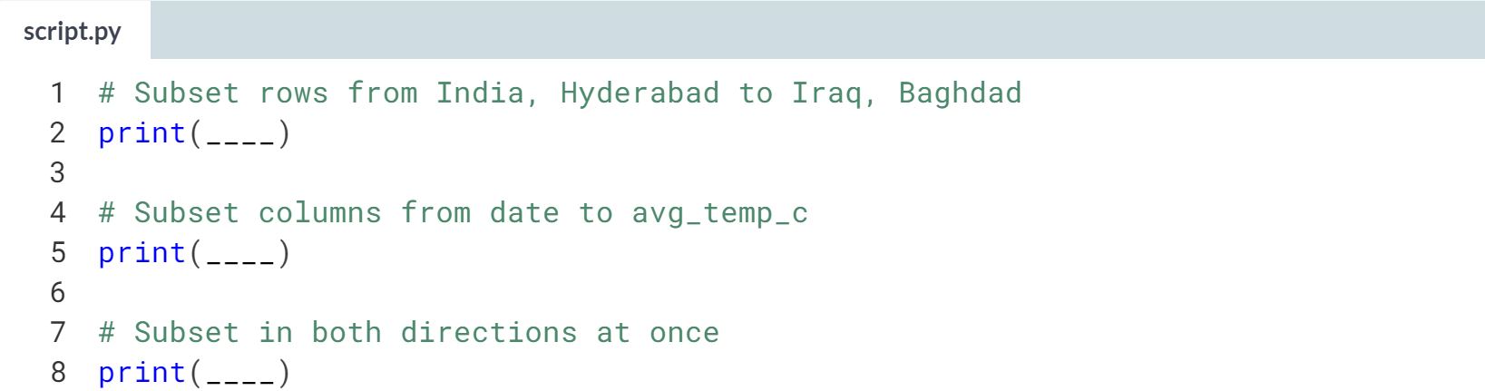

Hint

1. Slice rows with code like **df.loc[("a", "b"):("c", "d")]**.
2. Slice columns with code like **df.loc[:, "e":"f"]**.
3. Slice both ways with code like **df.loc[("a", "b"):("c", "d"), "e":"f"]**.

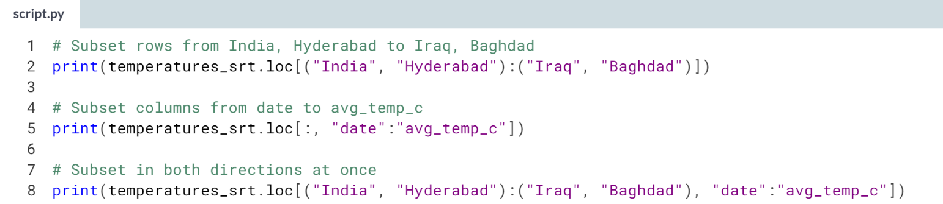

(Result on the next page)

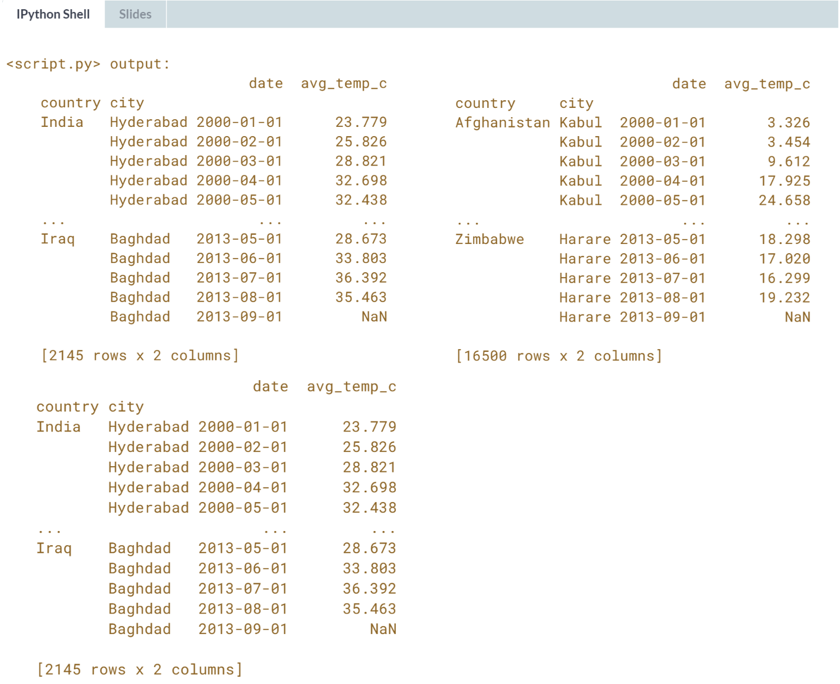

Brilliant bidirectional slicing! Slicing with **.loc[]** lets you take subsets in both directions at once.

# Slicing time series

Slicing is particularly useful for time series, since it's a common thing to want to filter for data within a date range. Add the date column to the index, then use .loc[] to perform the subsetting. The important thing to remember is to keep your dates in ISO 8601 format, that is, yyyy-mm-dd.

Recall from Chapter 1 that you can combine multiple Boolean conditions using logical operators (such as &). To do so in one line of code you'll need to add parentheses () around each condition.

pandas is loaded as pd and temperatures, with no index, is available.

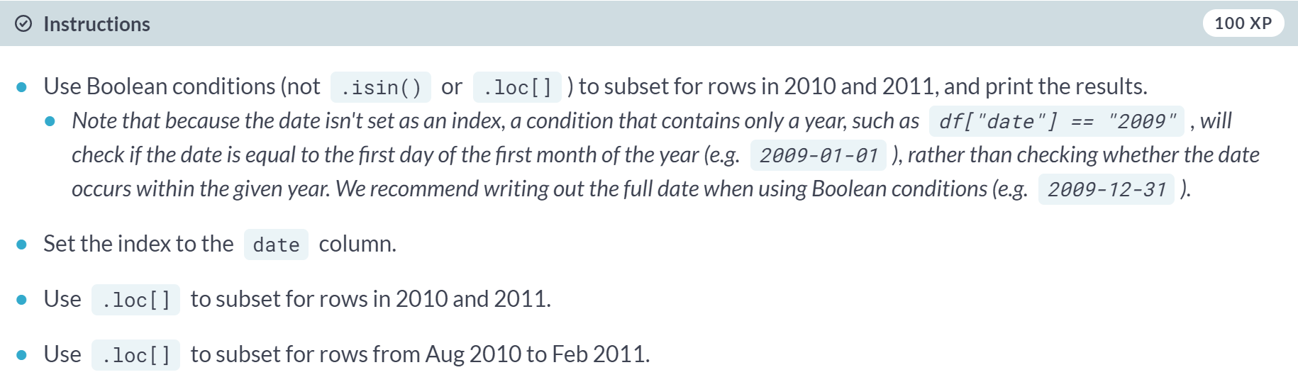

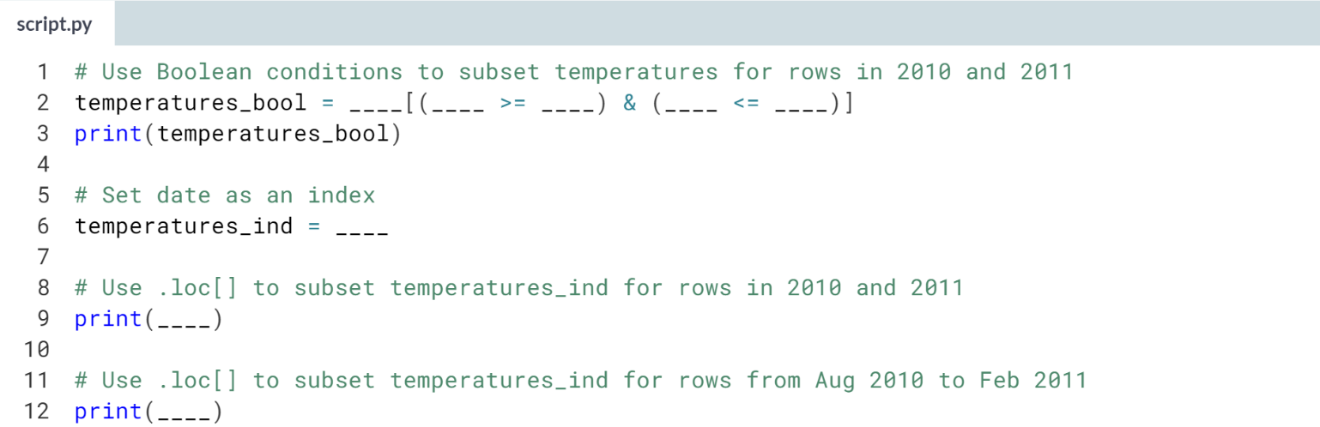

Hint

1. Subsetting via Boolean conditions takes the form **df[(condition1) & (condition2)]**.
2. Dates in 2010-2011 are between 2010-01-01 and 2011-12-31.
3. Use ***.set_index()*** to set the index. Subsetting via **.loc[]** takes the form **df["first":"last"]**.

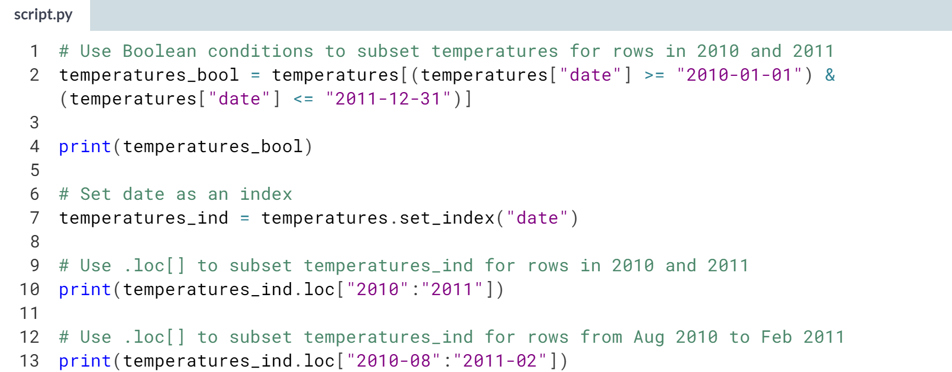

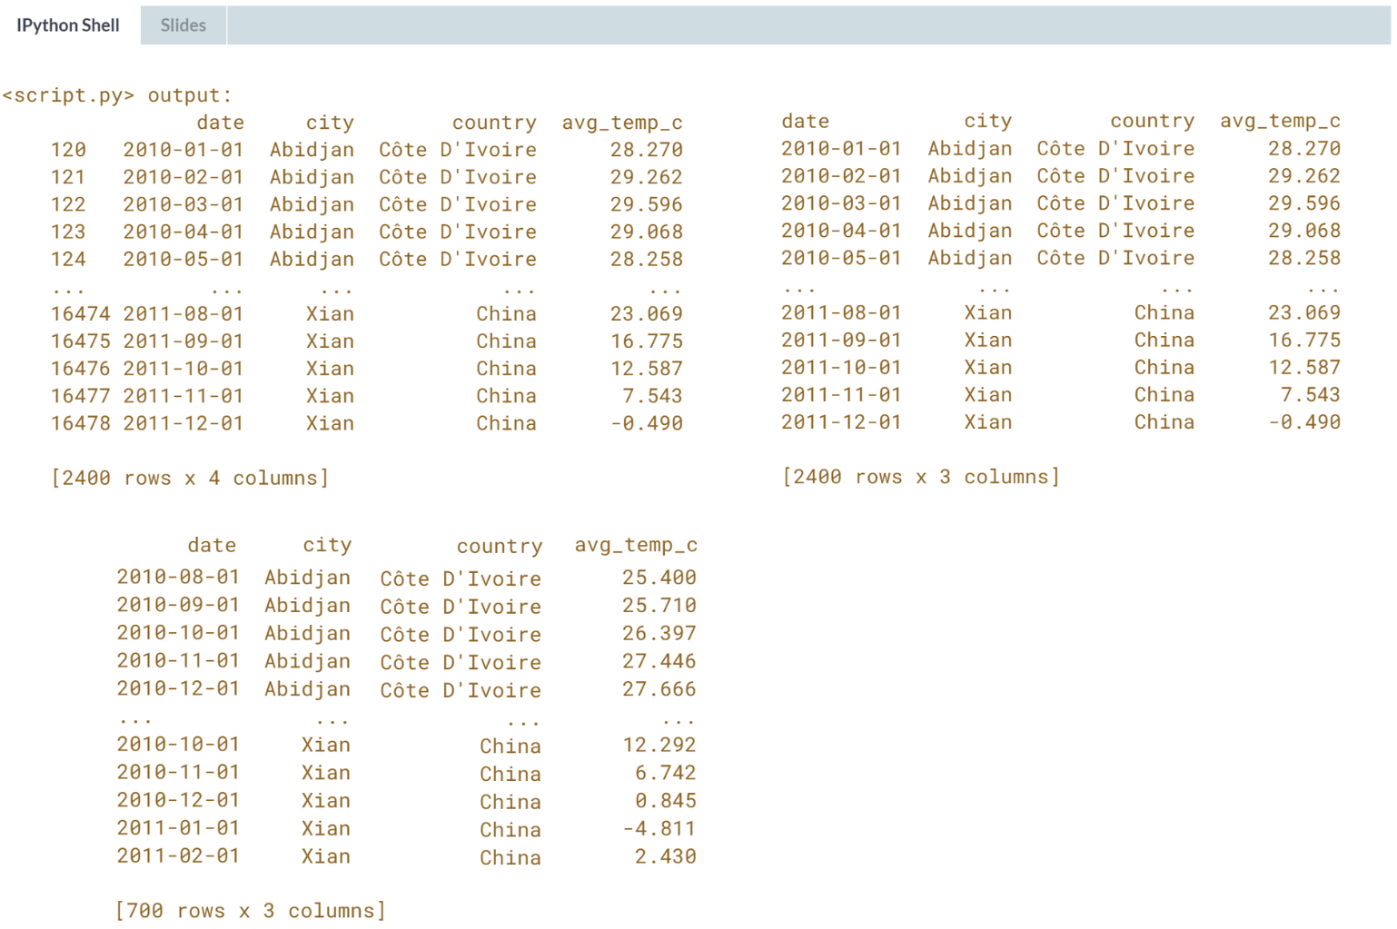  
Delightful data range slicing! Using **.loc[]** in conjunction with a date index provides an easy way to subset for rows before or after some date.

# Subsetting by row/column number

The most common ways to subset rows are the ways we've previously discussed: using a Boolean condition, or by index labels. However, it is also occasionally useful to pass row numbers.

This is done using .iloc[], and like .loc[], it can take two arguments to let you subset by rows and columns.

pandas is loaded as pd. temperatures (without an index) is available.

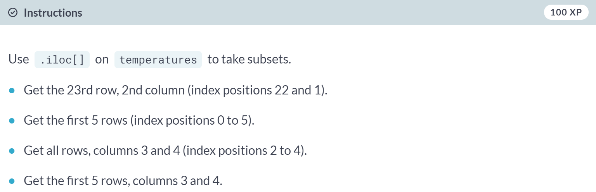

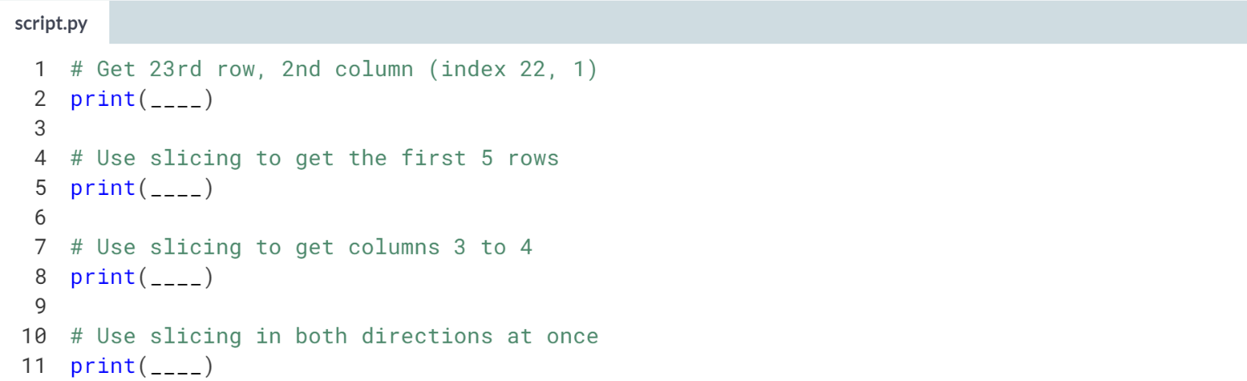

Hint

1. Row/column numbers start at zero.
2. **df.iloc[a:b]** subsets only rows.
3. Use **:** without first/last values to select all rows (or columns).

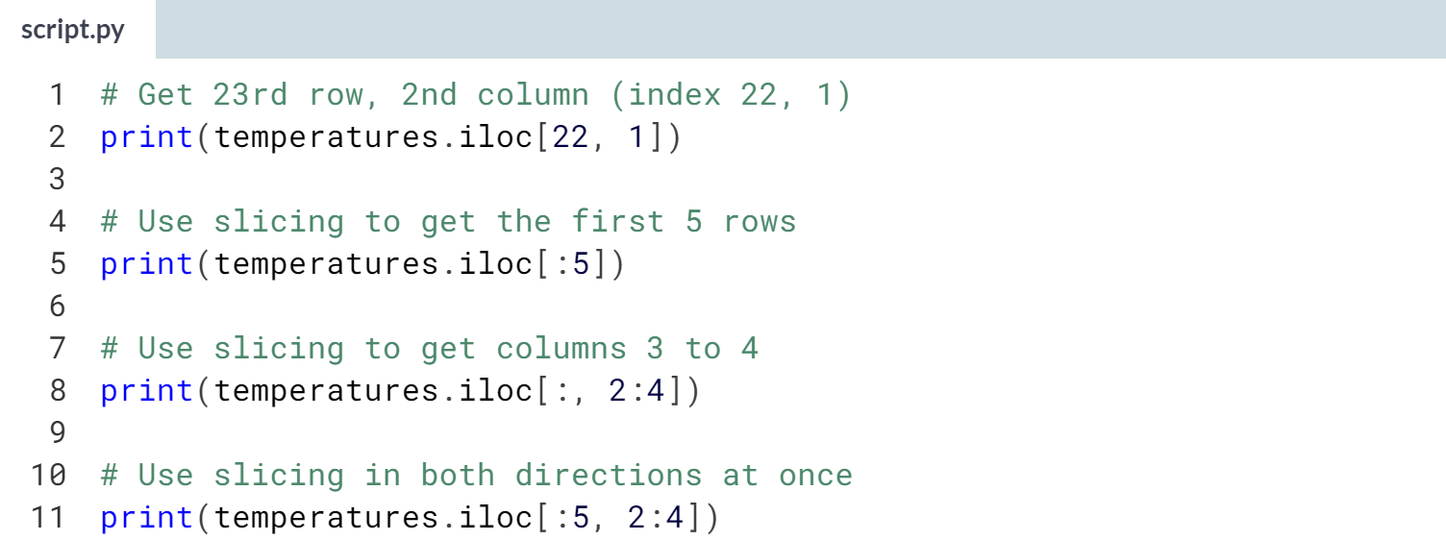

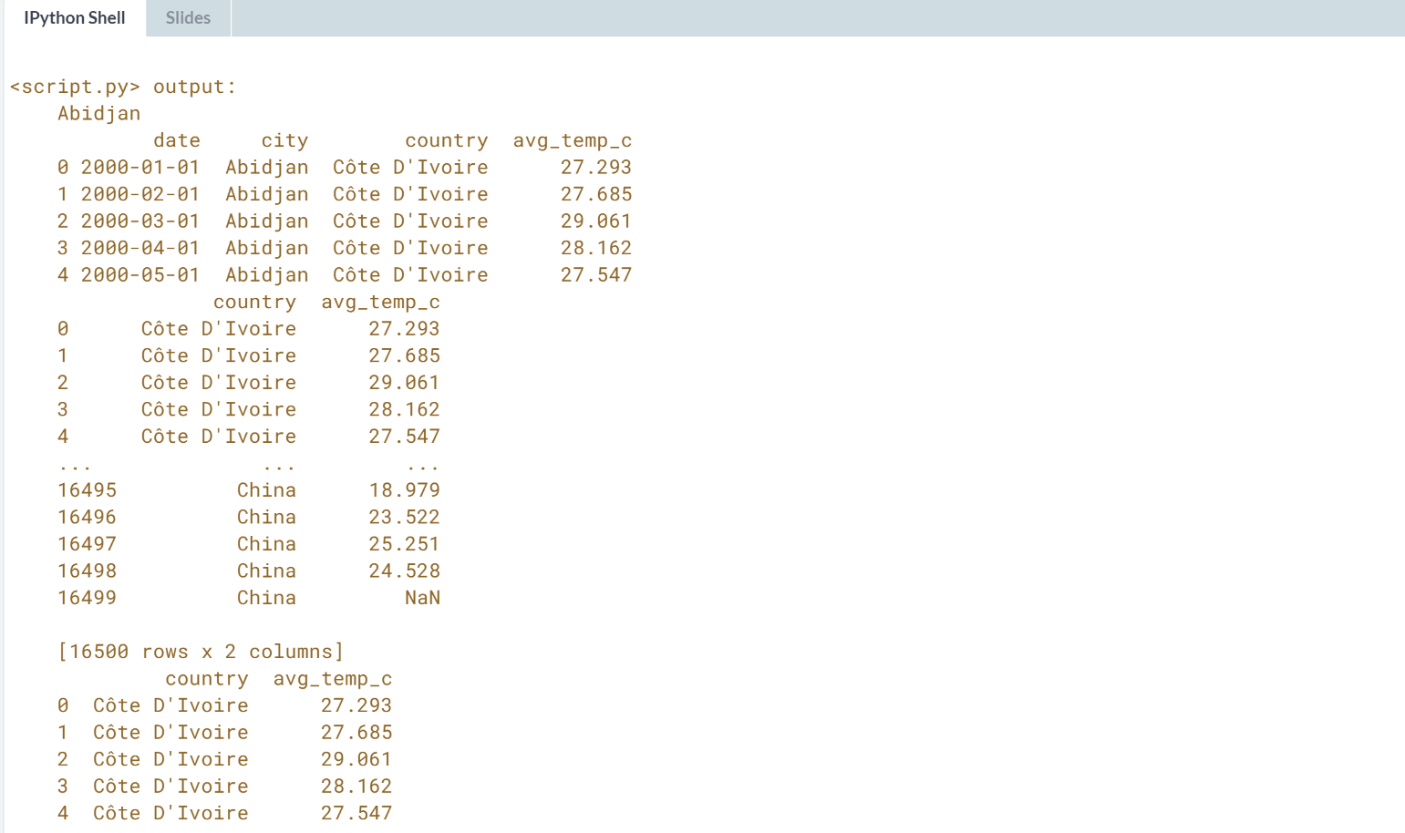

Insightful use of **.iloc[]**! Use **.iloc[]** to specify a subset using the row or column numbers.



We will perform subsetting and calculations on the pivot tables.

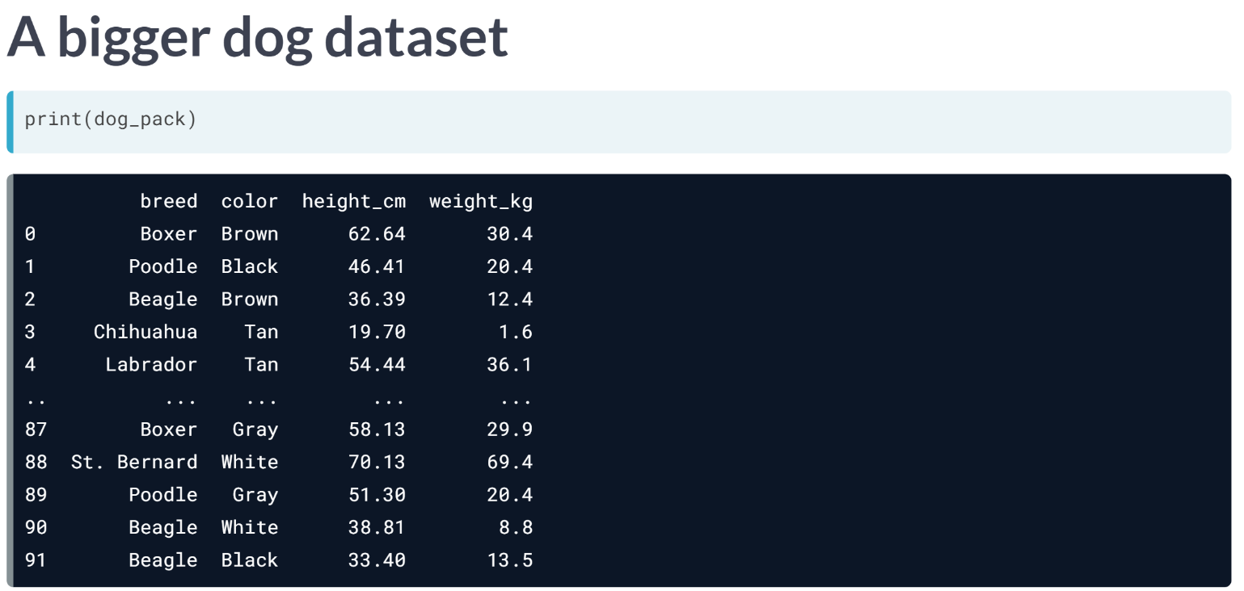  
Here's a larger version of the dog dataset. The extra dogs mean we have something to compute on.

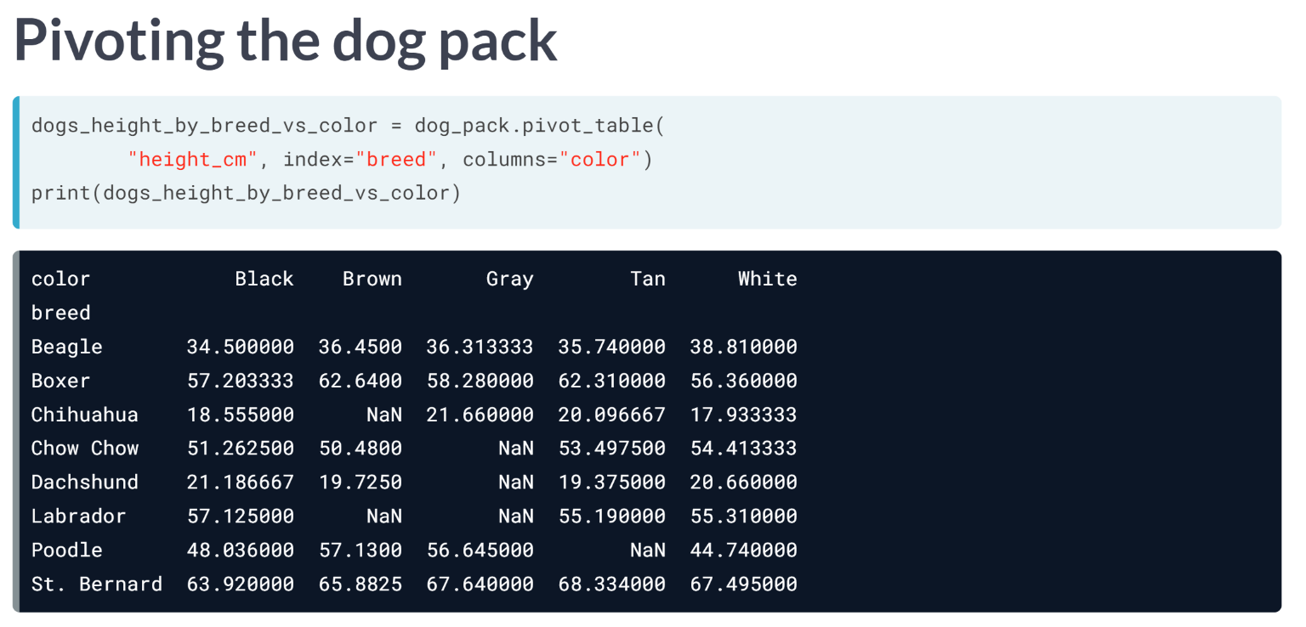  
Recall that you create a pivot table by calling ***.pivot_table()***. The first argument is the column name containing values to aggregate.

The index argument lists the columns to group by and display in rows, and the columns argument lists the columns to group by and display in columns. We will use the default aggregation function, which is mean.

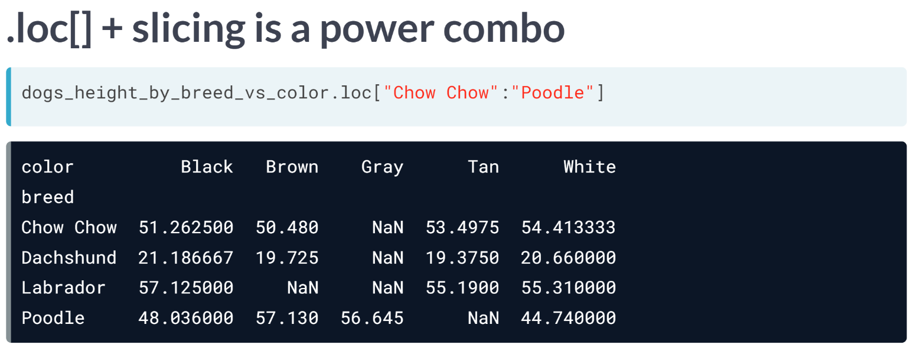  
Pivot tables are just DataFrames with sorted indexes, meaning all the lessons we've learned so far can be applied on them. In particular, the loc and slicing combination is ideal for subsetting pivot tables, like so.

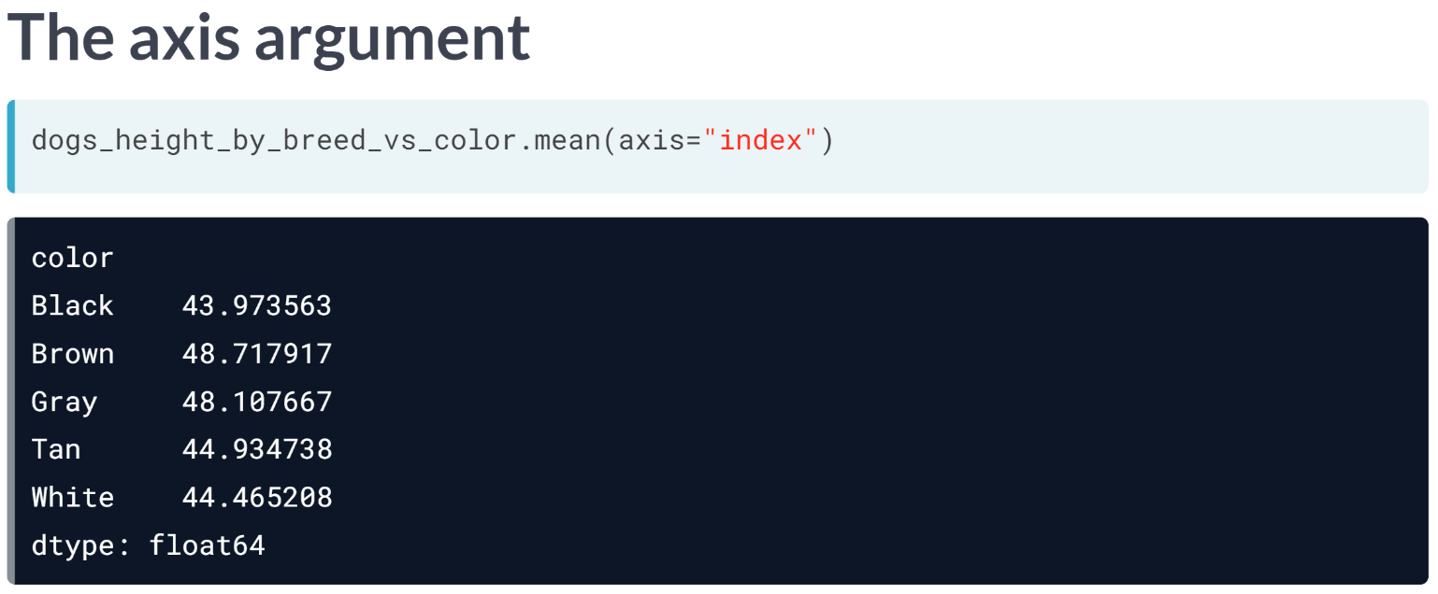  
The methods for calculating summary statistics on a DataFrame, such as mean, have an axis argument. The default value is "index", which means "calculate the statistic across rows". Here, the mean is calculated for each color. That is, "across the breeds". The behavior is the same as if you hadn't specified the axis argument.

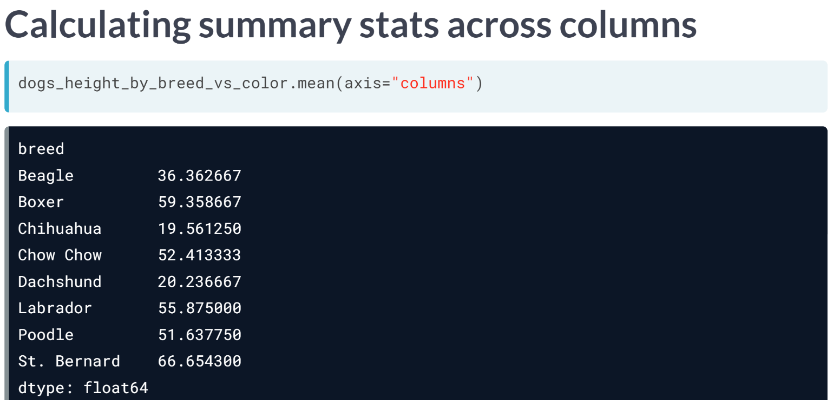  
To calculate a summary statistic for each row, that is "across the columns", you set axis to "columns". Here, the mean height is calculated for each breed. That is, "across the colors".

For most DataFrames, setting the axis argument doesn't make any sense, since you will have different data types in each column.

Though, pivot tables are a special case, since every column contains the same data type.

# Pivot temperature by city and year

It's interesting to see how temperatures for each city change over time. Looking at every month results in a big table, which can be tricky to reason about. Instead, let's look at how temperatures change by year.

You can access the components of a date (year, month and day) using code of the form dataframe["column"].dt.component.

For example, the month component is dataframe["column"].dt.month, and the year component is dataframe["column"].dt.year.

Once you have the year column, you can create a pivot table with the data aggregated by city and year, which you'll explore in the coming exercises.

pandas is loaded as pd. temperatures is available.

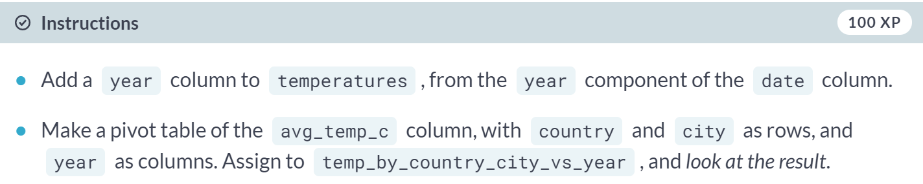

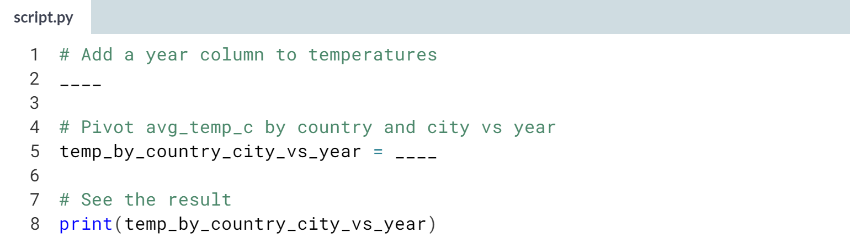

Hint

1. Access the year component of the column using **dataframe["column"].dt.year**.
2. Call ***.pivot_table()***, passing the temperature column, and setting index to a list containing *"country"* and *"city"* and columns to *"year"*.

(Solution on the next page)

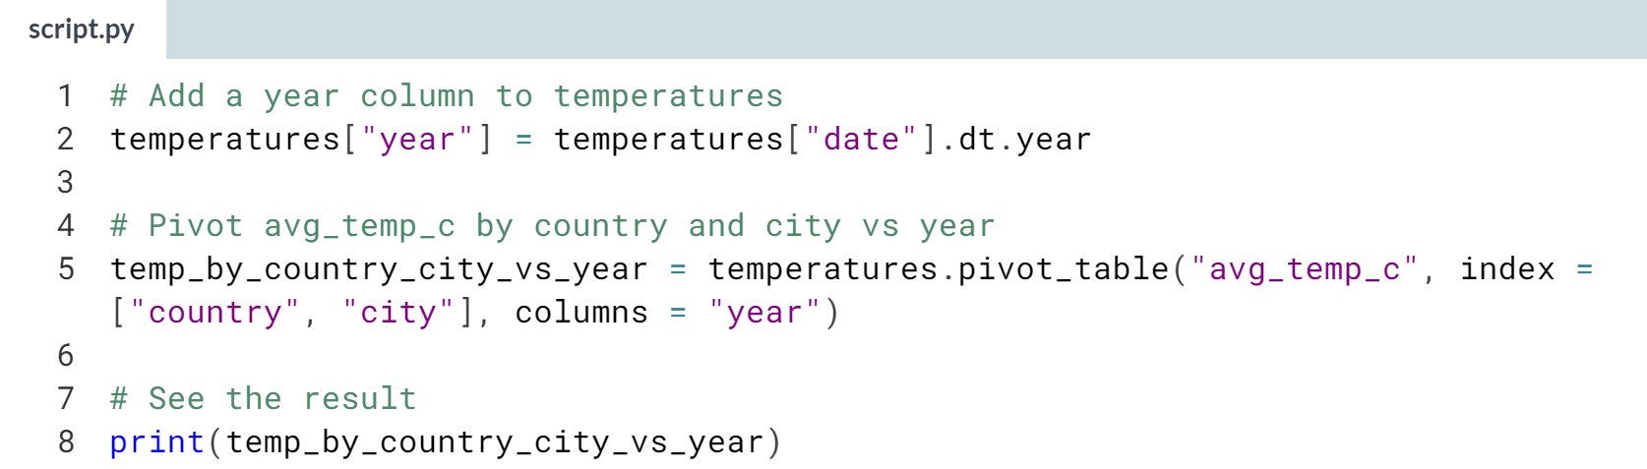

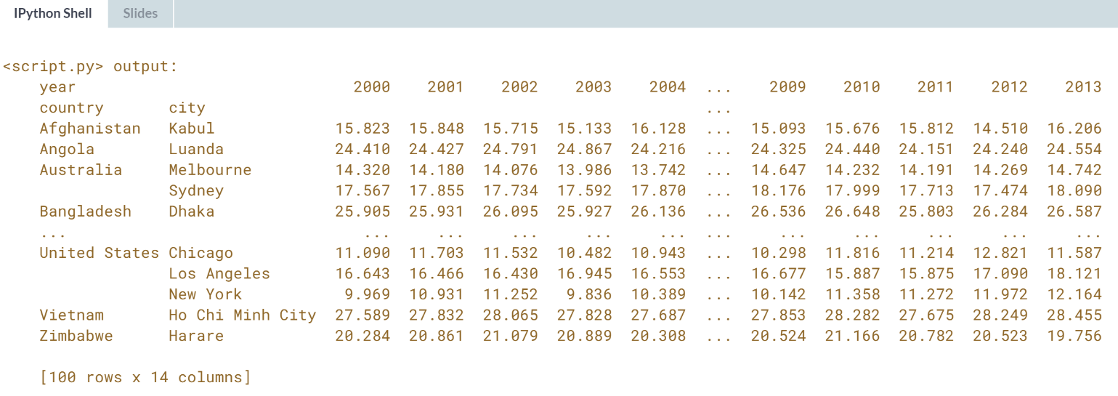

Powerful pivoting! Now you have the pivot table, let's manipulate it.

# Subsetting pivot tables

A pivot table is just a DataFrame with sorted indexes, so the techniques you have learned already can be used to subset them. In particular, the .loc[] + slicing combination is often helpful.

pandas is loaded as pd. temp_by_country_city_vs_year is available.

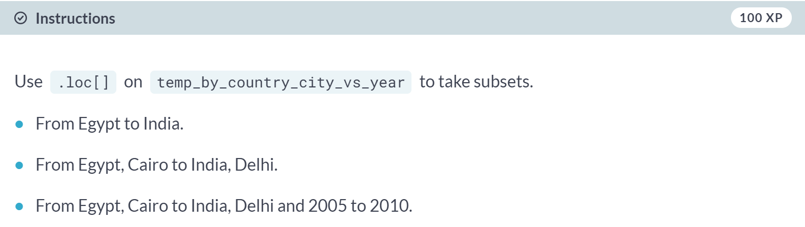

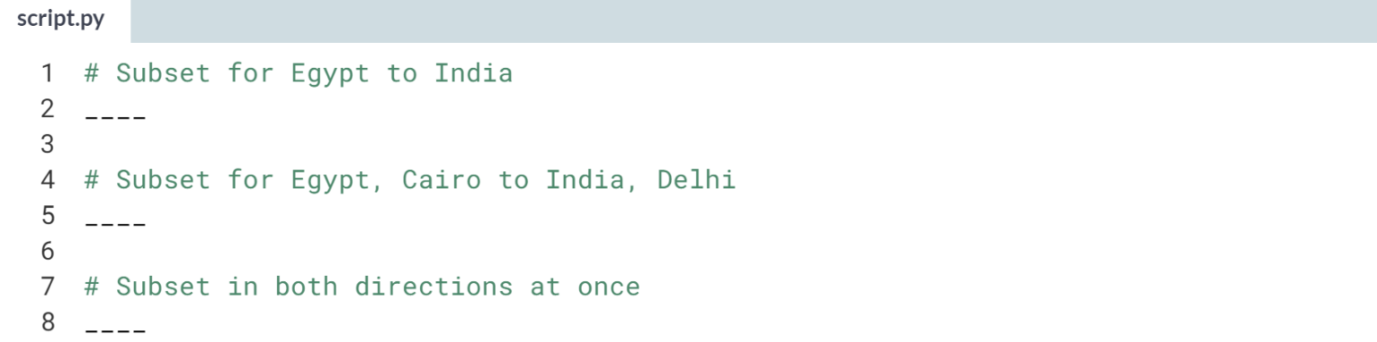

Hint

1. To subset rows at the outer level, use **.loc["country1":"country2"]**.
2. To subset rows at the outer level, use **.loc[("country1", "city1"):("country2", "city2")]**.
3. To subset in both directions, pass two arguments to **.loc[]**.

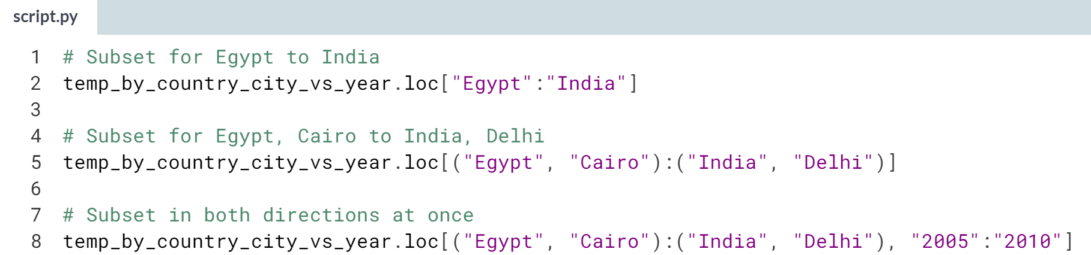  
Super pivot table subsetting! Slicing is especially helpful for subsetting pivot tables.

# Calculating on a pivot table

Pivot tables are filled with summary statistics, but they are only a first step to finding something insightful.

Often you'll need to perform further calculations on them. A common thing to do is to find the rows or columns where a highest or lowest value occurs.

Recall from Chapter 1 that you can easily subset a Series or DataFrame to find rows of interest using a logical condition inside of square brackets. For example: series[series > value].

pandas is loaded as pd and the DataFrame temp_by_country_city_vs_year is available.

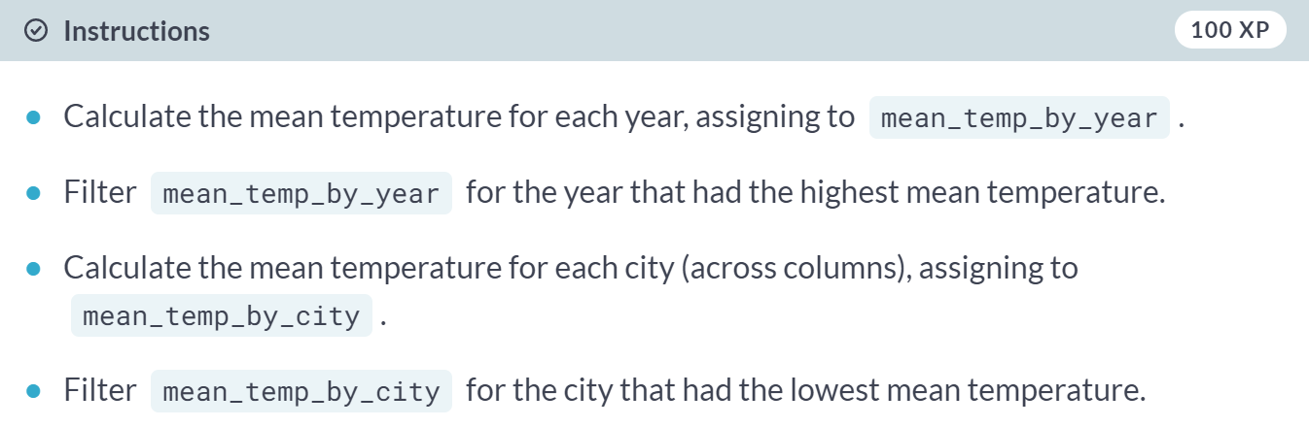

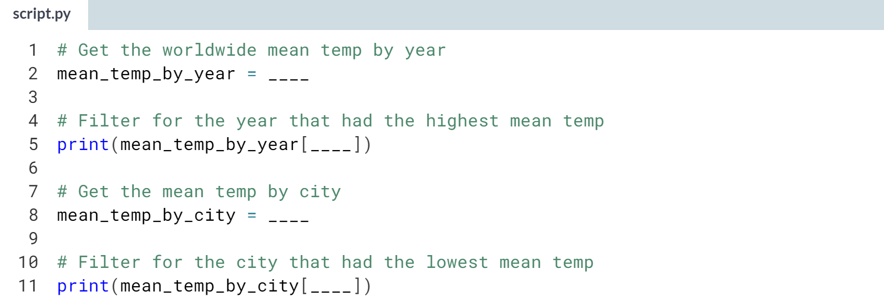

Hint

1. Call ***.mean()*** without arguments to get the mean of each column.
2. Use Boolean filtering of the form *mean_temp_by_year* equal to ***mean_temp_by_year.max()***.
3. Call ***.mean()***, setting *axis* to *"column"* to get the mean of each row.
4. Use Boolean filtering of the form *mean_temp_by_city* equal to ***mean_temp_by_city.min()***.

(Result on the next page)

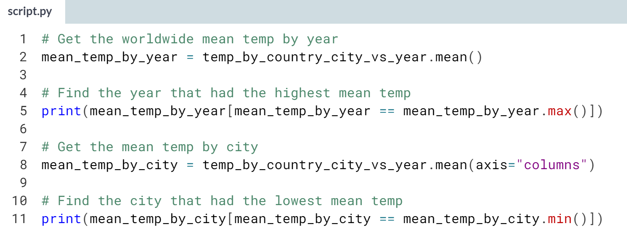

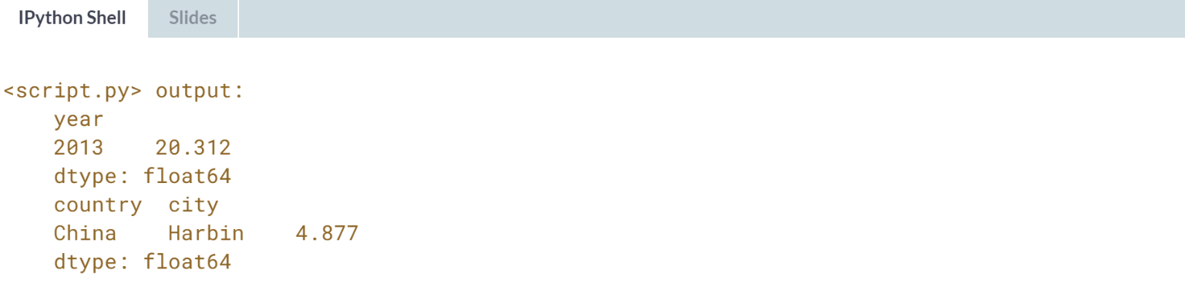

Classy calculating! With an average temperature just above freezing, Harbin is famous for its ice sculpture festival.

**4. Creating and Visualizing DataFrames**

Learn to visualize the contents of your DataFrames, handle missing data values, and import data from and export data to CSV files.



Plots are a powerful way to share the insights you've gained from your data. In this lesson, we will use a bigger dataset of dogs, called *dog_pack*, to make visualization easier.

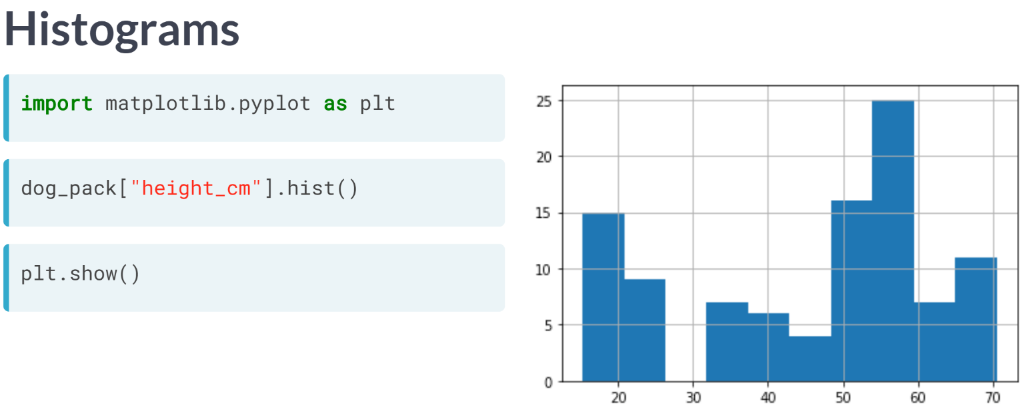  
Remember when we talked about the matplotlib at the beginning of the course? As a review, we use *'import matplotlib.pyplot as plt'* to import the package that enables us to display our visualization.

Let's create a histogram, which shows the distribution of a numeric variable. We can create a histogram of the height variable by selecting the column and calling ***.hist()***.

In order to show the plot, we need to call ***plt.show()***. The x-axis represents the heights of the dogs, and the y-axis represents the number of dogs in each height range.

By grouping observations into ranges, the histogram allows us to see that there are a lot of dogs around 50 to 60 centimeters tall.

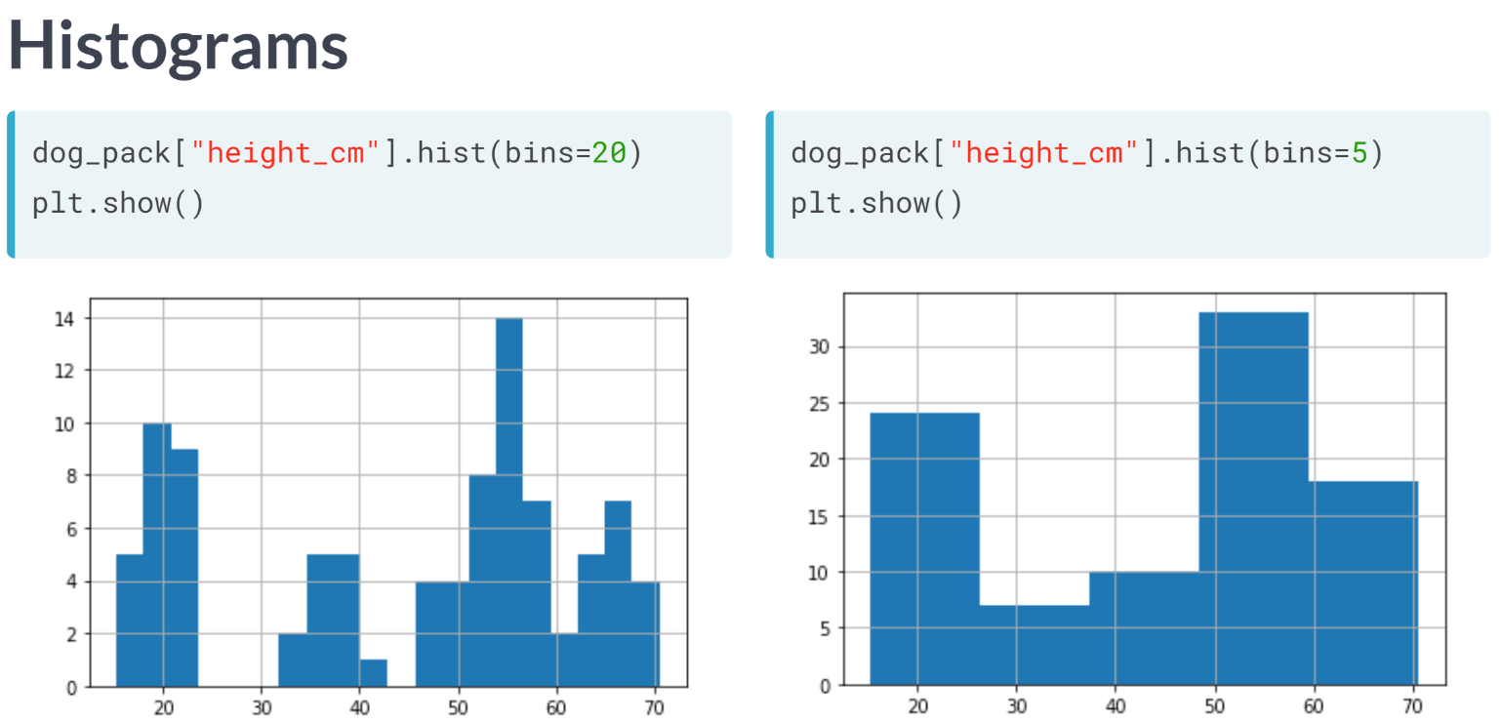  
We can adjust the number of bars, or bins, using the "bins" argument. Increasing or decreasing this can give us a better idea of what the distribution looks like.

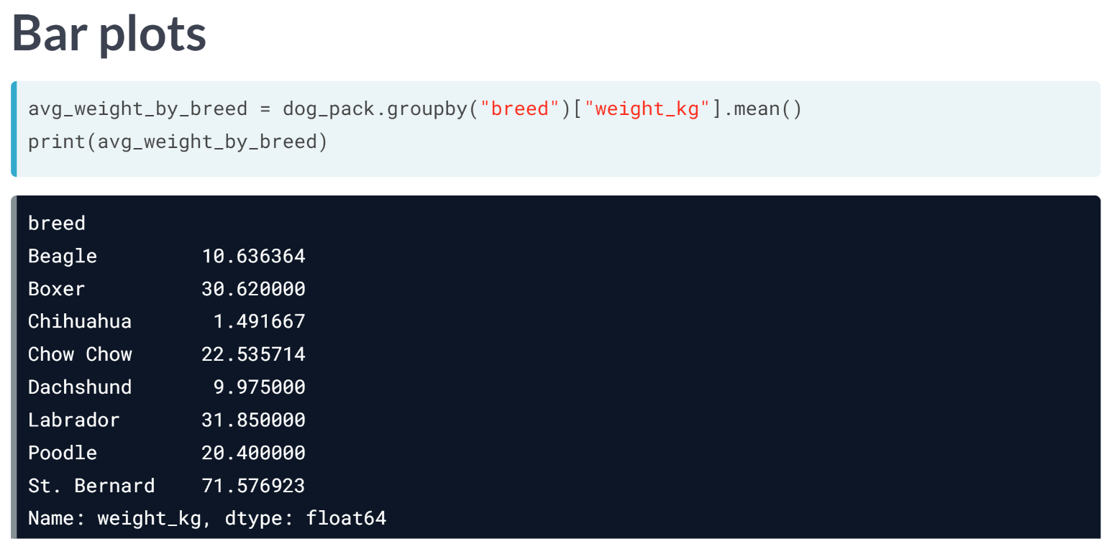  
Bar plots can reveal relationships between a categorical variable and a numeric variable, like breed and weight.

To compute the average weight of each breed, we group by breed, select the weight column, and take the mean, giving us the average weight of each breed.

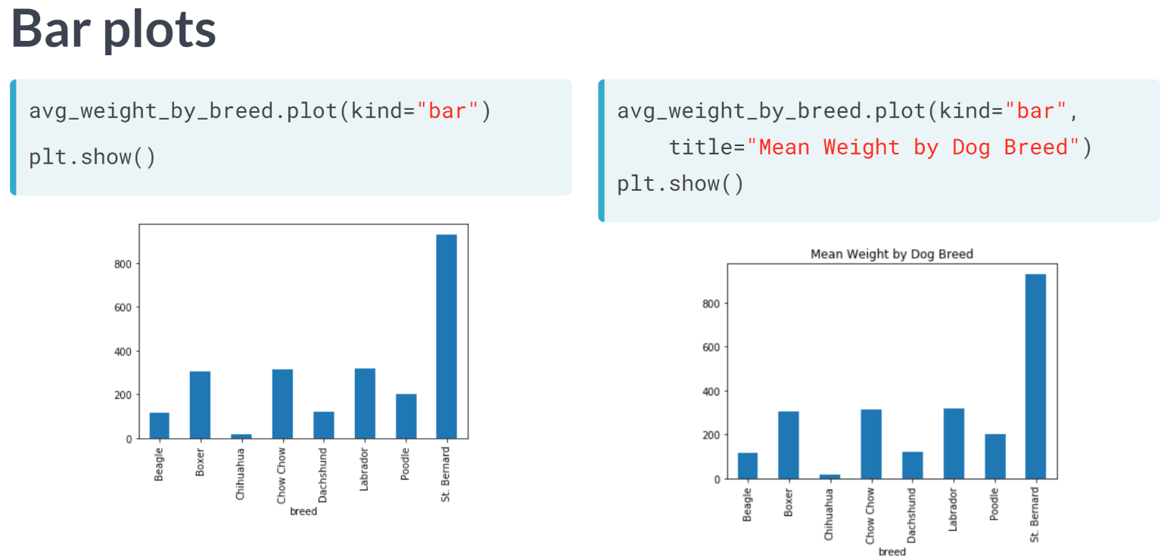  
Now we can create a bar plot from the mean weights using the plot method, setting "kind" equals to "bar". When calling ***plt.show()***, we see that a beautiful bar chart is generated.

To add a title, we can add the argument title inside the ***plot()*** method. It looks like St. Bernard are the heaviest breed on average.

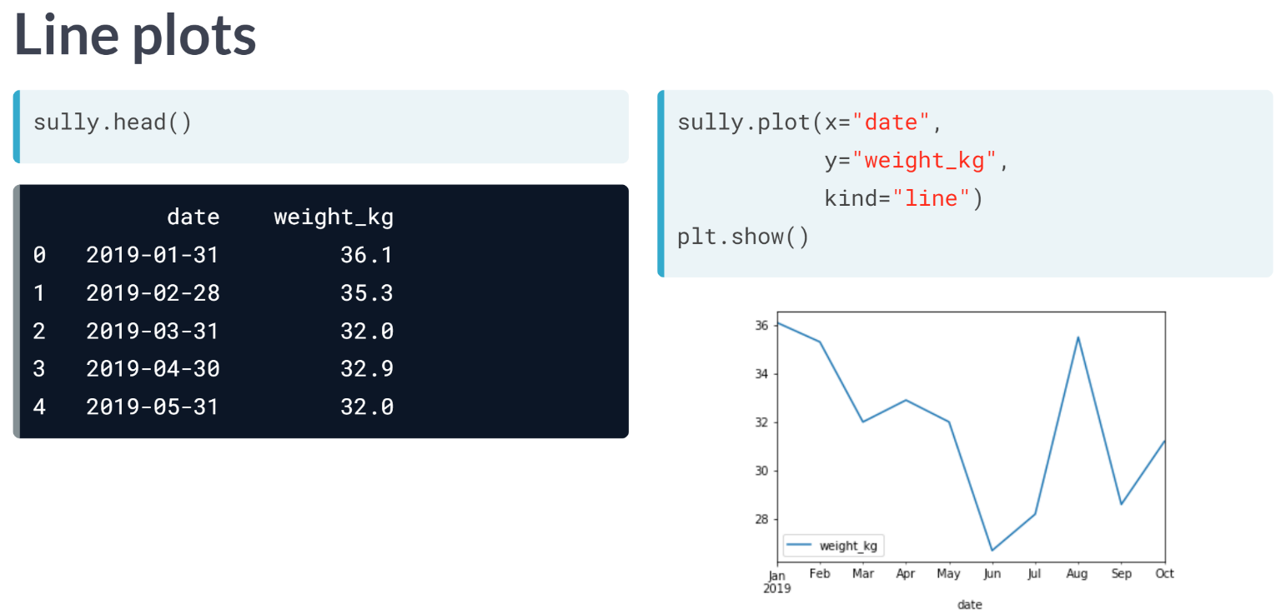  
Line plots are great for visualizing changes in numeric variables over time. Here, a Labrador named Sully has been weighed by his owner every month - let's see how his weight has changed over the year.

We can use the plot method again, but this time, we pass in three arguments: date as x, weight as y, and "kind" equals "line". You can see that Sully's weight has fluctuated quite a bit over this year.

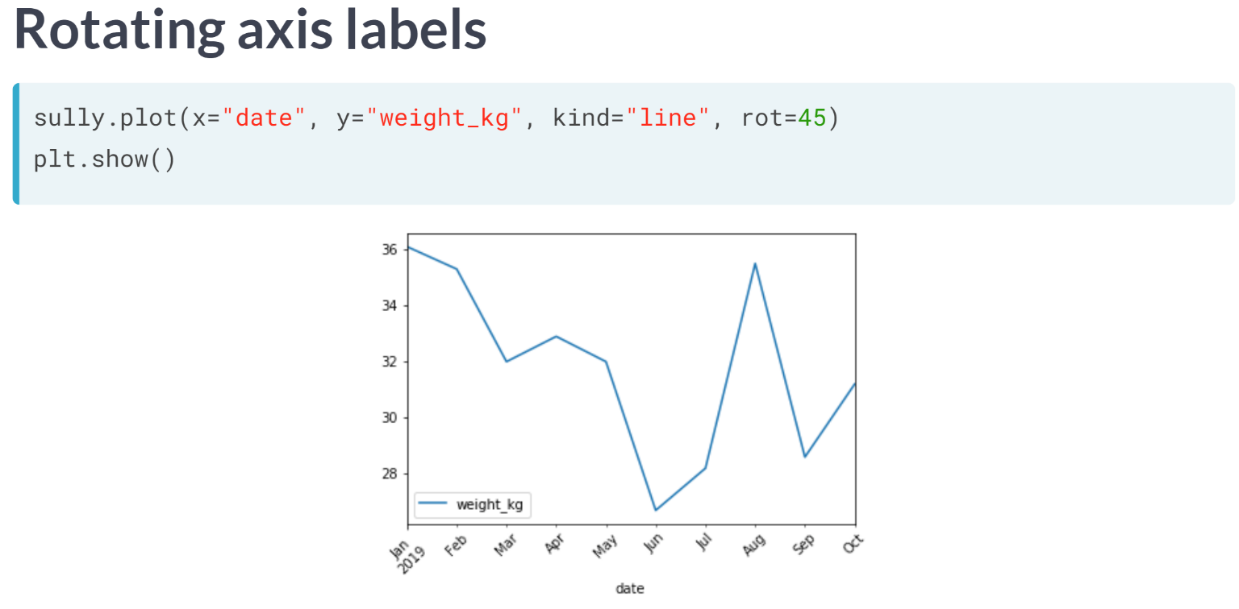  
We may want to rotate the x-axis labels to make the text easier to read. This can simply be done by passing an angle in degrees with the "rot" argument. Here, we rotate the labels by 45 degrees.

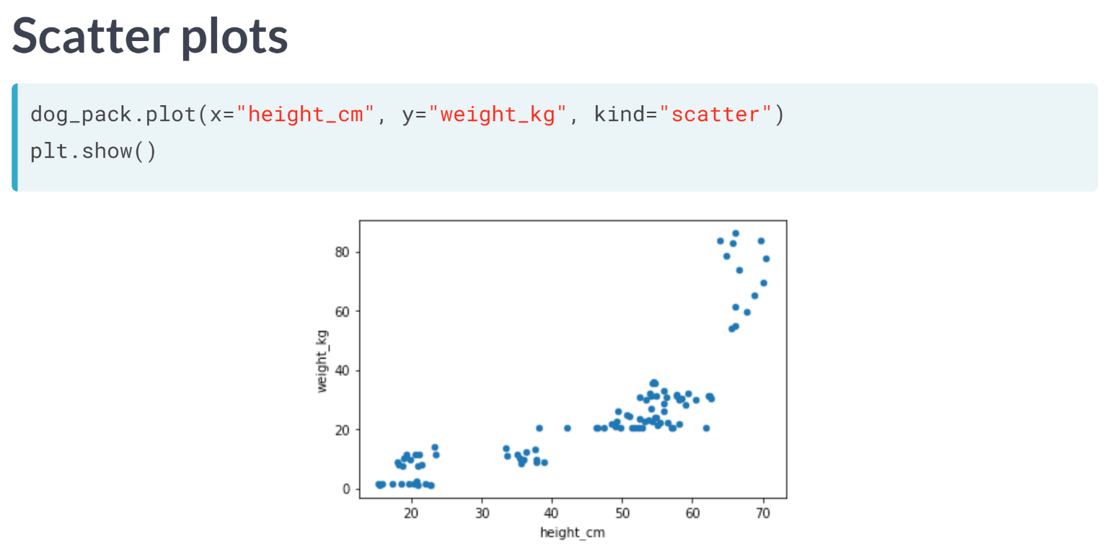  
Scatter plots are great for visualizing relationships between two numeric variables.

To plot each dog's height versus their weight, we call the ***plot()*** method, additionally specifying the "kind" argument to "scatter". From the plot, it looks like taller dogs tend to weigh more.

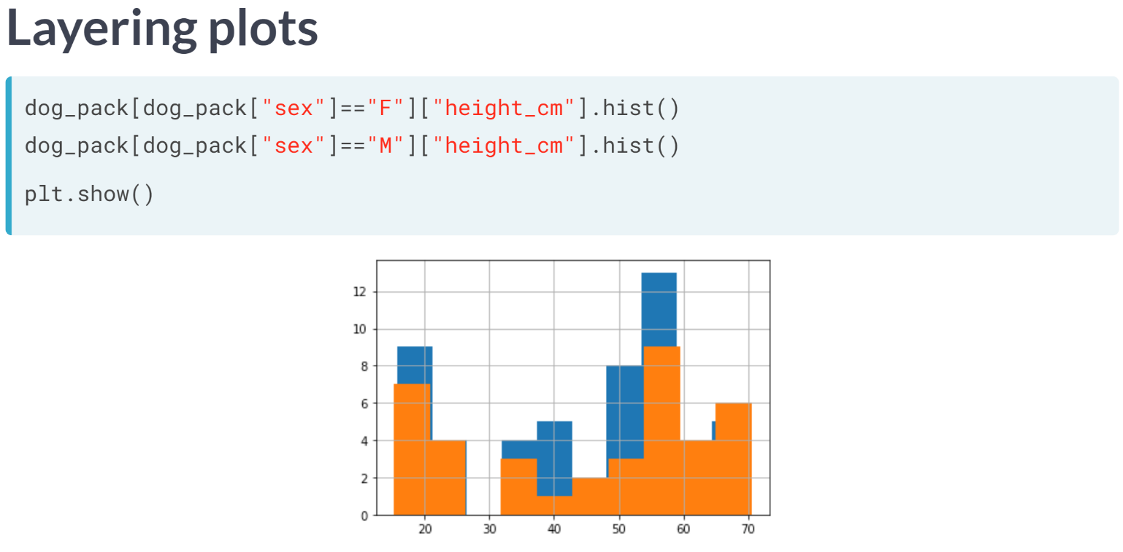  
Plots can also be layered on top of one another. For example, we can create a histogram of female dogs' heights, and put a histogram of male dogs' height on top, then call show.

However, we can't tell which color represents which sex.

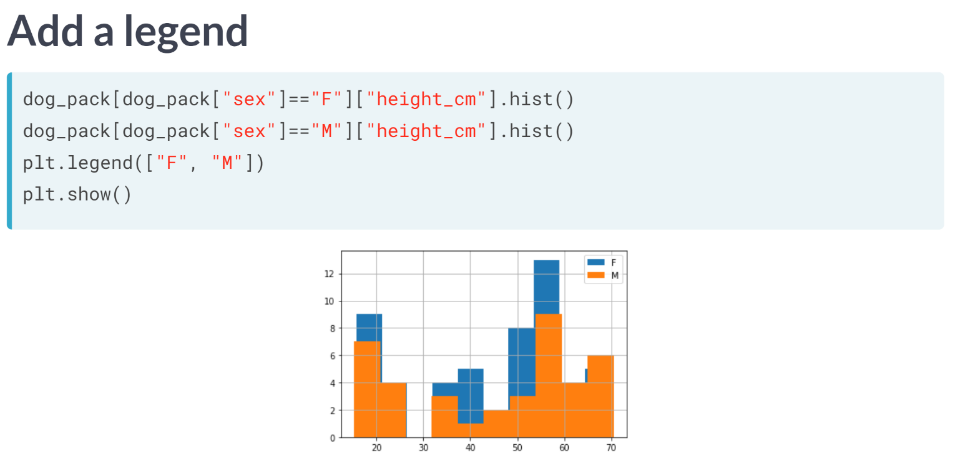  
We can use ***plt.legend()***, passing in a list of labels, and then call show.

Now we know which color is which, but we can't see what's going on behind the orange histogram.

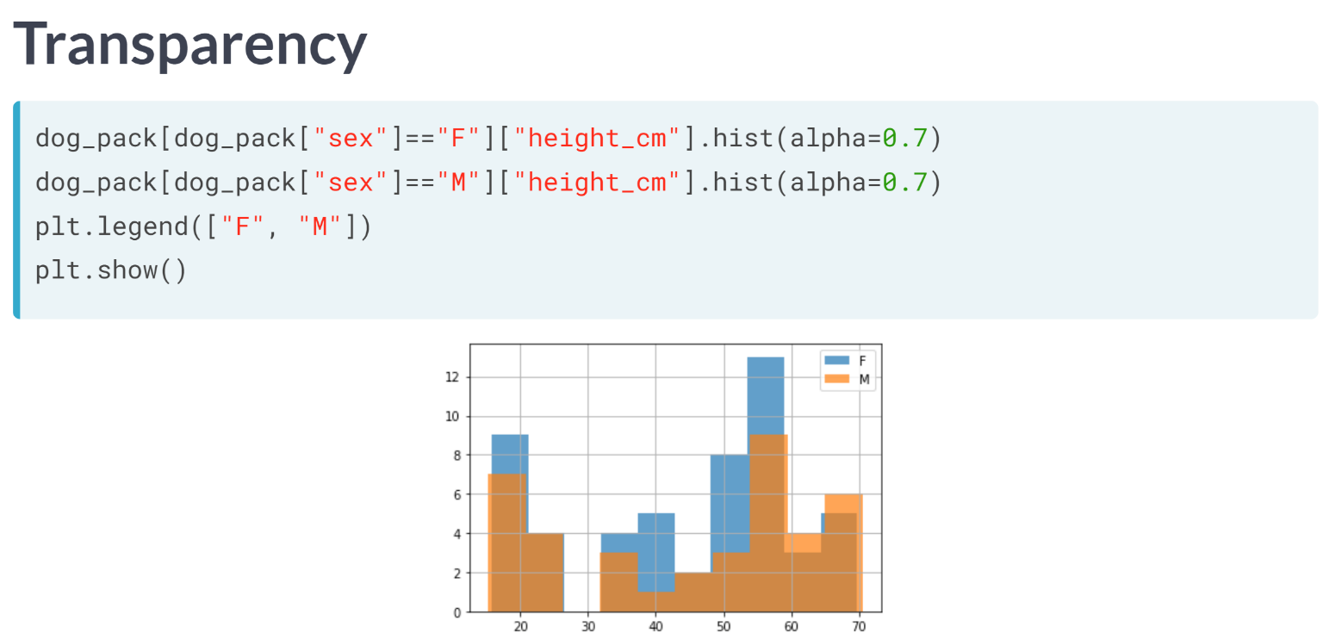

Let's fix this problem above by making the histograms translucent. We can use the hist's alpha argument, which takes a number.

0 means completely transparent, that is, invisible, and 1 means completely opaque.

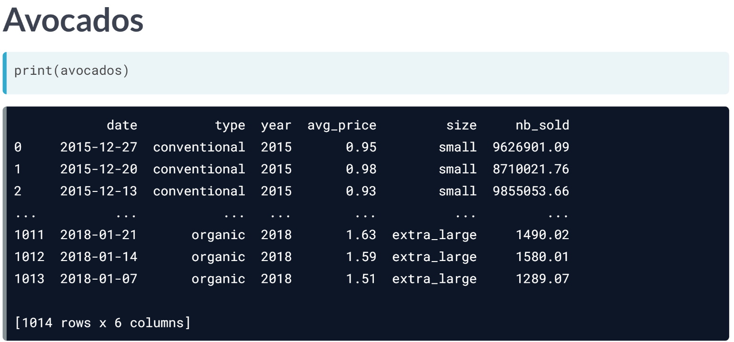  
In this chapter, we will be working with a dataset that contains weekly US avocado sales data, broken down by avocado size and whether or not the avocados were organic.

# Which avocado size is most popular?

Avocados are increasingly popular and delicious in guacamole and on toast. The Hass Avocado Board keeps track of avocado supply and demand across the USA, including the sales of three different sizes of avocado. In this exercise, you'll use a bar plot to figure out which size is the most popular.

Bar plots are great for revealing relationships between categorical (size) and numeric (number sold) variables, but you'll often have to manipulate your data first in order to get the numbers you need for plotting.

pandas has been imported as pd, and avocados is available.

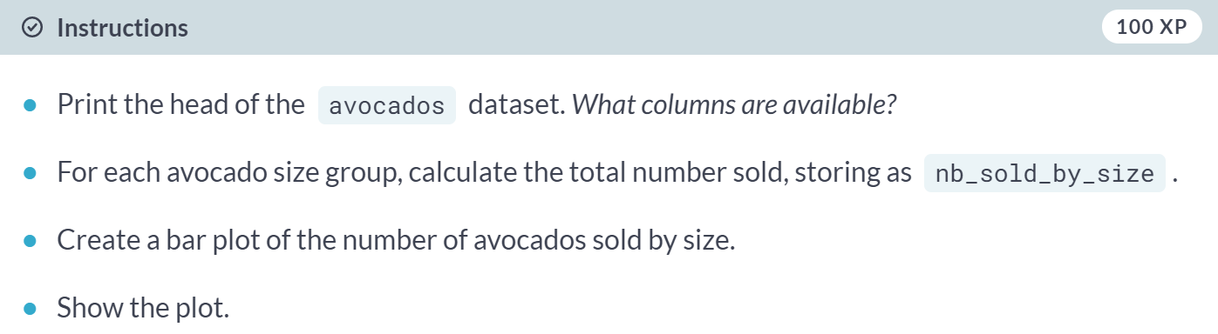

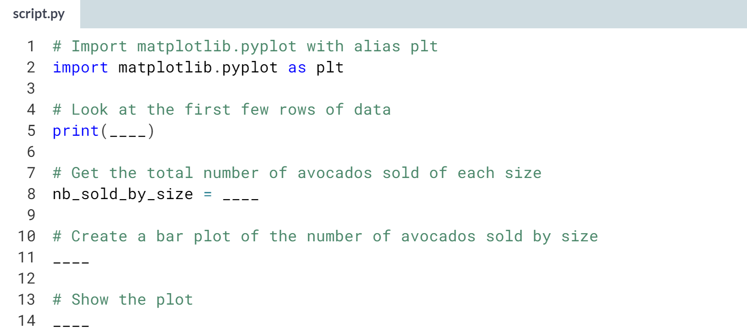

Hint

1. Group by size, select the *nb_sold* column, and calculate the sum.
2. Call ***.plot()***, setting kind to "bar" to create a bar plot.
3. Your plot won't appear until you display it using a function from *plt*.

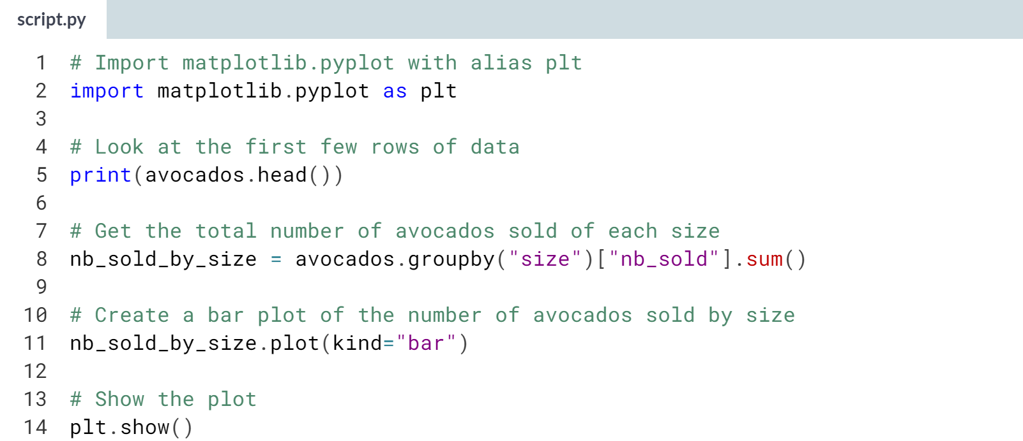

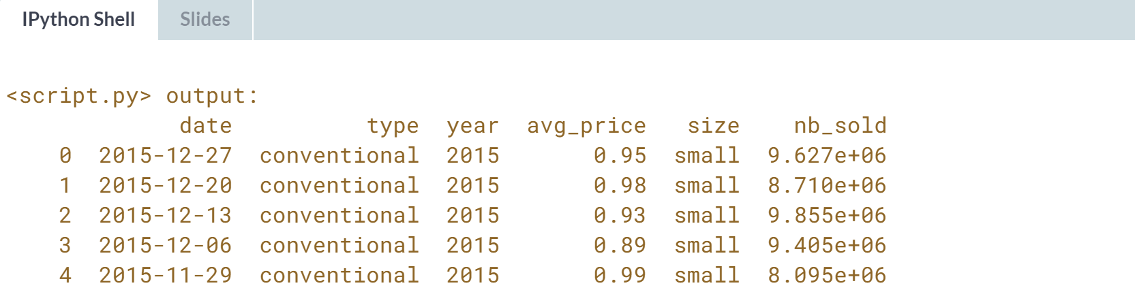

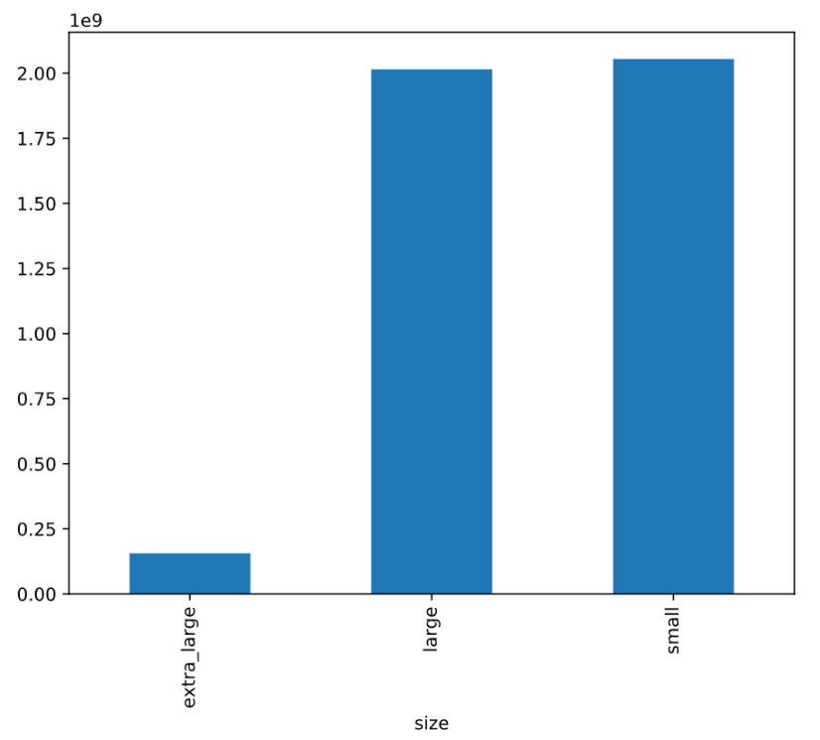  
Bedazzling bar plot! It looks like small avocados were the most-purchased size, but large avocados were a close second.

# Changes in sales over time

Line plots are designed to visualize the relationship between two numeric variables, where each data values is connected to the next one.

They are especially useful for visualizing change in a number over time, since each time point is naturally connected to the next time point. In this exercise, you'll visualize the change in avocado sales over three years.

pandas has been imported as pd.

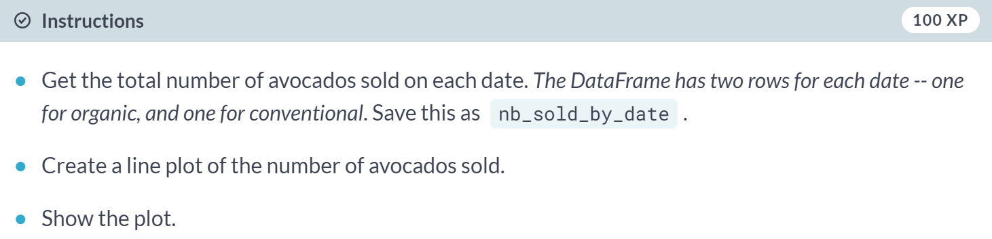

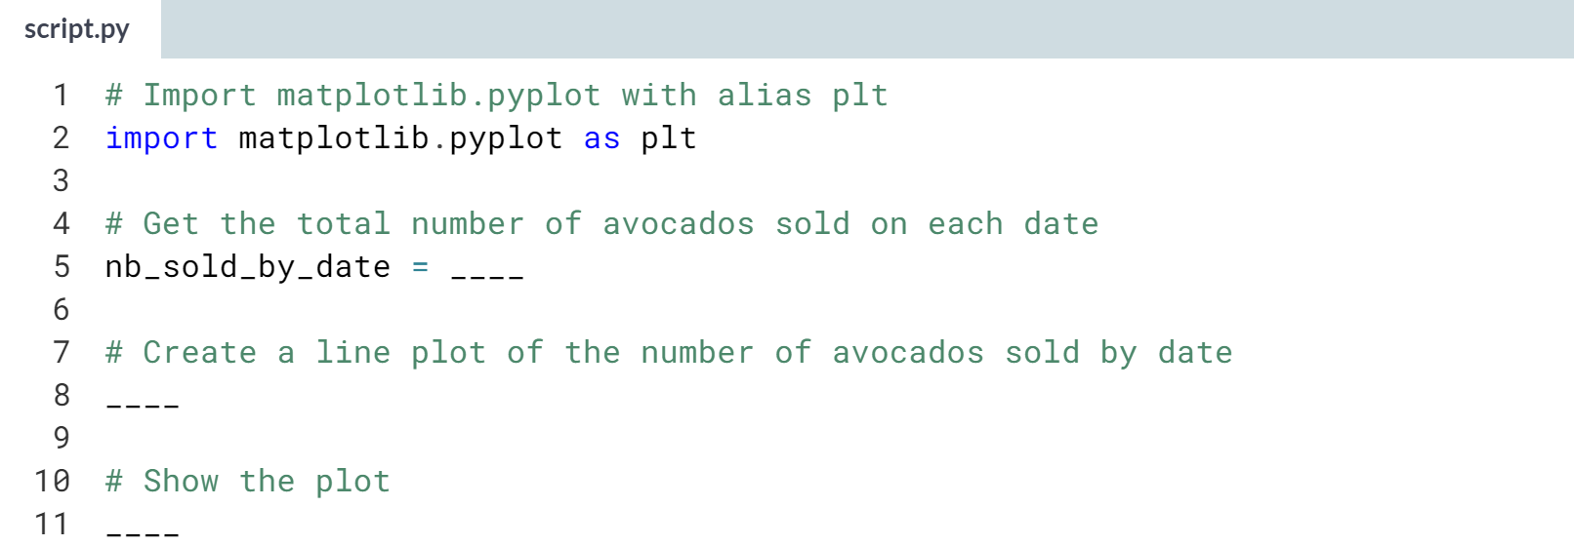

Hint

1. Group by *date*, select the *nb_sold* column, and calculate the sum.
2. Call ***.plot()***, setting *kind* to *"line"* to create a line plot.
3. Your plot won't appear until you display it using a function from *plt*.

(Solution on the next page)

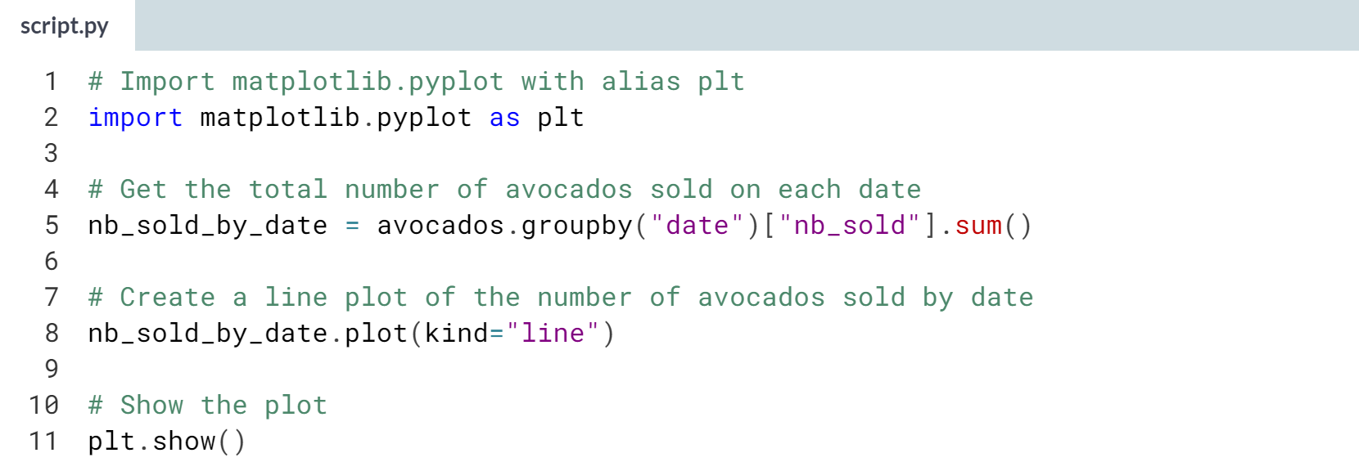

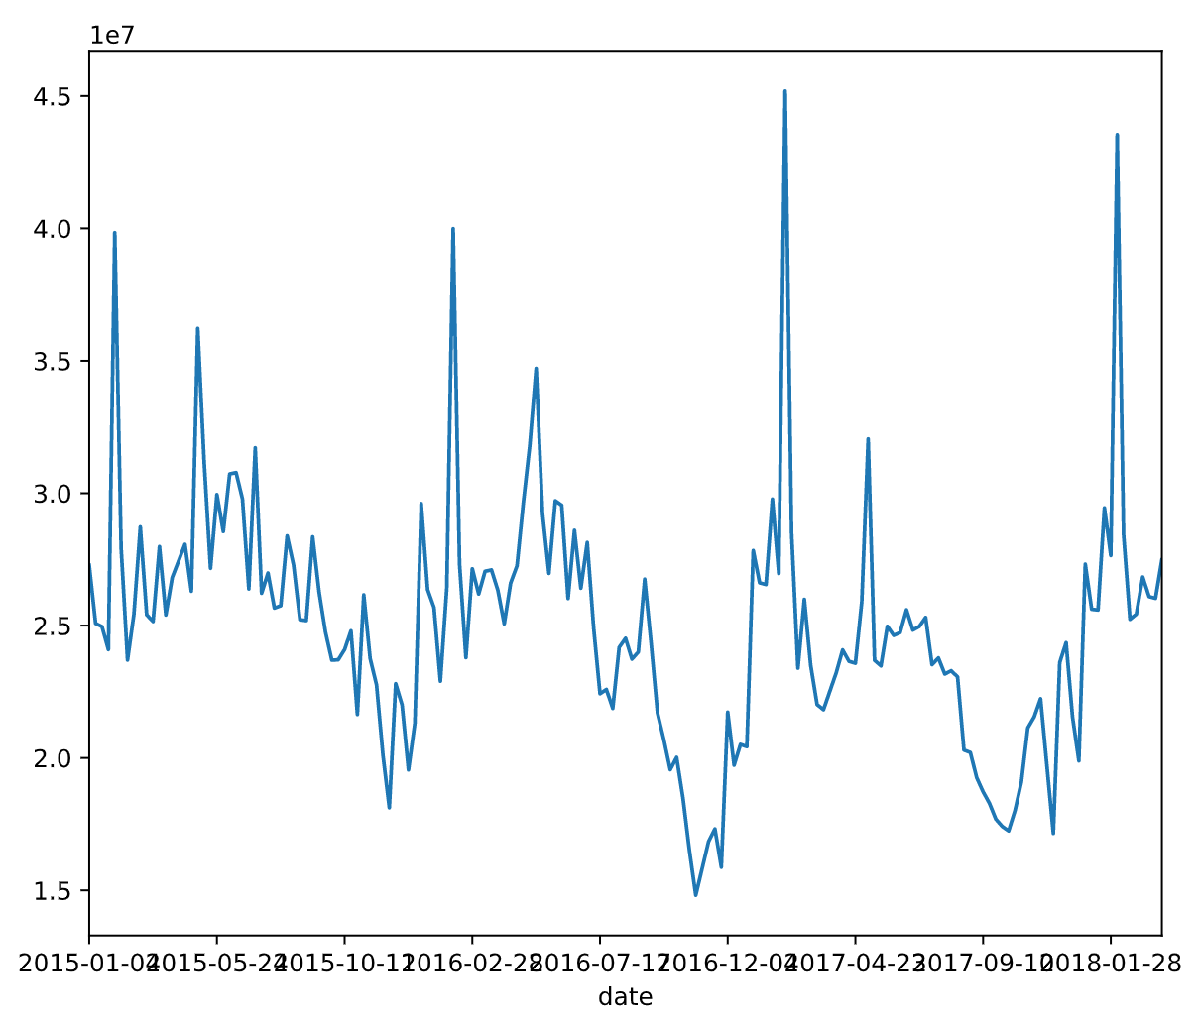  
Lovely line plot! Line plots are great for visualizing something over time. Here, it looks like the number of avocados spikes around the same time each year.

# Avocado supply and demand

Scatter plots are ideal for visualizing relationships between numerical variables. In this exercise, you'll compare the number of avocados sold to average price and see if they're at all related. If they're related, you may be able to use one number to predict the other.

matplotlib.pyplot has been imported as plt and pandas has been imported as pd.

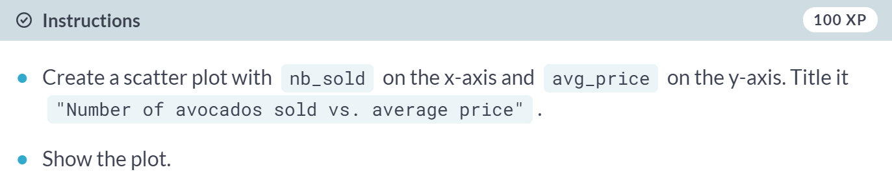

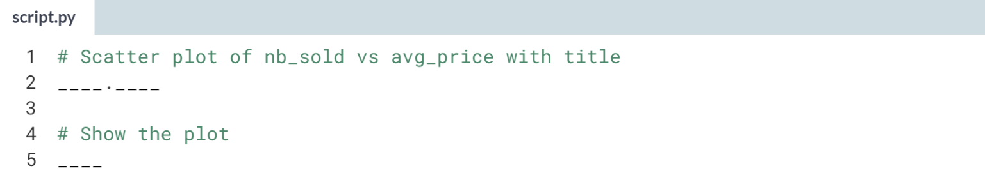

Hint

1. Call ***.plot()***, passing *"nb_sold"* and *"avg_price"*, and setting *kind* to *"scatter"*.
2. To add a title, use the *title* argument in ***.plot()***.

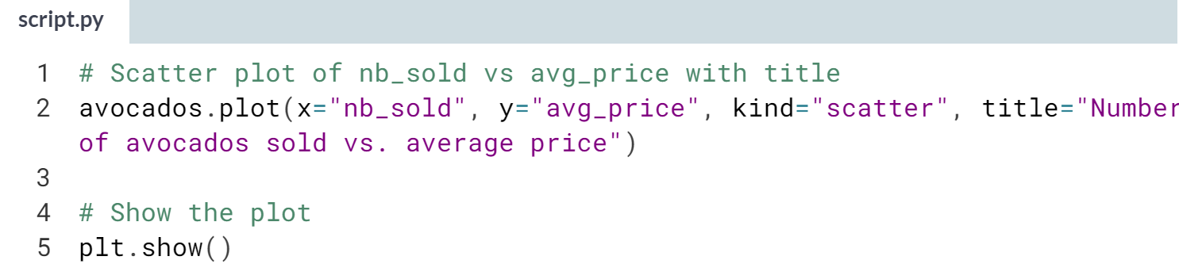

(Plot on the next page)

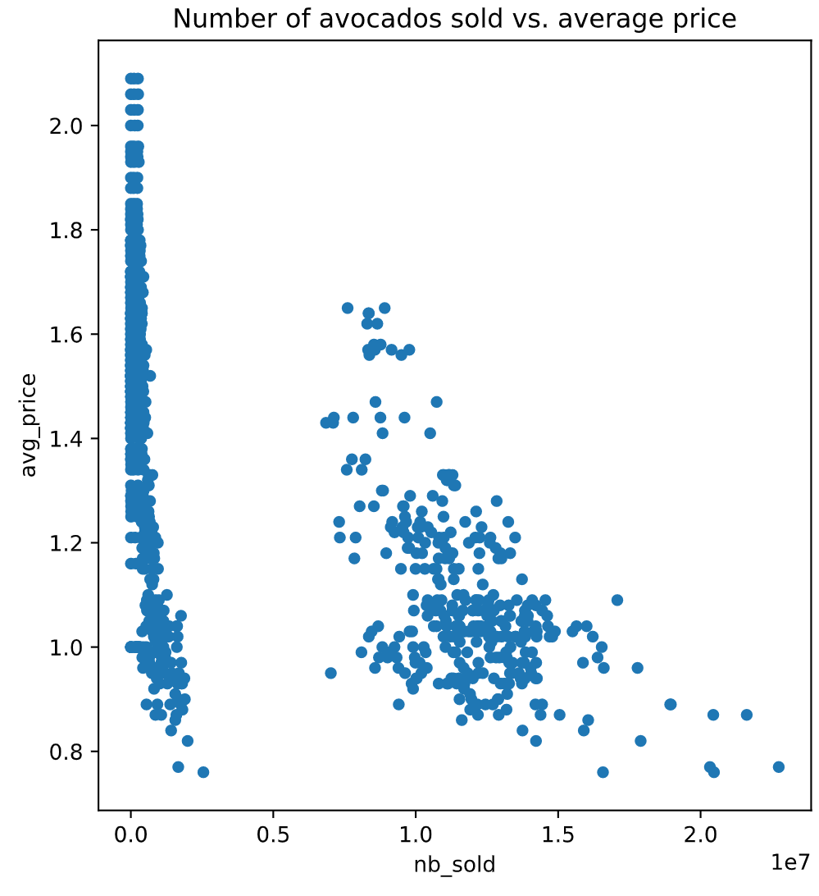  
Super scatter plot! It looks like when more avocados are sold, prices go down. However, this doesn't mean that fewer sales cause higher prices - we can only tell that they're correlated with each other.

# Price of conventional vs. organic avocados

Creating multiple plots for different subsets of data allows you to compare groups. In this exercise, you'll create multiple histograms to compare the prices of conventional and organic avocados.

matplotlib.pyplot has been imported as plt and pandas has been imported as pd.

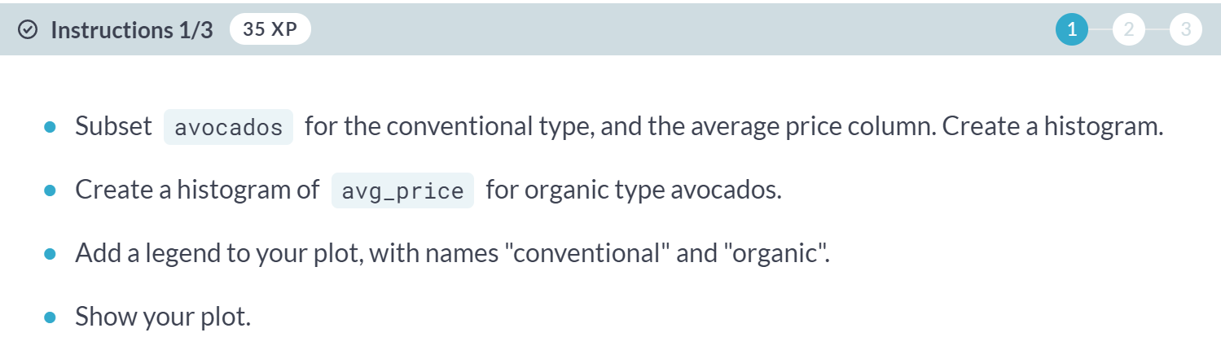

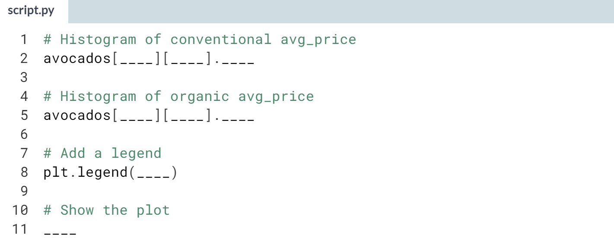

Hint

1. Subset rows using **avocados["type"] == "conventional"**.
2. Remember to select the *avg_price* column after subsetting and before plotting.
3. Call ***.hist()*** to draw a histogram.
4. Your plot won't appear until you display it using a function from *plt*.

(Solution on the next page)

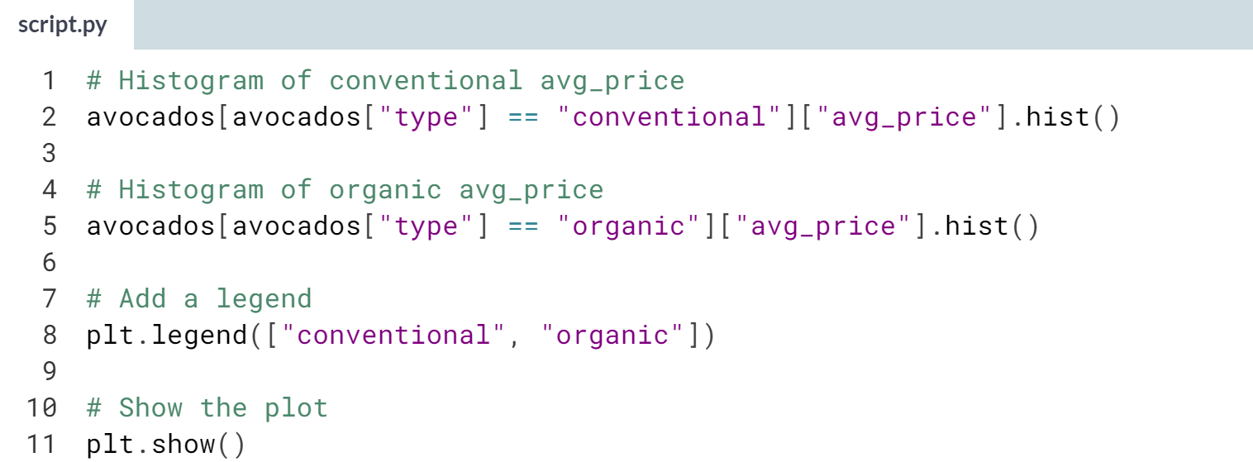

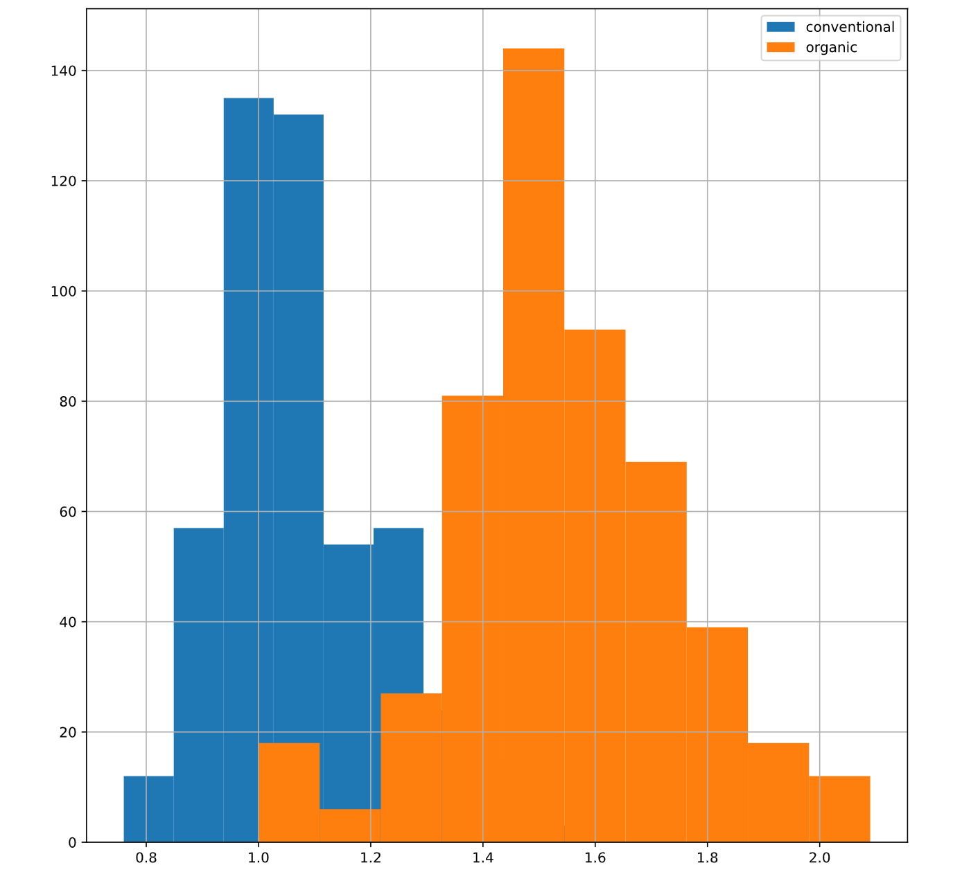

(Exercise continues on the next page)

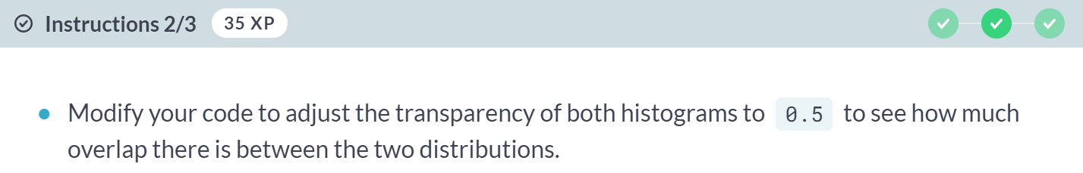

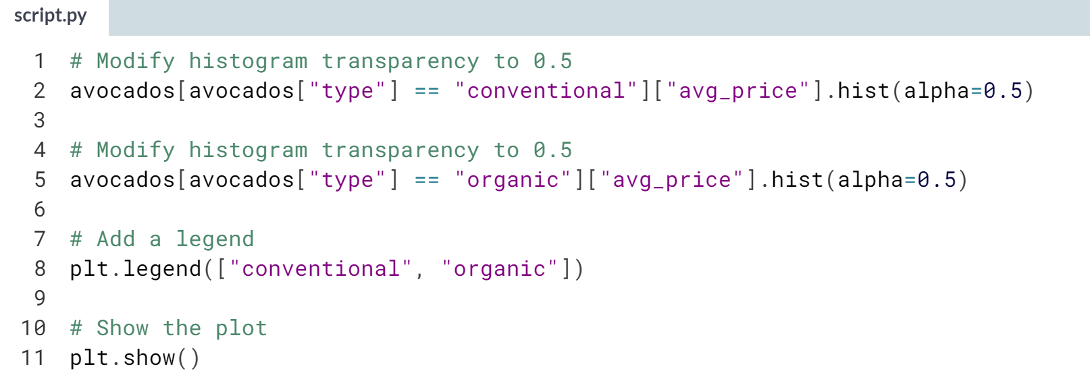

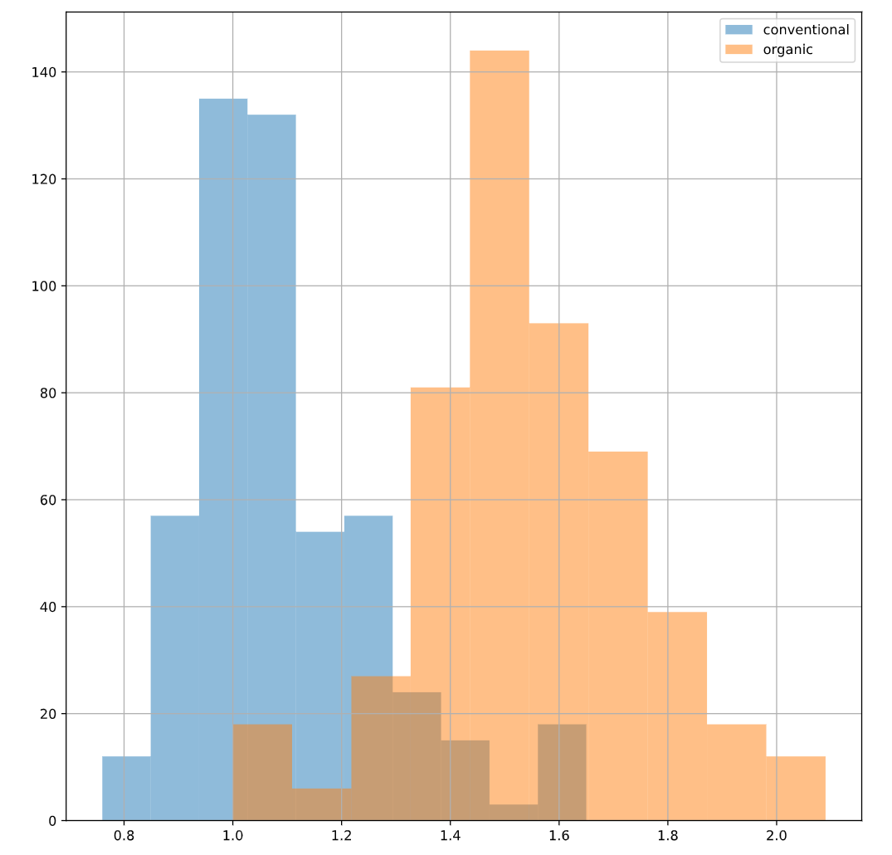

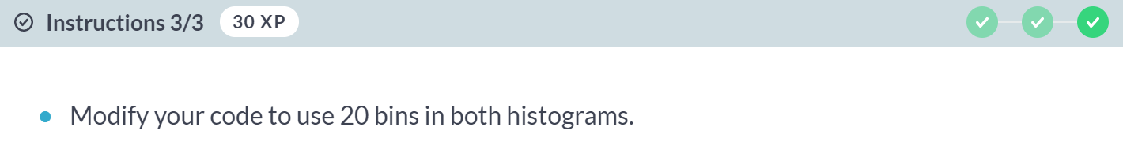

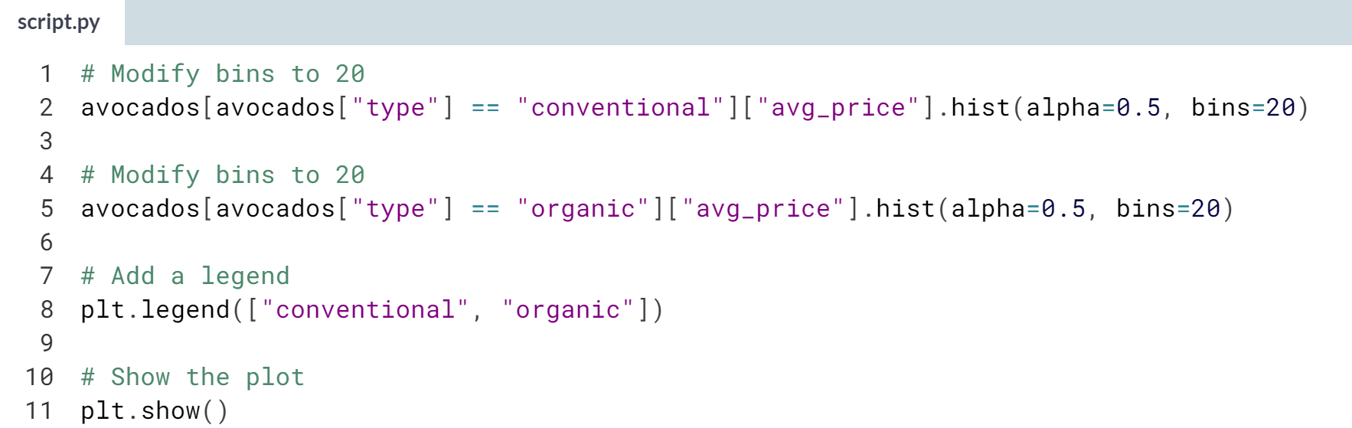

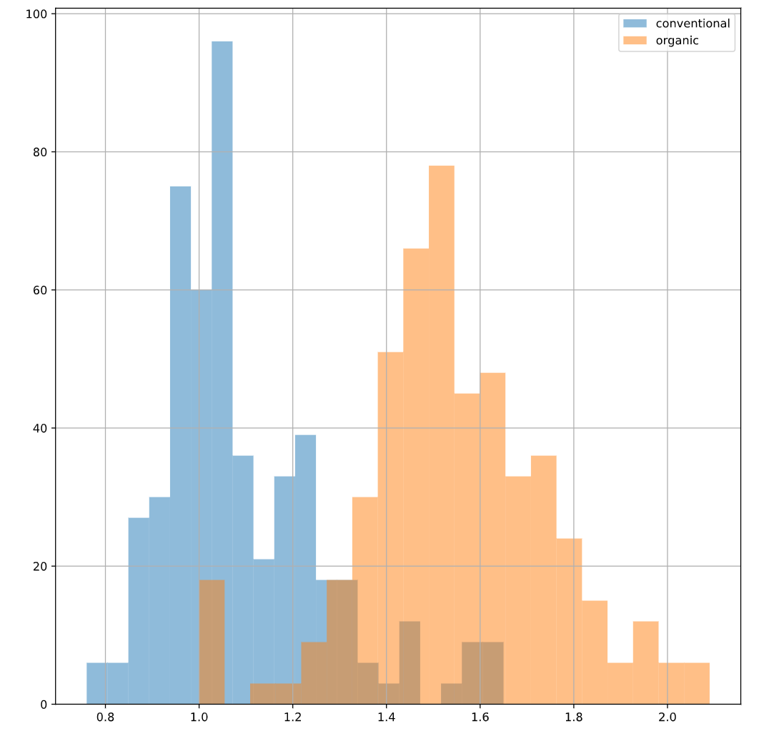  
Great layering! We can see that on average, organic avocados are more expensive than conventional ones, but their price distributions have some overlap



You could be given a DataFrame that has missing values, so it's important to know how to handle them.

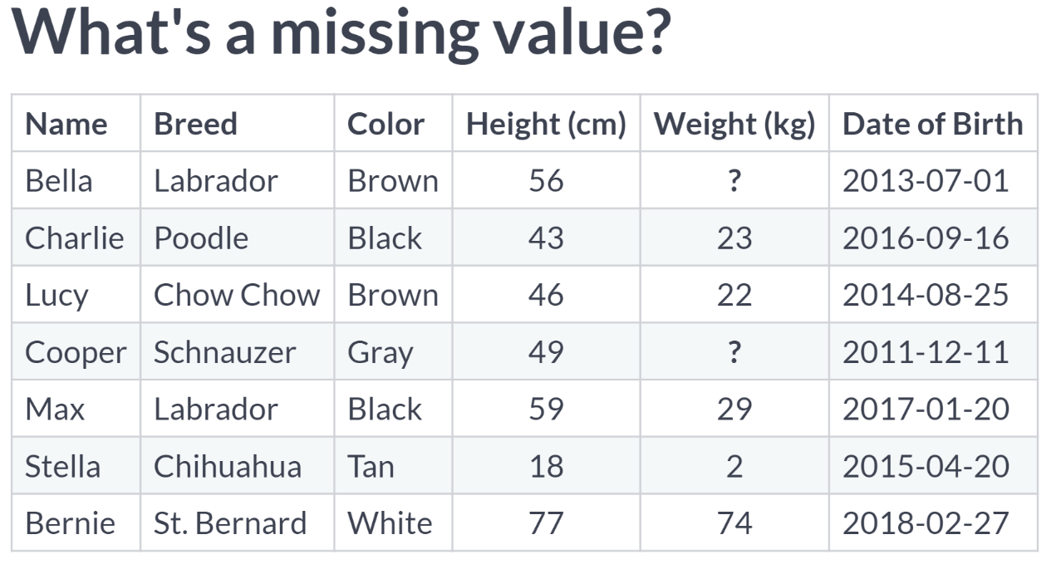  
Most data is not perfect - there's always a possibility that there are some pieces missing from your dataset.

For example, maybe on the day that Bella and Cooper's owner weighed them, the scale was broken. Now we have two missing values in our dataset.

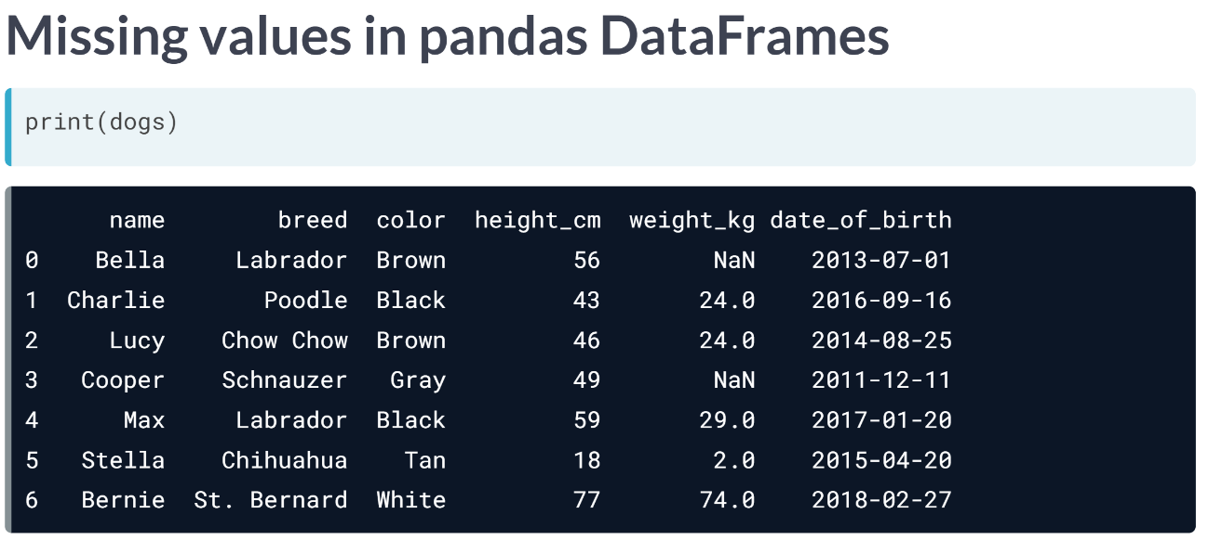  
In a pandas DataFrame, missing values are indicated with NaN, which stands for "not a number".

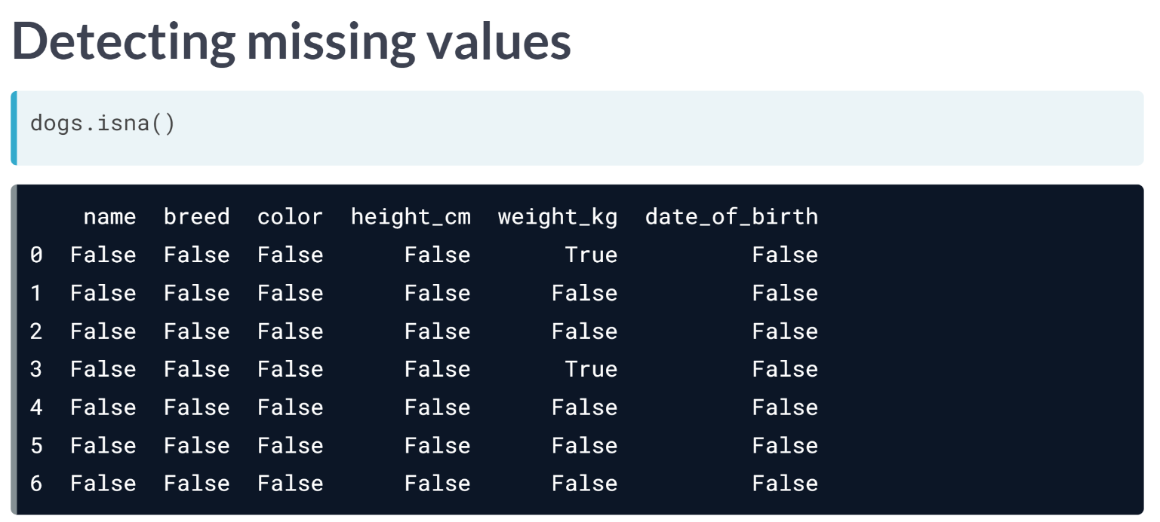  
When you first get a DataFrame, it's good idea to get a sense of whether it contains any missing values, and if so, how many.

That's where this ***isna()*** method comes into play.

We get a Boolean for every single value indicating whether the value is missing or not, but this isn't very helpful when you are working with a lot of data.

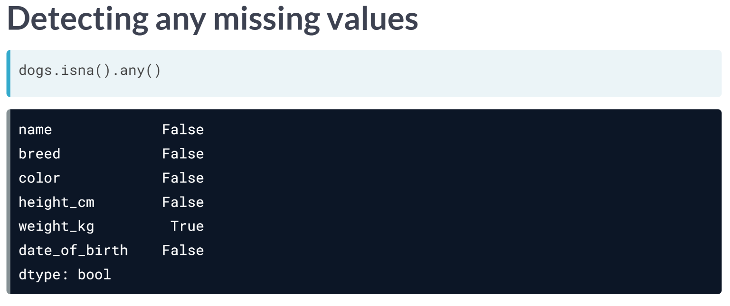  
If we chain ***.isna()*** with ***.any()***, we get one value for each variable that tells us if there are any missing values in that column.

Here, we see that there's at least one missing values in the weight column, but not in any of the others.

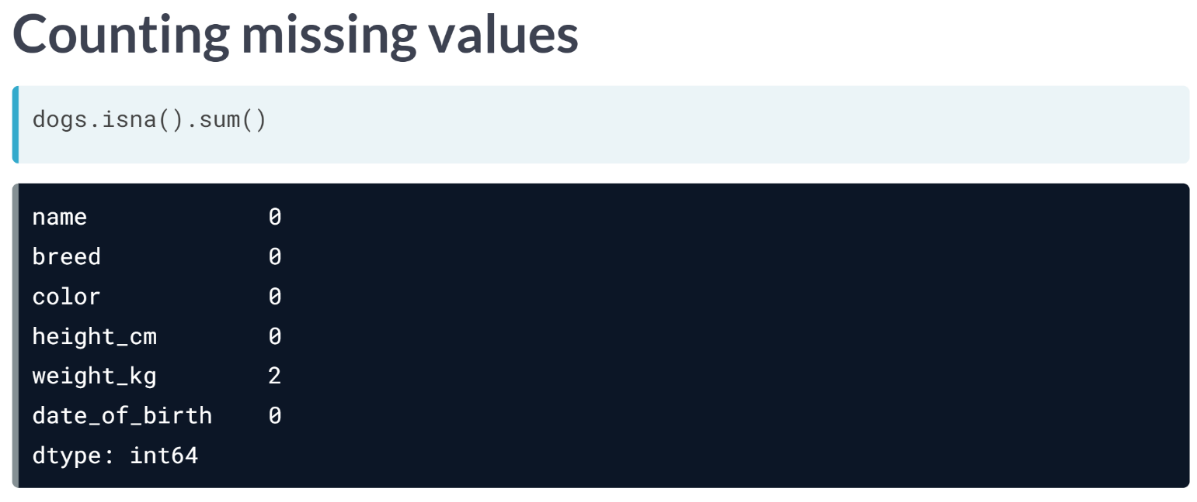  
Since taking the sum of Booleans is the same thing as counting the number of Trues, we can combine the sum with ***isna()*** to count the number of *NaNs* in each column.

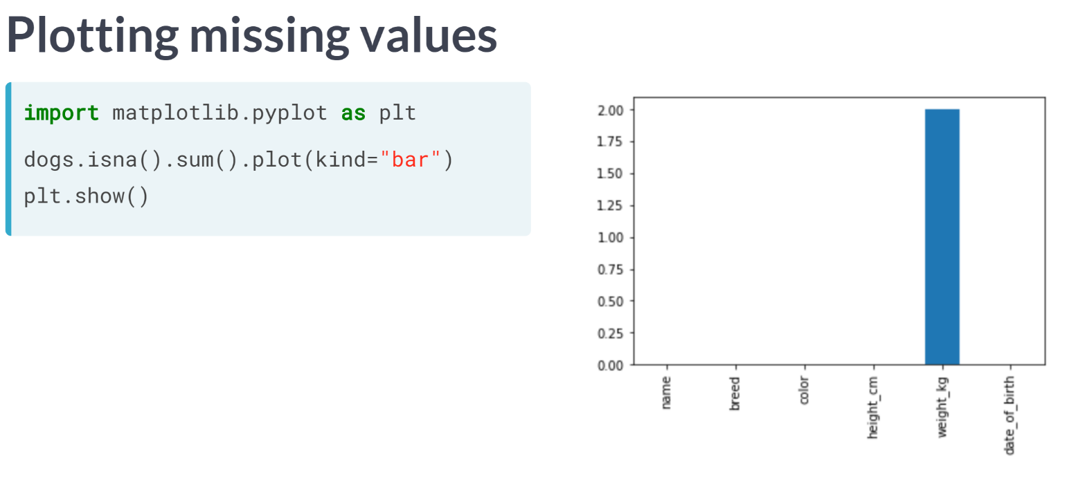  
We can use those counts to visualize the missing values in the dataset using a bar plot.

Plots like this are more interesting when you have missing data across different variables, while here, only weights are missing.

Now that we know there are missing values in the dataset, what can we do about them?

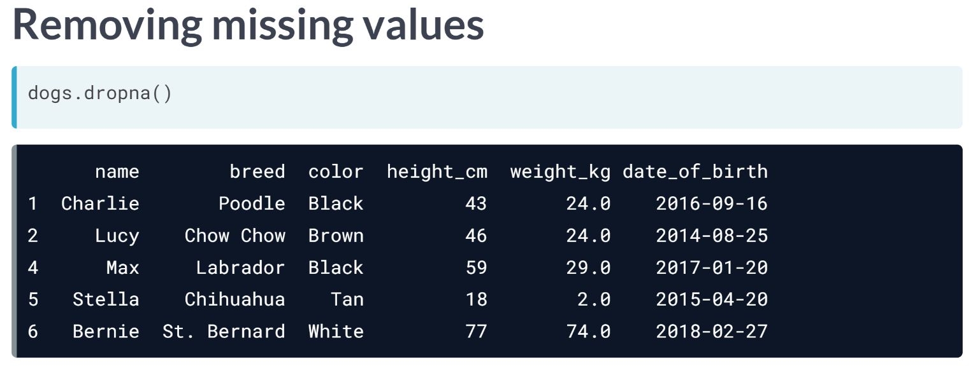  
One option is to remove the rows in the DataFrame that contain missing values. This can be done using the ***dropna()*** method.

However, this may not be ideal if you have a lot of missing data, since that means losing a lot of observations.

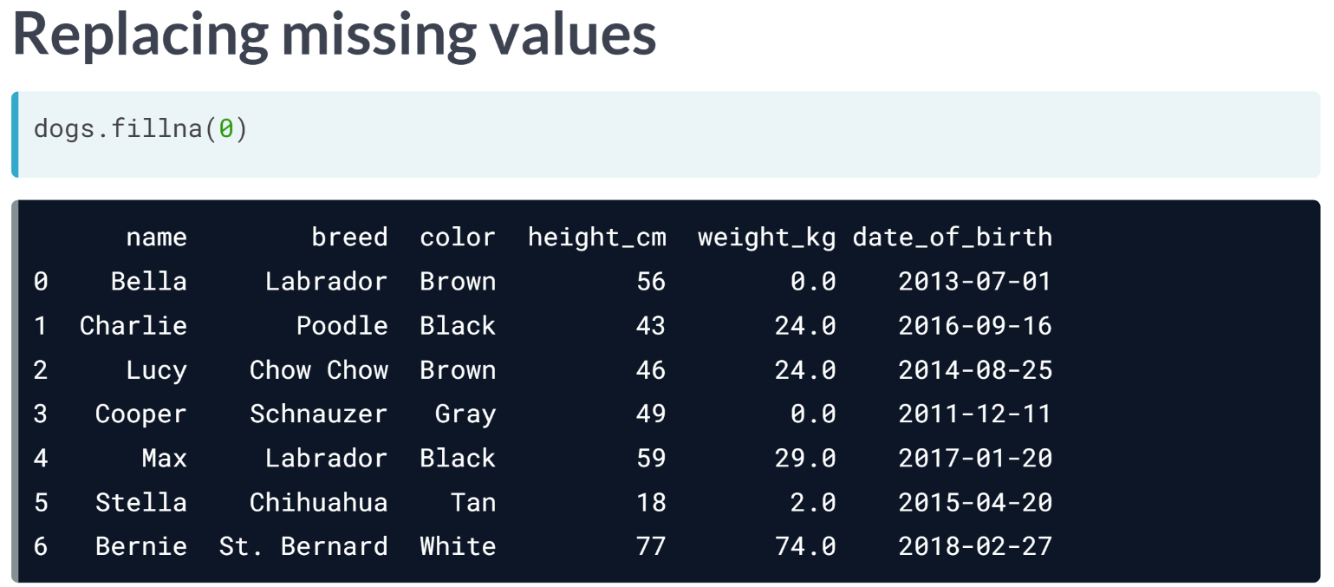  
Another option is to replace missing values with another value. The ***fillna()*** method takes in a value, and all NaNs will be replaced with this value.

There are also many sophisticated techniques for replacing missing values, which you can learn more about in the course about missing data.

# Finding missing values

Missing values are everywhere, and you don't want them interfering with your work. Some functions ignore missing data by default, but that's not always the behavior you might want.

Some functions can't handle missing values at all, so these values need to be taken care of before you can use them. If you don't know where your missing values are, or if they exist, you could make mistakes in your analysis.

In this exercise, you'll determine if there are missing values in the dataset, and if so, how many.

pandas has been imported as pd and avocados_2016, a subset of avocados that contains only sales from 2016, is available.

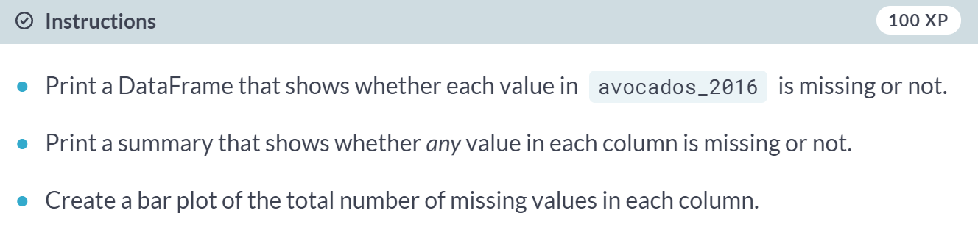

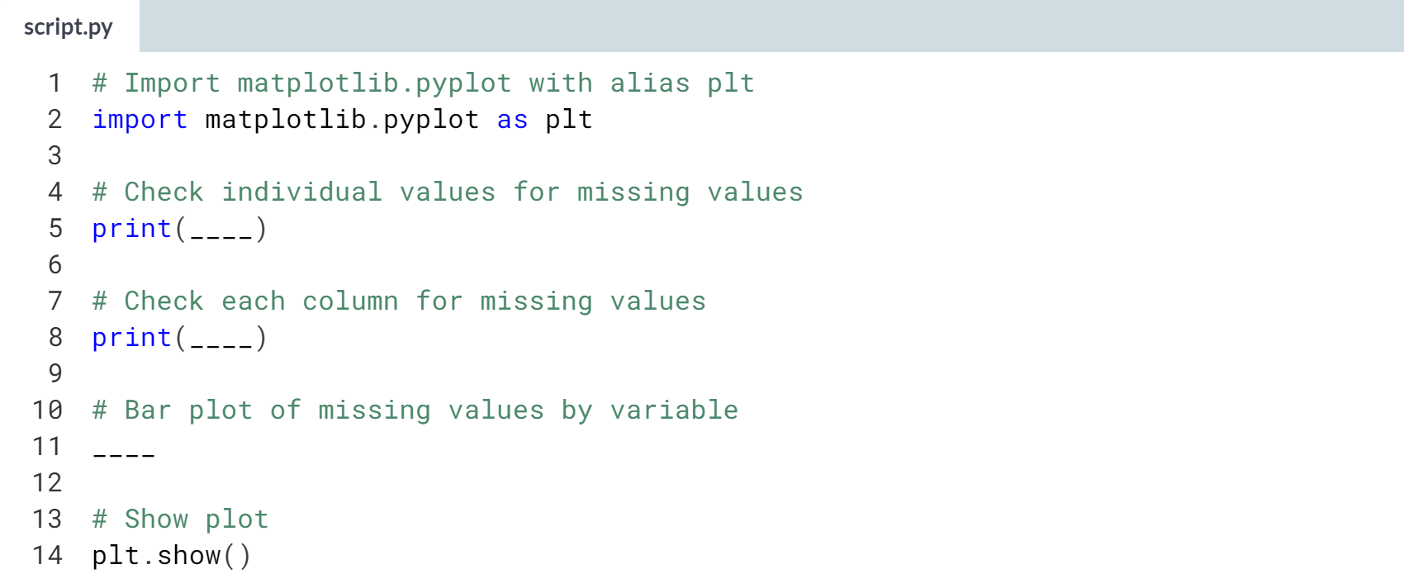

1. Use the ***.isna()*** method to check each individual value for missingness.
2. The ***.any()*** method will take a DataFrame of Booleans and flatten it to indicate if there are any *Trues* in each column.
3. The ***.sum()*** method can be used on a DataFrame of Booleans to count the number of *Trues* in each column.
4. Call ***.plot()***, setting *kind* to *"bar"* to draw a bar plot.

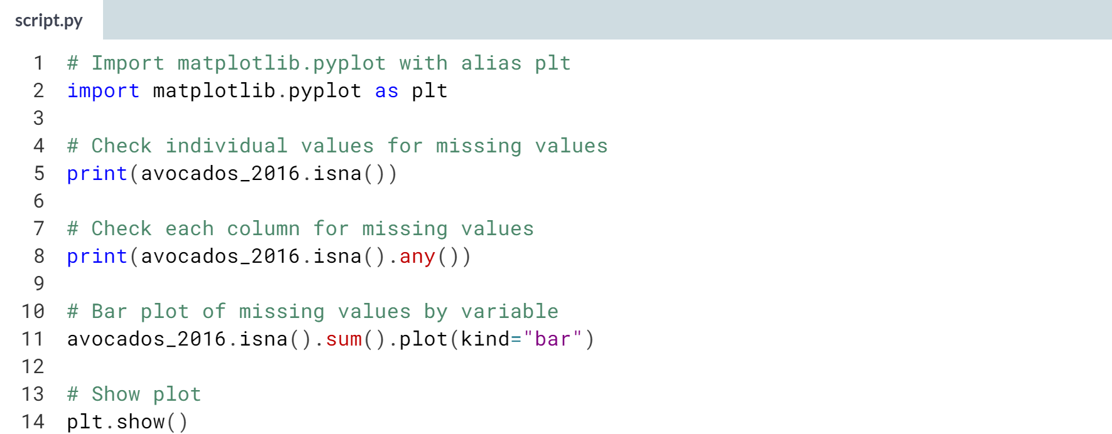

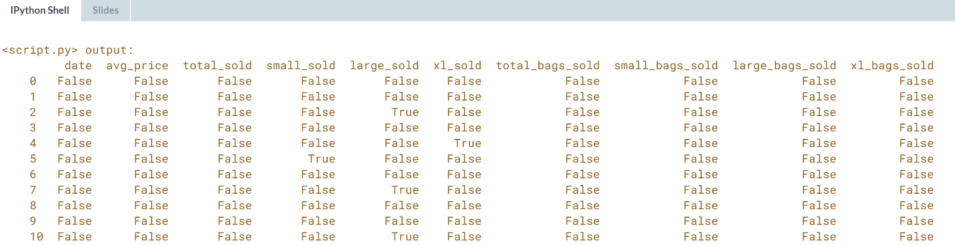

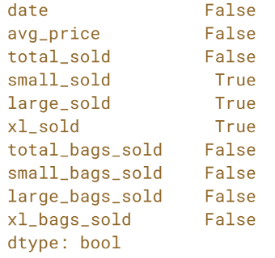 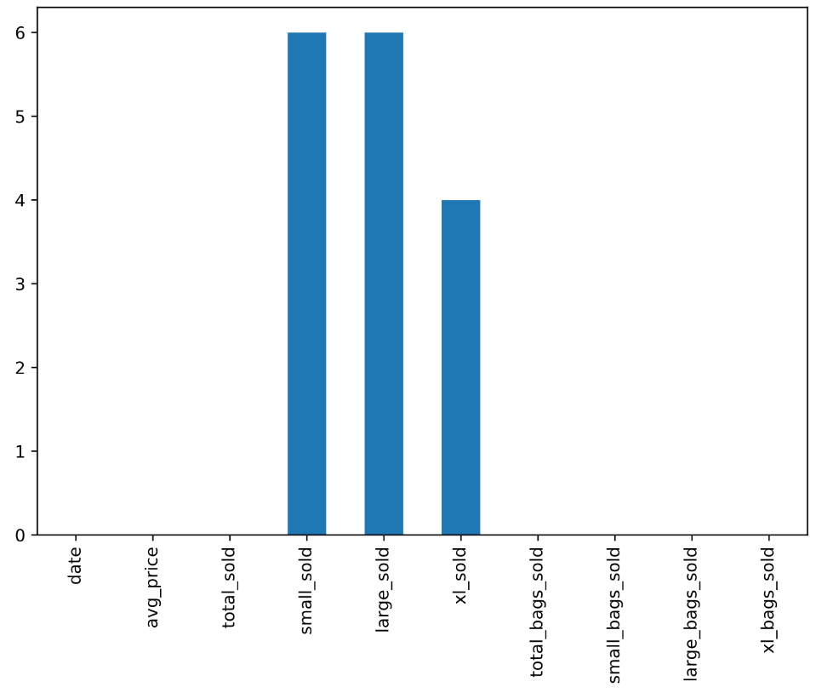  
Marvelous missing value detection! It looks like there are missing values in the *small_sold*, *large_sold*, and *xl_sold* columns.

# Removing missing values

Now that you know there are some missing values in your DataFrame, you have a few options to deal with them. One way is to remove them from the dataset completely. In this exercise, you'll remove missing values by removing all rows that contain missing values.

pandas has been imported as pd and avocados_2016 is available.

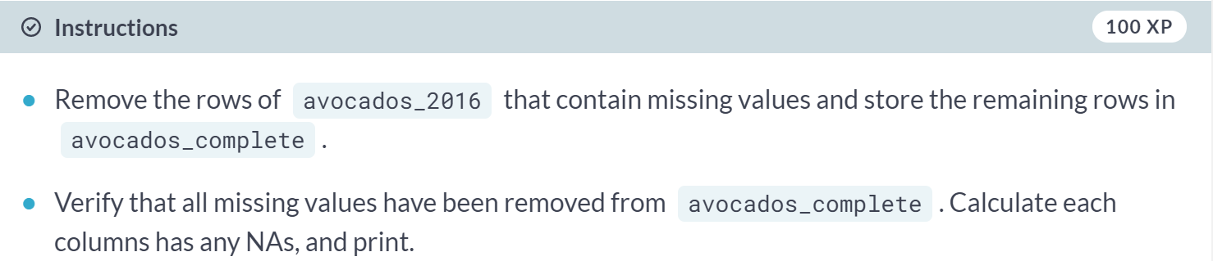

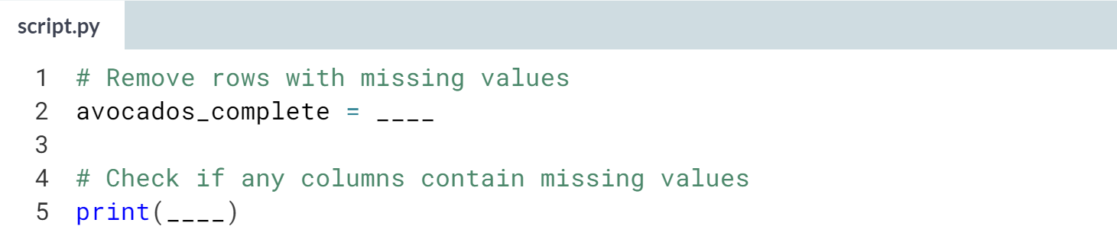

1. Call the method that **drop**s missing (NA) values.
2. Use the ***.any()*** method in combination with another to check columns for missing values.

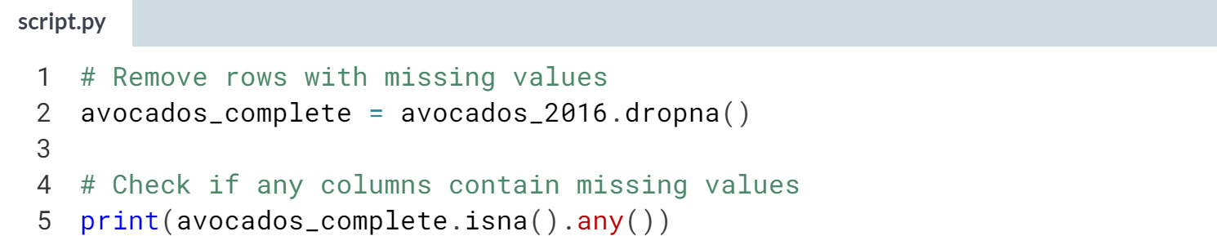  
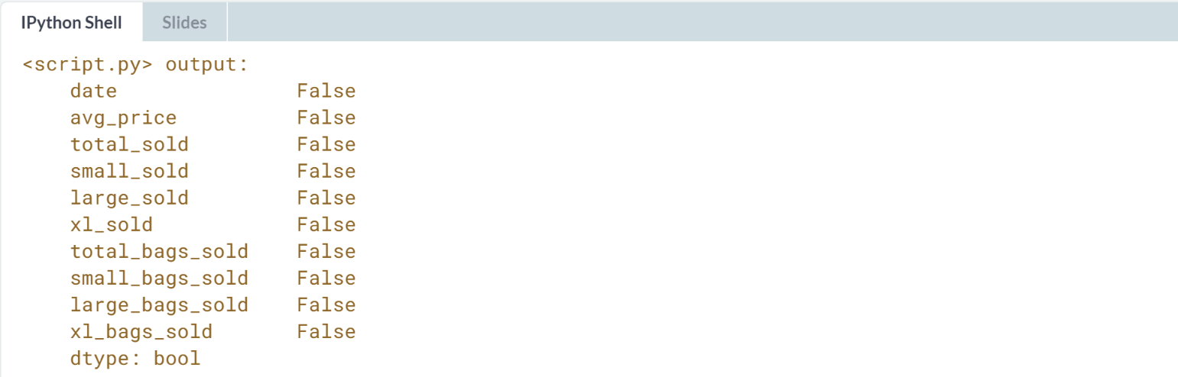

# Replacing missing values

Another way of handling missing values is to replace them all with the same value. For numerical variables, one option is to replace values with 0—you'll do this here. However, when you replace missing values, you make assumptions about what a missing value means. In this case, you will assume that a missing number sold means that no sales for that avocado type were made that week.

In this exercise, you'll see how replacing missing values can affect the distribution of a variable using histograms. You can plot histograms for multiple variables at a time as follows:

dogs[["height_cm", "weight_kg"]].hist()

pandas has been imported as pd and matplotlib.pyplot has been imported as plt.

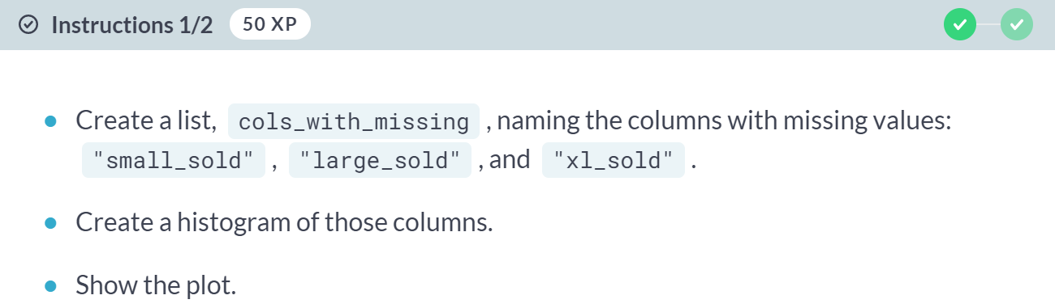

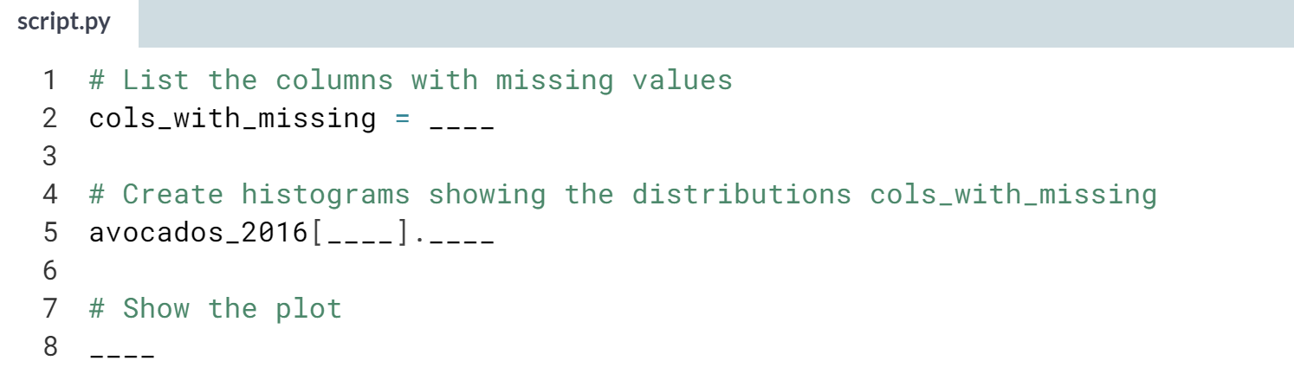

Hint

1. Make a list of 3 columns names.
2. Call ***.hist()*** on a DataFrame to create a histogram.
3. Pass a list of column names to the column argument of ***.hist()*** to plot distributions of multiple columns.

(Solution on the next page)

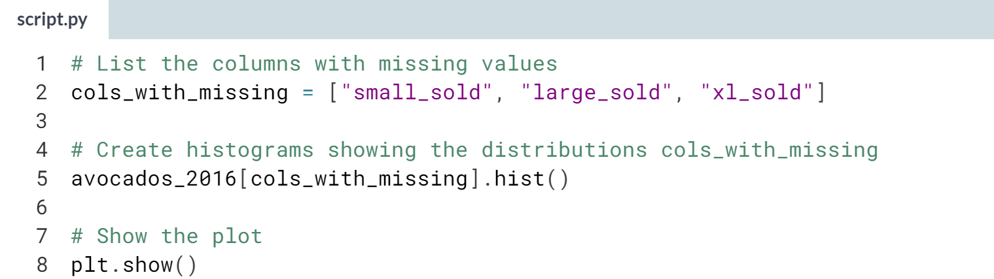

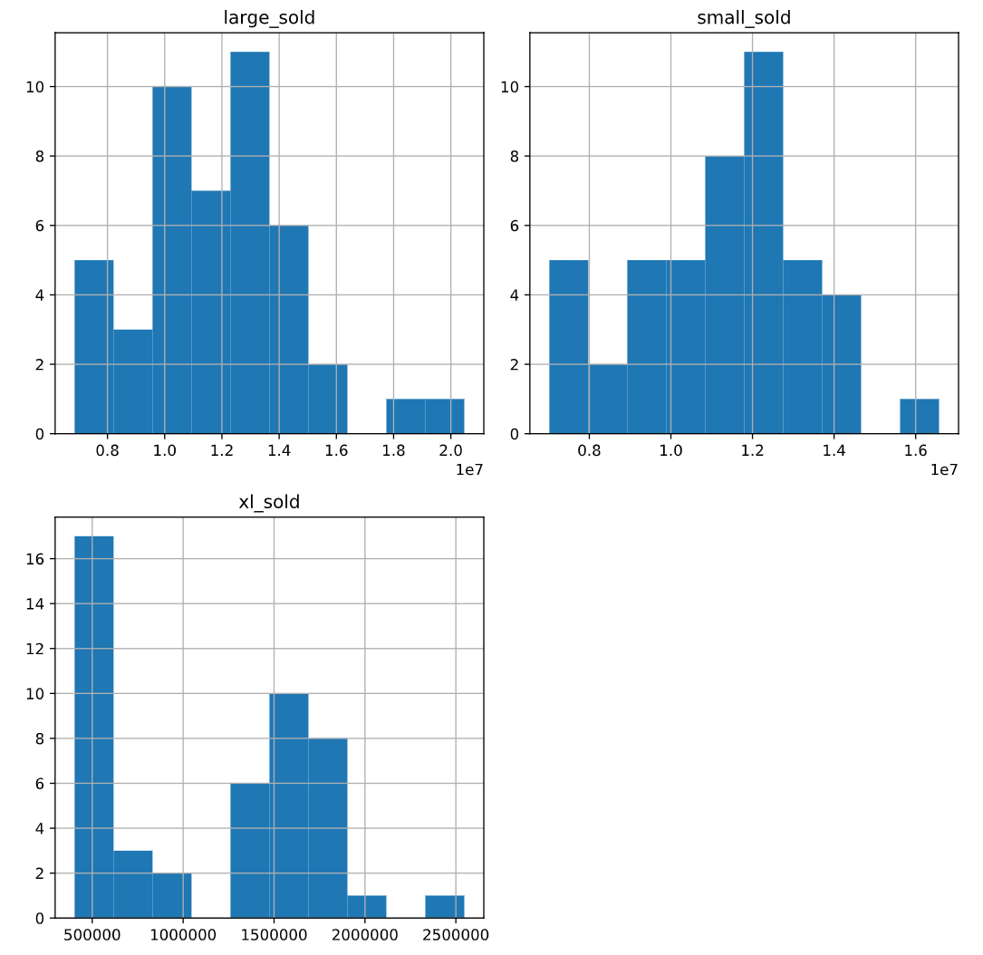

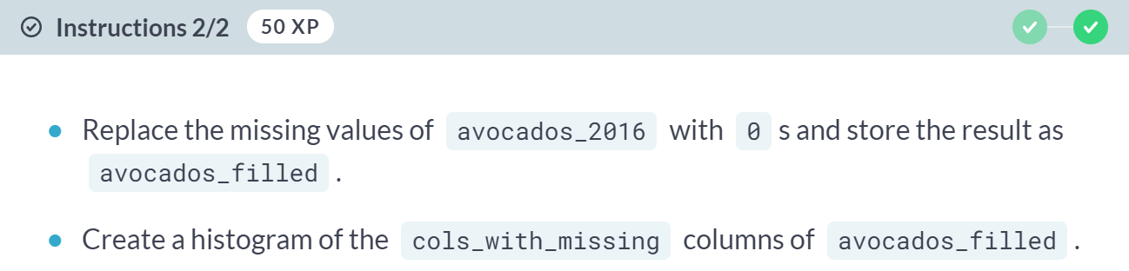

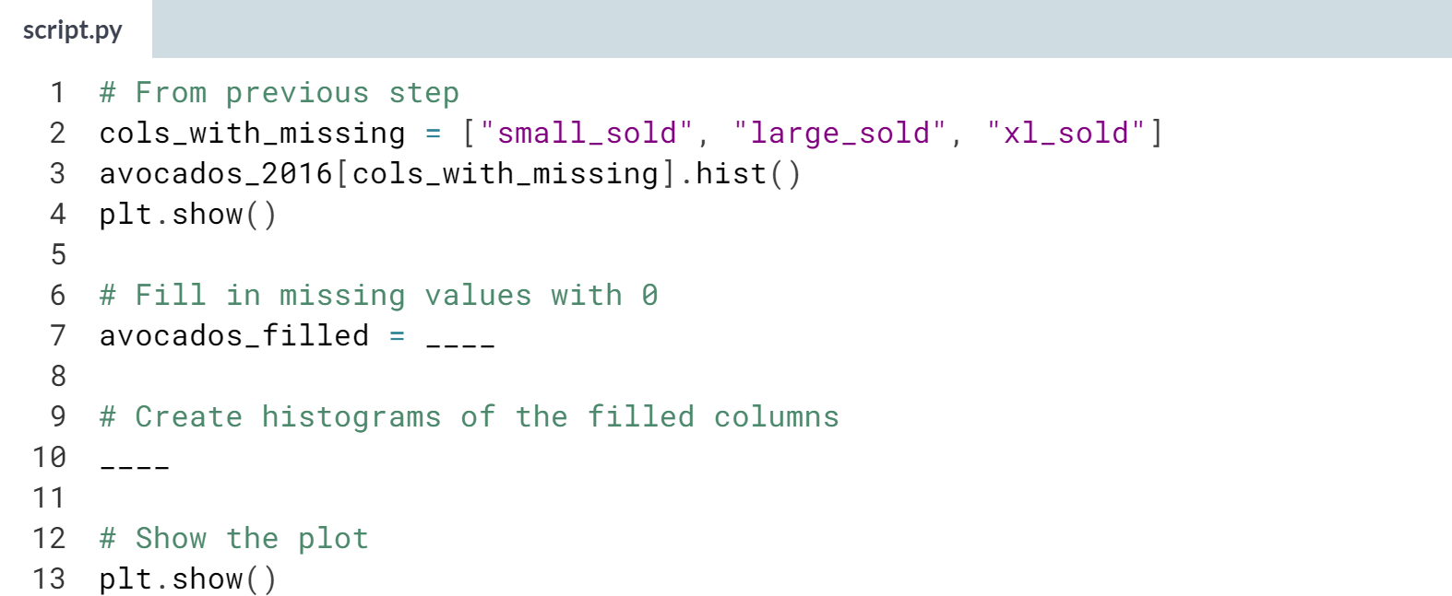

Hint

1. Remember the method to fill missing values?
2. The code to create the histogram will be very similar to the code used to create your first set of histograms.

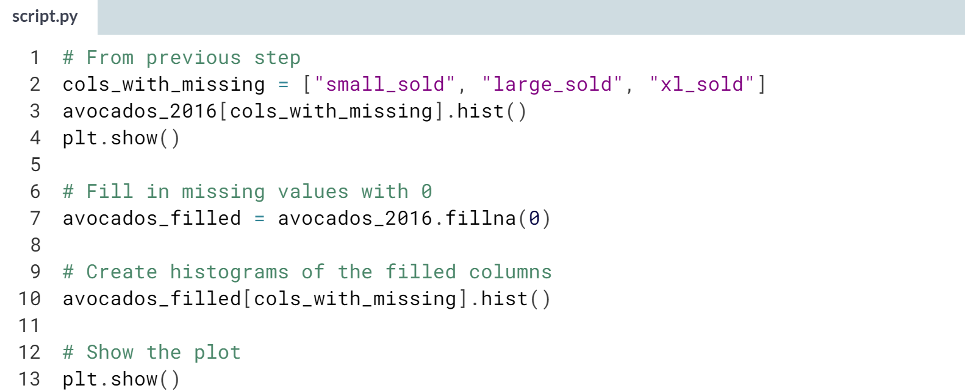

(Plot on the next page)

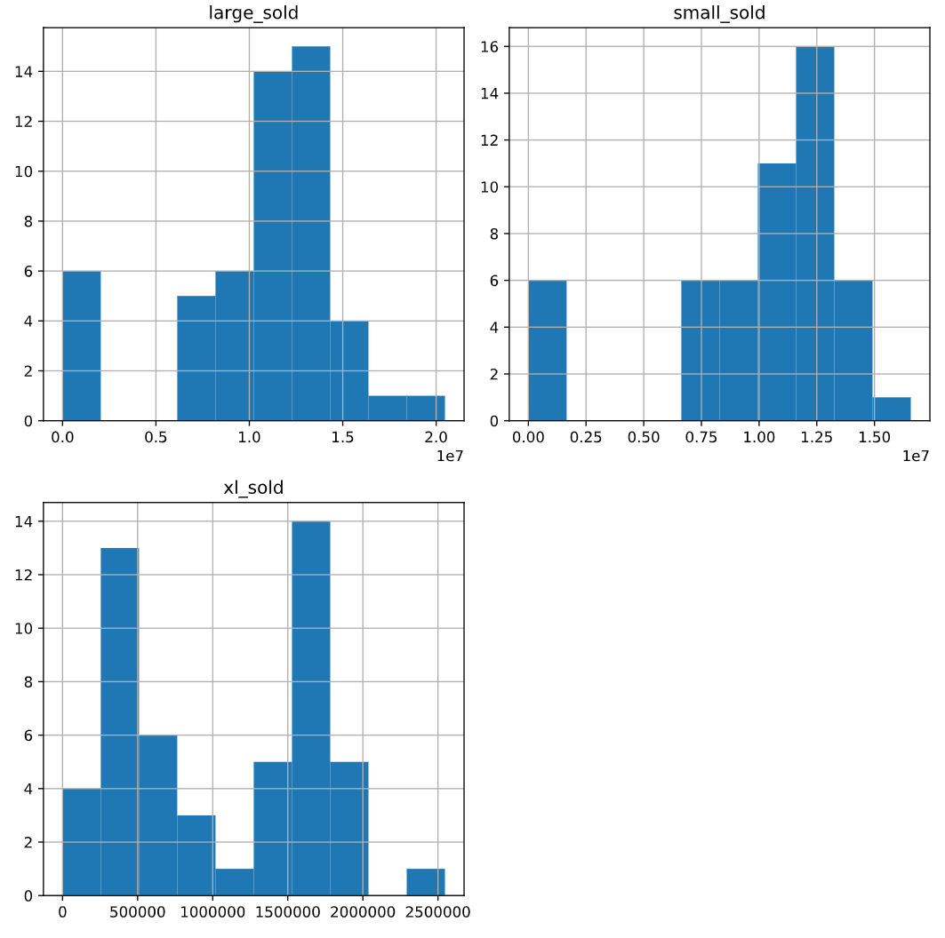  
Fabulous filling! Notice how the distribution has changed shape after replacing missing values with zeros.



Now that you've learned a lot about how to work with pandas DataFrames, let's learn how we can get into a DataFrame in the first place.

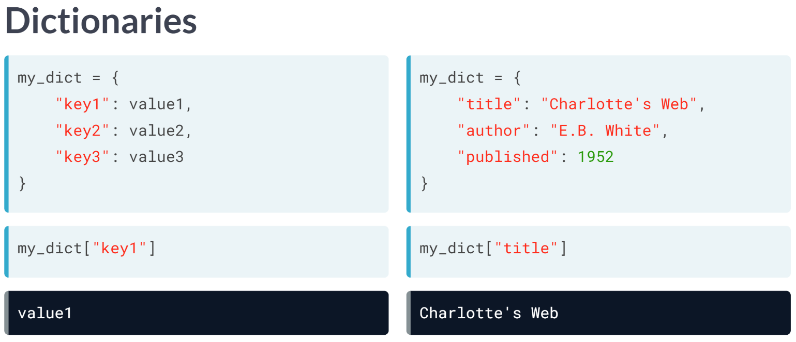  
Before creating your own DataFrames, let's talk about dictionaries. A dictionary is a way of storing data in Python. It holds a set of key-value pairs. We can create a dictionary like this above, using curly braces.

Let's create a dictionary that holds information about a book. "Title" is a key in the dictionary, and "Charlotte's Web" is its corresponding value, and so on. You can access values of dictionary via their keys in square brackets. For example, we can access the value of "title" like this.

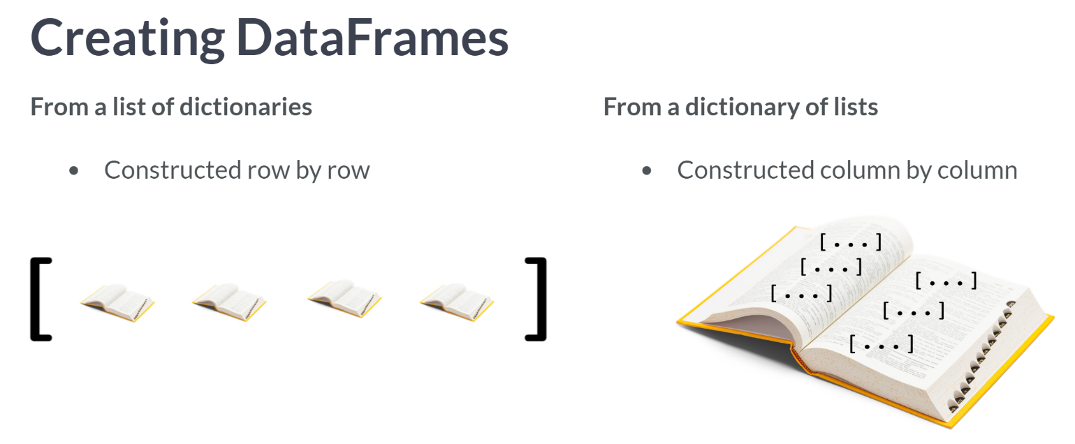  
There are many ways to create DataFrames, but we will discuss two ways: from a list of dictionaries, and from a dictionary of lists. In the first method, the DataFrame is built up row by row, while in the second method, the DataFrame is built up column by column.

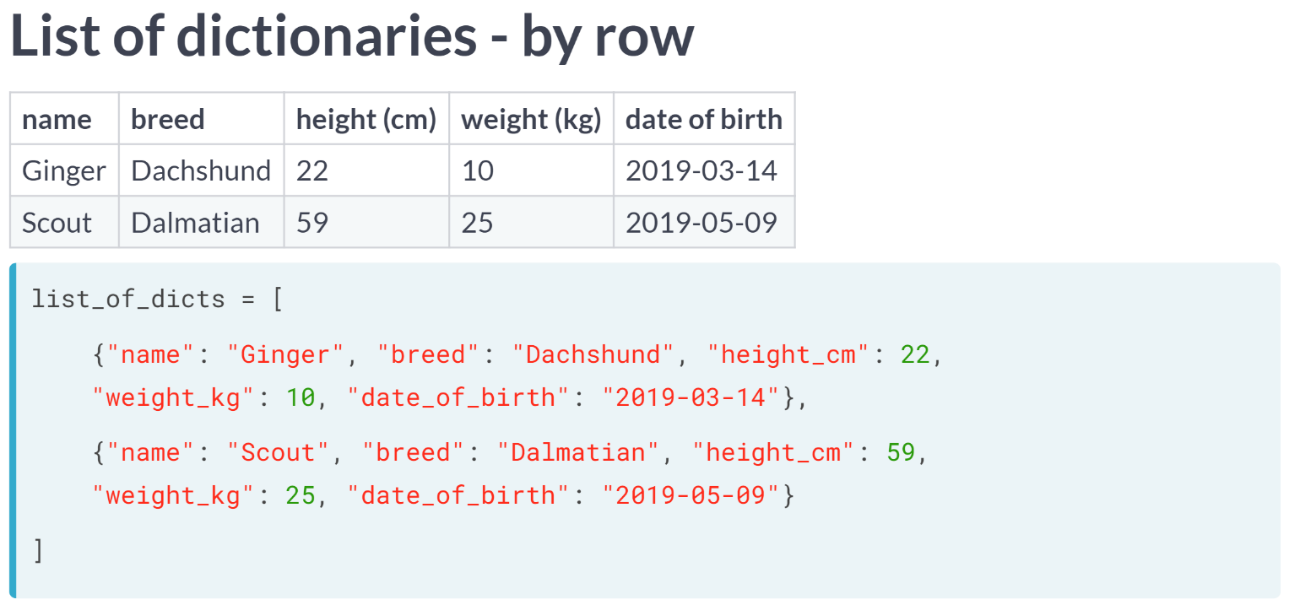  
We have some new dog data to put into a DataFrame. Let's start with the first method to do this, creating a list of dictionaries.

First, we will create a new list using square brackets to hold our dictionaries. Then, we will go through the first row of our data and put it in a dictionary. Each key, on the left of each colon, will become a column name.

Each value is one dog's data for that column. For the next row, we create another dictionary that follows the same format.

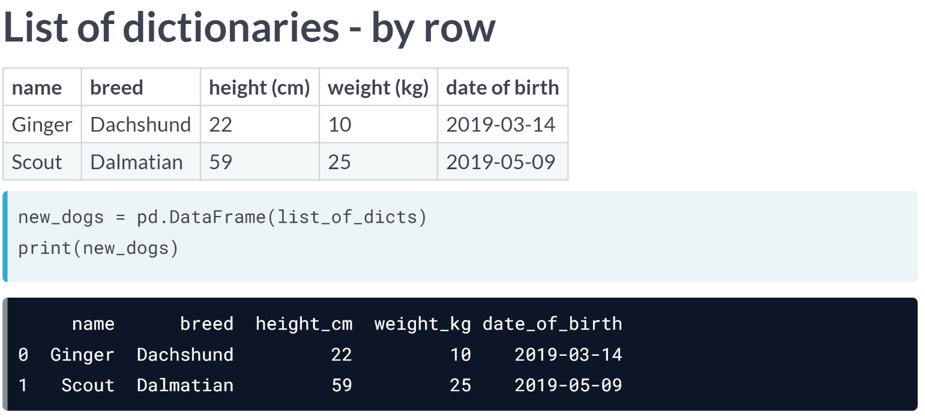Now that we have our list of dictionaries, we can pass it into pd.DataFrame to convert it into DataFrame form.

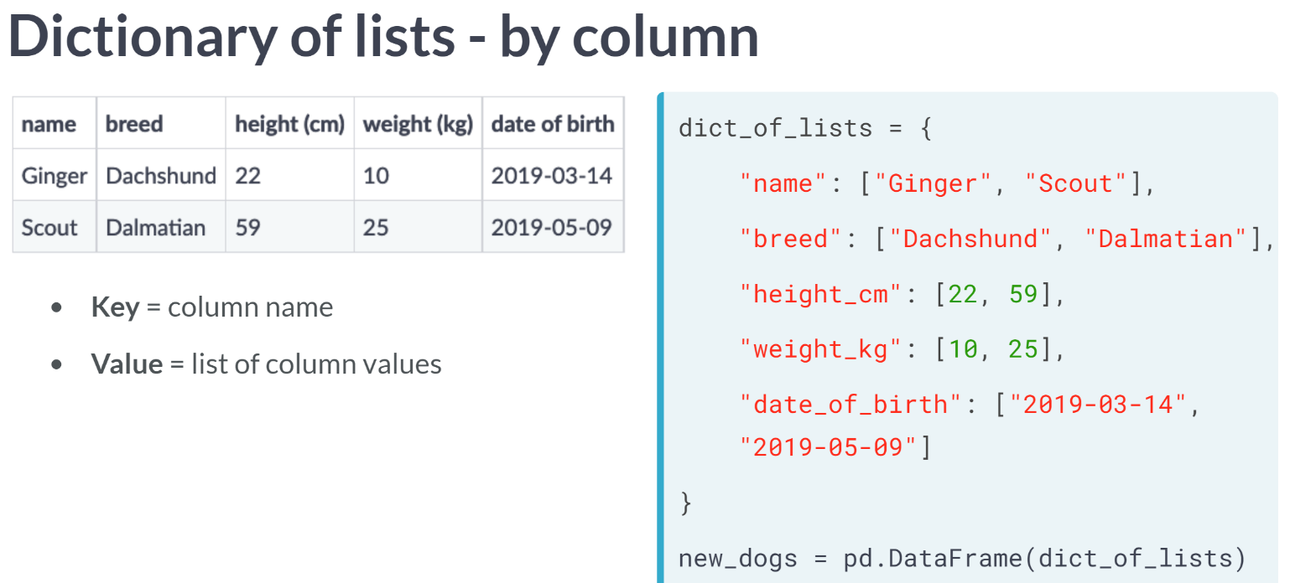  
Now let's talk about second way, the dictionary of lists method. When using this method, we need to go through the data column by column. Remember that keys are to the left of a colon, and values are to the right.

Each key will be a column name, and each value will be a list of the values in a column. First, we create a dictionary using curly braces. Let's start with the first column, which is called "name", so the first key is "name".

The value is a list containing each name from top to bottom. We repeat this process for other columns. Now that we have our dictionary of lists set up, we can pass it onto pd.DataFrame to convert it into a pandas DataFrame.

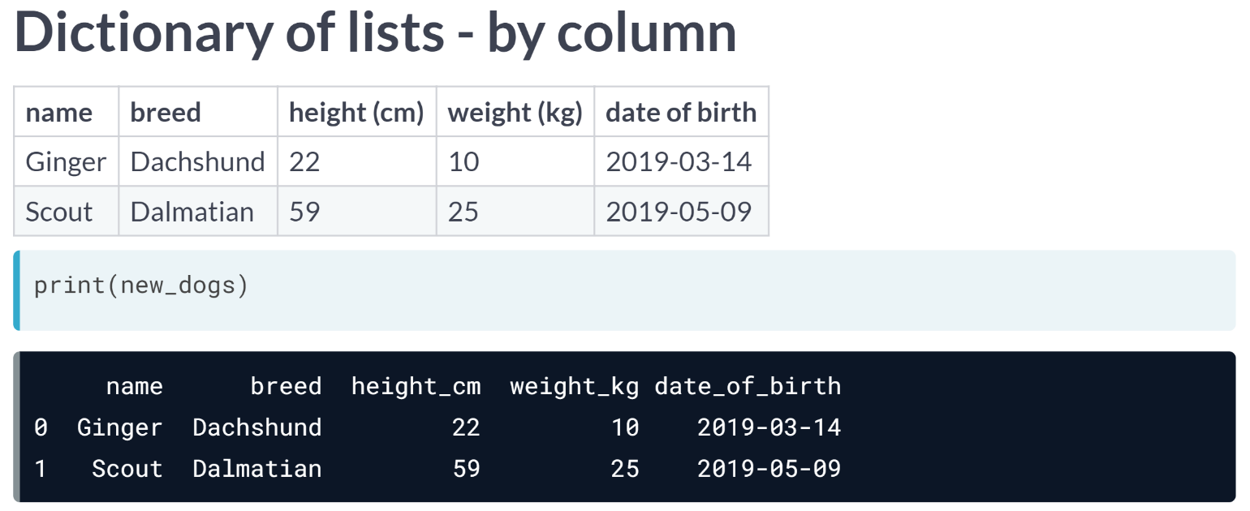  
If we print the new DataFrame, we can see that it's exactly what we wanted.

# List of dictionaries

You recently got some new avocado data from 2019 that you'd like to put in a DataFrame using the list of dictionaries method.

Remember that with this method, you go through the data row by row.

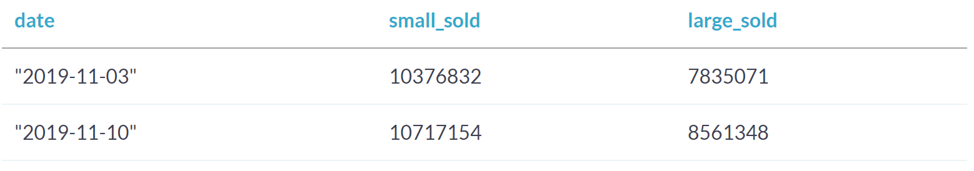

pandas as pd is imported.

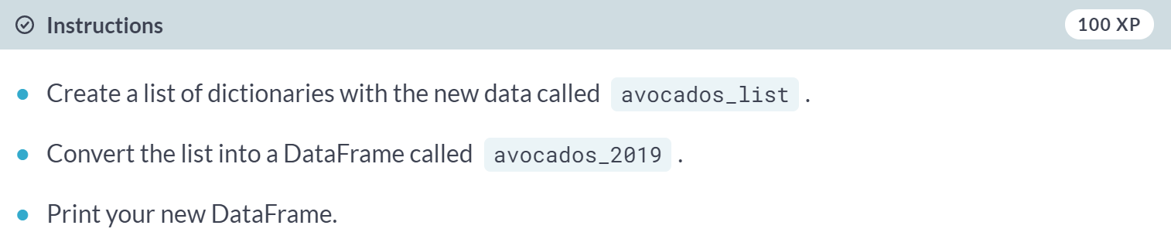

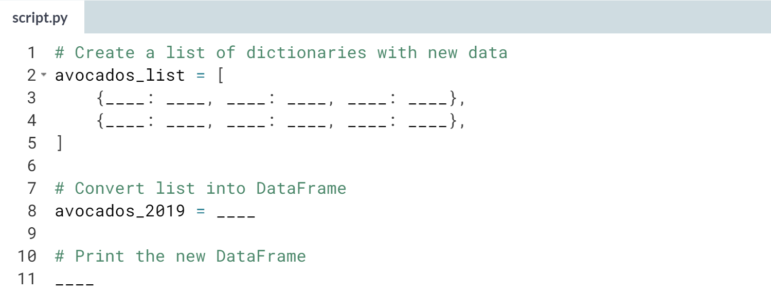

Hint

1. Each row of the data can be represented as a dictionary.
2. In each dictionary, column names are keys and data values are values.

(Solution on the next page)

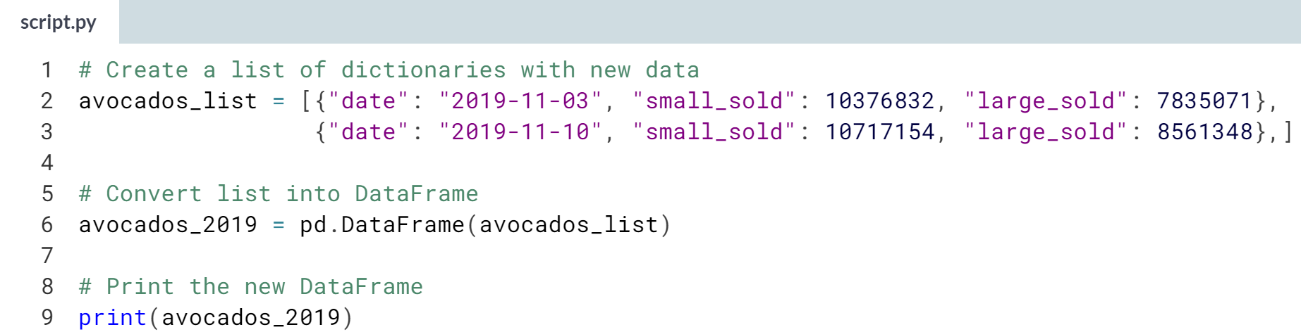

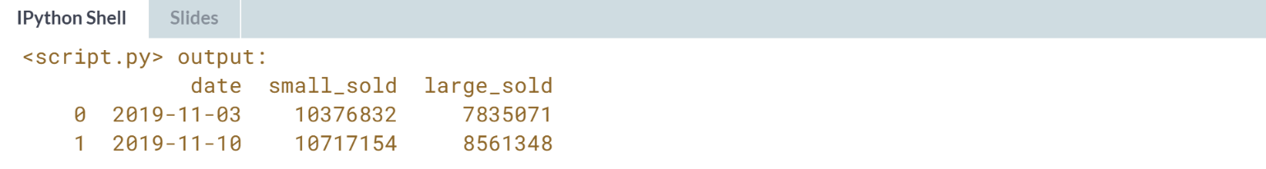

Lovely work with the list-of-dictionaries! The list-of-dictionaries method creates DataFrames row-by-row.

# Dictionary of lists

Some more data just came in! This time, you'll use the dictionary of lists method, parsing the data column by column.

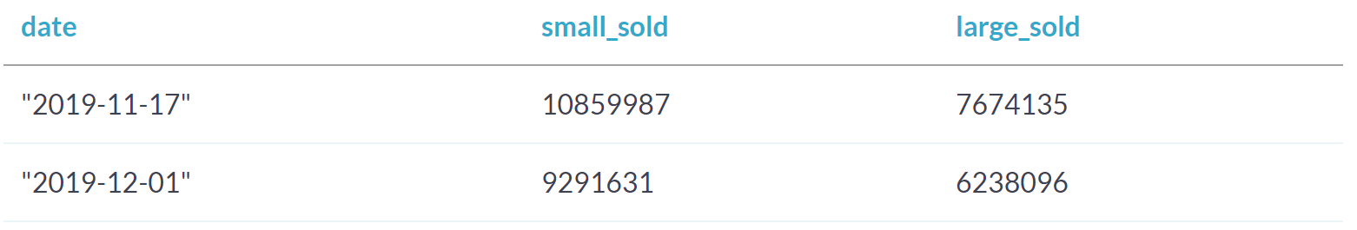

pandas as pd is imported.

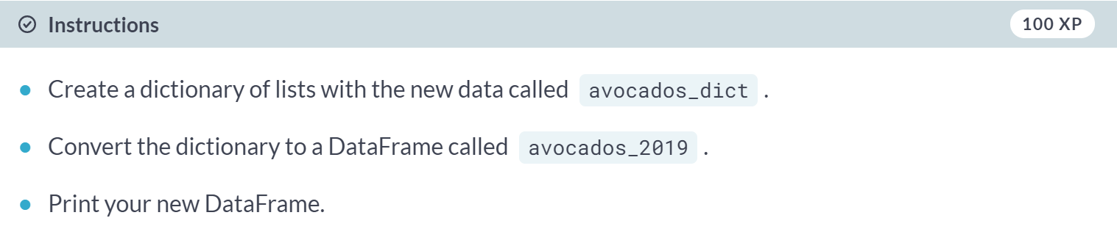

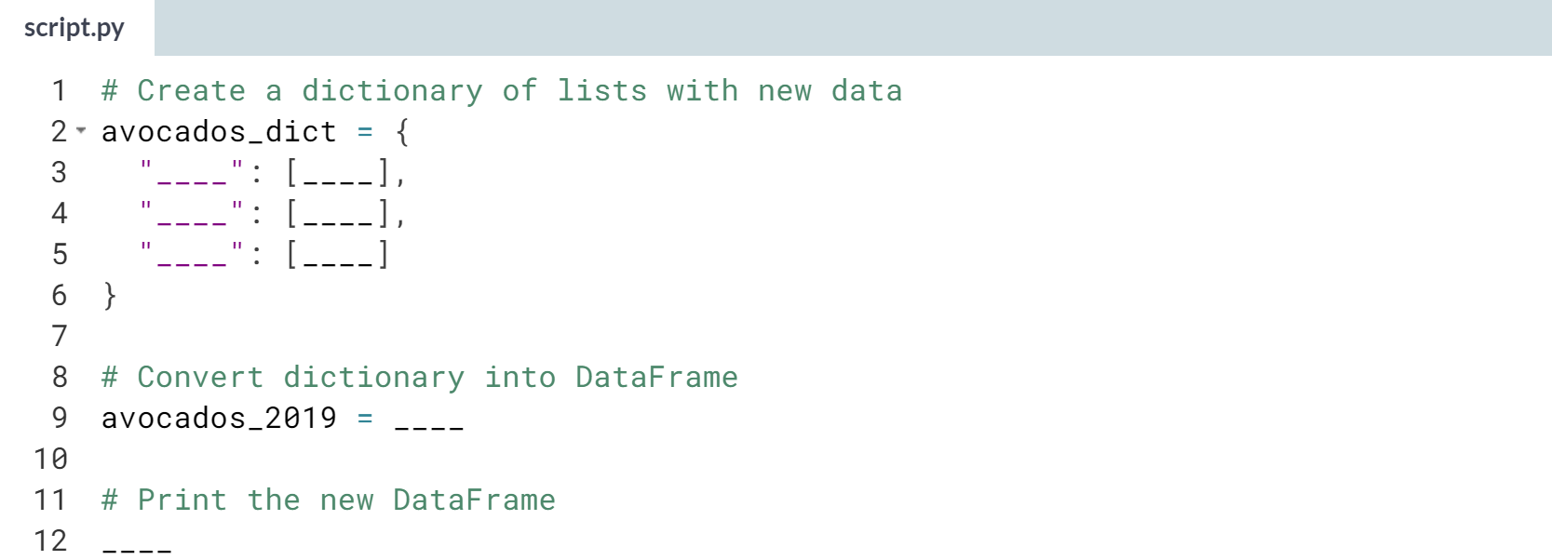

Hint

1. In a dictionary, column names are represented as keys.
2. Each column should have its own key-value pair in the dictionary.
3. Values can be stored in the dictionary in lists.

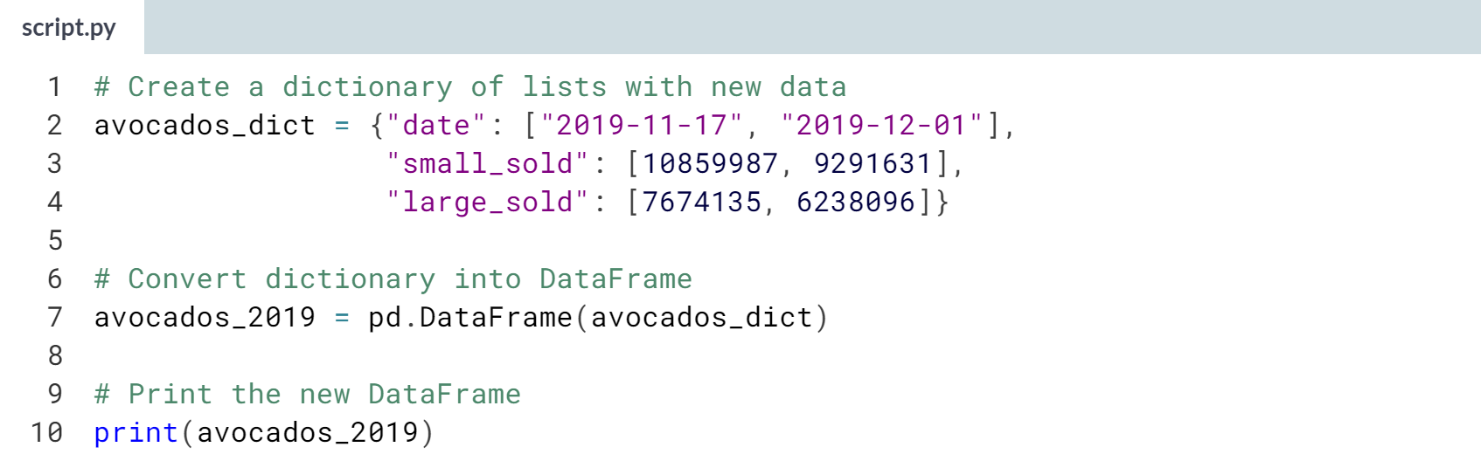

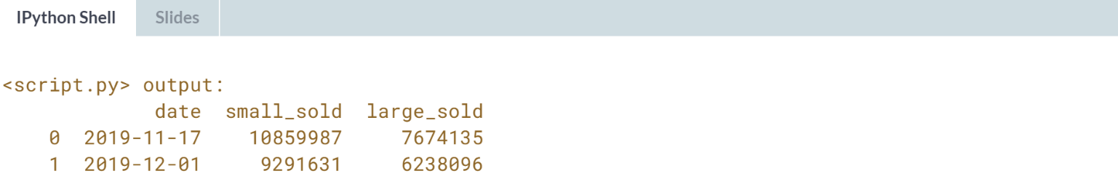

Delightful dictionary-of-lists usage! The list-of-dictionaries method creates DataFrames column-by-column.



You know how to create your own DataFrames, but typing out your data entry-by-entry isn't usually the most efficient way to get your data into a DataFrame. In this video, you will learn how to pull data from CSV files.

  
CSV, or comma separated values, is a common data storage file type. It's designed to store tabular data, just like a pandas DataFrame. It's a text file, where each row of data has its own line, and each value is separated by a comma.

Almost every database, programming language and piece of data analysis software can read and write CSV files.

That makes it a good storage format if you need to share your data with other people, who may be using different tools than you.

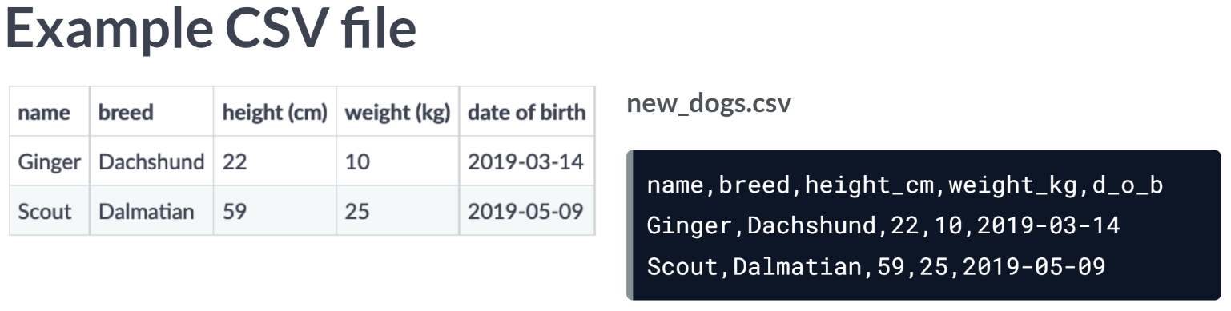  
Remember the dogs from the last video? Their data is stored in a CSV file called new_dogs.csv, which looks like this above.

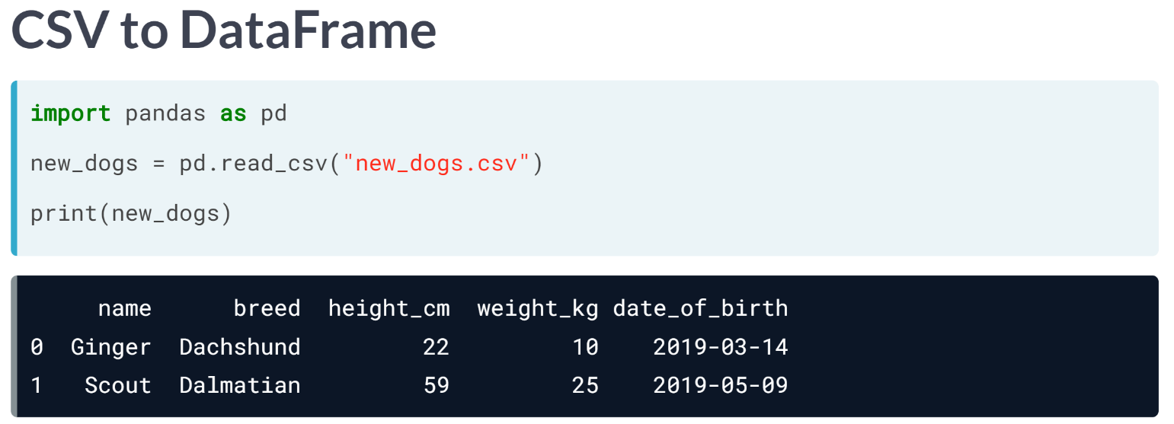  
We can put this data in a DataFrame using the handy pandas function, ***read_csv()*** and pass it the file path of the csv.

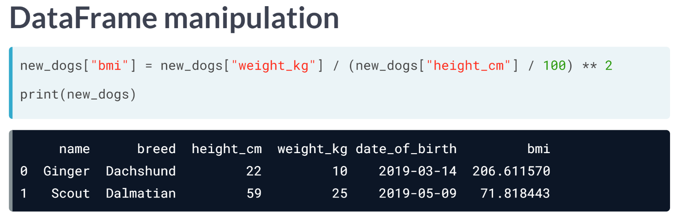  
Now that the data is in DataFrame form, we can manipulate it using some of the functions from earlier in this course.

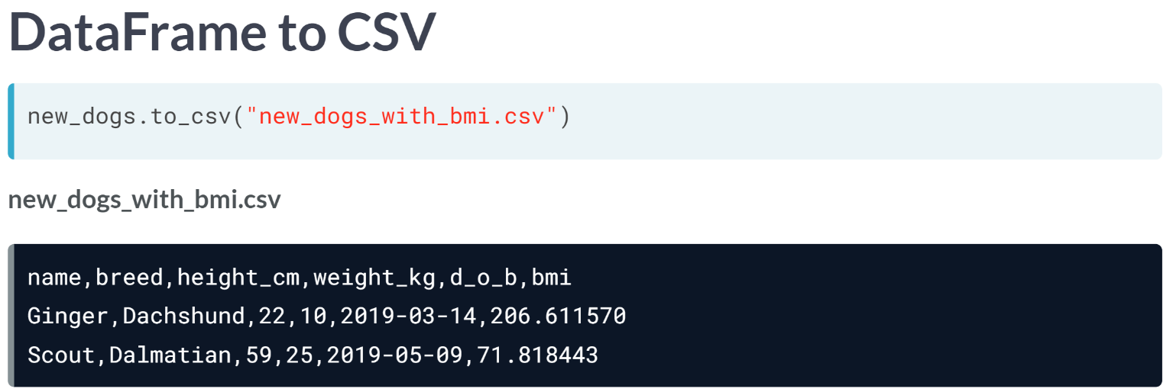  
Now that we've changed the data, let's create an updated CSV file to share with the dogs' owners. To convert a DataFrame to a CSV, we can use ***new_dogs.to_csv()*** and pass in a new file path. If we take a look at the new file, it contains the BMI column.

# CSV to DataFrame

You work for an airline, and your manager has asked you to do a competitive analysis and see how often passengers flying on other airlines are involuntarily bumped from their flights.

You got a CSV file (airline_bumping.csv) from the Department of Transportation containing data on passengers that were involuntarily denied boarding in 2016 and 2017, but it doesn't have the exact numbers you want.

In order to figure this out, you'll need to get the CSV into a pandas DataFrame and do some manipulation!

pandas is imported for you as pd. "airline_bumping.csv" is in your working directory.

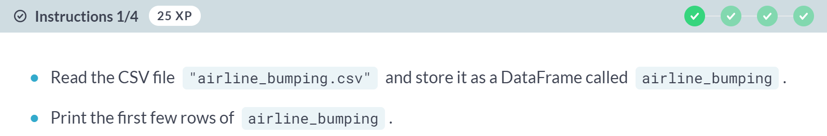

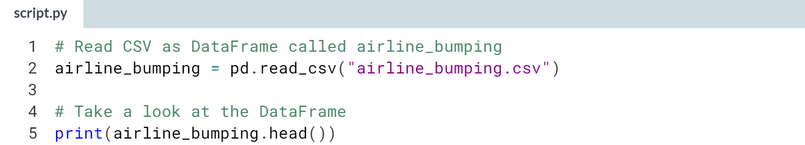

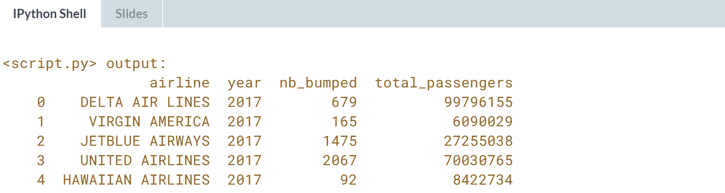

(Exercise continues on the next page)

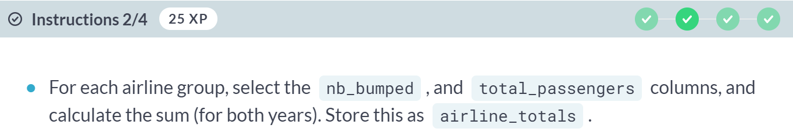

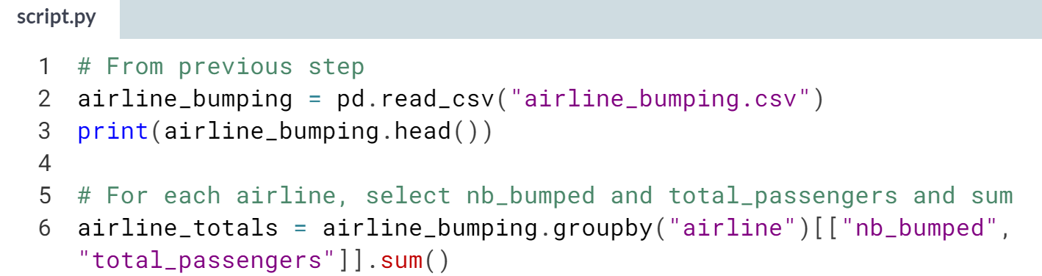

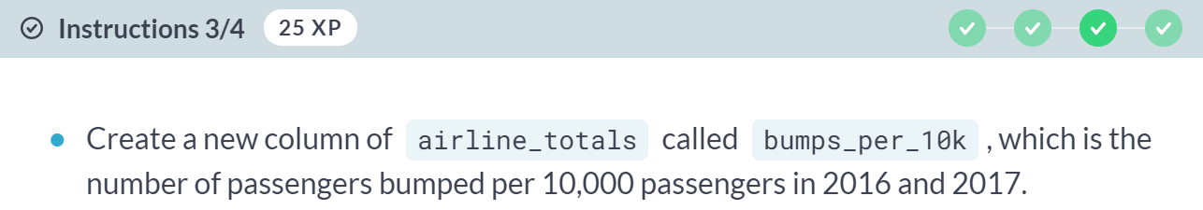

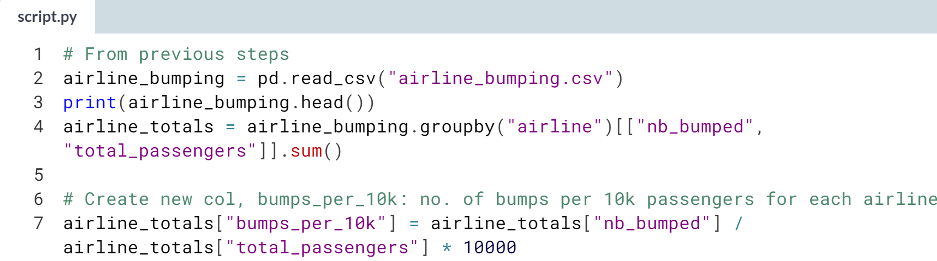

(Exercise continues on the next page)

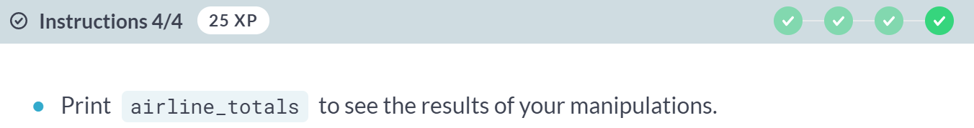

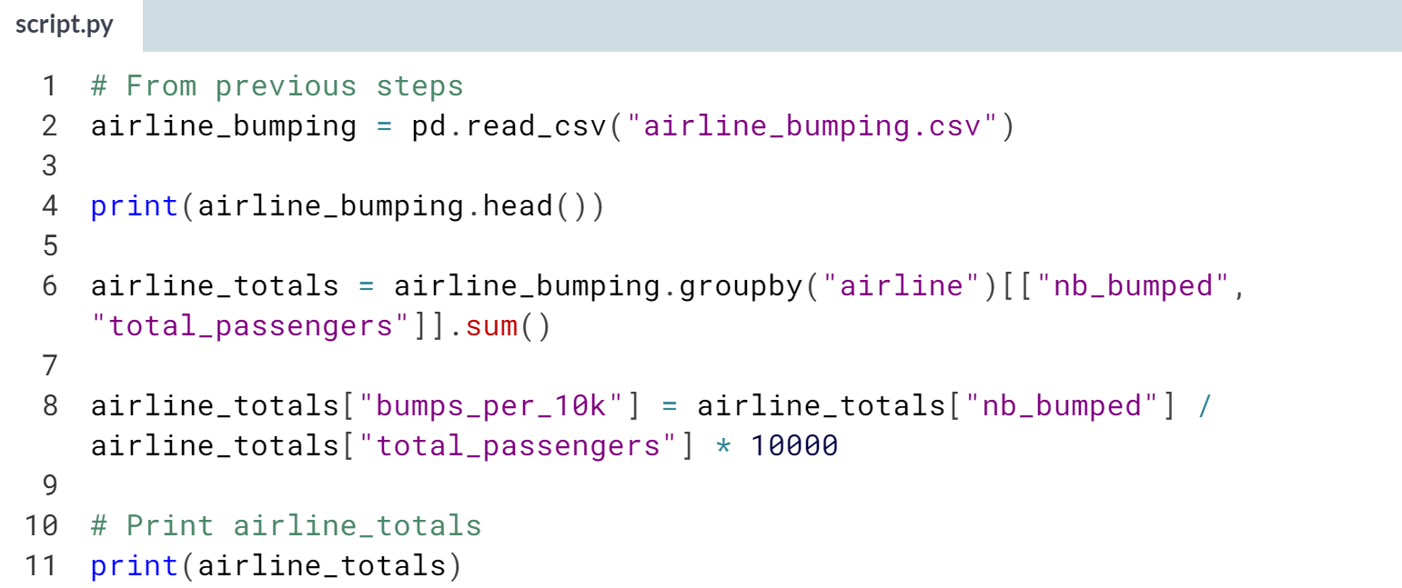

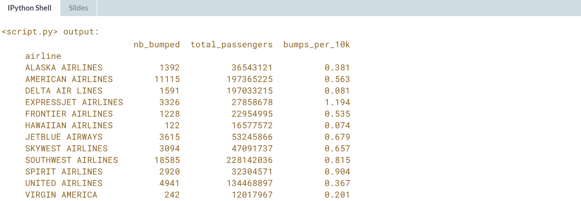

Masterful manipulation! Now you'll need to export this so you can share it with others.

# DataFrame to CSV

You're almost there! To make things easier to read, you'll need to sort the data and export it to CSV so that your colleagues can read it.

pandas as pd has been imported for you.

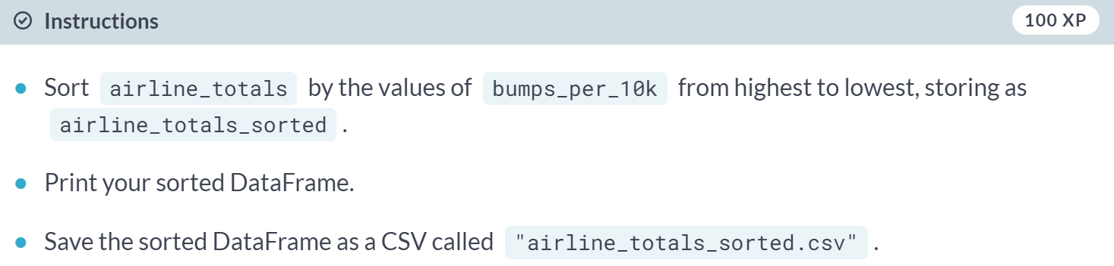

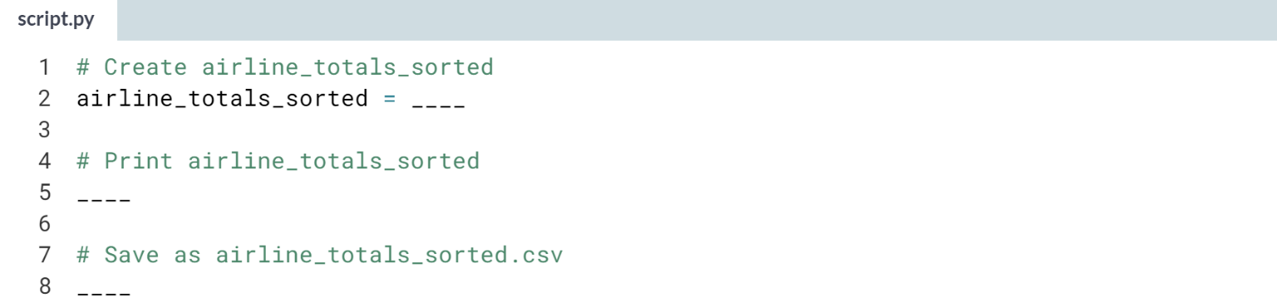

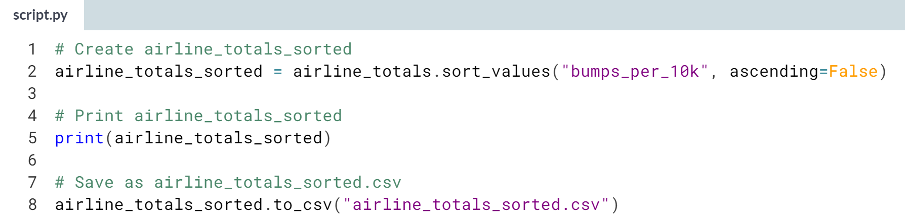

Hint

1. To sort in descending order, set ascending to *False*.
2. Save to CSV by calling ***.to_csv()***, passing the filename to save to as a string.

(Solution on the next page)

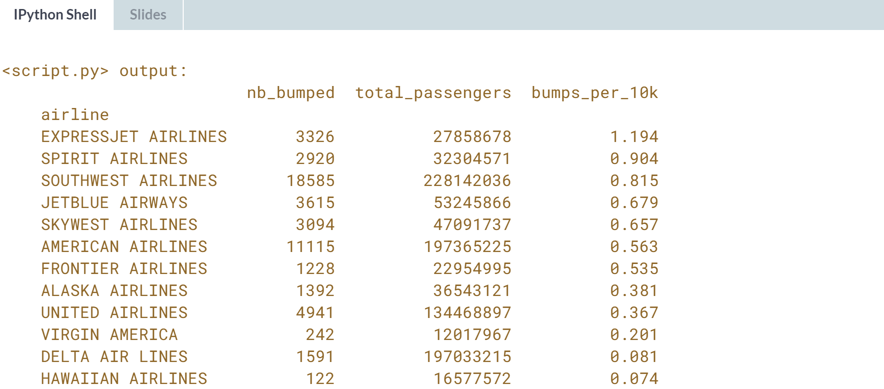

Excellent exporting! Now you can share these insights about your competitors with your team.



